FoodLoop
Intelligent Food Redistribution and Waste Minimisation
Project summary · methodology · workflow · comparison with existing research
Design and Analysis of Algorithms project
Algorithms: Minimum Cost Maximum Flow · Dijkstra · Greedy · 0/1 Knapsack
How to read this document
Sections 1–3 explain the project in plain words. Section 4 walks through every algorithm with a small worked example. Sections 5–8 give the formulas, results, testing and dashboard. Section 9 explains how FoodLoop differs from the 2023 and 2026 papers, and section 10 checks the project against the comparison document.

Contents
1. FoodLoop in one page 3
The problem 3
What FoodLoop does 3
The key idea 3
Results at a glance 3
2. The inputs 4
3. The workflow 4
4. Each stage explained simply 6
4.1 Validation 6
4.2 Dijkstra: road distances 6
4.3 Feasibility: which pairs are allowed 6
4.4 Greedy: expiry ranking and urgency tiers 6
4.5 Min Cost Max Flow: the allocation 7
4.6 0/1 Knapsack: loading the vehicles 8
4.7 The Greedy baseline 8
5. Formulas 8
5.1 Cost 8
5.2 The optimisation model (one tier) 9
5.3 Performance metrics 9
6. Results 9
6.1 Hand-built datasets 9
6.2 Scenario comparison (70 generated cities) 10
6.3 Scalability 10
6.4 What the results mean 11
7. Testing and verification 11
8. The dashboard 11
9. How FoodLoop differs from existing research 12
9.1 The two papers 12
9.2 Side-by-side comparison 12
9.3 What changes in our approach, and why it stands out 13
9.4 What the papers do that FoodLoop does not 14
10. Check against the comparison document 14
11. Limitations and future work 15
12. Glossary 15

1. FoodLoop in one page

The problem
Restaurants, supermarkets, hostels and event halls often have food left over at the end of the day. At the same time, orphanages, shelters, food banks and community kitchens nearby do not have enough. The food is perishable, so it has to reach the right place before it spoils, and transport costs money.
Deciding by hand who should send what to whom is hard. Each NGO needs particular kinds of food (vegetarian, non-vegetarian, vegan), some food expires within an hour, vehicles have limited space, and roads make some trips much longer than others.

What FoodLoop does
FoodLoop takes the list of donors, their food, the NGOs and their needs, the vehicles and the road map, and produces:
- an allocation plan: how many kilograms of each food lot go to each NGO;
- a delivery plan: which crates go on which vehicle trip, and when each trip leaves and arrives;
- performance figures: how much demand was met, how much food was left over, how much arrived before expiry, the transport cost and the running time.

The key idea
Food redistribution as a flow of kilograms
FoodLoop treats the problem as a network: food flows from donors' lots, along allowed routes, into NGOs. The Minimum Cost Maximum Flow algorithm finds the plan that delivers the largest possible amount of food, and among all such plans, the one with the lowest transport cost.
Three supporting algorithms prepare and finish the work: Dijkstra measures road distances, Greedy ranks food by how soon it expires, and 0/1 Knapsack packs the allocated food into vehicle trips.

Results at a glance
Test | What happened
Toy example (2 donors, 2 NGOs) | MCMF delivers 16 kg; a simple Greedy method delivers only 8 kg and wastes half the food.
Demo city (4 donors, 5 NGOs) | 186 kg allocated, 93% of demand met, 100% delivered before expiry; transport cost ₹368.45 (Greedy ₹371.45).
70 generated cities, 7 scenarios | Same food delivered by both methods; MCMF cheaper in all 70, saving 2.6–13.7% on allocation cost.
Scalability (5 to 320 donors) | MCMF solves 320 donors and 1,226 food lots in about 12 seconds; its cost saving grows with size, up to 17.9%.
Testing | 2,034 automated checks pass; an independent library (NetworkX) reproduces every distance and every optimal flow.

2. The inputs
Every dataset is a folder of six small CSV files, so it can be opened in Excel and edited easily. The dashboard can also edit them directly.
File | What it describes | Example row
donors.csv | Who has surplus food and where | D1, Spice Garden Restaurant, junction J1
packages.csv | Each food lot: category, kilograms, hours until it spoils | P10, Khichdi, VEG, 18 kg, 0.75 h
ngos.csv | Each NGO and how many kg it needs of each category (0 = does not accept) | N4, Little Hearts Childcare: VEG 25, NON_VEG 0, VEGAN 7
vehicles.csv | One vehicle per donor: capacity, speed, running cost | V1, scooter, 25 kg, 25 km/h, ₹6/km
nodes.csv, roads.csv | The road map: junctions and road lengths | J1 – J2, 3.0 km

A small settings file, config/params.csv, holds the rules that are the same for every dataset:
Setting | Value | Meaning
Handling time | 0.5 h | Time for the NGO to receive and serve the food after it arrives
Urgency tiers | 6 h, 24 h | Tier 1: spoils in under 6 h; tier 2: 6–24 h; tier 3: 24 h or more
Transport rate R | ₹0.50 per kg per km | Used to compare allocation plans
Crate size | 10 kg | Food travels in crates of at most 10 kg
Tier weights | 3, 2, 1 | How valuable a kilogram of each tier is when loading vehicles
Vehicle shift | 8 h | Every delivery must be served within the shift

Four datasets are included: toy (2 donors, hand-checked), demo (4 donors, 5 NGOs, hand-built test cases), and city and large (12 and 40 donors, produced by a seeded generator so they can be recreated exactly).

3. The workflow
FoodLoop runs the same seven stages every time. The C++ engine performs all the algorithms; the Python dashboard only edits the inputs and shows the results.
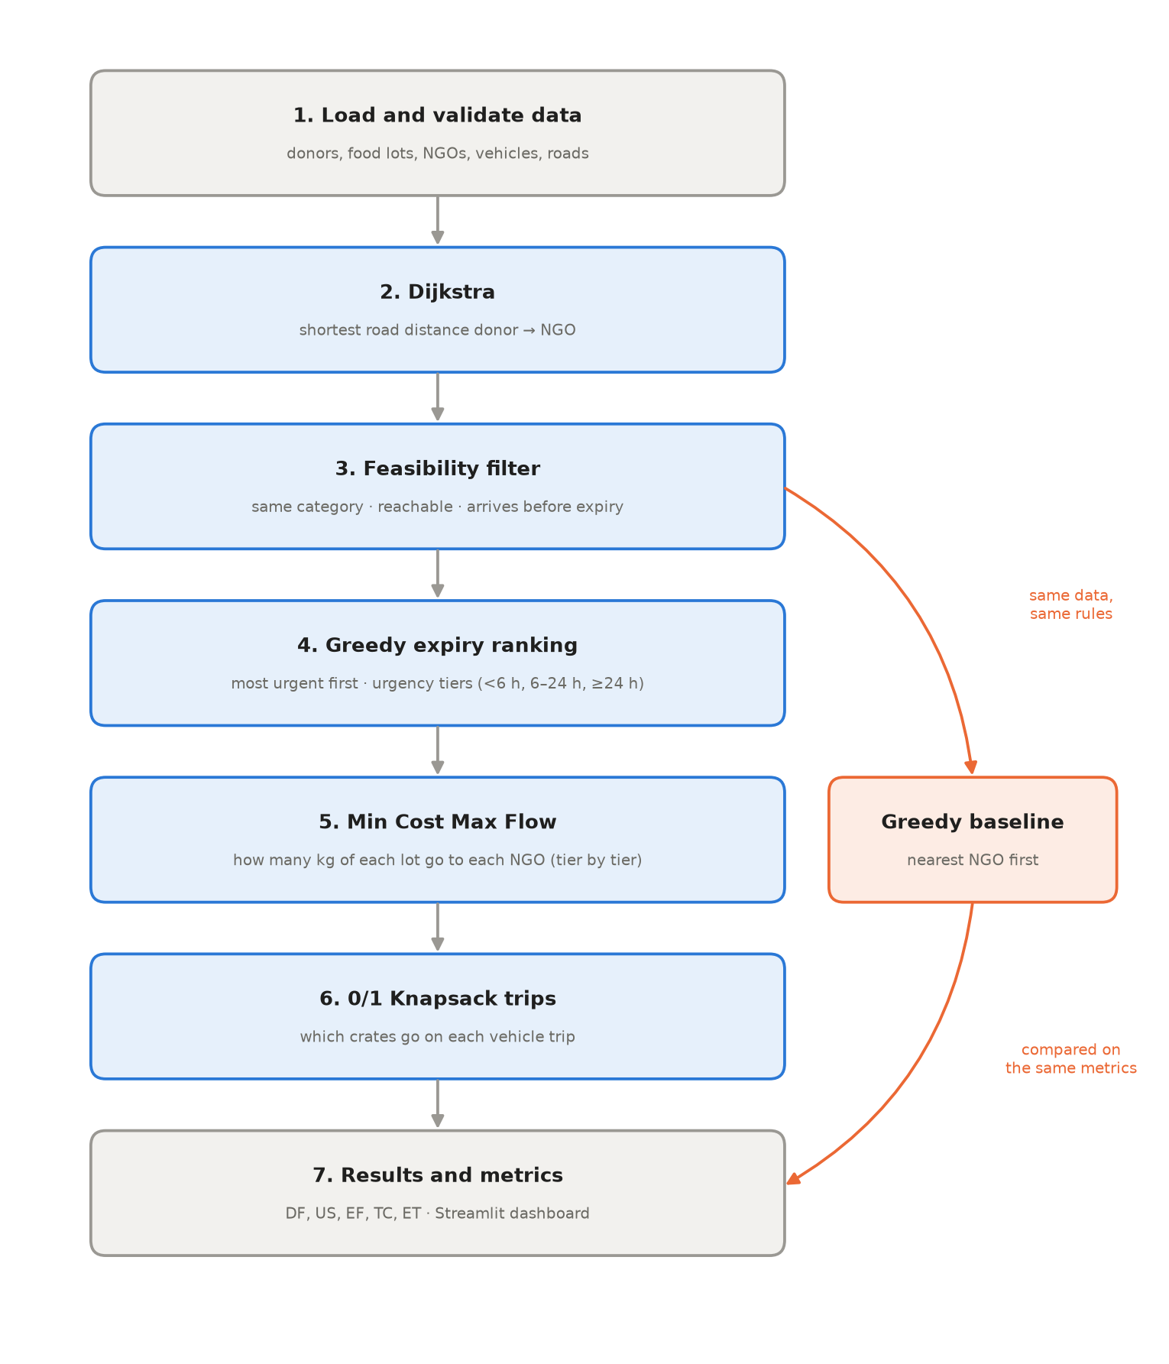
Figure 1. FoodLoop workflow. The Greedy baseline uses the same data and rules, so the comparison is fair.
Stage | Question it answers | Algorithm | Output
1. Load and validate | Is the data complete and sensible? | – | Clean dataset, or a clear error message
2. Distances | How far is each donor from each NGO by road? | Dijkstra | Distance matrix and routes
3. Feasibility | Which donor–NGO pairs are allowed at all? | Rule check | List of allowed (lot, NGO) pairs
4. Urgency | Which food must be handled first? | Greedy (Earliest Deadline First) | Ranked list and urgency tiers
5. Allocation | How many kg of each lot go to each NGO? | Min Cost Max Flow | Allocation plan
6. Loading | Which crates go on which vehicle trip? | 0/1 Knapsack + Greedy trip order | Trip plan, undelivered crates
7. Evaluation | How good is the plan, and how does it compare with Greedy? | Metric formulas | DF, US, EF, TC, ET; dashboard

4. Each stage explained simply

4.1 Validation
Before any algorithm runs, FoodLoop checks the data: every ID is unique, every lot belongs to a real donor, every NGO is on a real junction, food quantities are positive, demand and expiry are not negative, and vehicles have positive speed and capacity. A lot with 0 hours left is allowed and means already expired; the rules below make sure it is never sent. Bad data stops the run with a message such as “duplicate lot id 'TP1'”.

4.2 Dijkstra: road distances
Idea. Start at a donor's junction and grow outwards, always fixing the closest junction that has not been fixed yet. Because no road has negative length, a fixed distance can never be improved later.
- Set every junction's distance to infinity, except the start (0).
- Keep a priority queue (min-heap) that always returns the closest junction.
- Take the closest junction out; for each neighbour, check whether going through it is shorter, and if so update the neighbour and remember where it came from.
- Repeat until the queue is empty. The “came from” links give the actual route.
Example (donor D3, Sunrise Hostel at J10): the shortest distances to the five NGOs are 6.1, 9.3, 6.5, 3.0 and 9.0 km. To reach N1 the route goes through J9 (6.1 km) rather than J6 (6.2 km).
Why Dijkstra? Breadth-first search counts roads, not kilometres. Floyd–Warshall computes all pairs of junctions in O(V³), but only distances from donors are needed. Dijkstra is run once per donor: O(D · (V + E) log V).

4.3 Feasibility: which pairs are allowed
A food lot may go to an NGO only if all three rules hold. Pairs that fail are removed before the allocation starts, so they can never be chosen.
Rule | Condition | Reason
Compatibility | The NGO has demand for this food's category | A vegan kitchen never receives non-vegetarian food
Reachability | A road path exists | Isolated places cannot be served
Expiry | travel time + 0.5 h handling ≤ hours until the food spoils | Food must be served before it goes bad

Example. Khichdi (lot P10) has only 45 minutes. N4 is 3 km away by auto-rickshaw at 20 km/h: 9 minutes + 30 minutes handling = 39 minutes, so it is allowed. N1 would take 48 minutes, which is too late. The khichdi can only go to N4.

4.4 Greedy: expiry ranking and urgency tiers
Idea. Food that spoils first should be handled first. Lots are sorted by remaining shelf life, shortest first (ties: the larger lot first). This is the Earliest Deadline First rule, a classic greedy strategy.
The lots are then grouped into urgency tiers: tier 1 (under 6 h), tier 2 (6–24 h) and tier 3 (24 h or more). The allocation is solved tier by tier, so the most urgent food gets the first claim on the NGOs' demand. Sorting costs O(L log L).

4.5 Min Cost Max Flow: the allocation
What a flow network is. Imagine water pipes. Water enters at a source, passes through pipes of limited size, and leaves at a sink. Here, the “water” is kilograms of food:
- Source → each lot, pipe size = kg in the lot (a lot cannot give more than it has);
- Lot → (NGO, category), only for allowed pairs, cost = transport cost per kg;
- (NGO, category) → sink, pipe size = kg the NGO still needs in that category.
Splitting each NGO by category means food can only flow into the matching category, so compatibility is built into the network itself.
Goal. First push the maximum possible kilograms from source to sink (most food redistributed). Among all ways of doing that, choose the one with the minimum total transport cost. Delivering more food always wins over saving money.
How it works: Successive Shortest Augmenting Paths.
- Find the cheapest route from source to sink in the residual network (Bellman-Ford).
- Push as many kilograms along it as the narrowest pipe allows.
- Update the network: the used pipes shrink, and matching reverse pipes appear with negative cost.
- Repeat until no route from source to sink remains. The flow is then maximum and its cost is minimum.
Why reverse pipes matter. A reverse pipe lets a later route undo part of an earlier decision and get the cost back. That is something a greedy method can never do. Because reverse pipes have negative cost, Dijkstra cannot be used inside this step; Bellman-Ford handles negative costs.
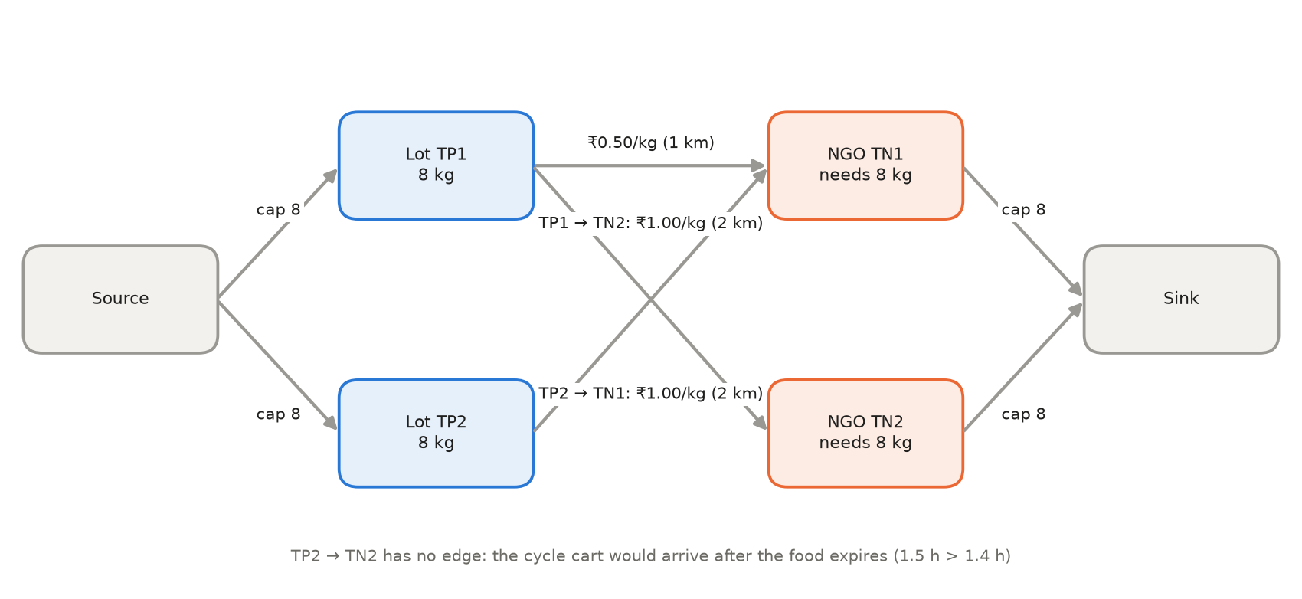
Figure 2. The toy flow network. Each NGO needs 8 kg of vegetarian food.
Step | Cheapest route found | Route cost per kg | What happens
1 | Source → TP1 → TN1 → Sink | ₹0.50 | 8 kg sent; TN1 is now full
2 | Source → TP2 → TN1 → (reverse) TP1 → TN2 → Sink | 1.00 − 0.50 + 1.00 = ₹1.50 | The reverse pipe moves TP1's food to TN2 and frees TN1 for TP2
3 | none | – | Stop: 16 kg delivered for ₹16

A greedy method sends TP1 to the nearest NGO (TN1) and then cannot use TP2 at all, because TP2 cannot reach TN2 before it spoils: 8 kg delivered, 8 kg wasted. MCMF delivers all 16 kg.
Complexity. One Bellman-Ford search costs O(V · E); each route pushes at least 1 kg, so a tier costs O(F · V · E), where F is the kg pushed. All costs are stored as whole paise so the arithmetic is exact.

4.6 0/1 Knapsack: loading the vehicles
The allocation says how much food goes where, but each donor has one vehicle with limited space. The food is split into crates of at most 10 kg (28 kg becomes 10 + 10 + 8). Each crate is worth kg × tier weight (3 for tier 1, 2 for tier 2, 1 for tier 3).
For each vehicle the trip planner repeats:
- Remove crates that could no longer arrive in time if the vehicle left now (reported as “expired”), or after the shift ends.
- Greedy picks the next destination: the NGO whose most urgent crate must leave soonest.
- 0/1 Knapsack picks which of that NGO's crates go on this trip, maximising total value without exceeding capacity.
- Drive there, unload, return; move the clock forward and repeat.
Knapsack by dynamic programming. dp[i][w] is the best value using the first i crates with capacity w: either skip crate i, or take it if it fits. Example with capacity 4 kg and crates A (3 kg, value 9), B (2, 5), C (2, 5):
crate \ capacity | 0 | 1 | 2 | 3 | 4
none | 0 | 0 | 0 | 0 | 0
A (3 kg, 9) | 0 | 0 | 0 | 9 | 9
B (2 kg, 5) | 0 | 0 | 5 | 9 | 9
C (2 kg, 5) | 0 | 0 | 5 | 9 | 10

The best load is B + C, worth 10. Greedy by value per kg would take A first (3 per kg) and then nothing else fits, giving 9. Crates cannot be cut, so greedy fails and dynamic programming is needed. Cost: O(n · W) per trip.
Demo example. Donor D1's scooter holds 25 kg but must deliver 31 kg to N1. Trip 1 carries 22 kg (served by 0.62 h); trip 2 carries the remaining 9 kg (served by 1.36 h), still before that food expires at 3 h.

4.7 The Greedy baseline
To show what MCMF adds, FoodLoop also runs a simple method on exactly the same data and rules: take lots in expiry order and send each to the nearest allowed NGO that still needs that category, spilling over to the next nearest if needed. It never changes a decision once made. Both plans then go through the same trip planner and the same metrics.

5. Formulas

5.1 Cost
Quantity | Formula | Unit
Travel time | t = D ÷ vehicle speed | hours
Allocation cost rate | C = D × R (R = ₹0.50 per kg per km) | ₹ per kg
Total allocation cost | TC = Σ x × D × R (x = kg allocated) | ₹
Trip cost | 2 × D × vehicle ₹/km for every round trip | ₹

The quantity x is multiplied in once, in TC. The per-kg rate R is used to compare allocations; the vehicle's own ₹/km is a per-trip cost used only for the real trip cost.

5.2 The optimisation model (one tier)
Part | Statement
Objective 1 | Maximise F = Σ x (total kg redistributed)
Objective 2 | Among all maximum-F plans, minimise TC = Σ x × C
Supply | Kg sent from each lot ≤ kg in the lot
Demand | Kg received by each NGO in each category ≤ its demand
Feasibility | x = 0 for any pair that fails compatibility, reachability or expiry
Integrality | x is a whole number of kg (guaranteed because all capacities are whole numbers)
Vehicle capacity | Not inside the flow network; enforced afterwards by the Knapsack loading stage

5.3 Performance metrics
Metric | Formula | Meaning
DF – demand fulfilment | allocated ÷ total NGO demand × 100 | Share of need that was met
US – unallocated surplus | total supply − allocated | Food that found no NGO
EF – expiry-feasible delivery | kg delivered before expiry ÷ allocated × 100 | Share of the plan that actually arrives in time
TC – allocation cost | Σ x × D × R | Transport cost of the allocation
ET – execution time | T_end − T_start, averaged over repeated runs | How long the algorithm takes

6. Results

6.1 Hand-built datasets
Dataset | Method | Allocated | DF | US | EF | TC
Toy | MCMF | 16 kg | 100% | 0 kg | 100% | ₹16.00
Toy | Greedy | 8 kg | 50% | 8 kg | 100% | ₹4.00
Demo | MCMF | 186 kg | 93% | 20 kg | 100% | ₹368.45
Demo | Greedy | 186 kg | 93% | 20 kg | 100% | ₹371.45

On the demo, 186 kg is the best any method could do: for every category it equals the smaller of supply and demand (100 + 45 + 41 kg). The 20 kg left over is exactly the vegetarian and non-vegetarian surplus.

6.2 Scenario comparison (70 generated cities)
Seven situations were tested, each on 10 generated cities with 12 donors and 15 NGOs:
Scenario | Allocated | MCMF cheaper in | Allocation-cost saving | Trip-cost saving
Baseline | equal (10/10) | 10/10 | 6.0% | 5.7%
Surplus (demand 70% of supply) | equal | 10/10 | 13.7% | 11.5%
Shortage (demand 140%) | equal | 10/10 | 2.6% | 4.5%
Strict diets | equal | 10/10 | 6.1% | 9.5%
Tight expiry (shelf life × 0.4) | equal | 10/10 | 8.7% | 12.7%
Small vehicles (capacity × 0.4) | equal | 10/10 | 6.0% | 5.5%
Tight expiry + shortage | equal | 10/10 | 3.6% | 13.6%

6.3 Scalability
Donors | Food lots | MCMF time | Greedy time | Cost saving
5 | 21 | 0.07 ms | 0.03 ms | 1.7%
40 | 160 | 12 ms | 0.4 ms | 15.5%
160 | 625 | 0.74 s | 7 ms | 14.0%
320 | 1,226 | 11.8 s | 33 ms | 17.9%
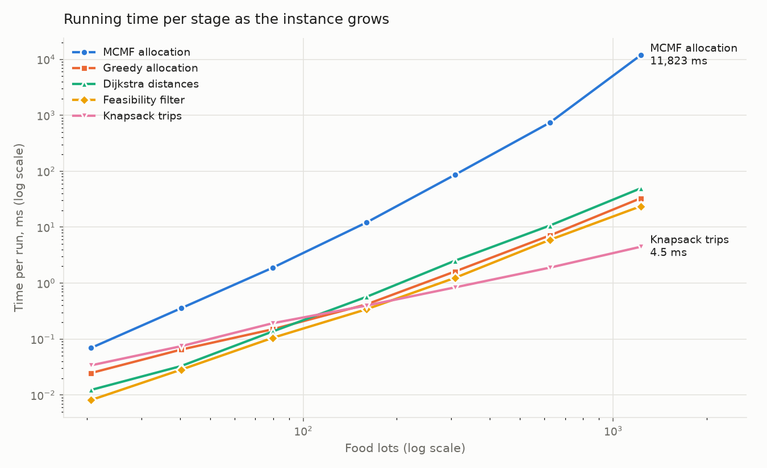
Figure 3. Running time of every stage as the instance grows (log–log).
Every stage except MCMF grows exactly as theory predicts (Dijkstra, feasibility and Greedy about L², Knapsack about L). MCMF's worst-case bound grows like L⁴, but the measured time grows like L³·¹⁶: Bellman-Ford stops as soon as nothing changes, which happens after only a few passes in this network.
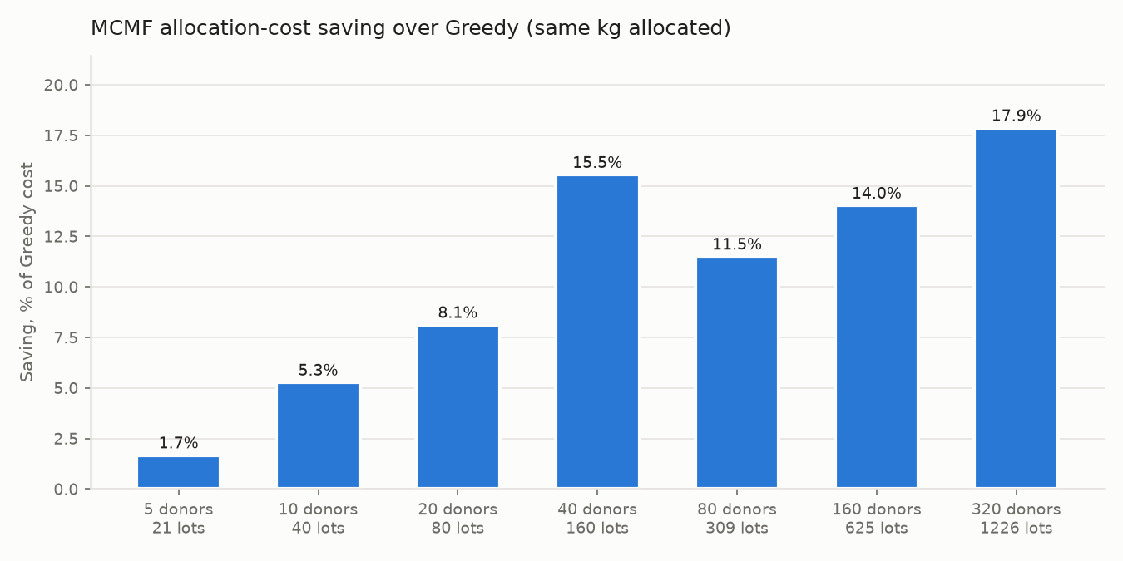
Figure 4. MCMF's allocation-cost saving over Greedy grows with the size of the city.

6.4 What the results mean
- Quantity. MCMF delivers more food than Greedy when routes are tight enough that a nearest-first choice strands food (the toy example). In well-connected cities, Greedy's spill-over usually finds a home for the food too.
- Cost. MCMF was cheaper in every one of the 70 generated cities, and the saving grows with size, because bigger networks give it more routes to rearrange.
- Trade-off. MCMF uses up to 360 times more computation than Greedy for up to 18% lower transport cost; even 320 donors finish in about 12 seconds.
- Honest weakness. In some scenarios Greedy's on-time delivery (EF) is slightly higher, because MCMF spreads food over more NGOs and so needs more trips.

7. Testing and verification
Test layer | What it proves | Checks
Hand-solved unit tests | Dijkstra, Greedy, MCMF and Knapsack give the answers worked out on paper | 394
Formula and validation tests | Cost and metric formulas match the methodology; bad data is rejected | 104
Scenario and edge-case tests | Surplus, shortage, incompatible food, small vehicles, expiry boundary, isolated NGO, zero distance | 1,536 (incl. random)
Randomised checks | 500 random cities: every plan obeys every rule; with one tier MCMF is never worse than Greedy | part of the above
Independent oracle | NetworkX reproduces every distance, allowed pair and optimal flow on all four datasets | 4 datasets

All 2,034 checks pass. One command, run_tests.bat, rebuilds the engine and runs everything.

8. The dashboard
The Streamlit dashboard (run_app.bat) is an interactive simulator: change any input or setting and the C++ engine re-optimises immediately.
Tab | Shows
Overview | DF, US, EF, TC and trip cost, each compared with Greedy; outcome and demand charts
Inputs | Editable tables of donors, vehicles, food lots and NGOs
Urgency | Greedy expiry ranking, tiers, and which NGOs each lot can reach
Allocation | Tier-by-tier MCMF results, MCMF and Greedy plans side by side, leftovers and unmet demand
Network | Map of donor → NGO flows, with optional Dijkstra routes and a focus on one donor or NGO
Trips | Timeline of every vehicle trip, loads, and undelivered crates
Distances | Dijkstra distance matrix and routes

9. How FoodLoop differs from existing research

9.1 The two papers
Dubey and Tanksale (2023), Expert Systems with Applications: “A Multi-Depot Vehicle Routing Problem with Time Windows, Split Pickup and Split Delivery for Surplus Food Recovery and Redistribution”. It plans vehicle routes: which vehicle visits which donors and receivers, in what order, within time windows, allowing a pickup or delivery to be split across vehicles. It minimises vehicle hiring cost, routing cost and penalties for unmet demand, and solves the problem with a Genetic Algorithm and a hybrid Genetic Algorithm with 3-opt local search, tested on benchmark instances and a real food-rescue case.
Rampazo, Jones, Godoi, Iamamoto and Cantane (2026), International Transactions in Operational Research (DOI 10.1111/itor.70252): “An Extended Goal Programming Framework Incorporating Poverty Measures: Application to Food Bank Logistics”. It decides how a food bank shares food among recipients fairly, weighting allocations by poverty and socio-economic vulnerability, across several planning periods with multi-product inventory and First Expired, First Out shelf-life control, using data from the São Paulo municipal food bank.

9.2 Side-by-side comparison
Aspect | Dubey & Tanksale (2023) | Rampazo et al. (2026) | FoodLoop
Main question | Which routes should vehicles drive? | How should a food bank share food fairly over time? | How many kg of each food lot should go to each NGO, then how should vehicles carry it?
Problem type | Multi-depot vehicle routing with time windows, split pickup and delivery | Multi-period, multi-product allocation with inventory | Single-period allocation as a flow network, followed by vehicle loading
Core method | Genetic Algorithm; hybrid GA with 3-opt | Extended Goal Programming with poverty index | Min Cost Max Flow (Successive Shortest Paths + Bellman-Ford)
Supporting methods | Genetic operators, 3-opt local search | Goal programming solver | Dijkstra, Greedy expiry ranking, 0/1 Knapsack (DP)
Solution quality | Good solutions, no optimality guarantee (metaheuristic) | Best compromise between weighted goals | Exact optimum for each urgency tier, in polynomial time
Objective | Minimise hiring, routing and unmet-demand penalty costs | Meet several goals, including fairness to the poorest | First maximise food redistributed, then minimise transport cost
Perishability | Pickup and delivery time windows | FEFO inventory over periods | Hard expiry rule on every route, urgency tiers, and an expiry re-check for every vehicle trip
Food compatibility | Not the focus | Multiple products | Built into the network: food can only flow to an NGO's matching category
Vehicle capacity | Inside the routing model | Not the focus | Separate Knapsack loading stage after allocation
Routing | Full multi-stop routes | Not modelled | Direct donor → NGO trips (routing is out of scope)
Fairness / poverty | Not modelled | Central | Not modelled
Evaluation | Benchmark instances and a real case study | Real food-bank data | Greedy vs MCMF on hand-built and seeded synthetic cities; scenario study; measured scalability against theoretical complexity
Tool | – | – | Interactive Streamlit decision-support simulator

9.3 What changes in our approach, and why it stands out
FoodLoop does not claim to be the first work on food redistribution, expiry handling or food compatibility; all of these have research foundations. What is distinct is how the problem is formulated and solved:
- It asks a different first question. The 2023 paper starts from vehicles and routes. FoodLoop starts from the food: “how much of each lot should each NGO receive?” The vehicles are planned afterwards. Separating allocation from loading makes each part solvable exactly.
- It uses exact, polynomial-time algorithms. The 2023 paper needs a Genetic Algorithm because vehicle routing is NP-hard, and the 2026 paper uses goal programming to balance competing goals. FoodLoop's allocation is a Minimum Cost Maximum Flow problem, which is solved exactly in polynomial time, gives the same answer every run, and can be checked against an independent library.
- Compatibility is part of the network's shape. Each NGO is split into one node per food category, and a lot connects only to nodes of its own category. A single flow computation therefore respects every dietary restriction without extra rules.
- Expiry is handled at three levels. A hard feasibility rule removes routes that would arrive too late, urgency tiers give the most perishable food the first claim on demand, and the trip planner re-checks expiry for every later trip and reports late food honestly instead of hiding it.
- Vehicle capacity has its own stage. Instead of mixing capacity into the allocation, a 0/1 Knapsack decides which crates go on each trip, with Greedy choosing the most urgent destination first.
- It measures its own value. Every run compares MCMF with a Greedy baseline on identical data and rules, and the study links measured running times to theoretical complexity (for example, MCMF grows like L³·¹⁶ against a theoretical bound of L⁴).
- It is an interactive tool. The Streamlit simulator lets a user change donors, food, NGOs or settings and see the new optimal plan immediately.
The contribution in one sentence
FoodLoop's contribution is a distinct algorithmic formulation and integration: category-wise Minimum Cost Maximum Flow over expiry-feasible routes, solved by urgency tier, combined with Dijkstra distances, Greedy expiry ranking and a separate Knapsack loading stage, and evaluated experimentally against a Greedy baseline. It is not a new optimisation algorithm.

9.4 What the papers do that FoodLoop does not
- Multi-stop vehicle routing (2023): FoodLoop's trips go directly from one donor to one NGO.
- Fairness and poverty weighting (2026): FoodLoop treats all NGOs equally and optimises efficiency.
- Multiple periods and inventory (2026): FoodLoop plans one period at a time.
- Real operational data (both papers): FoodLoop uses hand-built and seeded synthetic data.
These are clear scope boundaries, which also makes them natural future work.

10. Check against the comparison document
Every row of the comparison document was checked against the implemented code. The project matches all of them; a few rows can be stated more precisely.
Comparison-document row | Status | Note
Objective: maximise redistribution, minimise transport cost and avoidable wastage | Matches | MCMF maximises flow first, then minimises TC; wastage is reported as US
Problem: allocation from multiple donors to NGOs by supply, demand, expiry and compatibility | Matches | All four are enforced (supply and demand as capacities, expiry and compatibility as feasibility)
Methodology: graph-based framework with allocation, shortest paths and resource constraints | Matches | Flow network + Dijkstra + capacities
Main algorithm: MCMF with Successive Shortest Augmenting Path | Matches | Bellman-Ford finds each shortest path; verified against NetworkX
Supporting: Dijkstra, Greedy expiry prioritisation, 0/1 Knapsack | Matches | All three implemented and tested
Perishability: prioritise by expiry and check delivery feasibility | Matches | Could also mention urgency tiers and the per-trip expiry re-check
Allocation strategy: how much each donor allocates to each NGO | Matches | Computed per food lot, which is finer; donor totals follow directly
Transportation: shortest distances and costs in the allocation | Matches | C = D × R in every flow edge
Resource constraints: supply, demand, compatibility, vehicle capacity | Matches, reword | Vehicle capacity is enforced in the Knapsack stage after allocation, not inside MCMF
Output: allocation quantities, food priorities, delivery plans | Matches | Plus trip timings and undelivered crates
Evaluation: Greedy vs MCMF on food distributed, demand fulfilled, cost and time | Matches | Plus EF and unallocated surplus; 70-instance scenario study and scalability study
2026 paper: different scope, no claim that expiry handling is new | Matches | Section 9.3 keeps the same wording

Suggested edits to the comparison document:
- Change future tense (“we intend to use…”) to present tense: everything is now implemented.
- In “Resource constraints”, say that vehicle capacity is handled by a separate Knapsack loading stage.
- In “Performance evaluation”, state that the data is synthetic (hand-built and seeded generated cities), since the 2023 paper uses a real case study.
- Consider adding rows for: solution approach (exact polynomial vs metaheuristic), planning horizon (single vs multi-period), routing (direct trips vs multi-stop), and the interactive simulator.
- Confirm the publication date of the Rampazo et al. paper before final submission, so the citation year and month match the publisher's page.

11. Limitations and future work
Limitation | Effect | Possible future work
Direct trips only | Small leftover allocations make low-load trips | Multi-stop routing for small loads
Allocation assumes vehicles leave at time 0 | A few crates on later trips can miss expiry (reported, not hidden) | Feed trip timing back into the allocation
Tiers solved one after another | Optimal within each tier, not guaranteed across tiers | A single network with tier-based priorities
Exact category matching | Vegan food does not fill a vegetarian NGO's VEG demand | Allow substitution between compatible categories
No fairness weighting | All NGOs treated equally | Priority weights for the most vulnerable
Synthetic data | Results show behaviour, not real-world savings | Calibrate with real donation records
Bellman-Ford inside MCMF | About 12 s for 320 donors | Dijkstra with Johnson potentials for faster searches

12. Glossary
Term | Meaning
Flow network | A graph whose edges carry an amount (here, kg of food) up to a capacity, from a source to a sink
Residual network | The network of remaining capacities, including reverse edges that allow earlier choices to be undone
Augmenting path | A source-to-sink route in the residual network along which more food can be pushed
Bellman-Ford | A shortest-path algorithm that works even when some edges have negative cost
Earliest Deadline First | The greedy rule of handling whatever expires first
Urgency tier | A group of lots with similar remaining shelf life, solved together
Crate | An indivisible unit of food of at most 10 kg, used when loading vehicles
Lexicographic objective | Optimise the first goal fully, then the second goal without hurting the first
DF, US, EF, TC, ET | Demand fulfilment, unallocated surplus, expiry-feasible delivery, allocation cost, execution time

