Locora — City Guide Mobile Application
eProject Documentation

Team Members
Student ID | Name
Student1605338 | HIMESH
Student1557185 | MUHAMMAD DANIYAL
Student1598122 | SHEHERYAR MUSHTAQ
Student1573040 | AYAN HASSAN
Student1577060 | MUHAMMAD ANAS

Index
- Introduction
- Objectives
- Problem Statement
- Functional Requirements Coverage
- Non-Functional Requirements Coverage
- Project Screenshots
- Hardware / Software Requirements

1. Introduction
Locora is a cross-platform city guide mobile application built using Flutter and Firebase. It is designed to help both residents and tourists discover the most authentic and curated experiences within a city — including popular attractions, restaurants, hotels, and events.
The project is inspired by the modern travel discovery experience and follows the eProject methodology recommended by Aptech — a step-by-step, real-life implementation of concepts taught in class. Locora brings together everything from authentication, real-time databases, location services, mapping, and content management into one unified application.
The current release focuses on Pakistan as its first launch region, with Karachi as the flagship city. The architecture is built to scale to additional cities and countries with minimal changes.

2. Objectives
The primary objectives of the Locora project are:
- To build a real-life, production-grade mobile application that simulates an industry-style project flow.
- To provide users with a single platform to discover, explore, and review city attractions.
- To allow admins to manage attractions, events, and content dynamically through an in-app dashboard.
- To demonstrate practical use of Flutter, Firebase, Cloudinary, and OpenStreetMap in a real-world scenario.
- To apply best UI/UX practices for a modern, dark-themed, mobile-first experience.
- To produce well-structured, scalable, and maintainable code with proper documentation.

3. Problem Statement
Tourists and even local residents often struggle to find reliable, organized, and up-to-date information about places to visit, eat, or stay within a city. Existing solutions are either fragmented (separate apps for hotels, food, events), cluttered with advertisements, or do not focus on local cultural authenticity.
Locora solves this by offering:
- A single curated platform to browse attractions, restaurants, hotels, and events.
- Verified user reviews and ratings to help users make informed decisions.
- Integrated maps and directions so users never get lost.
- Personalized favorites so users can save places they care about.
- An admin-controlled catalog ensuring the data shown is moderated and accurate.

4. Functional Requirements Coverage
The following table maps each Aptech functional requirement to its implementation in Locora.

4.1 User Registration and Authentication
- Users can create accounts via Email/Password or Google Sign-In (Firebase Authentication).
- Secure login flow with session persistence using firebase_auth.
- Password reset option is available from the login screen.
- Implemented in: lib/screens/auth/register.dart, lib/screens/auth/login.dart

4.2 City Selection
- Users select their city during onboarding/setup.
- City data (description, image, region) is stored in lib/data/cities.dart.
- Implemented in: lib/screens/essentials/setup_screen.dart

4.3 Attraction Listings
- The home tab displays a grid of attractions, restaurants, hotels, and events for the selected city.
- Users can filter by category (All / Attraction / Restaurant / Hotel / Event).
- Each card shows: name, cover image, category, and star rating.
- Implemented in: lib/screens/essentials/tabs/home_tab.dart

4.4 Detailed Information
- Tapping a listing opens a detailed view with cover image, description, category, location, rating, reviews, and an "Open in Maps" link.
- Implemented in: lib/screens/city/detailed_attraction_card.dart

4.5 Maps and Directions
- Integrated OpenStreetMap via flutter_map shows all attractions of the selected city as colored markers.
- Users can tap a marker to view details and use url_launcher to open external map applications for directions.
- Implemented in: lib/screens/essentials/tabs/map_tab.dart

4.6 User Reviews and Ratings
- Logged-in users can post a text review with a star rating on any attraction.
- Reviews are stored in Cloud Firestore and rendered in real-time.
- Implemented in: lib/widgets/reviews/

4.7 Search Functionality
- A search bar on the home tab lets users search attractions by name.
- Combined with category filters for refined results.
- Implemented in: lib/screens/essentials/tabs/home_tab.dart

4.8 User Profile and Preferences
- Users can view and edit their profile, including name, avatar (Cloudinary upload), and city preference.
- A dedicated Favorites tab lets users revisit saved places.
- Implemented in: lib/screens/essentials/tabs/profile_tab.dart, lib/screens/essentials/tabs/favorites_tab.dart

4.9 Admin Dashboard
- An in-app Admin Dashboard (role-protected) lets admins add, edit, and remove attractions and events.
- Implemented in: lib/screens/admin/dashboard.dart, lib/screens/admin/manage_places.dart

5. Non-Functional Requirements Coverage
Requirement | How Locora Implements It
Responsiveness | Asynchronous Firestore streams keep UI updates under 1–2 seconds.
Loading Time | Flutter Splash + cached network images (cached_network_image) for fast initial paint.
User Interface | Built using ForUI + custom dark theme for a modern, consistent design language.
Accessibility | Legible typography, high-contrast dark mode, large touch targets.
User-friendly | Bottom navigation, clear iconography (hugeicons), guided onboarding flow.
Operability | Stateless widgets where possible; minimal rebuilds for performance.
Error Handling | Try/catch blocks around all Firebase calls with user-facing snack-bar messages.
Scalability | Firestore backend scales horizontally; city-based data partitioning ready for expansion.
Security | Firebase Auth + Firestore security rules restrict writes to authenticated users.
Documentation | This file + inline code comments + README.

6. Project Screenshots

6.1 Onboarding Screen
The welcome screen introduces the user to Locora's value proposition: exploring Pakistan like a local.
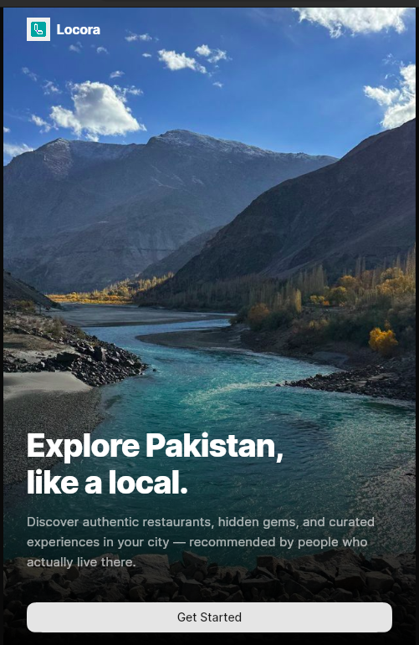
Figure: Onboarding

6.2 Login / Authentication
A clean, dark-themed sign-in screen with email/password and Google Sign-In support.
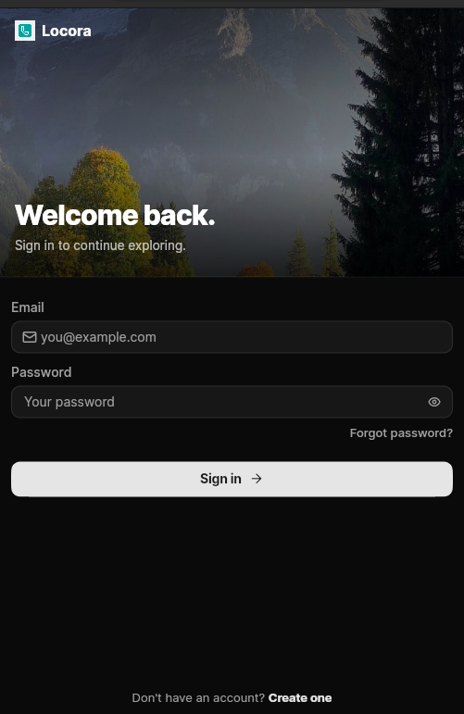
Figure: Login

6.3 Home — Attraction Listings
The main browse screen showing categorized cards (Attractions, Restaurants, Hotels, Events) with search and filters for the selected city (Karachi).
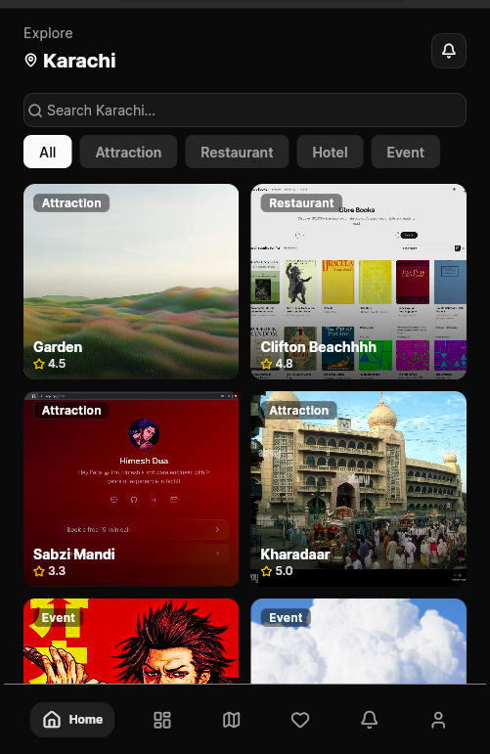
Figure: Home Attractions

6.4 Attraction Detail Screen
Tapping a listing shows full details — gallery, description, rating, review composer, "Open in Maps", and Save-to-Favorites.
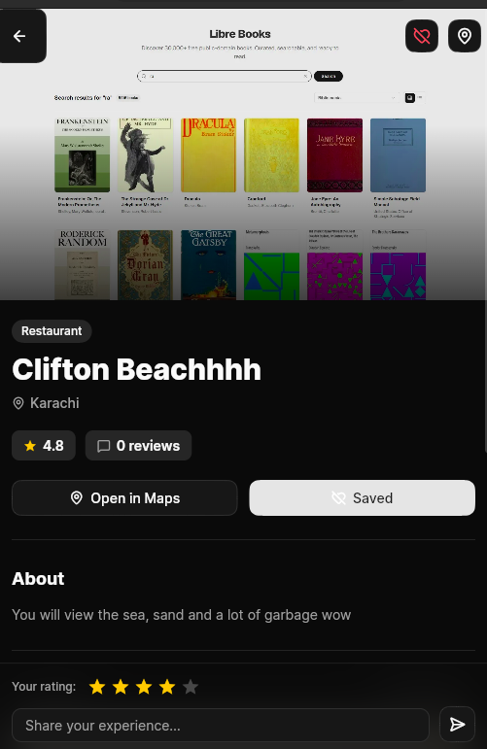
Figure: Attraction Detail

6.5 Interactive Map View
All attractions in the selected city plotted on an integrated map with color-coded category markers.
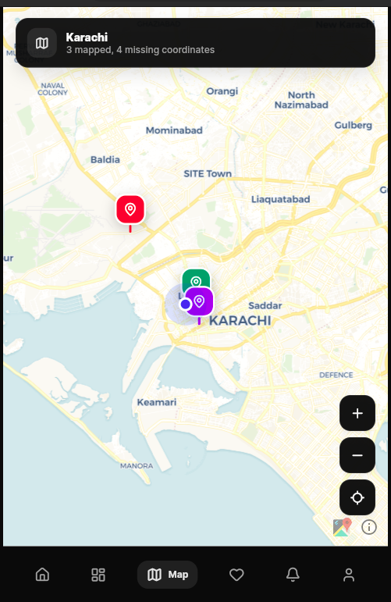
Figure: Map View

7. Hardware / Software Requirements

Hardware
- A modern development laptop or desktop (Intel i5 / Ryzen 5 or above recommended)
- 8 GB RAM minimum (16 GB recommended for Flutter + Android emulator)
- 10 GB free disk space for Flutter SDK, Android SDK, and emulators
- Android device or emulator (API 21 / Android 5.0+) for testing
- iOS device or Mac with Xcode (optional, for iOS builds)

Software
- Flutter SDK ^3.11.4
- Dart (bundled with Flutter)
- Android Studio or VS Code with Flutter & Dart extensions
- Firebase CLI for backend deployment
- Git for version control

Key Packages Used
Package | Purpose
firebase_core, firebase_auth, cloud_firestore | Backend, authentication & database
google_sign_in | Social authentication
cloudinary_public | Image upload & hosting
flutter_map, latlong2 | OpenStreetMap-based map view
geolocator | Current-location services
cached_network_image | Optimized image loading
forui, flex_color_scheme | UI design system & theming
hugeicons | Icon library
url_launcher | External navigation (maps, websites)
shared_preferences | Local persistence
image_picker | Profile / place image selection

End of Document

