# Black Myth: Wukong

*Experience the ultimate gaming journey!*

———————————————————————————————————————

## 🎮 Game Information

|  |  |
| --- | --- |
| **Developer** | [Game Science](https://store.steampowered.com/search/?developer=Game%20Science&snr=1_5_9__2000) |
| **Publisher** | [Game Science](https://store.steampowered.com/search/?developer=Game%20Science&snr=1_5_9__2000) |
| **Release Date** | 20 Aug, 2024 |
| **Genre** | [Action](https://store.steampowered.com/genre/Action/?snr=1_5_9__408), [Adventure](https://store.steampowered.com/genre/Adventure/?snr=1_5_9__408), [RPG](https://store.steampowered.com/genre/RPG/?snr=1_5_9__408) |
| **Platform** | PC |

## 📝 Description

## *Black Myth: Wukong is an action RPG rooted in Chinese mythology. The story is based on Journey to the West, one of the Four Great Classical Novels of Chinese literature. You shall set out as the Destined One to venture into the challenges and marvels ahead, to uncover the obscured truth beneath the veil of a glorious legend from the past*

## ✨ Key Features

• Action RPG  
• Dark Fantasy  
• Stunning Graphics

## 📸 Screenshots

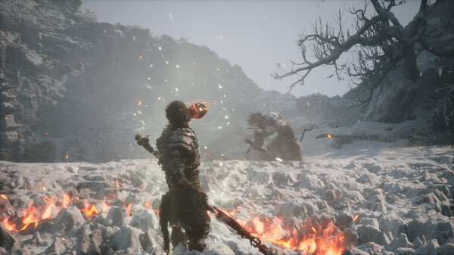

## 💻 System Requirements

|  |  |
| --- | --- |
| **Minimum Requirements** | **Recommended Requirements** |
| Processor:  Intel Core i5-8400 / AMD Ryzen 5 1600 | Processor:  Intel Core i7-9700 / AMD Ryzen 5 5500 |
| RAM: 16 GB RAM | RAM: 16 GB RAM |
| Graphics:  NVIDIA GeForce GTX 1060 6GB / AMD | Graphics: NVIDIA GeForce RTX 2060 / AMD Radeon |
| Storage:  130 GB available space | Storage:  130 GB available space |