# Counter-Strike: Global Offensive

*Experience the ultimate gaming journey!*

——————————————————————————————————————

## 🎮 Game Information

|  |  |
| --- | --- |
| **Developer** | Valve |
| **Publisher** | Valve |
| **Release Date** | August 21, 2012 |
| **Genre** | Tactical First-Person Shooter |
| **Platforms** | PC |

## 📝 Description

### *Global Offensive has nine official game modes: Competitive, Casual, Deathmatch, Arms Race, Demolition, Wingman, Flying Scoutsman, Retakes and Danger Zone.*

## ✨ Key Features

• Shooting  
• Multiplayer Mode  
• Great Soundtrack

## 📸 Screenshots

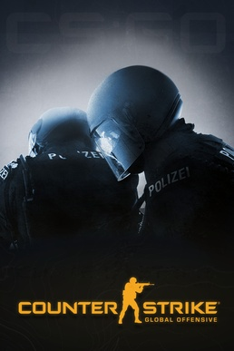 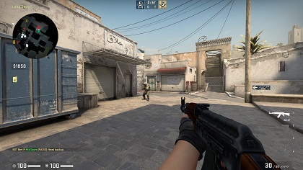 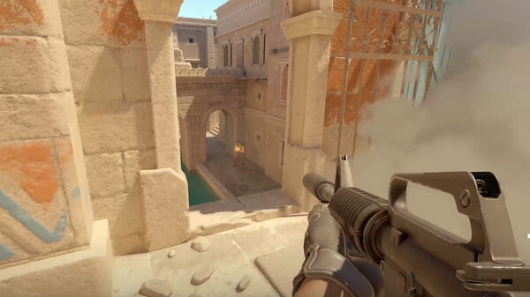

## 💻 System Requirements

|  |  |
| --- | --- |
| **Minimum Requirements** | **Recommended Requirements** |
| Processor:  Intel Core i5 @ 3.3 GHz or better, or AMD Ryzen 3 @ 3.1 GHz or better | Processor:  Intel Core i7-6700K or better, or AMD Ryzen 7 1800X or better |
| RAM: 8 GB RAM | RAM: 8 GB RAM |
| Graphics:  NVIDIA GeForce GTX 1050Ti (4GB), GTX 1060 (3GB), GTX 1650 (4GB) | Graphics: NVIDIA GeForce GTX 1060 (6GB), NVIDIA GeForce 970 (4GB) |
| Storage:  80 GB available space | Storage:  80 GB available space |