# Doom Eternal

*Experience the ultimate gaming journey!*

——————————————————————————————————————

## 🎮 Game Information

|  |  |
| --- | --- |
| **Developer** | [id Software](https://store.steampowered.com/developer/bethesda?snr=1_5_9__2000) |
| **Publisher** | [Bethesda Softworks](https://store.steampowered.com/publisher/bethesda?snr=1_5_9__2000) |
| **Release Date** | 20 Mar, 2020 |
| **Genre** | Action |
| **Platforms** | PC |

## 📝 Description

## *Hell’s armies have invaded Earth. Become the Slayer in an epic single-player campaign to conquer demons across dimensions and stop the final destruction of humanity.*

## ✨ Key Features

• Story Rich  
• Multiplayer Mode  
• Great Soundtrack

## 📸 Screenshots

  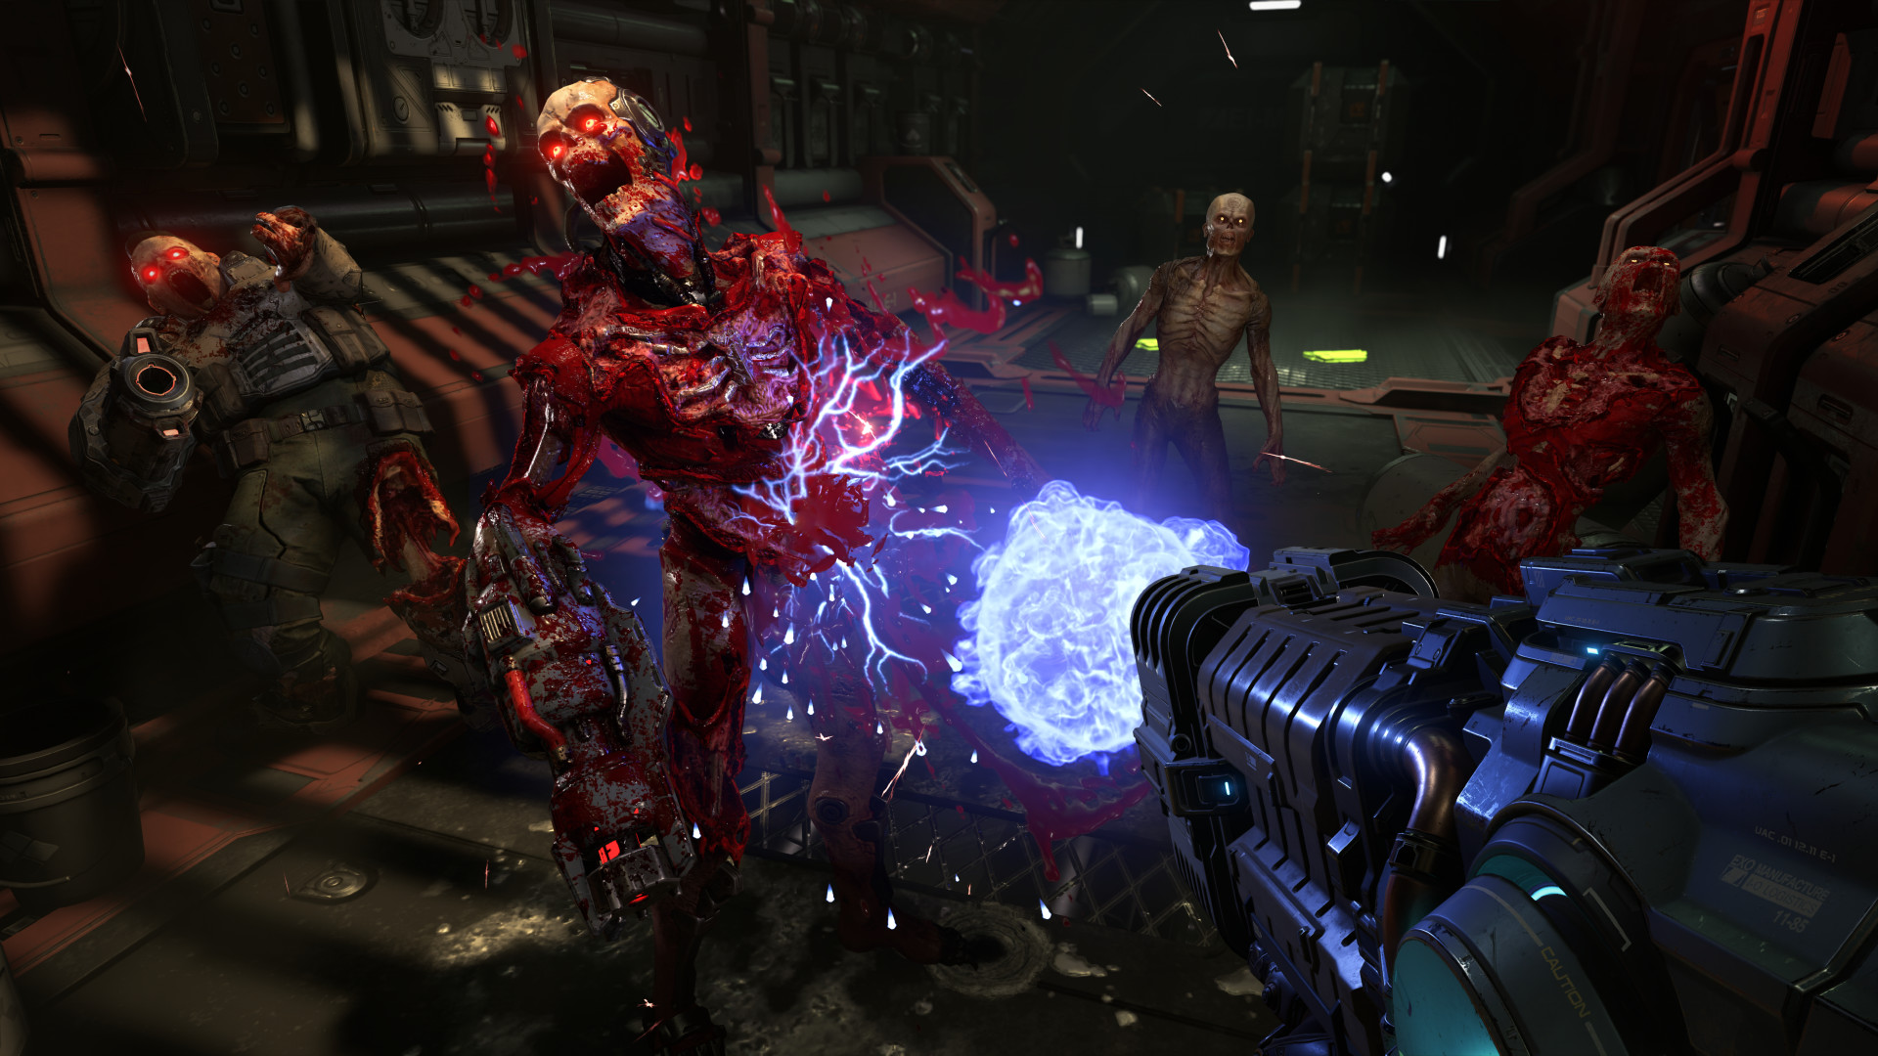

## 💻 System Requirements

|  |  |
| --- | --- |
| **Minimum Requirements** | **Recommended Requirements** |
| Processor:  Intel Core i5 @ 3.3 GHz or better, or AMD Ryzen 3 @ 3.1 GHz or better | Processor:  Intel Core i7-6700K or better, or AMD Ryzen 7 1800X or better |
| RAM: 8 GB RAM | RAM: 8 GB RAM |
| Graphics:  NVIDIA GeForce GTX 1050Ti (4GB), GTX 1060 (3GB), GTX 1650 (4GB) or AMD Radeon R9 280(3GB), AMD Radeon R9 290 (4GB), RX 470 (4GB | Graphics: NVIDIA GeForce GTX 1060 (6GB), NVIDIA GeForce 970 (4GB), AMD RX 480 (8GB) |
| Storage:  80 GB available space | Storage:  80 GB available space |