# Final Fantasy VII Remake

*Experience the ultimate gaming journey!*

——————————————————————————————————————

## 🎮 Game Information

|  |  |
| --- | --- |
| **Developer** | [Square Enix](https://store.steampowered.com/developer/squareenix?snr=1_5_9__2000) |
| **Publisher** | [Square Enix](https://store.steampowered.com/developer/squareenix?snr=1_5_9__2000) |
| **Release Date** | 17 Jun, 2022 |
| **Genre** | [Action](https://store.steampowered.com/genre/Action/?snr=1_5_9__408), [Adventure](https://store.steampowered.com/genre/Adventure/?snr=1_5_9__408), [RPG](https://store.steampowered.com/genre/RPG/?snr=1_5_9__408) |
| **Platforms** | PlayStation5 |

## 📝 Description

## *This critically-acclaimed game, which mixes traditional command-based combat and real-time action, makes its Steam debut along with FF7R EPISODE INTERmission─a new story arc featuring Yuffie Kisaragi.*

## ✨ Key Features

• Action-Adventure  
• realistic  
• Spectacle Fighter

## 📸 Screenshots

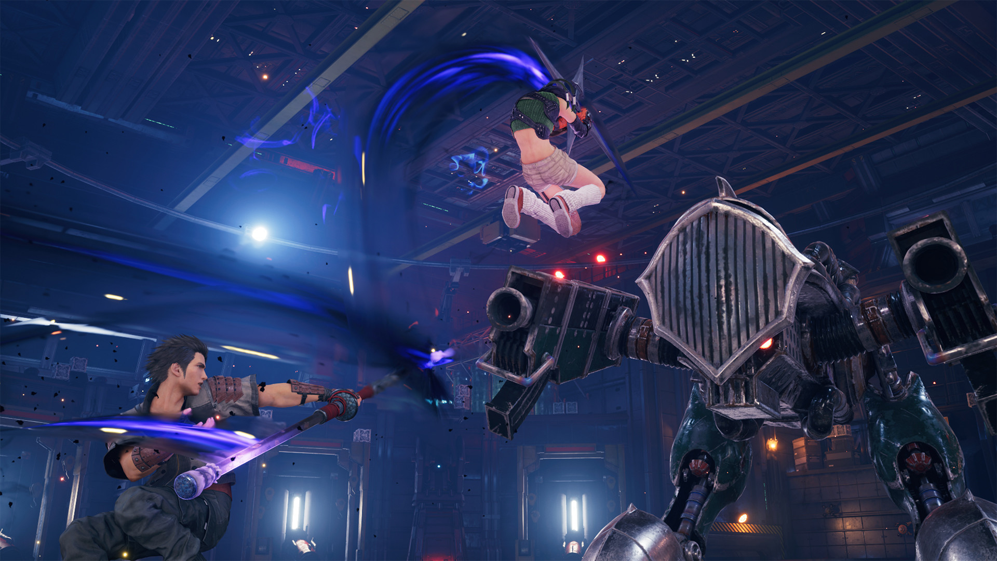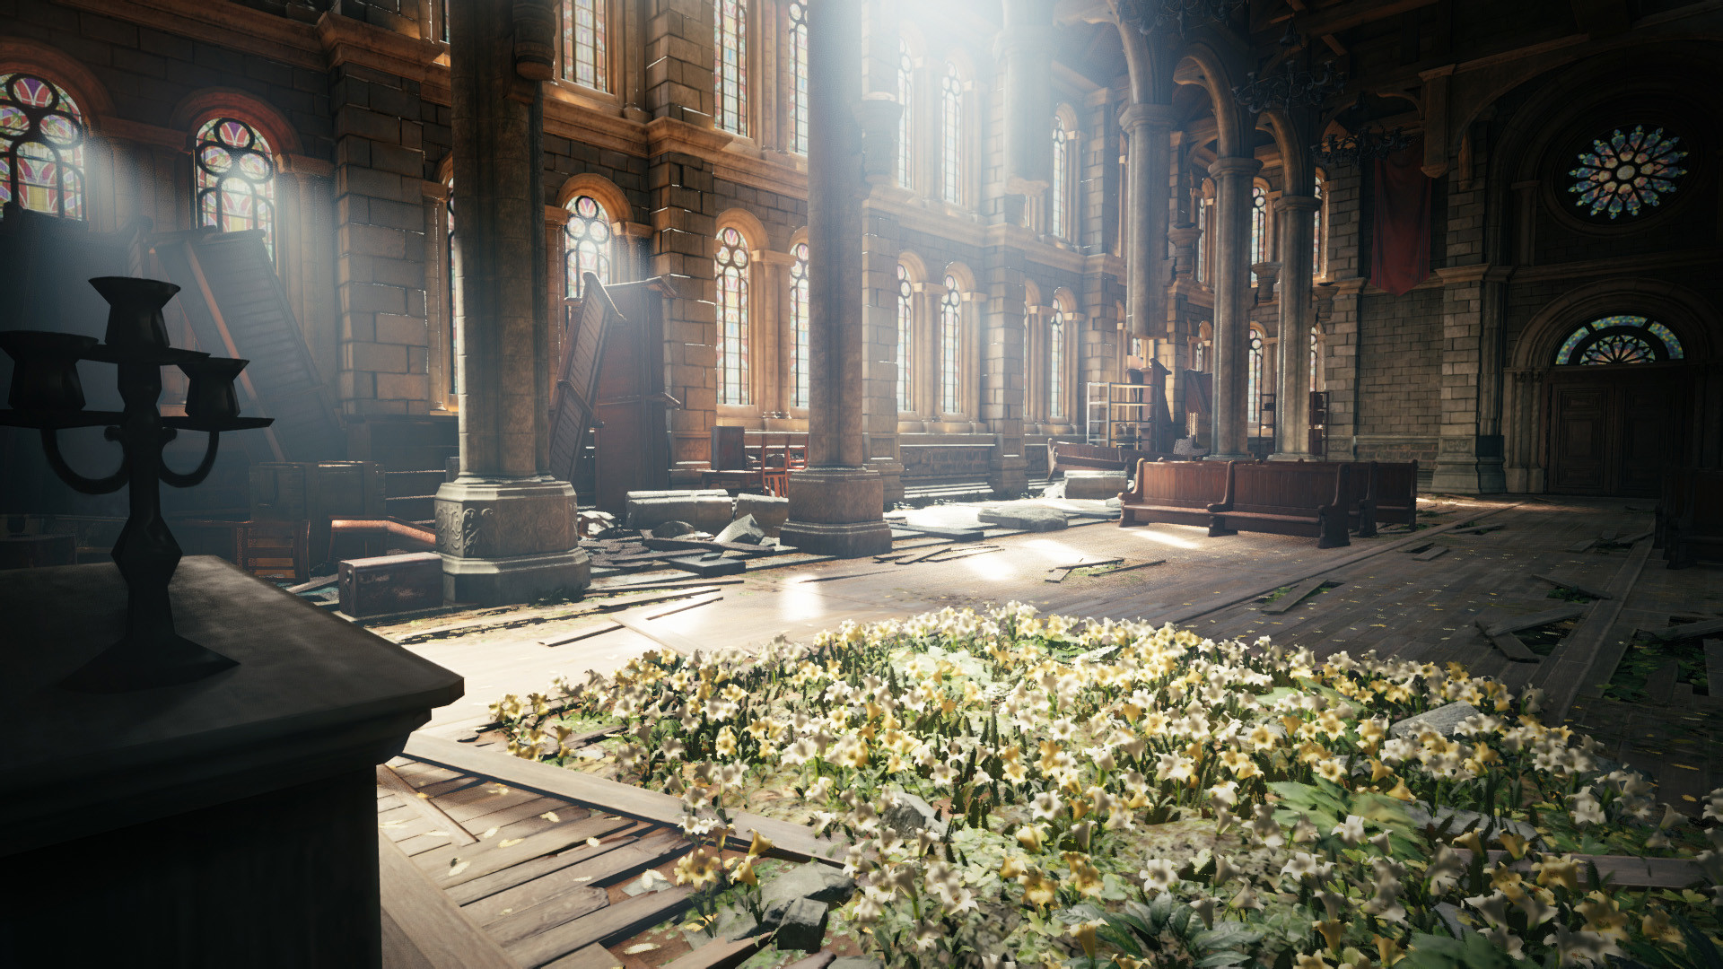

## 💻 System Requirements

|  |  |
| --- | --- |
| **Minimum Requirements** | **Recommended Requirements** |
| Processor: PlayStation5 | Processor: PlayStation5 |
| Storage: 100 GB available space | Storage: 100 GB available space |