# Forza Horizon 5

*Experience the ultimate gaming journey!*

——————————————————————————————————————

## 🎮 Game Information

|  |  |
| --- | --- |
| **Developer** | [Playground Games](https://store.steampowered.com/developer/XboxGameStudios?snr=1_5_9__2000) |
| **Publisher** | [Xbox Game Studios](https://store.steampowered.com/publisher/XboxGameStudios?snr=1_5_9__2000) |
| **Release Date** | 9 Nov, 2021 |
| **Genre** | [Action](https://store.steampowered.com/genre/Action/?snr=1_5_9__408), [Adventure](https://store.steampowered.com/genre/Adventure/?snr=1_5_9__408), [Racing](https://store.steampowered.com/genre/Racing/?snr=1_5_9__408), [Simulation](https://store.steampowered.com/genre/Simulation/?snr=1_5_9__408), [Sports](https://store.steampowered.com/genre/Sports/?snr=1_5_9__408) |
| **Platforms** | Xbox |

## 📝 Description

Your Ultimate Horizon Adventure awaits! Explore the vibrant and ever-evolving open world landscapes of Mexico with limitless, fun driving action in hundreds of the world’s greatest cars.

## ✨ Key Features

• Open World Exploration  
• Multiplayer Mode  
• Stunning Graphics

## 📸 Screenshots

 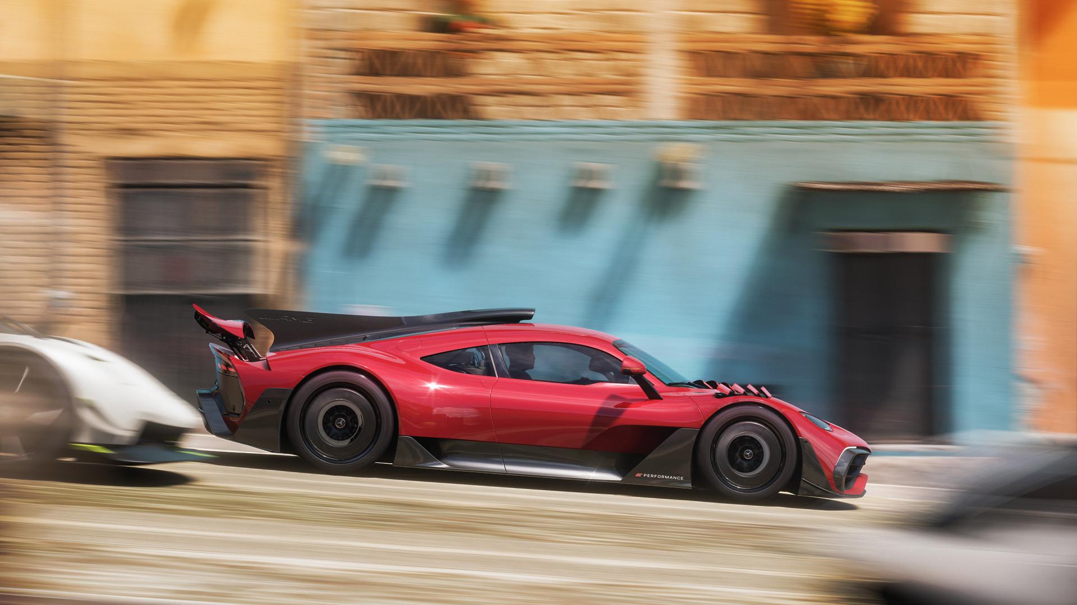 

## 💻 System Requirements

|  |  |
| --- | --- |
| **Minimum Requirements** | **Recommended Requirements** |
| Processor:  Intel i5-4460 or AMD Ryzen 3 1200 | Processor:  Intel i5-8400 or AMD Ryzen 5 1500X |
| RAM: 8 GB RAM | RAM: 16 GB RAM |
| Graphics:  NVidia GTX 970, AMD RX 470, OR Intel Arc A380 | Graphics:  NVidia GTX 1070, AMD RX 590, OR Intel Arc A750 |
| Storage: 110 GB available space | Storage: 110 GB available space |