# Gears 5

*Experience the ultimate gaming journey!*

——————————————————————————————————————

## 🎮 Game Information

|  |  |
| --- | --- |
| **Developer** | The Coalition |
| **Publisher** | [Xbox Game Studios](https://store.steampowered.com/publisher/XboxGameStudios?snr=1_5_9__2000) |
| **Release Date** | 10 Sep, 2019 |
| **Genre** | [Action](https://store.steampowered.com/genre/Action/?snr=1_5_9__408), [Adventure](https://store.steampowered.com/genre/Adventure/?snr=1_5_9__408) |
| **Platforms** | Xbox, PC |

## 📝 Description

*From one of gaming’s most acclaimed sagas, Gears is bigger than ever. With all-out war descending, Kait Diaz breaks away to uncover her connection to the enemy and discovers the true danger to Sera – herself.*

## ✨ Key Features

• Action-Adventure  
• Multiplayer Mode  
• Female Protagonist

## 📸 Screenshots

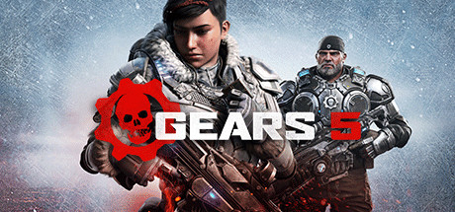 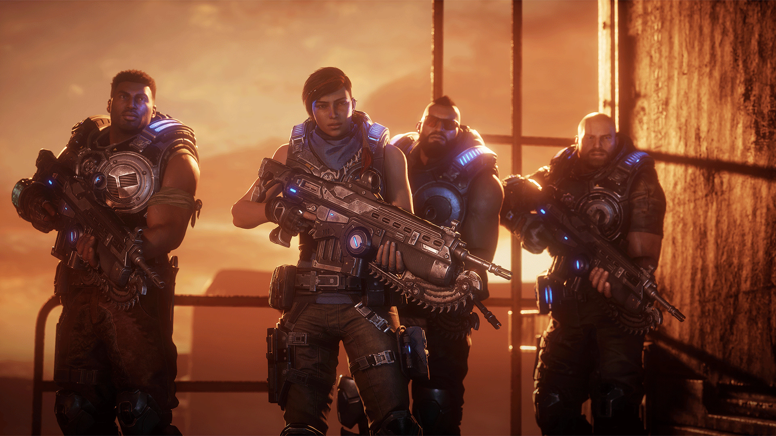

## 💻 System Requirements

|  |  |
| --- | --- |
| **Minimum Requirements** | **Recommended Requirements** |
| Processor:  AMD FX-6000 series | Intel i3 Skylake | Processor:  AMD Ryzen 3 | Intel i5 Skylake |
| RAM: 8 GB RAM | RAM: 8 GB RAM |
| Graphics: AMD Radeon R9 280 | NVIDIA GeForce GTX 760 (Windows 10) | NVIDIA GeForce GTX 1050 (Windows 7) | Graphics: AMD Radeon RX 570 | NVIDIA GeForce GTX 970 (Windows 10) | NVIDIA GeForce GTX 1660ti (Windows 7) |
| Storage:  80 GB available space | Storage:  80 GB available space |