# Halo Infinite

*Experience the ultimate gaming journey!*

——————————————————————————————————————

## 🎮 Game Information

|  |  |
| --- | --- |
| **Developer** | [343 Industries](https://store.steampowered.com/developer/XboxGameStudios?snr=1_5_9__408) |
| **Publisher** | [Xbox Game Studios](https://store.steampowered.com/publisher/XboxGameStudios?snr=1_5_9__408) |
| **Release Date** | 15 Nov, 2021 |
| **Genre** | [Action](https://store.steampowered.com/genre/Action/?snr=1_5_9__408), [Free To Play](https://store.steampowered.com/genre/Free%20to%20Play/?snr=1_5_9__408) |
| **Platforms** | Xbox |

## 📝 Description

From one of gaming's most iconic sagas, Halo is bigger than ever. Featuring an expansive open-world campaign and a dynamic free to play multiplayer experience.

## ✨ Key Features

• Free to play  
• Multiplayer Mode  
• Competitive

## 📸 Screenshots

  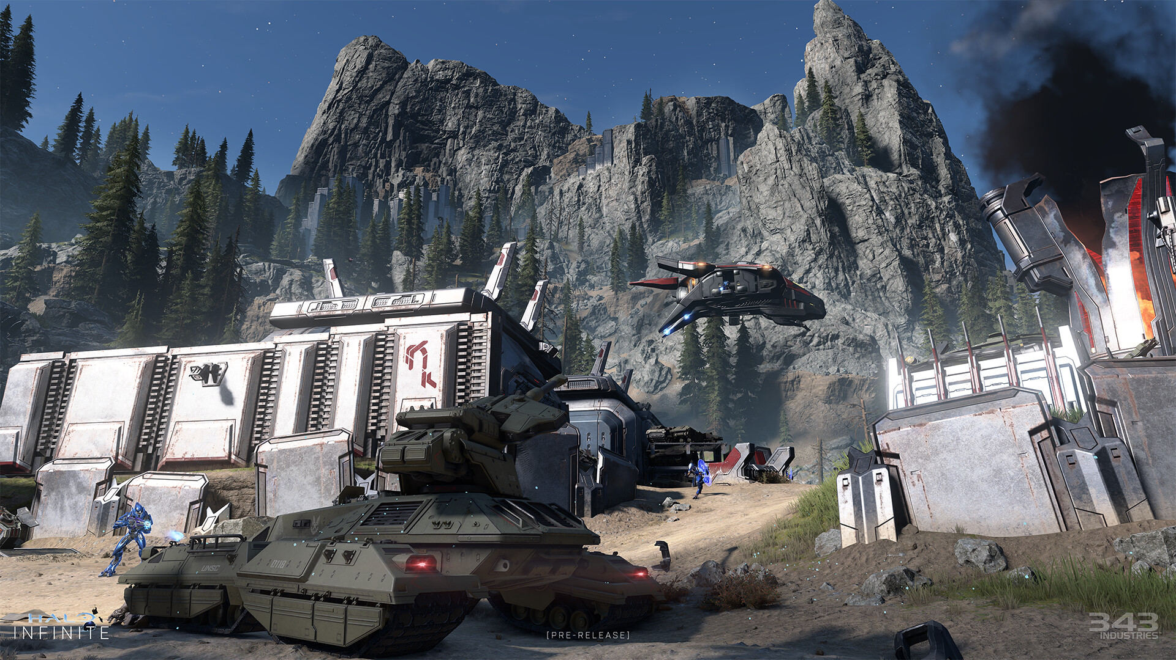

## 💻 System Requirements

|  |  |
| --- | --- |
| **Minimum Requirements** | **Recommended Requirements** |
| Device: Xbox | Device: Xbox |
| Storage: 50 GB available space | Storage: 50 GB available space |