# Horizon Forbidden West

*Experience the ultimate gaming journey!*

——————————————————————————————————————

## 🎮 Game Information

|  |  |
| --- | --- |
| **Developer** | [Guerrilla](https://store.steampowered.com/developer/playstationstudios?snr=1_5_9__408), [Nixxes Software](https://store.steampowered.com/developer/playstationstudios?snr=1_5_9__408) |
| **Publisher** | [PlayStation Publishing LLC](https://store.steampowered.com/publisher/playstationstudios?snr=1_5_9__408) |
| **Release Date** | 21 Mar, 2024 |
| **Genre** | [Action](https://store.steampowered.com/genre/Action/?snr=1_5_9__408), [RPG](https://store.steampowered.com/genre/RPG/?snr=1_5_9__408) |
| **Platforms** | PS5, PC |

## 📝 Description

Experience the epic Horizon Forbidden West™ in its entirety with bonus content and the Burning Shores expansion included.

## ✨ Key Features

• Open World Exploration  
• Singleplayer   
• Stunning Graphics

## 📸 Screenshots

 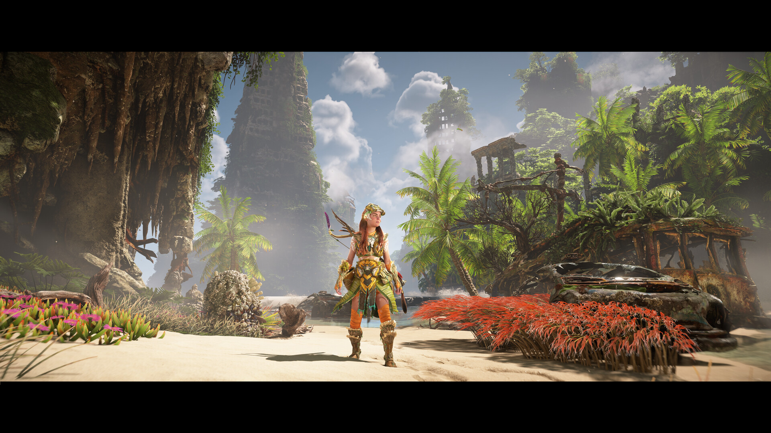 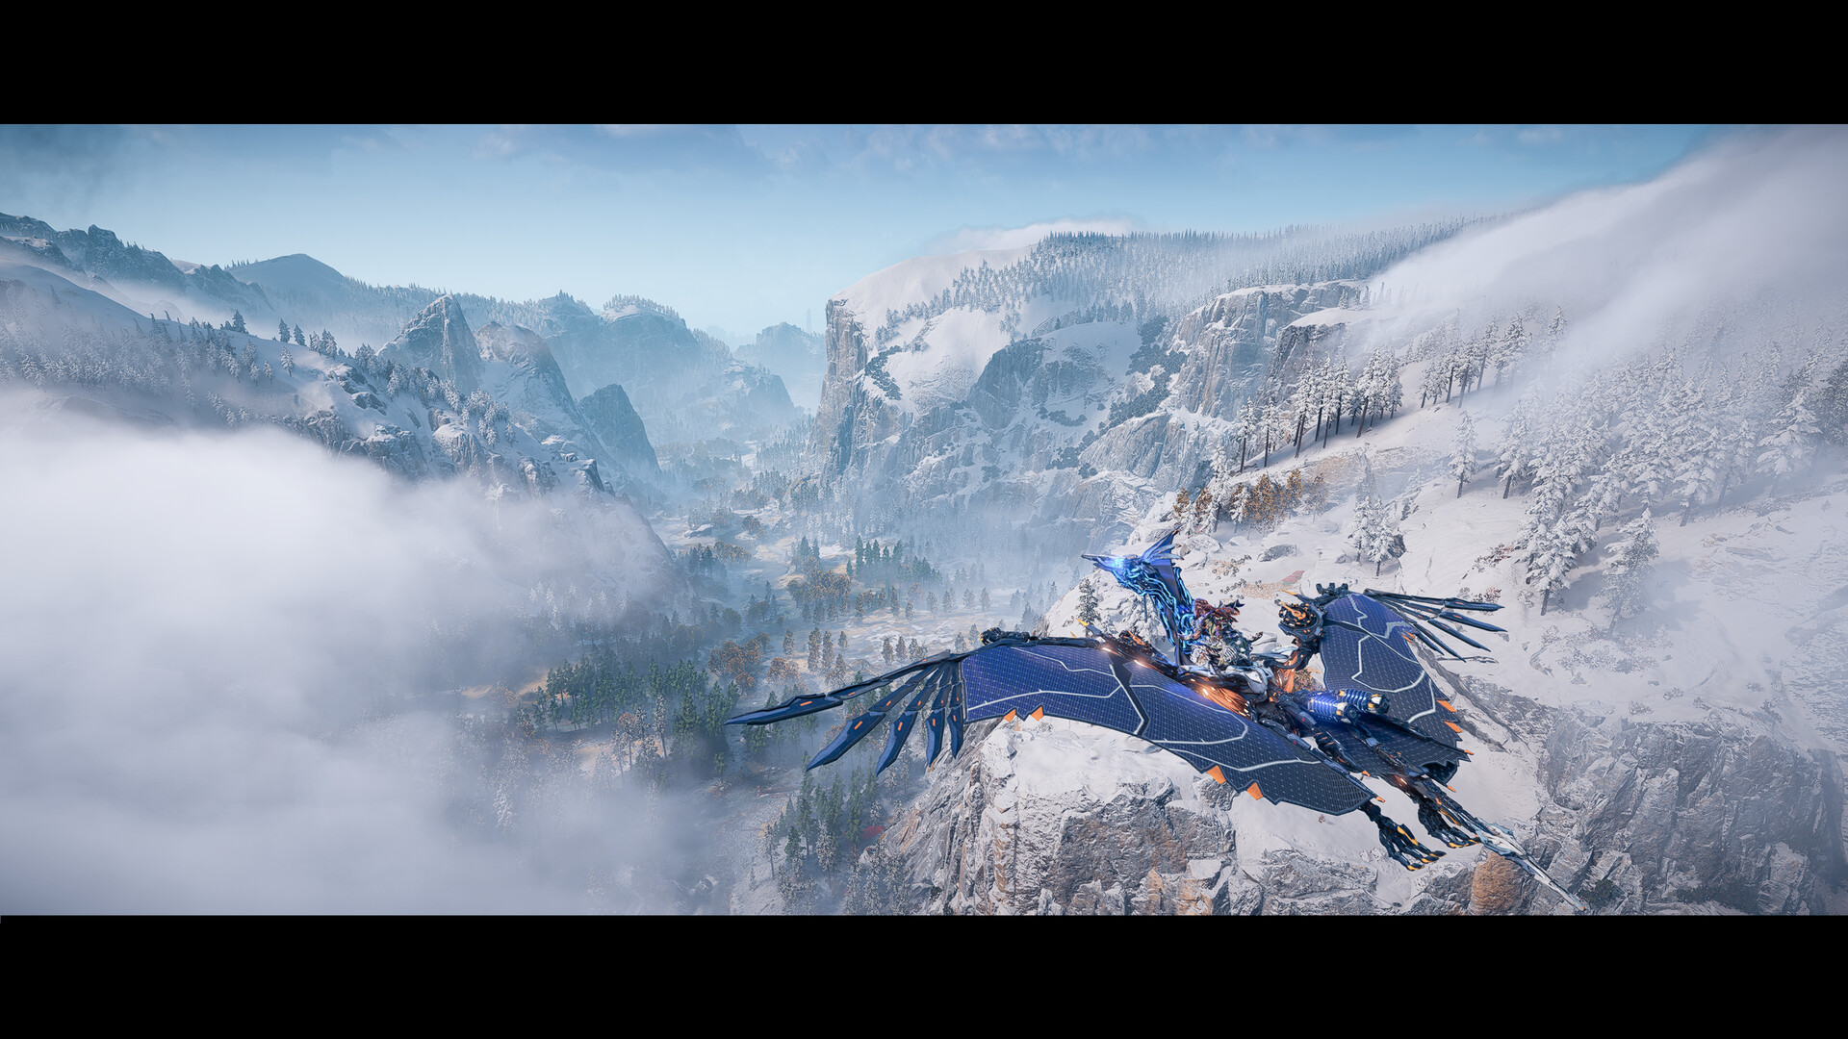

## 💻 System Requirements

|  |  |
| --- | --- |
| **Minimum Requirements** | **Recommended Requirements** |
| Processor:  Intel Core i3-8100 or AMD Ryzen 3 1300X | Processor:  Intel Core i5-8600 or AMD Ryzen 5 3600 |
| RAM: 16 GB RAM | RAM: 16 GB RAM |
| Graphics: NVIDIA GeForce GTX 1650 4GB or AMD Radeon RX 5500XT 4GB | Graphics: NVIDIA GeForce RTX 3060 or AMD Radeon RX 5700 |
| Storage:  150 GB available space | Storage: 150 GB available space |