# Mario Kart 8 Deluxe

*Experience the ultimate gaming journey!*

——————————————————————————————————————

## 🎮 Game Information

|  |  |
| --- | --- |
| **Developer** | [Nintendo](https://en.wikipedia.org/wiki/Nintendo) |
| **Publisher** | [Nintendo](https://en.wikipedia.org/wiki/Nintendo) |
| **Release Date** | March 16, 2020 |
| **Genre** | Kart Racing |
| **Platforms** | Nintendo Switch |

## 📝 Description

*Mario Kart 8 is a*[*kart racing game*](https://en.wikipedia.org/wiki/Kart_racing_game)*; players control characters from the*[*Mario*](https://en.wikipedia.org/wiki/Mario_(franchise))*universe,*[*The Legend of Zelda*](https://en.wikipedia.org/wiki/The_Legend_of_Zelda)*,*[*Animal Crossing*](https://en.wikipedia.org/wiki/Animal_Crossing)*,*[*Splatoon*](https://en.wikipedia.org/wiki/Splatoon)*,*[*[e]*](https://en.wikipedia.org/wiki/Mario_Kart_8#cite_note-8)*or the players' [Miis](https://en.wikipedia.org/wiki/Mii" \o "Mii), to race in*[*go-karts*](https://en.wikipedia.org/wiki/Go-kart)*around a course .*

## ✨ Key Features

• Kart Racing  
• Multiplayer Mode  
• Best Selling

## 📸 Screenshots

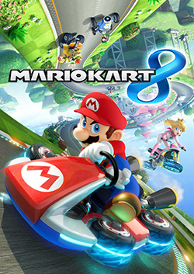 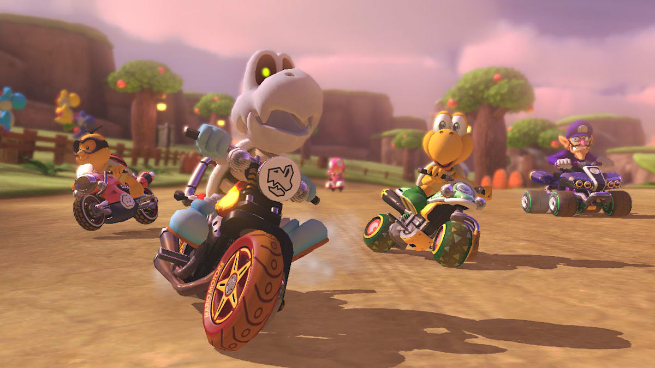 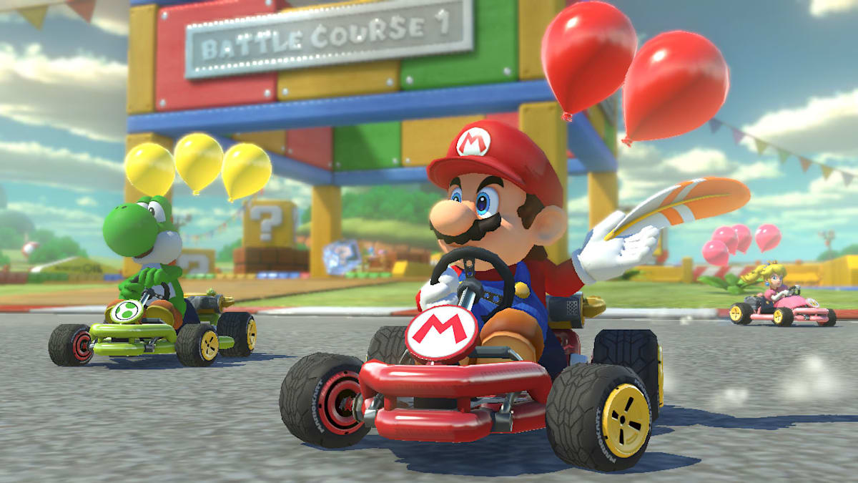

## 💻 System Requirements

|  |  |
| --- | --- |
| **Minimum Requirements** | **Recommended Requirements** |
| Device: Nintendo switch | Device: Nintendo Switch |
| Storage: 11.3 GB | Storage: 11.3 GB |