# Ratchet & Clank: Rift Apart

*Experience the ultimate gaming journey!*

——————————————————————————————————————

## 🎮 Game Information

|  |  |
| --- | --- |
| **Developer** | [Insomniac Games](https://store.steampowered.com/curator/42527123?snr=1_5_9__408), [Nixxes Software](https://store.steampowered.com/developer/playstationstudios?snr=1_5_9__408) |
| **Publisher** | [PlayStation Publishing LLC](https://store.steampowered.com/publisher/playstationstudios?snr=1_5_9__408) |
| **Release Date** | 26 Jul, 2023 |
| **Genre** | Action Role-Play |
| **Platforms** | PlayStation 5 |

## 📝 Description

Blast your way through an interdimensional adventure with Ratchet and Clank – now on PC! Help them take on an evil emperor from another reality as you jump between action-packed worlds and beyond at hyper-speed!

## ✨ Key Features

• 3D Platformer  
• Action-Adventure  
• Stunning Graphics

## 📸 Screenshots

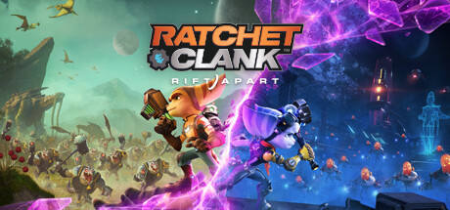 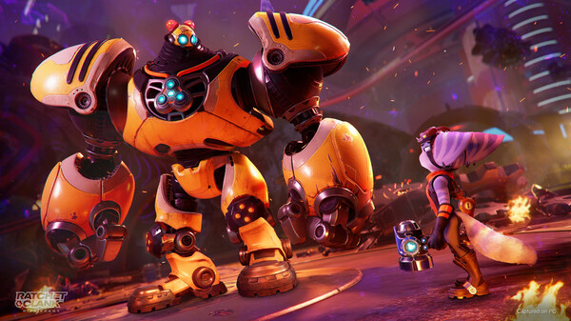 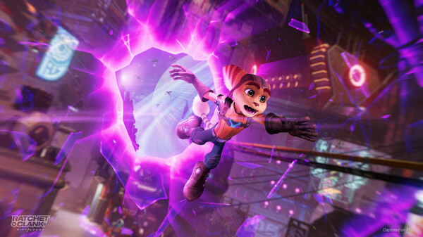

## 💻 System Requirements

|  |  |
| --- | --- |
| **Minimum Requirements** | **Recommended Requirements** |
| Processor: PlayStation 5 console | Processor: PlayStation 5 console |
| Graphics: 60 FPS with dynamic 4K resolution | Graphics: 60 FPS with dynamic 4K resolution |
| Storage: 75 GB available space | Storage: 75 GB available space |