# Super Mario Odyssey

*Experience the ultimate gaming journey!*

——————————————————————————————————————

## 🎮 Game Information

|  |  |
| --- | --- |
| **Developer** | Nintendo |
| **Publisher** | Nintendo |
| **Release Date** | October 27, 2017 |
| **Genre** | Platformer, Action |
| **Platforms** | Nintendo switch |

## 📝 Description

*Super Mario Odyssey* is a [platform game](https://en.wikipedia.org/wiki/Platform_game) in which players control [Mario](https://en.wikipedia.org/wiki/Mario) as he travels across 14 different worlds, known as "Kingdoms" within the game, on the hat-shaped ship *Odyssey*, to rescue [Princess Peach](https://en.wikipedia.org/wiki/Princess_Peach) from [Bowser](https://en.wikipedia.org/wiki/Bowser), who plans to forcibly marry her

## ✨ Key Features

• Open World Exploration  
• Action  
• Adventure

## 📸 Screenshots

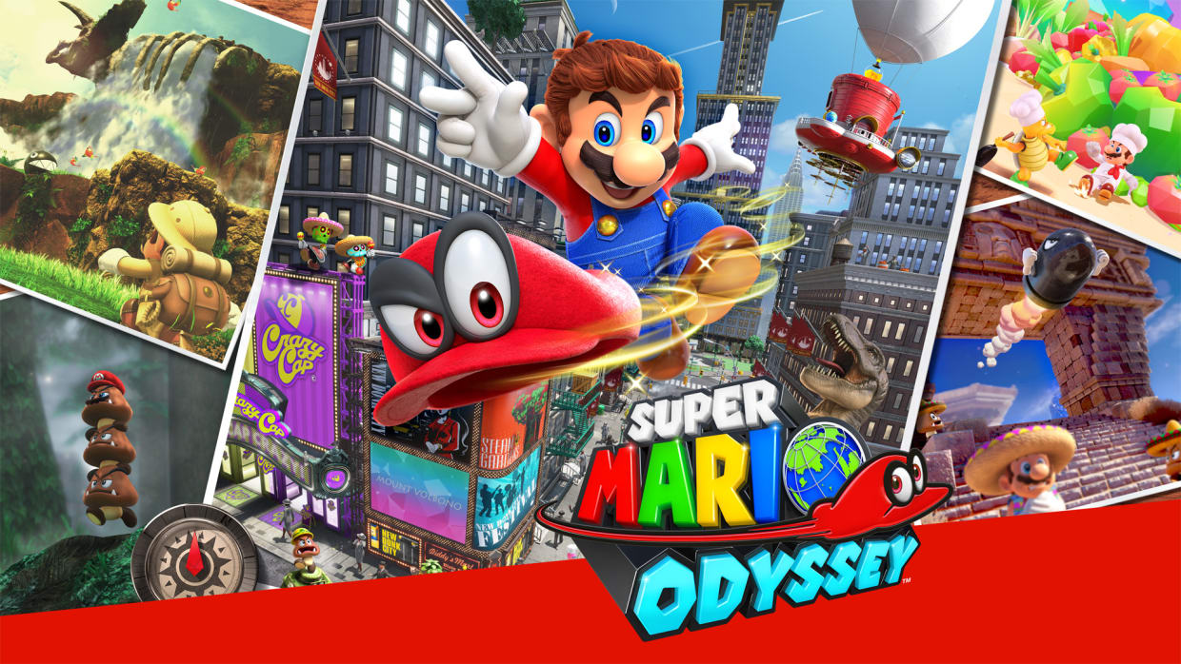 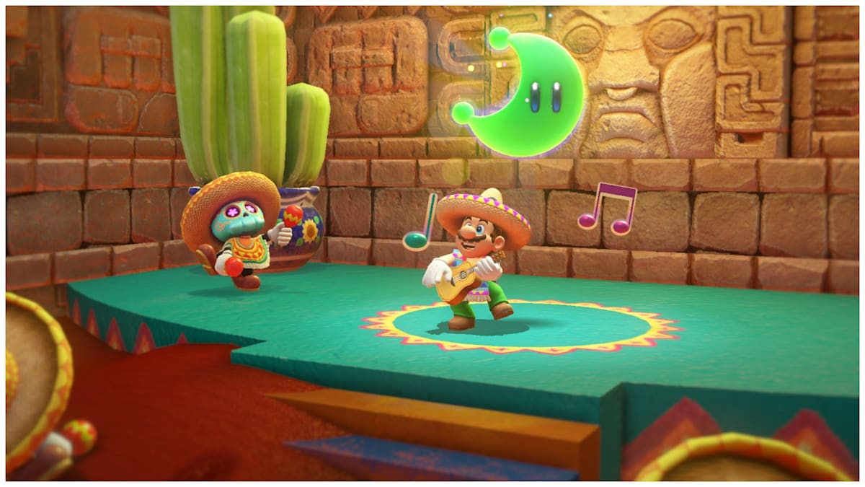 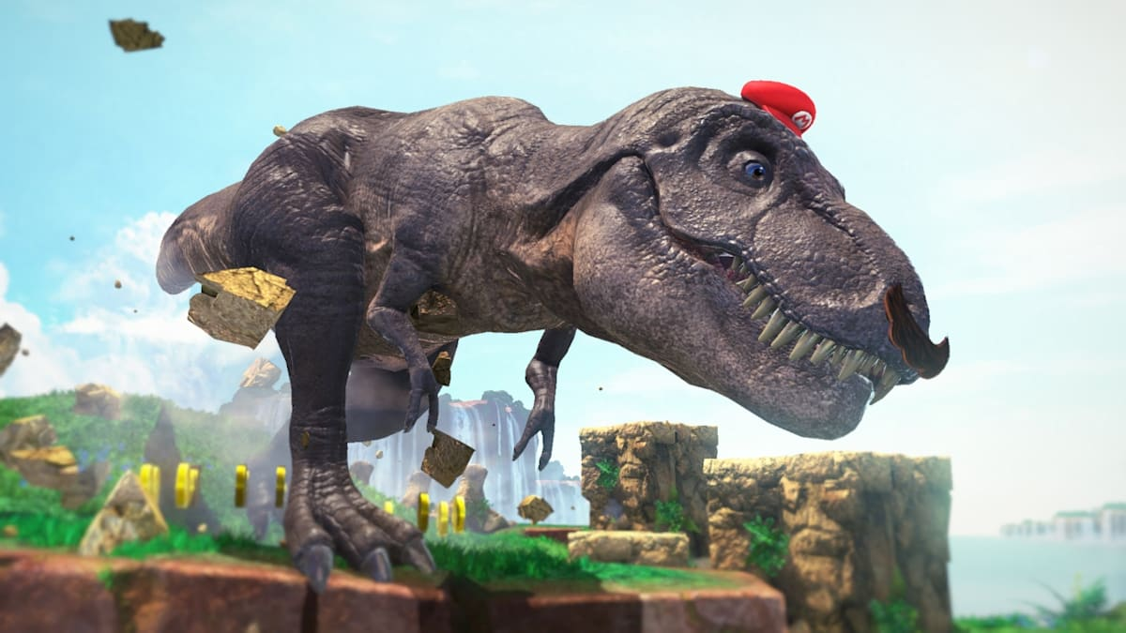

## 💻 System Requirements

|  |  |
| --- | --- |
| **Minimum Requirements** | **Recommended Requirements** |
| Device: Nintendo Switch | Device: Nintendo Switch |
| Storage: 5.6 GB | Storage: 5.6 GB |