# Super Smash Bros. Ultimate

*Experience the ultimate gaming journey!*

——————————————————————————————————————

## 🎮 Game Information

|  |  |
| --- | --- |
| **Developer** | Nintendo |
| **Publisher** | Nintendo |
| **Release Date** | December 7, 2018 |
| **Genre** | Action, Fighting, Multiplayer |
| **Platforms** | Nintendo Switch |

## 📝 Description

*Super Smash Bros. Ultimate* is a [platform fighter](https://en.wikipedia.org/wiki/Platform_fighter) for up to eight players in which characters from [Nintendo](https://en.wikipedia.org/wiki/Nintendo) games and third-party franchises fight to knock each other out of an arena.

## ✨ Key Features

• Campaign  
• Multiplayer Mode  
• Fighting

## 📸 Screenshots

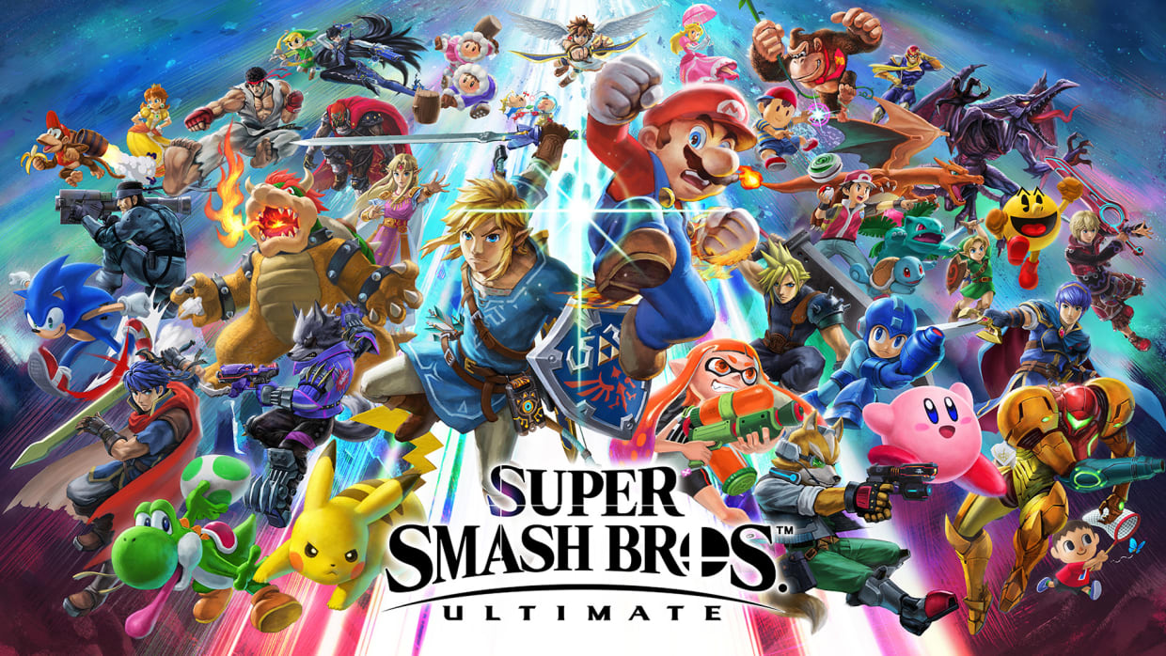 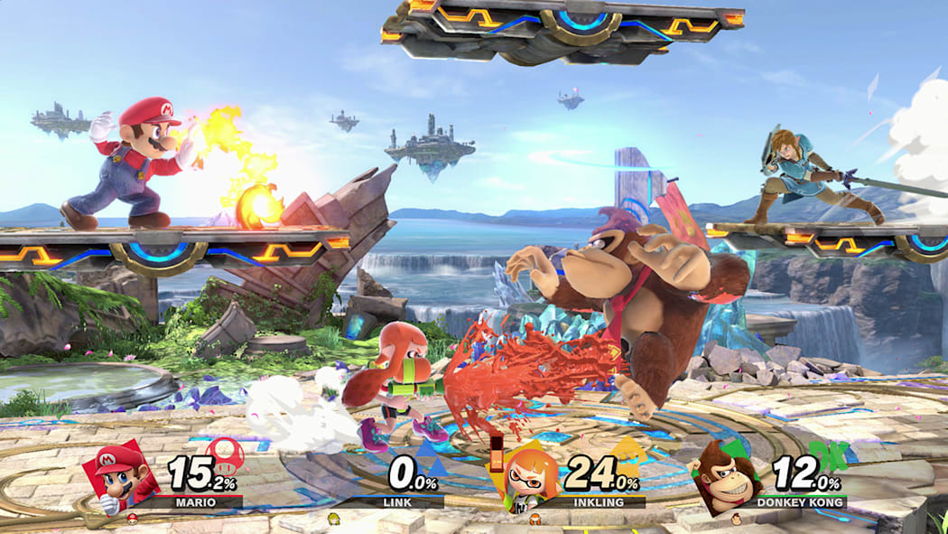 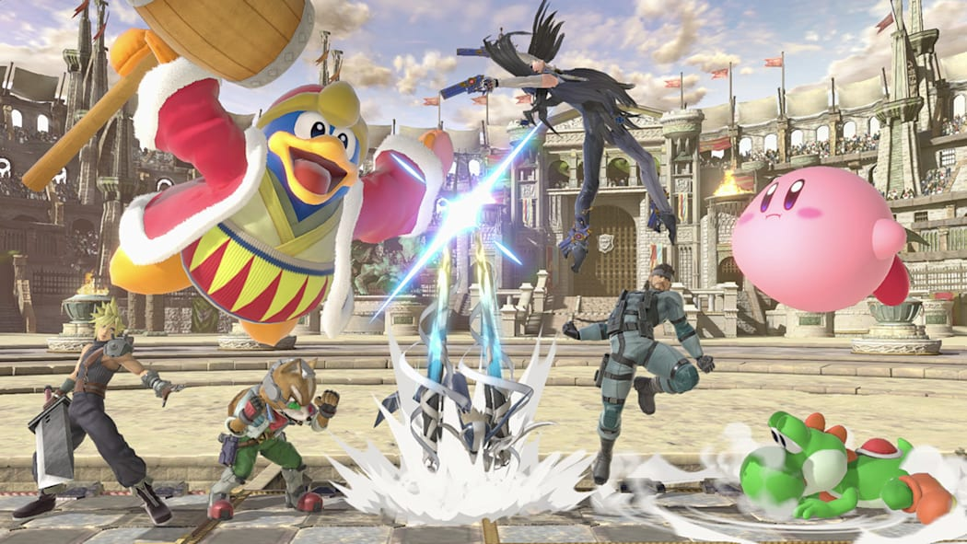

## 💻 System Requirements

|  |  |
| --- | --- |
| **Minimum Requirements** | **Recommended Requirements** |
| Device: Nintendo Switch | Device: Nintendo Switch |
| Storage: 17.3 GB | Storage: 17.3 GB |