# The Legend of Zelda: Breath of the Wild

*Experience the ultimate gaming journey!*

——————————————————————————————————————

## 🎮 Game Information

|  |  |
| --- | --- |
| **Developer** | Nintendo |
| **Publisher** | Nintendo |
| **Release Date** | March 3, 2017 |
| **Genre** | Adventure, Action, Role-Playing |
| **Platforms** | Nintendo Switch |

## 📝 Description

*Breath of the Wild* is an open world [action-adventure game](https://en.wikipedia.org/wiki/Action-adventure_game). Players are tasked with exploring the kingdom of [Hyrule](https://en.wikipedia.org/wiki/Hyrule) while controlling [Link](https://en.wikipedia.org/wiki/Link_(The_Legend_of_Zelda)). *Breath of the Wild* encourages [nonlinear gameplay](https://en.wikipedia.org/wiki/Nonlinear_gameplay), which is illustrated by the lack of defined entrances or exits to areas, scant instruction given to the player, and encouragement to explore freely

## ✨ Key Features

• Open World Exploration  
• Multiplayer Mode  
• Side Quest

## 📸 Screenshots

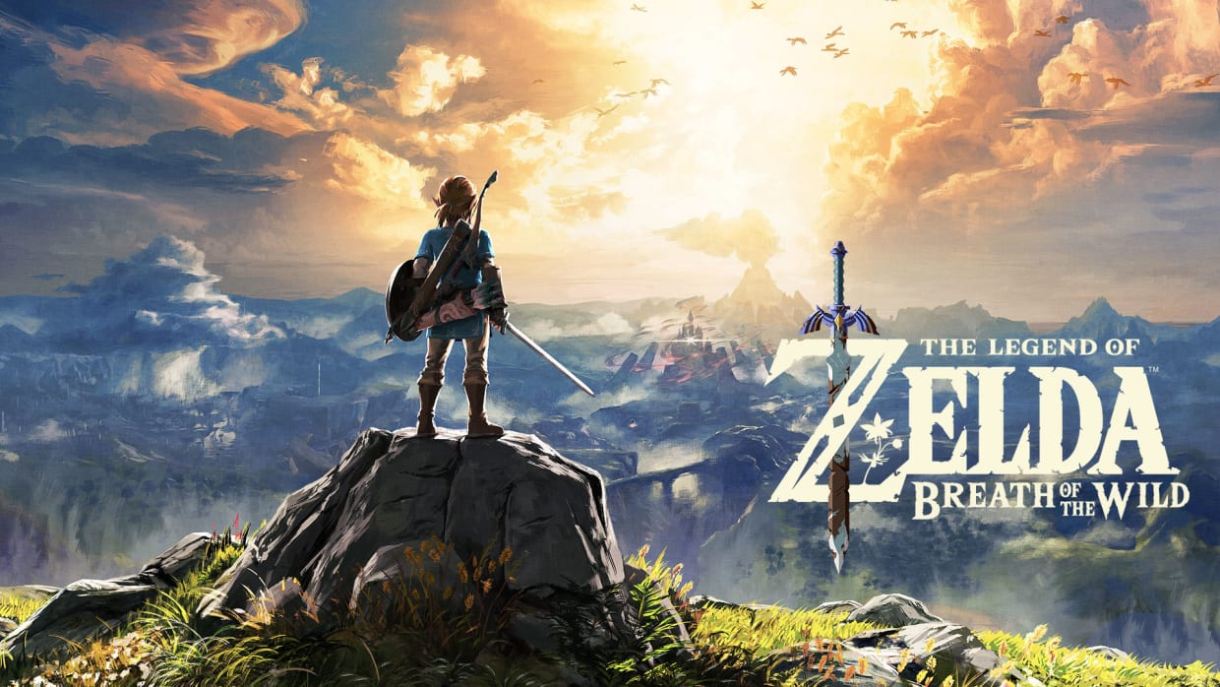 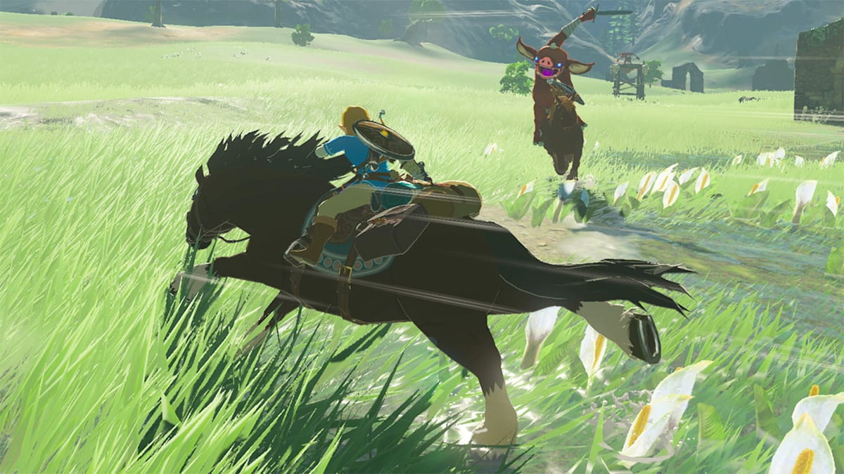 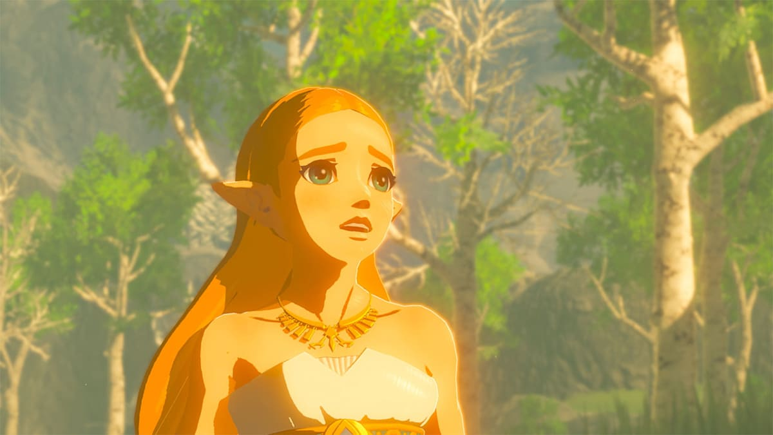

## 💻 System Requirements

|  |  |
| --- | --- |
| **Minimum Requirements** | **Recommended Requirements** |
| Device: Nintendo Switch | Device: Nintendo Switch |
| Storage: 14.4 GB | Storage: 14.4 GB |