# The Witcher

*Experience the ultimate gaming journey!*

——————————————————————————————————————

## 🎮 Game Information

|  |  |
| --- | --- |
| **Developer** | [CD PROJEKT RED](https://store.steampowered.com/developer/CDPR?snr=1_5_9__408) |
| **Publisher** | [CD PROJEKT RED](https://store.steampowered.com/developer/CDPR?snr=1_5_9__408) |
| **Release Date** | 18 May, 2015 |
| **Genre** | [RPG](https://store.steampowered.com/genre/RPG/?snr=1_5_9__408) |
| **Platforms** | PC |

## 📝 Description

You are Geralt of Rivia, mercenary monster slayer. Before you stands a war-torn, monster-infested continent you can explore at will. Your current contract? Tracking down Ciri — the Child of Prophecy, a living weapon that can alter the shape of the world.

## ✨ Key Features

• Open World Exploration  
• Multiplayer Mode  
• Stunning Graphics

## 📸 Screenshots

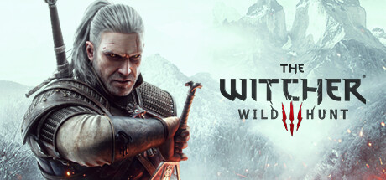 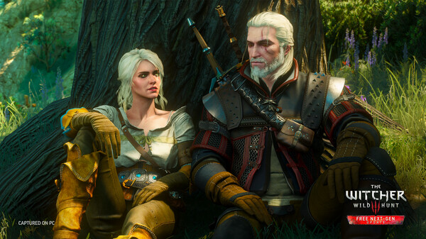 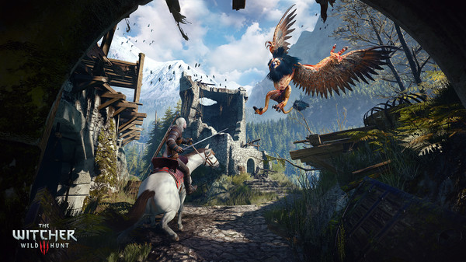 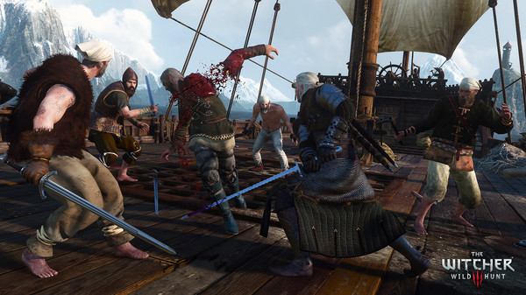

## 💻 System Requirements

|  |  |
| --- | --- |
| **Minimum Requirements** | **Recommended Requirements** |
| Processor: Intel CPU Core i5-2500K 3.3GHz / AMD A10-5800K APU (3.8GHz) | Processor:  Intel Core i5-7400 / Ryzen 5 1600 |
| RAM: 6 GB RAM | RAM: 8 GB RAM |
| Graphics:  Nvidia GPU GeForce GTX 660 / AMD GPU Radeon HD 7870 | Graphics: Nvidia GTX 1070 / Radeon RX 480 |
| Storage:  50 GB available space | Storage:  50 GB available space |