# Write a python GUI program to craete text box and accept a value from user using tkinter module.

import tkinter as tk

def on_submit():
user_input = entry.get()
result_label.config(text=f" Name of user: {user_input}")
# main window
root = tk.Tk()
root.title("Textbox Demo")

# label
label = tk.Label(root, text="Enter your name :")
label.pack(pady=10)

#Entry widget
entry = tk.Entry(root)
entry.pack(pady=10)

#button to submit
submit_button = tk.Button(root, text="Submit", command=on_submit)
submit_button.pack(pady=10)

#result
result_label = tk.Label(root, text="")
result_label.pack(pady=10)

root.mainloop()

OUTPUT

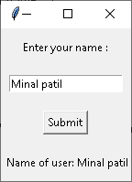

# Write a python GUI program to add button in your application using tkinter module.
import tkinter as tk
def on_button_click(color):
root.config(bg=color) # Change the background color

# Create the main window
root = tk.Tk()
root.title("Button Demo")
root.geometry("300x150")

frame=tk.Frame(root)

# Use StringVar objects to store the label text
label_text = tk.StringVar()
label_text.set("Hello, Tkinter!")

# Create a label
label = tk.Label(root, textvariable=label_text)
label.pack(anchor="center")

# Create a button
button = tk.Button(frame, text="red button", command=lambda: on_button_click("red"), width=10, height=2)
button1 = tk.Button(frame, text="green button", command=lambda: on_button_click("green"), width=10, height=2)
button2 = tk.Button(frame, text="blue button", command=lambda: on_button_click("blue"), width=10, height=2)

# Use grid method to position the buttons
button.pack(side="left")
button1.pack(side="left")
button2.pack(side="left")
frame.pack(pady=50)

# Run the Tkinter event loop
root.mainloop()

OUTPUT
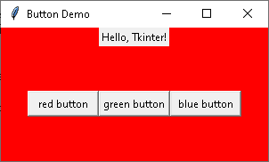
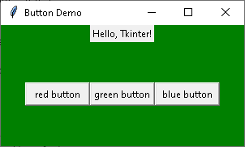
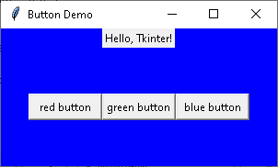

# Write a python GUI program to create checkbutton and combobox widget using tkinter module.

import tkinter as tk
from tkinter import ttk

def on_submit():
user_name = name.get()
user_class = clas.get()
sub1=s1.get()
sub2=s2.get()
sub3=s3.get()
sub4=s4.get()
result_name.config(text=f" Name : {user_name}")
result_class.config(text=f" Class : {user_class}")
result_subject.config(text=f" Subjects : {sub1} {sub2} {sub3} {sub4}")
# main window
root = tk.Tk()
root.title(" GUI 8 ")
in_frame=tk.Frame(root)
#Entry widget
label = tk.Label(in_frame, text="Name :")
label.grid(row=5,column=0)
name = tk.Entry(in_frame,width=33)
name.grid(row=5,column=1)

# Combobox widget
combolabel = tk.Label(in_frame, text="Class :")
combolabel.grid(row=15,column=0)
n=tk.StringVar()
clas = ttk.Combobox(in_frame, width=30, textvariable = n)
clas["values"]=("FY BSc","SY BSc","TY BSc")
clas.current(0)
clas.grid(row=15,column=1)

# Checkbox
checklabel = tk.Label(in_frame, text="Subjects :")
checklabel.grid(row=25,column=0)
s1=tk.StringVar()
s2=tk.StringVar()
s3=tk.StringVar()
s4=tk.StringVar()
button1=tk.Checkbutton(in_frame, text="Python",variable=s1,onvalue = "Python", offvalue = "", height = 2, width = 10)
button2=tk.Checkbutton(in_frame, text="PHP",variable=s2,onvalue = "PHP", offvalue = "", height = 2, width = 10)
button3=tk.Checkbutton(in_frame, text="Java",variable=s3,onvalue = "Java", offvalue = "", height = 2, width = 10)
button4=tk.Checkbutton(in_frame, text="HTML",variable=s4,onvalue ="HTML", offvalue = "", height = 2, width = 10)

button1.grid(row=25,column=1)
button2.grid(row=25,column=2)
button3.grid(row=26,column=2)
button4.grid(row=26,column=1)

in_frame.pack()
#button to submit
submit_button = tk.Button(root, text="Submit", command=on_submit)
submit_button.pack(pady=10)

#result
result_name = tk.Label(root, text="")
result_class = tk.Label(root, text="")
result_subject = tk.Label(root, text="")
result_name.pack(pady=10)
result_class.pack(pady=10)
result_subject.pack(pady=10)

root.mainloop()

OUTPUT
