CHAPTER FOUR
RESULTS
This chapter presents the results of the study in the order of the research objectives. Data from 500 participants were analysed: 172 received Placebo, 168 received Drug A and 160 received Drug B. Before analysis, the dataset was screened for missing values, implausible entries and inconsistent labels, and these were corrected. All analyses were done in Microsoft Excel using the Data Analysis ToolPak, pivot tables and built-in functions.
The change in systolic blood pressure (SBP) was calculated as Baseline SBP minus Week 12 SBP. A positive value therefore means that blood pressure went down, and the larger the number, the bigger the fall. Three ideas are used throughout the chapter. First, results for numerical variables are written as mean ± SD: the mean is the average, and the standard deviation (SD) shows how widely individual values are spread around that average. Second, the p-value tells us whether a difference could easily have happened by chance. A p-value below 0.05 is called statistically significant, meaning the difference is unlikely to be due to chance alone; a p-value of 0.05 or above means there is no convincing evidence of a difference. Third, very small p-values are reported as p < 0.001.
4.1 Baseline Characteristics of the Participants
Table 1 describes the participants at the start of the study. Of the 500 participants, 267 (53.4%) were female and 233 (46.6%) were male, and the mean age was 51.96 years (SD = 12.33). Most participants had never smoked (61.6%), while 19.2% were former smokers and 19.2% were current smokers. Physical activity was low in 41.6%, moderate in 38.8% and high in 19.6% of participants, and 39.2% had a family history of hypertension. Participants came from all six geopolitical zones, with the largest group from the South East zone (19.0%). The average BMI was 28.0 kg/m², which falls in the overweight range, and the average baseline SBP was 128.4 mmHg.
Table 1: Baseline Characteristics of the Participants by Treatment Group
Characteristic | Overall (N = 500) | Placebo (n = 172) | Drug A (n = 168) | Drug B (n = 160) | p-value
Female (%) | 53.4 | 52.9 | 56.0 | 51.2 | 0.686
Current smoker (%) | 19.2 | 16.3 | 23.2 | 18.1 | 0.568
Former smoker (%) | 19.2 | 19.8 | 19.0 | 18.8
Low physical activity (%) | 41.6 | 33.7 | 48.2 | 43.1 | 0.044
Moderate activity (%) | 38.8 | 47.1 | 33.9 | 35.0
High activity (%) | 19.6 | 19.2 | 17.9 | 21.9
Family history of hypertension (%) | 39.2 | 37.8 | 36.9 | 43.1 | 0.461
Age (years) | 52.0 ± 12.3 | 52.1 ± 13.2 | 51.7 ± 12.0 | 52.1 ± 11.7 | 0.936
BMI (kg/m²) | 28.0 ± 5.0 | 28.1 ± 4.8 | 28.4 ± 4.8 | 27.4 ± 5.3 | 0.187
Baseline SBP (mmHg) | 128.4 ± 12.1 | 128.1 ± 12.0 | 128.4 ± 12.1 | 128.7 ± 12.2 | 0.926
Fasting glucose (mg/dL) | 108.4 ± 17.0 | 108.1 ± 16.8 | 107.6 ± 17.1 | 109.5 ± 17.3 | 0.570
HbA1c (%) | 5.23 ± 0.58 | 5.25 ± 0.60 | 5.20 ± 0.58 | 5.24 ± 0.58 | 0.780
Categorical variables are shown as % of each column; numerical variables as mean ± SD. p-values compare the three groups (chi-square test for categories, one-way ANOVA for numbers). One p-value is given per variable.
The purpose of Table 1 is to check that the three groups started out similar, so that any later difference in blood pressure can be credited to the drugs rather than to differences between the people. The p-values show that the groups were similar in sex (p = 0.686), smoking (p = 0.568), family history (p = 0.461), age, BMI, baseline SBP, fasting glucose and HbA1c (all p > 0.05). Baseline diastolic pressure (p = 0.737) and total cholesterol (p = 0.589) were also similar and are not shown in the table. The only exception was physical activity (p = 0.044): the Placebo group had fewer people with low activity (33.7%) than the Drug A (48.2%) and Drug B (43.1%) groups. This is a small difference, and it is considered again in Section 4.4, where it is shown not to have changed the findings.
4.2 Effect of Treatment on Systolic Blood Pressure
Across all participants, mean SBP fell from 128.41 mmHg at baseline to 118.30 mmHg at Week 12, an average fall of 10.11 mmHg. A paired t-test, which compares each person's own readings before and after treatment, showed that this fall was statistically significant (t = 25.72, df = 499, p < 0.001). However, this overall figure mixes the three groups, so Table 2 shows the result for each group separately.
Table 2: Systolic Blood Pressure Before and After 12 Weeks of Treatment (Mean ± SD, mmHg)
Group | n | Baseline SBP | Week 12 SBP | SBP reduction
Placebo | 172 | 128.1 ± 12.0 | 124.1 ± 13.0 | 4.0 ± 7.5
Drug A | 168 | 128.4 ± 12.1 | 117.8 ± 12.9 | 10.6 ± 7.6
Drug B | 160 | 128.7 ± 12.2 | 112.5 ± 13.7 | 16.1 ± 6.7
All participants | 500 | 128.4 ± 12.1 | 118.3 ± 14.0 | 10.1 ± 8.8
SBP reduction = Baseline SBP − Week 12 SBP.
Table 2 shows that the groups began with almost the same average blood pressure (about 128 mmHg) but ended in very different places. Participants on Placebo improved by only 4.0 mmHg, those on Drug A by 10.6 mmHg and those on Drug B by 16.1 mmHg. The small fall in the Placebo group is expected, because blood pressure readings often drift down slightly over time even without an active drug. Figure 1 displays the same result as a boxplot. In each box, the line in the middle is the median, the box covers the middle half of participants, and the whiskers show the range of typical values. The boxes for Drug A and Drug B sit clearly higher than the Placebo box, meaning larger reductions.
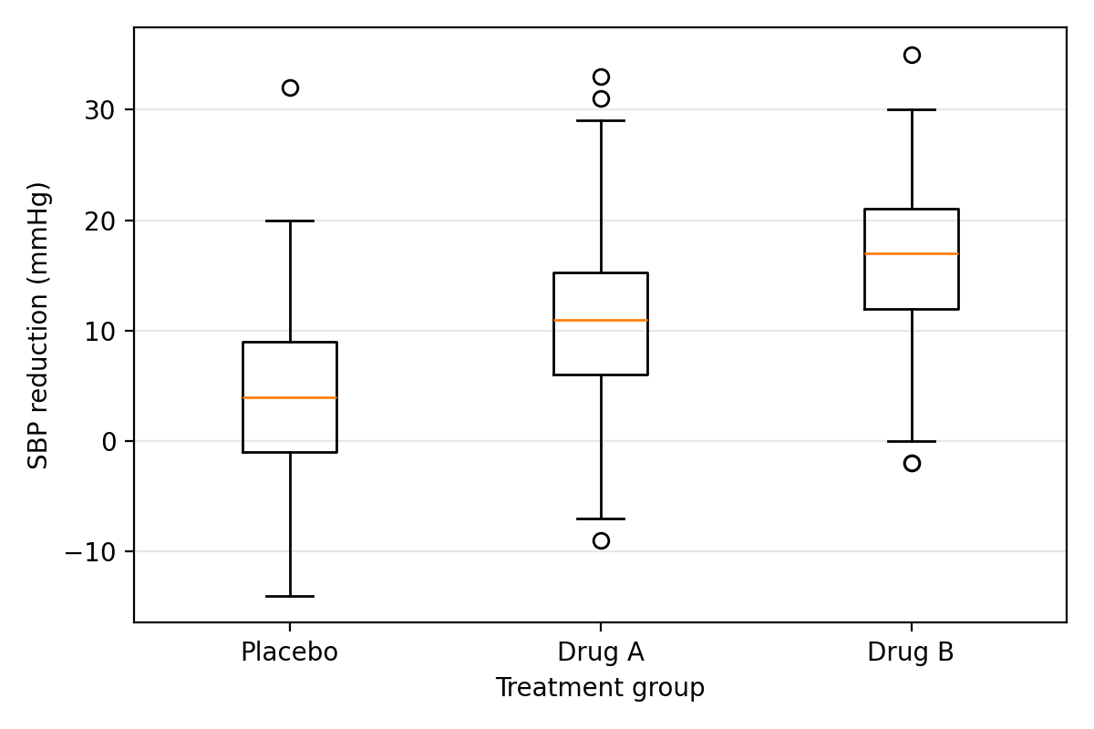
Figure 1: Reduction in Systolic Blood Pressure by Treatment Group
4.2.1 Do the three groups differ? (One-way ANOVA)
To test whether the three groups differ, a one-way analysis of variance (ANOVA) was used. ANOVA is the standard test for comparing the averages of three or more groups in a single step. It gave F(2, 497) = 115.66, p < 0.001, so the differences in Table 2 are far too large to be due to chance. The null hypothesis, that mean SBP change does not differ between groups, is therefore rejected. Treatment group alone accounted for about 31.8% of all the variation in blood pressure change between participants (12,245.63 out of a total sum of squares of 38,556.95).
4.2.2 Which groups differ from which? (Pairwise comparisons)
ANOVA shows that at least one group is different, but not which one. To find out, the groups were compared two at a time using t-tests that do not assume equal spread in the groups (Welch t-tests). Drug A lowered SBP by 6.64 mmHg more than Placebo (t = 8.13, df = 337, p < 0.001), and Drug B lowered it by 12.12 mmHg more than Placebo (t = 15.59, df = 330, p < 0.001). Drug B also performed better than Drug A, with an extra fall of 5.48 mmHg (t = 6.93, df = 324, p < 0.001). Because three comparisons were made, a stricter cut-off of 0.0167 (0.05 divided by 3, known as the Bonferroni correction) was applied to avoid false positives, and all three differences remained significant. In summary, both drugs worked better than Placebo, and Drug B worked best.
4.3 Adherence and Treatment Response
Adherence is the percentage of prescribed doses a participant actually took. The average adherence was 82.2% (SD = 13.3) and it was similar in the three groups (p = 0.297). To see whether taking more of the treatment was linked to a bigger fall in blood pressure, the Pearson correlation coefficient (r) was used. This number runs from −1 to +1: values near 0 mean little or no relationship, and positive values mean that the two measures rise together.
Across all participants, r = 0.113 (p = 0.012), a weak but statistically significant positive relationship: people who took more of their treatment tended to have a slightly larger fall in SBP. The picture became clearer when each group was examined separately. In the Drug A group the relationship was moderate and significant (r = 0.271, p < 0.001). In the Drug B group it was positive but not significant (r = 0.127, p = 0.109), and in the Placebo group there was no relationship (r = -0.096, p = 0.212), which makes sense because a placebo has no active ingredient to take more of. So adherence appeared to influence the effect of Drug A most clearly, which partly supports the secondary hypothesis. These group-level results are exploratory and show association, not proof that adherence caused the difference.
4.4 Predictors of the Reduction in Systolic Blood Pressure
Multiple linear regression was used to find which characteristics predict how much a person's blood pressure falls. This method estimates the effect of each factor while holding the others constant. For each factor, the coefficient (B) is the change in SBP reduction, in mmHg, linked to a one-unit increase in that factor. R² shows how much of the total variation in the outcome the model explains, where 0 means nothing and 1 means everything.
A first model using only adherence, age, BMI and fasting glucose explained just 1.3% of the variation (R² = 0.013) and was not significant overall (F(4, 495) = 1.65, p = 0.160). The reason is that it left out the single most important factor, the treatment group. A second model was therefore built that added Drug A and Drug B (compared with Placebo), HbA1c, smoking status and physical activity. Its results are in Table 3.
Table 3: Multiple Regression Model for Reduction in Systolic Blood Pressure
Predictor | B | 95% CI | p-value
Constant | -0.823 | -8.85 to 7.20 | 0.840
Drug A (compared with Placebo) | 6.635 | 5.08 to 8.19 | < 0.001
Drug B (compared with Placebo) | 12.162 | 10.59 to 13.74 | < 0.001
Adherence (per 1% increase) | 0.051 | 0.00 to 0.10 | 0.038
Age (per year) | -0.004 | -0.06 to 0.05 | 0.890
BMI (per kg/m²) | 0.025 | -0.12 to 0.17 | 0.728
Fasting glucose (per mg/dL) | -0.011 | -0.07 to 0.04 | 0.686
HbA1c (per 1%) | 0.048 | -1.50 to 1.59 | 0.951
Current smoker (compared with never) | 2.372 | 0.70 to 4.04 | 0.005
Former smoker (compared with never) | 0.499 | -1.17 to 2.17 | 0.557
Moderate activity (compared with low) | 1.279 | -0.17 to 2.73 | 0.084
High activity (compared with low) | 0.107 | -1.64 to 1.86 | 0.905
R² = 0.340; adjusted R² = 0.325; F(11, 488) = 22.82, p < 0.001. CI = confidence interval.
The second model was highly significant and explained 34.0% of the variation in SBP reduction, far more than the first. Three findings stand out. First, treatment group was by far the strongest predictor: compared with Placebo, Drug A gave an extra 6.64 mmHg fall and Drug B an extra 12.16 mmHg fall (both p < 0.001), which agrees with Section 4.2. Second, higher adherence was independently linked to a larger fall (B = 0.051, p = 0.038); in practical terms, every 10-percentage-point increase in adherence was associated with about 0.5 mmHg of extra reduction. Third, current smokers had a 2.37 mmHg larger fall than people who had never smoked (p = 0.005). This should not be read as smoking being helpful. Current smokers started with higher blood pressure (mean 132.2 mmHg compared with 128.2 mmHg in never-smokers), so they had more room to fall.
Age, BMI, fasting glucose, HbA1c and physical activity did not significantly predict the reduction. Importantly, physical activity, the one baseline factor that differed between groups in Table 1, was not a significant predictor (moderate p = 0.084; high p = 0.905), and the drug effects barely changed after it was included in the model (Drug A 6.64 mmHg and Drug B 12.16 mmHg, compared with 6.64 and 12.12 mmHg without adjustment). The small imbalance in activity therefore did not affect the conclusions.
4.5 Adverse Events and the Balance between Benefit and Harm
Table 4 shows how many participants in each group reported at least one adverse event (side effect). The chi-square test was used because both variables, treatment group and whether an adverse event occurred, are categories. It checks whether the proportions in the groups differ more than chance would allow. All expected counts were above 5, so the test was suitable.
Table 4: Adverse Events by Treatment Group
Group | n | Adverse event reported n (%) | No adverse event n (%)
Placebo | 172 | 12 (7.0) | 160 (93.0)
Drug A | 168 | 30 (17.9) | 138 (82.1)
Drug B | 160 | 48 (30.0) | 112 (70.0)
χ² = 29.77, df = 2, p < 0.001.
Adverse events became more common as the treatment got stronger: 7.0% with Placebo, 17.9% with Drug A and 30.0% with Drug B (χ² = 29.77, df = 2, p < 0.001). Figure 2 shows this pattern.
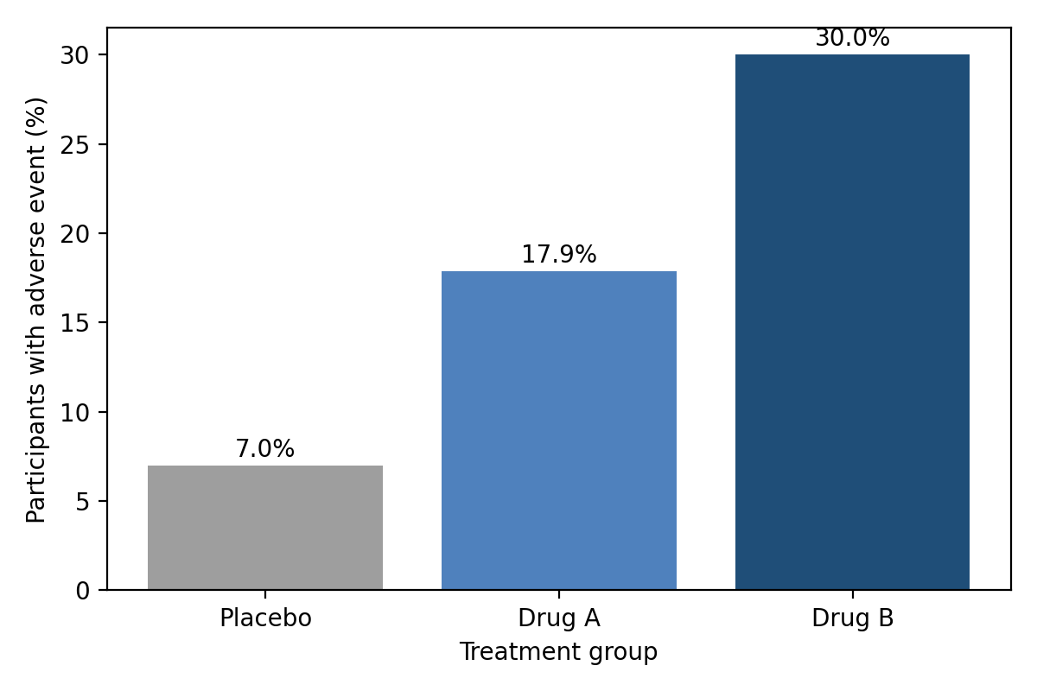
Figure 2: Proportion of Participants Reporting an Adverse Event by Treatment Group
Putting Sections 4.2 and 4.5 together shows a trade-off. Drug B gave the biggest fall in blood pressure (16.1 mmHg) but about three in ten of its users reported an adverse event. Drug A lowered blood pressure by less (10.6 mmHg) but had a lower rate of adverse events (17.9%). Which drug is preferable therefore depends on how much blood pressure reduction a patient needs and how much risk of side effects is acceptable. The study recorded whether an event occurred but not how severe it was, so this comparison is limited.
4.6 Summary of Findings
Objective 1 (baseline comparability). The three groups were similar at the start in all measured characteristics except physical activity (p = 0.044), which did not affect the results.
Objective 2 (change in SBP). Mean SBP fell by 4.0 mmHg on Placebo, 10.6 mmHg on Drug A and 16.1 mmHg on Drug B. The difference was highly significant (ANOVA p < 0.001), so the null hypothesis is rejected. Both drugs outperformed Placebo, and Drug B outperformed Drug A.
Objective 3 (adherence). Higher adherence was weakly linked to a larger fall in SBP overall (r = 0.113), mainly among Drug A users (r = 0.271). The secondary hypothesis is partly supported.
Objective 4 (predictors). Treatment group, adherence and current smoking significantly predicted the fall in SBP, while age, BMI, glucose, HbA1c and physical activity did not. The model explained 34.0% of the variation.
Objective 5 (adverse events). Adverse events rose from 7.0% (Placebo) to 17.9% (Drug A) and 30.0% (Drug B), a significant difference. The stronger blood pressure effect of Drug B therefore came with more side effects.

