Lab 3 — REST API and Two Services
Seitkazy Nurym
Two separate Flask services, both with in-memory data:
- Service A — Catalog (catalog_service.py, port 5001): products.
- Service B — Orders (orders_service.py, port 5002): orders. When an order is created, B asks A for the product over HTTP (with a 2-second timeout), calculates the total, and saves the product name and price inside the order.
How to run:
pip install -r requirements.txt
python catalog_app.py --port 5001
python order_app.py --port 5002 --catalog-url http://127.0.0.1:5001

Endpoints:
Service A (port 5001)
- POST /products — body {"name": "Laptop", "price": 499.99}
  - 201 with the product (including id)
  - 400 if name is missing/empty or price is not a number > 0
- GET /products/<id>
  - 200 with the product
  - 404 if not found
Service B (port 5002)
- POST /orders — body {"product_id": 1, "quantity": 3}
  - 201 with the order: id, product_id, product_name, product_price, quantity, total
  - 400 if product_id or quantity is not a positive integer
  - 404 if the product does not exist in the catalog
  - 503 if Service A is stopped or does not answer within 2 seconds
- GET /orders/<id>
  - 200 with the saved order (uses only B's own data, never calls A)
  - 404 if not found
All responses and errors are JSON.
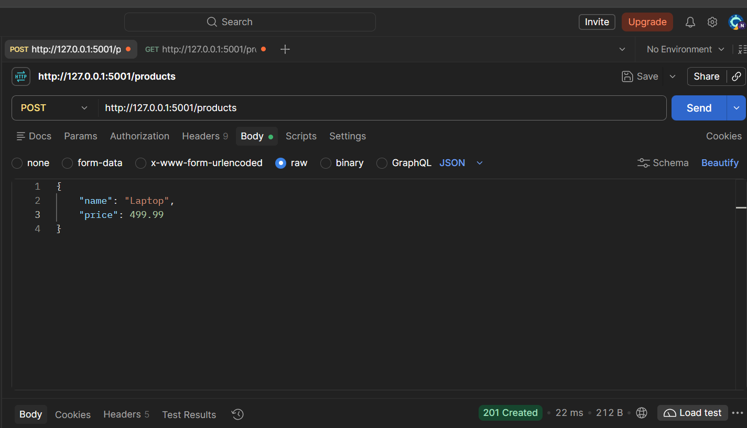
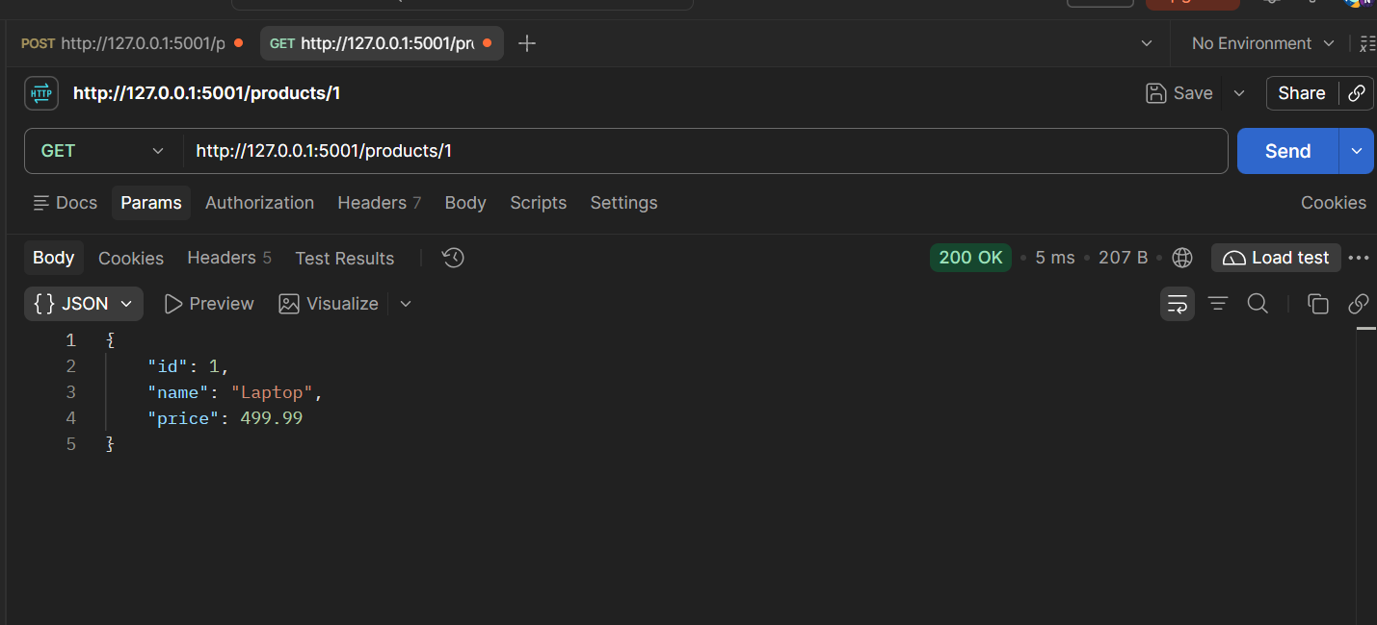
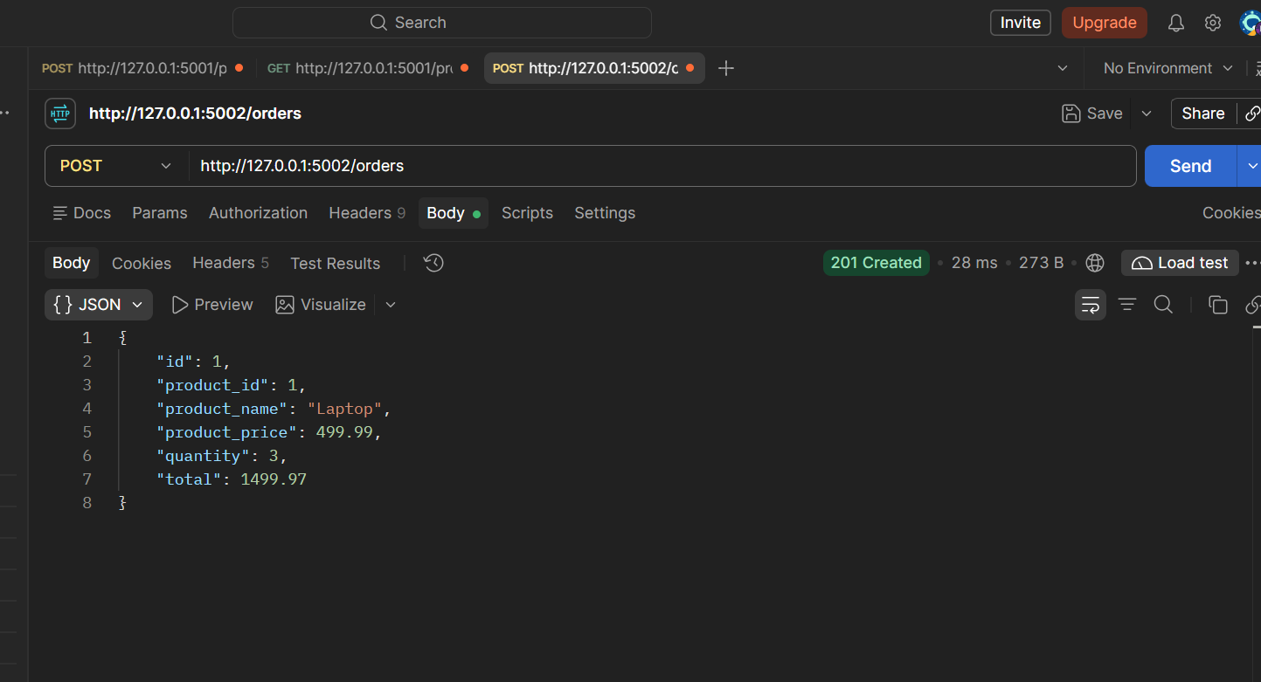
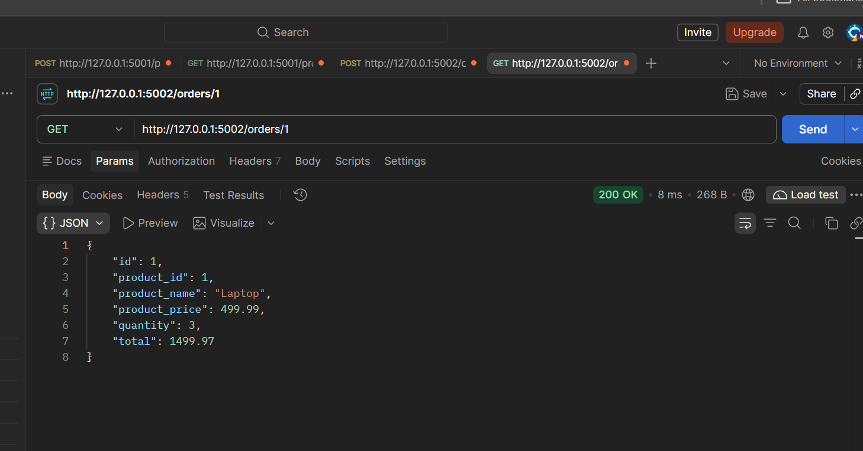
Server A is stopped.
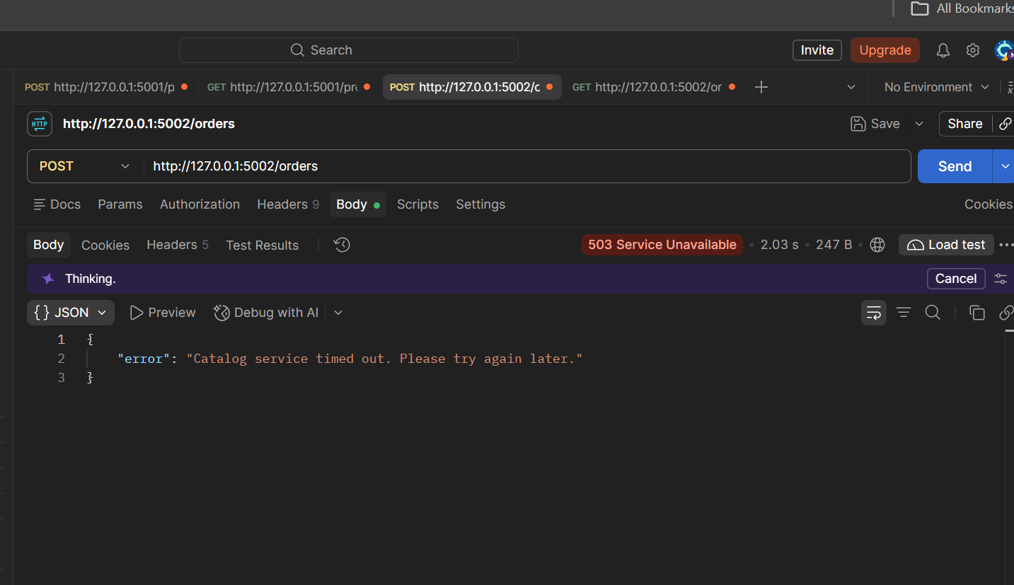
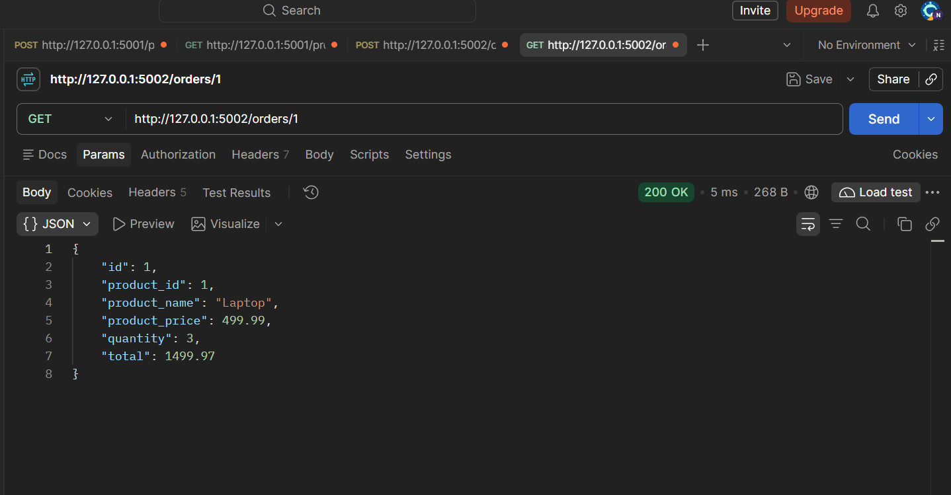

Lab 4. Product Catalogue Replication
Seitkazy Nurym
Service | Port | File
Catalog Primary | 5001 | catalog_primary.py
Catalog Replica | 5002 | catalog_replica.py
Order Service | 5003 | order_service.py
pip install -r requirements.txt
python catalog_replica.py --port 5002
python catalog_primary.py --port 5001 --replica-url http://127.0.0.1:5002
python order_app.py --port 5003 --primary-url http://127.0.0.1:5001 --replica-url http://127.0.0.1:5002

python test.py async
python test.py sync

Results
Time | Catalog Primary | Catalog Replica | Order sees
Before update | 500000, v1 | 500000, v1 | 500000
Immediately after async PUT | 450000, v2 | 500000, v1 | Old price 500000
After 5 seconds | 450000, v2 | 450000, v2 | New price 450000

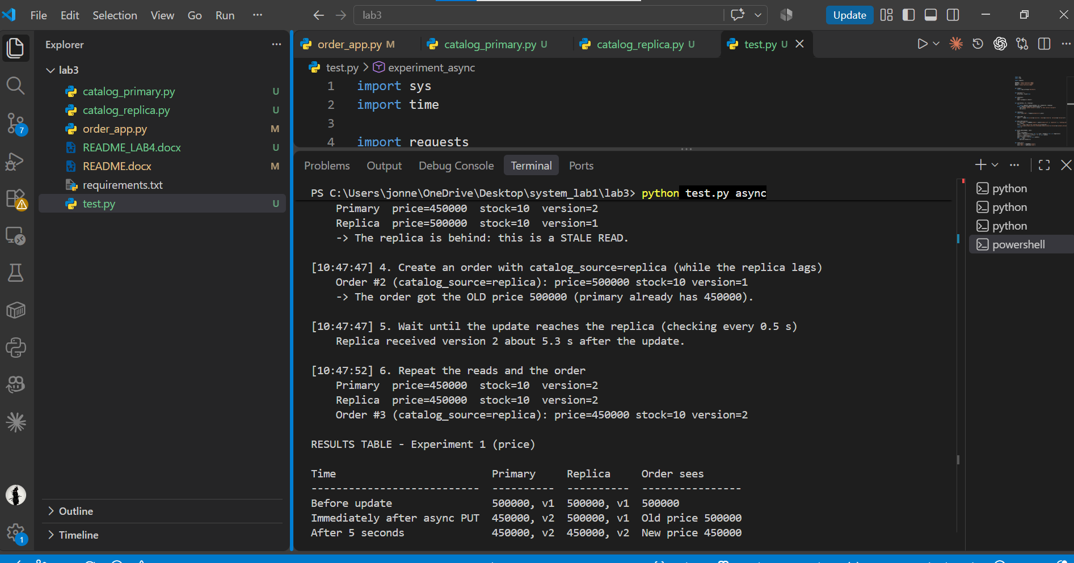
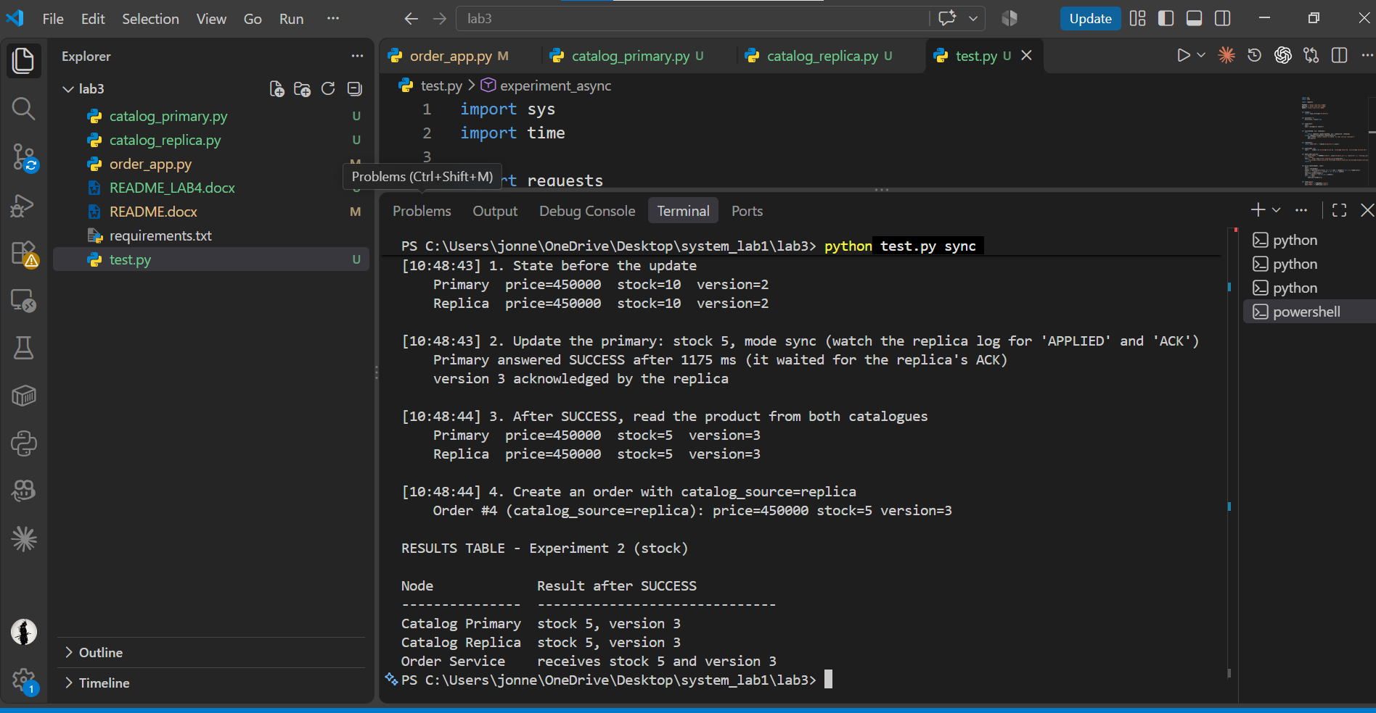
Order read from the replica. The primary had already changed to 450000 (v2), but the update was still on its way to the replica, which still held 500000 (v1).
What is a stale read? A read that returns data that is already out of date, because the copy being read has not received the latest update yet.
When does the primary return SUCCESS in async mode? Right after it stores the update locally, before the replica has received it.
When does the primary return SUCCESS in sync mode? Only after the replica has applied the update and sent back its ACK.
Why is sync mode usually slower? The primary has to wait for a network round trip to the replica and for the replica to confirm before it can answer. In async mode it answers immediately and the delivery happens in the background.

