Multimodal Fashion & Context Retrieval
Glance ML Internship Assignment - Final Submission
Himkesh Tak · BTech, Computer Science, IIT Jodhpur

1. Project Overview
This document proposes a solution for an intelligent fashion image search engine that retrieves images from a diverse database based on natural language descriptions — covering not just garment attributes, but scene context and overall style. The system is built as two modular pipelines: an Indexer that processes raw images into a searchable multi-vector representation, and a Retriever that parses natural language queries and returns ranked results.

2. Approaches Considered
Several architectural directions were evaluated before settling on a final approach. The comparison below focuses on how well each handles fashion-specific compositional queries — the core challenge this assignment is designed around.
Approach | Core idea | Pros | Cons
Vanilla CLIP zero-shot | Dual encoder, pooled global embeddings, cosine similarity search. | No training, fully zero-shot, fast. | Fails compositional queries (attribute-binding / bag-of-words problem).
Domain-adapted CLIP (FashionCLIP) | Same architecture, fine-tuned on fashion image-text pairs. | Much better fashion vocabulary and product-level accuracy. | Still pooled-vector, inherits the same binding weakness.
Hard-negative fine-tuning (NegCLIP-style) | Fine-tune with deliberately attribute-swapped captions as hard negatives. | Directly targets the binding problem; well studied. | Needs curated negative data and GPU fine-tuning budget.
V2 multi-vector named querying (implemented) | Route one query into garment, region, and vibe text; search three matched named-vector indexes and fuse weighted scores. | Modular, interpretable, query-adaptive, and scalable bounded fusion. | Three model spaces, detector dependency, LLM latency, and weight-calibration risk.
Structured attribute / region hybrid (v1) | Detect garment regions, embed each region, decompose query into phrases, score with sum-of-max. | Modular, explainable, extensible, handles compositional AND-queries well. | More moving parts; detector/parser errors can propagate.
VLM re-ranking | Use CLIP for fast recall, then a vision-language model verifies top-K candidates. | Best raw compositional accuracy. | Not scalable as a first-pass filter; per-call latency and cost.

3. Architecture v1 - Region-Level Late Interaction
V1 was the initial architecture proposed to improve compositional retrieval beyond a single pooled Fashion-CLIP vector. It combines global recall with open-vocabulary garment regions and a fixed sum-of-max reranker. This is a self-contained historical design; it is not the implemented V2 pipeline described later.
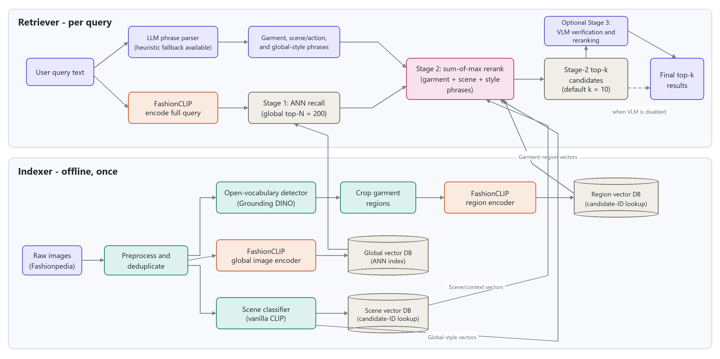
Figure 1. V1 indexer and two-stage retrieval flow.

3.1 V1 indexer
- Validate, resize, deduplicate, and reject corrupt Fashionpedia images.
- Use scene prompts to create one scene embedding for office, street, park, or home context.
- Detect multiple garment regions with Grounding DINO or OWL-ViT and crop each valid box.
- Encode each crop with Fashion-CLIP, producing approximately two to five region vectors per image.
- Store a separate global Fashion-CLIP vector for first-pass ANN recall and region vectors keyed by image ID and garment label.

3.2 Architecture v1 - Retriever and Query Behavior
V1 uses a fixed two-stage retrieval process. It first retrieves global candidates, then evaluates garment and scene phrases only against those candidates. The aggregation does not adapt its weights to the type of query.
- Parse the user text into garment phrases and scene phrases using a fixed JSON schema.
- Encode the full query with Fashion-CLIP and retrieve a bounded global top-N candidate set.
- For every garment phrase, select the highest-scoring candidate region; score scene phrases against the scene embedding.
- Sum the per-phrase maximum scores, optionally verify a small top-k with a VLM, and return descending results.

V1 mapping to the five assignment prompts
# | Query | How the pipeline handles it
1. Attribute specific | "A person in a bright yellow raincoat." | Single garment phrase ("yellow raincoat") matched against raincoat-labeled regions via sum-of-max.
2. Contextual / place | "Professional business attire inside a modern office." | Scene phrase ("modern office") scored against the scene classifier embedding; garment phrase ("professional business attire") scored against garment regions.
3. Complex semantic | "Someone wearing a blue shirt sitting on a park bench." | Garment phrase ("blue shirt") vs shirt regions; scene phrase ("park bench") vs scene embedding — parsed and scored independently, then summed.
4. Style inference | "Casual weekend outfit for a city walk." | No single hard attribute — relies on global FashionCLIP embedding similarity (Stage 1 recall) plus scene phrase ("city walk") scoring; style is inherently fuzzy, so global similarity carries more weight here.
5. Compositional | "A red tie and a white shirt in a formal setting." | Two garment phrases ("red tie", "white shirt") each matched to their own region type — this is the case a pooled CLIP vector fails and the region-level sum-of-max is specifically designed to solve.

3.3 Architecture v1 - Shortcomings and Future Work

V1 shortcomings
- Cascading errors: missed detections, poor crops, and label heuristics multiply; a missed region cannot be recovered during reranking.
- Fixed aggregation: sum-of-max cannot increase scene importance for place queries or global style importance for aesthetic queries.
- Scene/style conflation: office or park location signals share one bucket with casual, formal, or weekend style language.
- Storage complexity: multiple region vectors and label metadata per image complicate indexing, updates, and consistency.
- Empirical outcome: initial testing underperformed the vanilla Fashion-CLIP baseline because the extra stages added more failure points than useful signal.

V1 modularity, scalability, and zero-shot behavior
Modularity: detection, cropping, global recall, region reranking, and optional VLM verification are separable components. Scalability: corpus-wide work is limited to one ANN global-vector search, while region reranking is bounded by N candidates; however, storing several region vectors per image increases memory and operational complexity. Zero-shot: open-vocabulary detection and Fashion-CLIP accept unseen garment phrases, but detector vocabulary, attribute binding, and crop quality limit novel fine-grained descriptions.

V1 future work
- Measure detector recall and crop quality independently before optimizing retrieval.
- Train with attribute-swapped hard negatives and support multiple high-confidence garment boxes.
- Replace fixed equal aggregation with calibrated per-query weights or learned fusion.
- Separate physical location from style/mood and add a place-aware text-image model.
- Evaluate all five prompts with human relevance labels, Precision@K, Recall@K, MRR, and nDCG.

4. Architecture v2 - Strategy A Multi-Vector Named Querying
V2 is the implemented and recommended architecture. It stores one Qdrant point per image while preserving garment, region, and vibe as three independently searchable named vectors. Unlike V1, there is no global-recall gate that can remove an image before the other experts contribute.

4.1 V2 indexer and vector contract
Global preprocessing computes an MD5 over raw bytes, skips duplicates, rejects corrupt or oversized files, applies EXIF orientation, composites transparency onto white, converts to RGB, and safely bounds image dimensions before model-specific normalization.
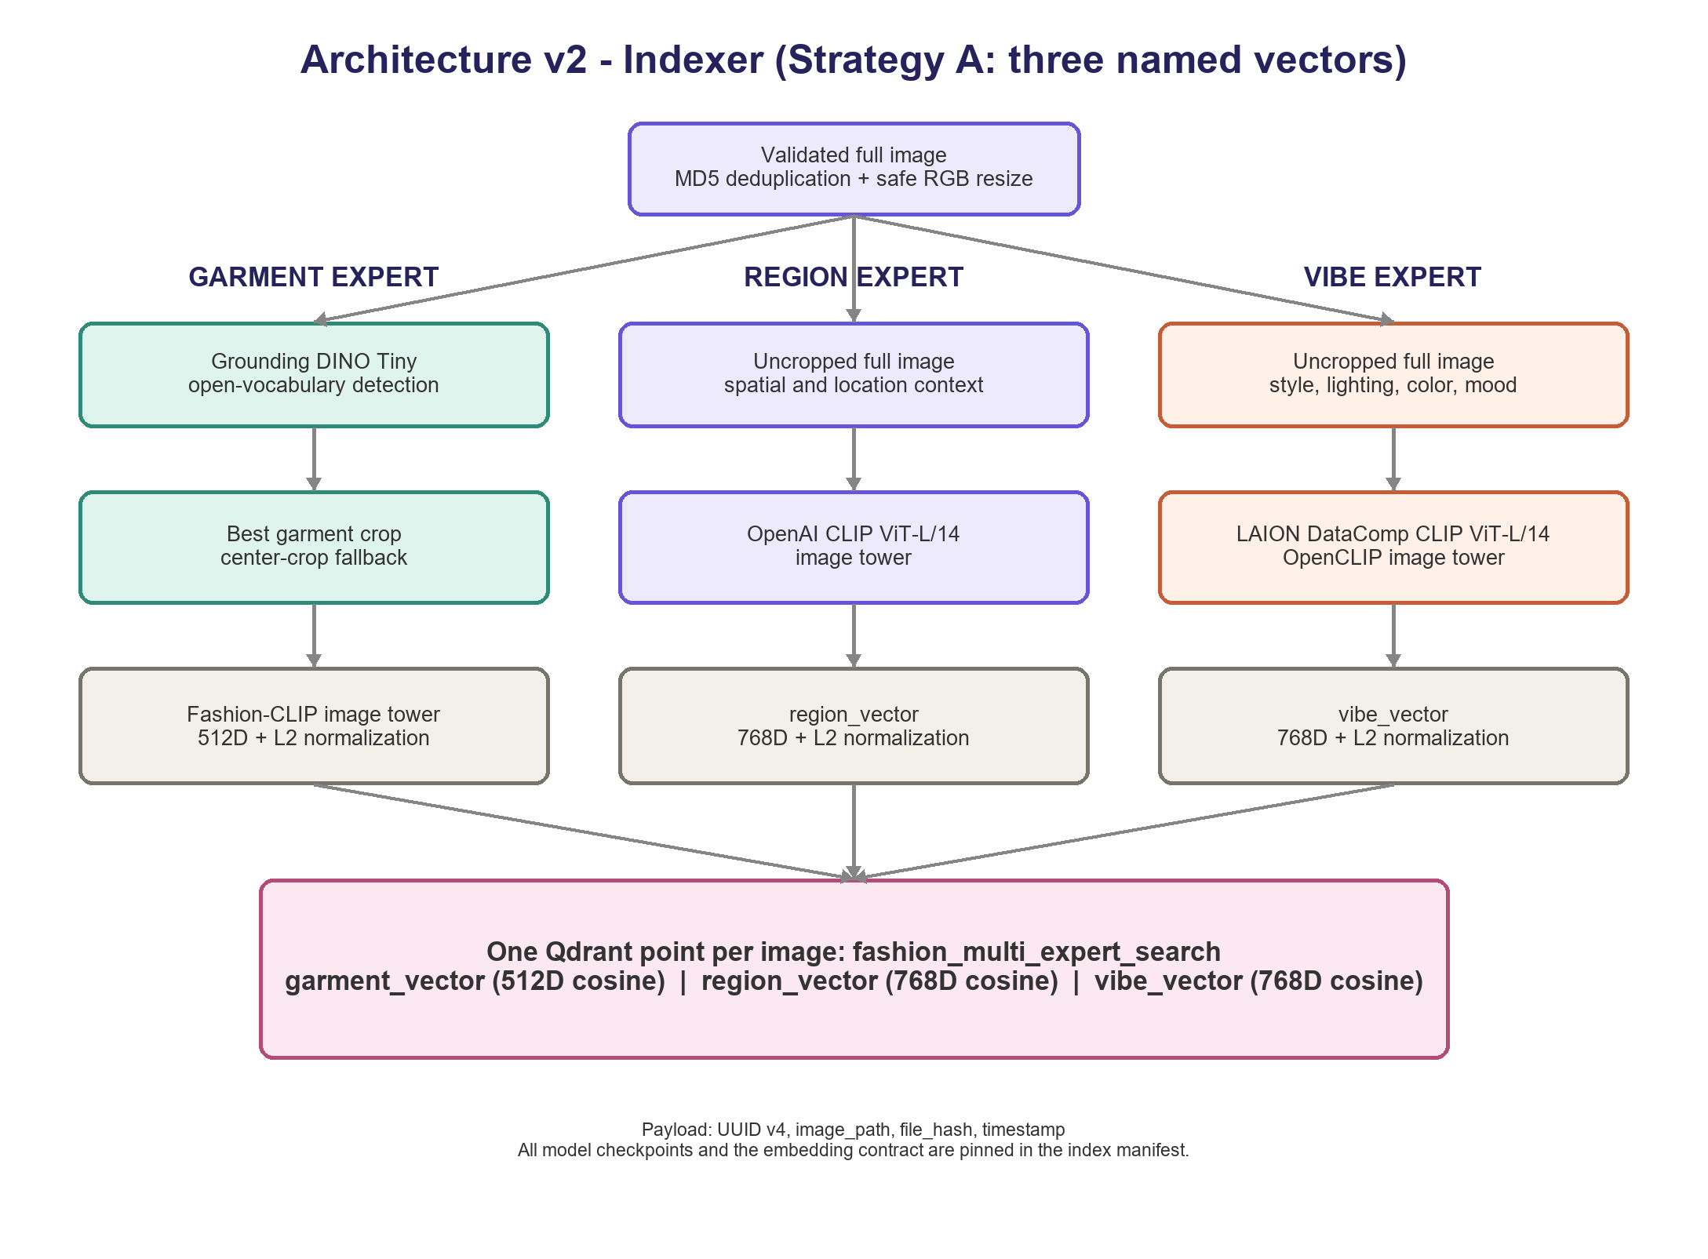
Figure 2. V2 indexer: one record with three independent named vectors.
- Garment expert: Grounding DINO Tiny selects the best garment crop; center crop is the fallback; Fashion-CLIP outputs a normalized 512D garment_vector.
- Region expert: the uncropped image passes through OpenAI CLIP ViT-L/14, producing a normalized 768D region_vector with a matching text tower.
- Vibe expert: the uncropped image passes through LAION DataComp OpenCLIP ViT-L/14, producing a normalized 768D vibe_vector for styling, palette, lighting, and mood.

4.2 Architecture v2 - Retriever and Score Fusion
OpenRouter returns a strict Pydantic QueryPlan with garment_query, region_query, vibe_query, alpha, beta, and gamma. Each query must be non-empty, every weight must be in [0, 1], and decimal validation requires alpha + beta + gamma to equal exactly 1.0.
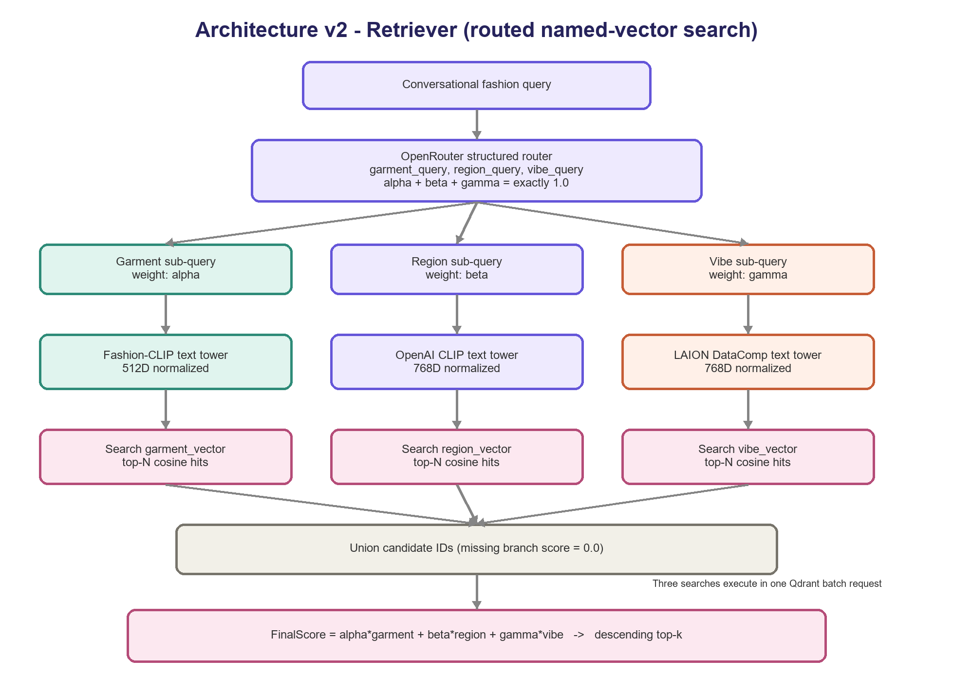
Figure 3. V2 query routing, three named-vector searches, and deterministic fusion.
Fashion-CLIP, OpenAI CLIP, and LAION DataComp text towers encode the routed sub-queries into normalized 512D, 768D, and 768D vectors. Qdrant executes all three top-N searches in one batch. Candidate IDs are unioned, a missing branch receives baseline 0.0, and results are sorted using the exact formula below.
FinalScore = alpha * garment_score + beta * region_score + gamma * vibe_score

4.3 Architecture v2 - Results, Shortcomings, and Future Work

Observed benchmark
The verified index contains 800 deterministic samples from 3,200 images, 800 unique hashes, and the exact 512/768/768 named-vector schema. For the unseen query "Vintage oversized leather jacket at a rainy train station," weights were 0.50/0.30/0.20; each branch returned 100 candidates; warm CPU latency was 4.97 seconds, including 4.25 seconds for LLM routing, 0.67 seconds for text encoding, 0.042 seconds for Qdrant, and 0.002 seconds for fusion. Outerwear and leather relevance was strong, but no top-ten image clearly showed a train station.

V2 shortcomings
- Single-crop garment branch: the highest-confidence box can miss secondary garments or fine compositional attributes.
- Weight calibration: valid weights can still overemphasize one expert; no minimum branch floor is currently enforced.
- LLM overhead: routing dominates warm latency and introduces cost plus limited run-to-run variation.
- Semantic overlap: region and vibe can both respond to backgrounds, so branch meanings require prompt discipline.
- Development deployment: embedded Qdrant and absolute image paths are not the final one-million-image production design.

V2 modularity, scalability, and zero-shot behavior
Modularity: indexer and retriever packages separate preprocessing, experts, storage, routing, encoding, and fusion. Scalability: Qdrant performs three ANN searches and application fusion touches at most 3N IDs, but one million float32 points require about 8.2 GB of raw vectors plus HNSW and payload overhead; server or cluster mode, sharding, on-disk vectors, and GPU-batched ingestion are required. Zero-shot: matched CLIP text-image towers and open-vocabulary detection accept novel combinations, with weaker behavior for rare fabrics, negation, counting, and precise spatial relations.

V2 future work
- Calibrate or bound dynamic weights and log every routed plan for branch-level error analysis.
- Support multiple garment boxes and hard-negative Fashion-CLIP fine-tuning.
- Add place-aware and weather named vectors while retaining one Qdrant point per image.
- Use a cross-encoder or VLM only for uncertain top-k reranking and evaluate with labeled IR metrics.

5. Repository and Reproducibility
GitHub repository: https://github.com/Himkeshtak/Final-pipeline-Glance-Fashion
The submitted code is divided into two packages that communicate through the validated Qdrant schema and model manifest. Runtime images, Qdrant data, model caches, and credentials remain outside application logic and source control.
Final-pipeline-Glance-Fashion/
fashion_indexer/ preprocessing, experts, database, pipeline, cli
fashion_retriever/ llm, encoders, database, fusion, pipeline, cli
index_fashion.py indexing entry point
retrieve_fashion.py retrieval entry point
benchmark_retrieval.py qualitative benchmark and gallery

Reproduction commands
- Index: python index_fashion.py --images-dir val_test2020/test --max-images 800 --shuffle-seed 2020
- Retrieve: python retrieve_fashion.py "Vintage oversized leather jacket at a rainy train station" --top-k 10
- Benchmark: python benchmark_retrieval.py "Vintage oversized leather jacket at a rainy train station" --candidate-limit 100 --top-k 10

6. Final selection
V1 remains documented as an independently defined historical architecture with its own retrieval logic, limitations, scalability profile, zero-shot behavior, and future work. V2 is the separately defined implemented submission because named-vector querying retains specialist evidence without V1's global-recall gate, supports query-dependent weighting, exposes branch scores for debugging, and has already completed an 800-image end-to-end benchmark. The next rigorous milestone is human-labeled evaluation of the five assignment prompts with compositional hard negatives and standard ranking metrics.

