Multimodal Fashion & Context Retrieval
Glance ML Internship Assignment - Final Submission
Himkesh Tak · BTech, Computer Science, IIT Jodhpur

1. Project Overview
This document proposes a solution for an intelligent fashion image search engine that retrieves images from a diverse database based on natural language descriptions — covering not just garment attributes, but scene context and overall style. The system is built as two modular pipelines: an Indexer that processes raw images into a searchable multi-vector representation, and a Retriever that parses natural language queries and returns ranked results.

2. Approaches Considered
Several architectural directions were evaluated before settling on a final approach. The comparison below focuses on how well each handles fashion-specific compositional queries — the core challenge this assignment is designed around.
Approach | Core idea | Pros | Cons
Vanilla CLIP zero-shot | Dual encoder, pooled global embeddings, cosine similarity search. | No training, fully zero-shot, fast. | Fails compositional queries (attribute-binding / bag-of-words problem).
Domain-adapted CLIP (FashionCLIP) | Same architecture, fine-tuned on fashion image-text pairs. | Much better fashion vocabulary and product-level accuracy. | Still pooled-vector, inherits the same binding weakness.
Hard-negative fine-tuning (NegCLIP-style) | Fine-tune with deliberately attribute-swapped captions as hard negatives. | Directly targets the binding problem; well studied. | Needs curated negative data and GPU fine-tuning budget.
Linear alignment on frozen CLIP | Train a small linear layer on top of frozen text embeddings to recover binding signal. | Cheap, no backbone retraining. | Gains mostly validated on synthetic benchmarks, weaker guarantee on real photos.
Structured attribute / region hybrid (v1) | Detect garment regions, embed each region, decompose query into phrases, score with sum-of-max. | Modular, explainable, extensible, handles compositional AND-queries well. | More moving parts; detector/parser errors can propagate.
VLM re-ranking | Use CLIP for fast recall, then a vision-language model verifies top-K candidates. | Best raw compositional accuracy. | Not scalable as a first-pass filter; per-call latency and cost.

The central technical issue behind most of these tradeoffs is well documented in vision-language research: standard CLIP-style models pool all image patches into a single vector, which causes attributes to lose their binding to the correct object. A query like "a purple sphere" can score highly against an image containing a purple cube next to a yellow sphere, because the pooled representation treats attributes and objects as an unordered set rather than a structured scene. This is precisely the "red shirt vs. blue pants" failure mode the assignment's compositional query is designed to probe.

3. Initial Chosen Approach & Architecture (v1)
The initial v1 proposal combined domain-adapted CLIP recall, open-vocabulary region detection, and fixed sum-of-max late-interaction reranking. It is retained here to show the architectural progression and tradeoffs; the implemented and recommended system is Architecture v2 in Section 7.
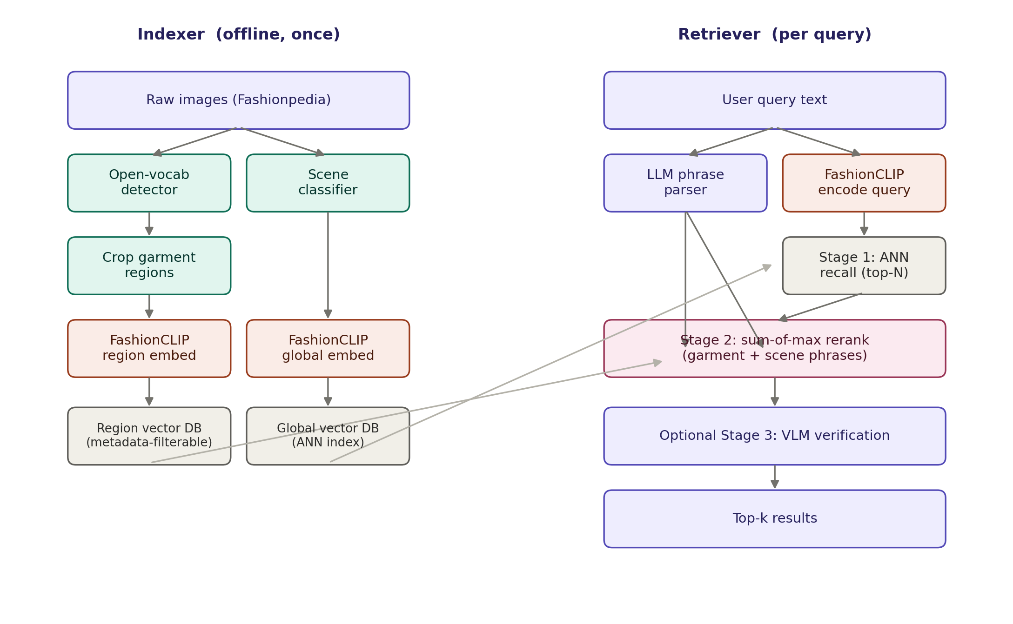

3.1 Indexer
- Ingest raw images from the Fashionpedia dataset.
- Preprocess: resize, deduplicate, discard corrupt files.
- Scene tagging: zero-shot CLIP prompts ("office interior", "urban street", "park", "home interior") produce a scene label and embedding per image.
- Garment detection: an open-vocabulary detector (Grounding DINO / OWL-ViT) locates garments using a fixed fashion vocabulary, with no need for a trained segmentation model.
- Region cropping and embedding: each detected garment region is cropped and encoded with FashionCLIP, producing 2–5 region vectors per image.
- Global embedding: the full image is separately encoded with FashionCLIP for fast first-pass recall.
- Storage: global embeddings go into an ANN-indexed vector store (FAISS/Chroma); region embeddings go into a metadata-filterable store keyed by image ID and garment label.

3.2 Retriever
- Parse the query into garment phrases and scene phrases using a small LLM with a fixed JSON schema.
- Encode the full query with FashionCLIP for Stage 1 recall.
- Stage 1 — recall: ANN search against the global vector store returns the top-N candidates from the full corpus. This is the only step that touches the whole dataset, keeping the system scalable.
- Stage 2 — rerank: fetch region vectors for just the N candidates; score each garment phrase against its best-matching region (optionally restricted to regions sharing the phrase's detected label) and each scene phrase against the scene embedding; sum the per-phrase maximum scores into one composite score per candidate.
- Stage 3 (optional) — a vision-language model verifies the top-k results for a final precision pass on the hardest compositional queries.

3.3 How this handles the five evaluation queries
# | Query | How the pipeline handles it
1. Attribute specific | "A person in a bright yellow raincoat." | Single garment phrase ("yellow raincoat") matched against raincoat-labeled regions via sum-of-max.
2. Contextual / place | "Professional business attire inside a modern office." | Scene phrase ("modern office") scored against the scene classifier embedding; garment phrase ("professional business attire") scored against garment regions.
3. Complex semantic | "Someone wearing a blue shirt sitting on a park bench." | Garment phrase ("blue shirt") vs shirt regions; scene phrase ("park bench") vs scene embedding — parsed and scored independently, then summed.
4. Style inference | "Casual weekend outfit for a city walk." | No single hard attribute — relies on global FashionCLIP embedding similarity (Stage 1 recall) plus scene phrase ("city walk") scoring; style is inherently fuzzy, so global similarity carries more weight here.
5. Compositional | "A red tie and a white shirt in a formal setting." | Two garment phrases ("red tie", "white shirt") each matched to their own region type — this is the case a pooled CLIP vector fails and the region-level sum-of-max is specifically designed to solve.

4. Repository / Codebase
GitHub repository: https://github.com/Himkeshtak/Final-pipeline-Glance-Fashion
The implementation is split into two independent Python packages. fashion_indexer owns preprocessing, expert image encoders, Qdrant writes, and indexing orchestration; fashion_retriever owns structured query routing, matched text encoders, named-vector search, score fusion, and retrieval orchestration. Runtime data is supplied through CLI arguments and the Qdrant collection rather than embedded in model logic.
Final-pipeline-Glance-Fashion/
fashion_indexer/ config, preprocessing, experts, database, pipeline, cli
fashion_retriever/ config, llm, encoders, database, fusion, pipeline, cli
tests/ model-free unit and contract tests
index_fashion.py indexing entry point
retrieve_fashion.py retrieval entry point
Execution:
- Dataset: place Fashionpedia validation images under val_test2020/test. The submitted experiment deterministically sampled 800 of 3,200 images with shuffle seed 2020.
- Build the index: python index_fashion.py --images-dir val_test2020/test --max-images 800 --shuffle-seed 2020
- Query: python retrieve_fashion.py "Vintage oversized leather jacket at a rainy train station" --top-k 10
- Benchmark: python benchmark_retrieval.py "Vintage oversized leather jacket at a rainy train station" --candidate-limit 100 --top-k 10

5. Future Work

5a. How to extend this solution to add locations (cities, places) and weather
Architecture v2 can add cities, landmarks, and weather without redesigning score fusion. For location, the region branch can be strengthened with a place-recognition checkpoint, city or landmark prompt sets, and EXIF/GPS metadata when available; metadata should be used as an additional filtered signal rather than mixed into the visual embedding. Weather can be introduced as a fourth named vector in the same Qdrant point, with a matched zero-shot image/text model for conditions such as rain, snow, fog, and sunshine. The structured query plan then adds a weather sub-query and delta weight, with alpha + beta + gamma + delta constrained to 1. This preserves the single-record Strategy A design and keeps location, weather, garment, and aesthetic evidence independently searchable.

5b. How to improve precision
Precision should be improved with measured, branch-specific interventions. First, build a human-labeled query set covering the five assignment prompts plus hard attribute-binding negatives, and report Precision@K, Recall@K, MRR, and nDCG. Then calibrate or bound the LLM weights, log every query plan, and compare learned or grid-searched fusion against the dynamic weights. Garment errors can be reduced with better detector prompts, multi-box support, and hard-negative Fashion-CLIP fine-tuning. Region precision can use a stronger place-aware model, while a cross-encoder or VLM can rerank only a small uncertain top-k. These changes keep expensive reasoning off the full corpus and target the failure source instead of adding another global stage.

6. Addressing the Evaluation Criteria

6a. Thoughtful solution and known shortcomings
Architecture v2 retains CLIP-style zero-shot matching but separates garment, place, and aesthetic evidence into model-matched named-vector spaces. This directly targets the assignment's multi-attribute retrieval requirement while preserving inspectable branch scores. Its known shortcomings are:
- Garment detection remains a bottleneck: only the highest-confidence garment box is encoded, and the center-crop fallback preserves recall but may dilute fine attributes.
- Routing can be miscalibrated: the Pydantic schema enforces alpha + beta + gamma = exactly 1.0, but it does not yet enforce a minimum contribution from each branch.
- Latency is dominated by cold model loading and the OpenRouter request; Qdrant search and deterministic score fusion are comparatively small parts of a warm query.

6b. Modular code
Logic is separated from data through the fashion_indexer and fashion_retriever packages. Preprocessing, model experts, persistence, LLM routing, text encoding, and fusion are independent modules assembled by CLI entry points. Pipelines receive their components through constructors, paths and limits are configuration values, and raw images, Qdrant storage, model caches, and credentials are excluded from source control. The remaining portability limitation is that payloads currently store absolute image paths; production deployment should use stable IDs or dataset-relative URIs.

6c. Scalability to 1 million images
Retrieval logic remains bounded as the corpus grows: Qdrant searches three ANN named indexes for a fixed top-N, and application fusion evaluates at most 3N unique IDs (300 with N=100), not all images. One million float32 points contain 2,048 values each and require about 8.2 GB for raw vectors before HNSW graphs, payloads, segments, backups, and replicas. The algorithm therefore scales, but the current embedded local Qdrant deployment does not: production should use Qdrant server or cluster mode with sharding, replication, on-disk vectors, payload indexes, tuned HNSW, and optional quantization. Initial million-image ingestion would also need GPU batching, multiple workers, bulk upserts, durable checkpoints, and retry queues.

6d. Zero-shot capability
Retrieval is zero-shot with respect to this assignment's labels. Grounding DINO accepts open-vocabulary garment prompts, and every indexed image vector is paired with the matching Fashion-CLIP, OpenAI CLIP, or LAION DataComp text tower. The LLM can route novel combinations of materials, silhouettes, places, lighting, and moods without adding a catalog class. Limits remain for rare garments, subtle fabrics, negation, counting, precise spatial relations, and concepts weakly represented in pretraining. The benchmark retrieved outerwear, leather, and a wet urban scene for an unseen composite query, but did not retrieve a clear train station, demonstrating useful rather than perfect zero-shot compositionality.

7. Architecture Revision: Dynamic Multi-Branch Retrieval (v2)
The implemented submission replaces the v1 fixed late-interaction proposal with Strategy A: Multi-Vector Named Querying. Each image is still one database record, but garment, region, and vibe evidence remain three independently searchable vectors. This section is the authoritative specification of the submitted v2 system and supersedes Section 3.

7.1 Indexing pipeline and vector contract
Global preprocessing runs once before the experts: raw bytes are streamed into an MD5 deduplication check; corrupt, decompression-bomb, or oversized images are rejected; EXIF orientation is applied; transparency is composited onto white; and images are converted to RGB and safely bounded before each checkpoint's official processor performs normalization.
- Garment expert - Grounding DINO Tiny receives the open-vocabulary targets garment, clothing, apparel, and dress. The highest-confidence valid box is clamped and cropped; if no box survives, the largest center square is used. Fashion-CLIP encodes that crop into a 512-dimensional garment_vector, which is L2-normalized.
- Region expert - the uncropped image is encoded by openai/clip-vit-large-patch14 into a 768-dimensional region_vector. This paired CLIP checkpoint replaced the proposed image-only Scene-ViT so the retriever can use the checkpoint's matching text tower for office, street, park, and other location descriptions. The output is L2-normalized.
- Vibe expert - the uncropped image is encoded by laion/CLIP-ViT-L-14-DataComp.XL-s13B-b90K through OpenCLIP, producing a normalized 768-dimensional vibe_vector for palette, lighting, environment, styling composition, and aesthetic mood. The upstream checkpoint is a DataComp CLIP ViT-L/14, not EVA02.
Qdrant stores one UUID v4 point per image in fashion_multi_expert_search. Its named-vector schema is garment_vector (512D cosine), region_vector (768D cosine), and vibe_vector (768D cosine). The payload contains image_path, file_hash, and UTC timestamp. Full checkpoint revisions and preprocessing contracts are persisted in an index manifest and validated before retrieval, preventing incompatible image and text spaces from being compared.
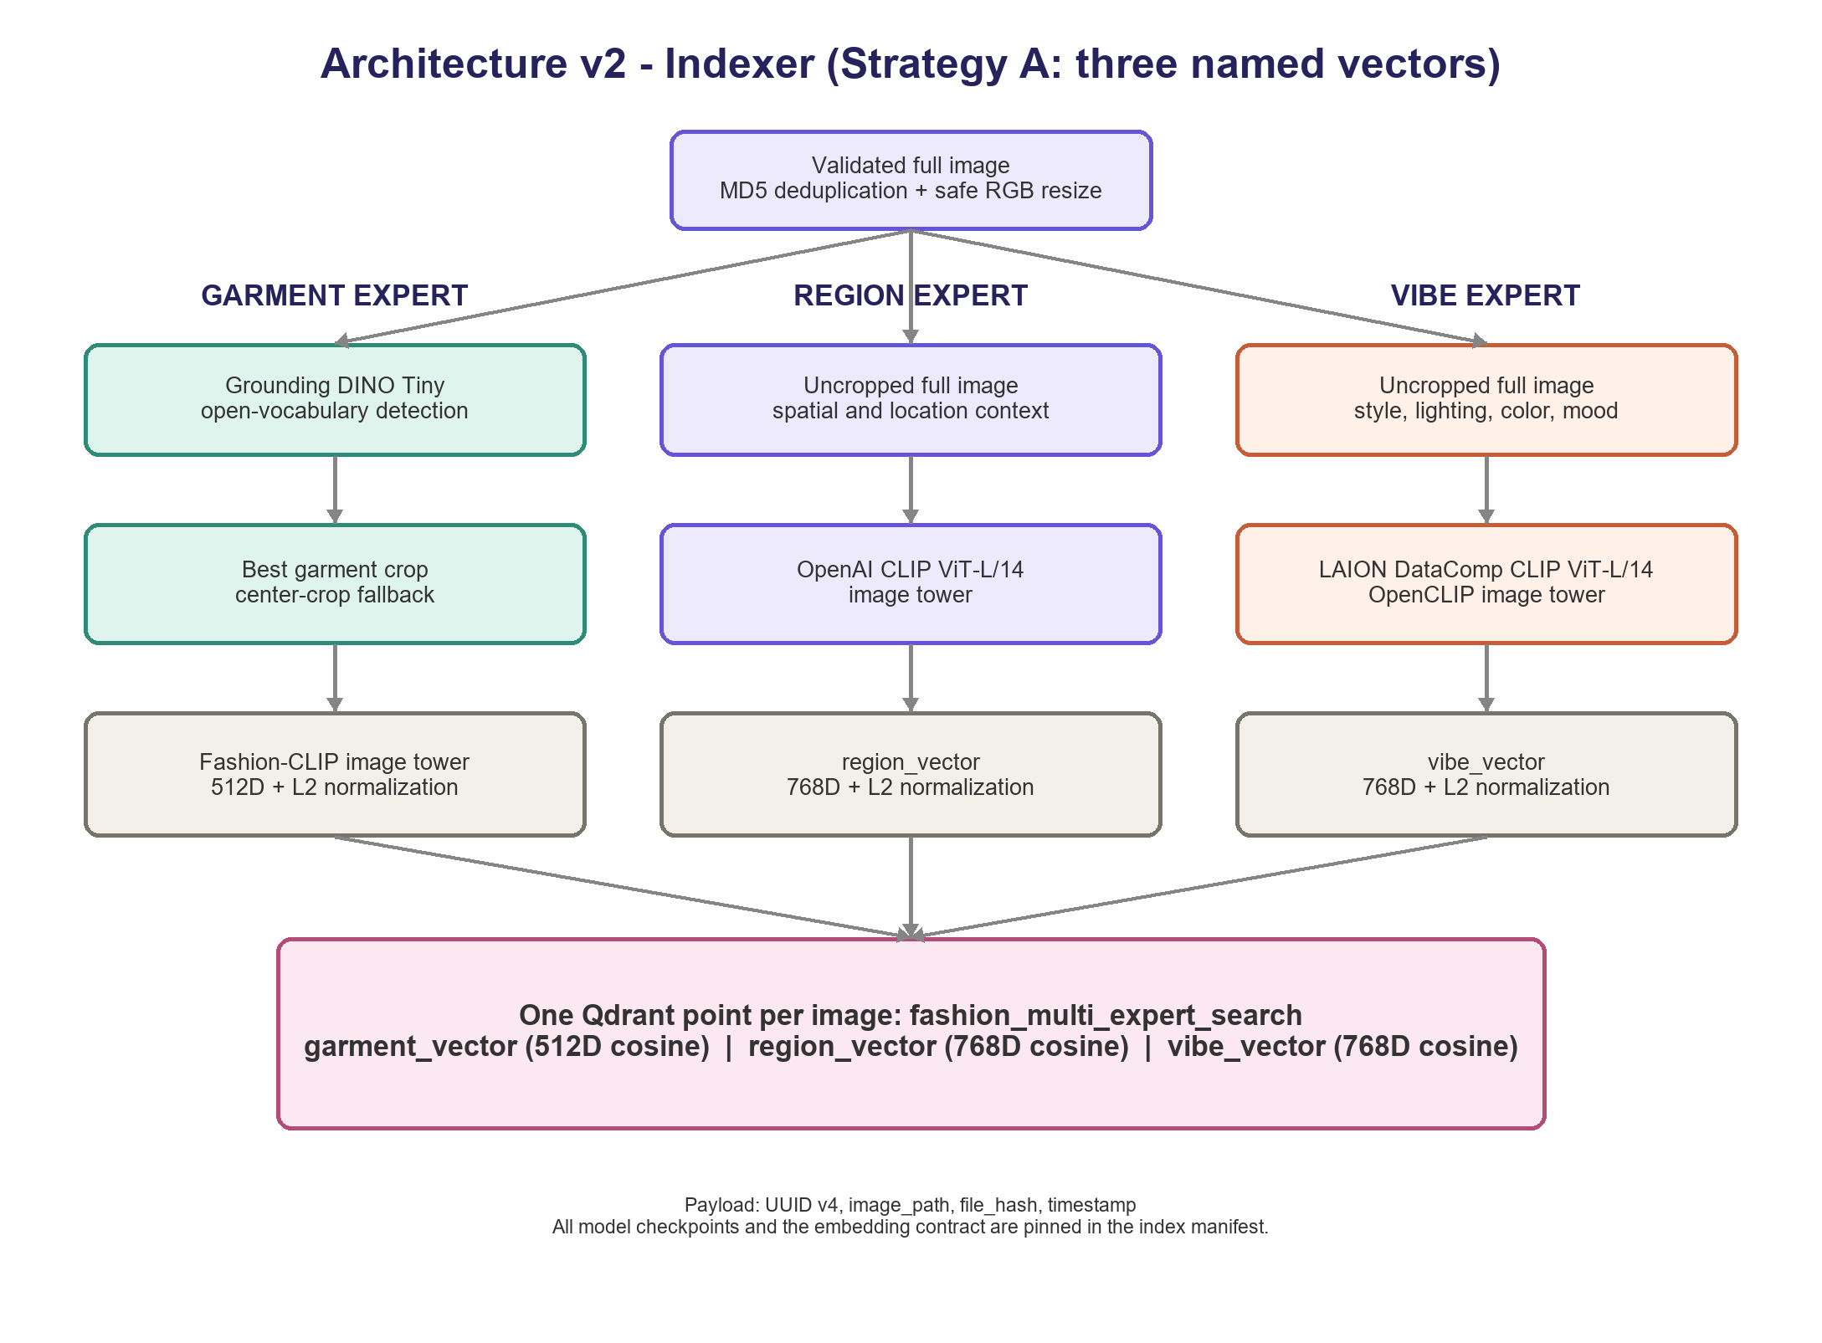

7.2 Query routing, named-vector search, and fusion
OpenRouter produces a strict Pydantic QueryPlan containing garment_query, region_query, vibe_query, alpha, beta, and gamma. Every query is non-empty, each weight is in [0, 1], unknown fields are rejected, and decimal validation requires alpha + beta + gamma to equal exactly 1.0. The three sub-queries are encoded by the matching Fashion-CLIP (512D), OpenAI CLIP ViT-L/14 (768D), and LAION DataComp OpenCLIP (768D) text towers and L2-normalized.
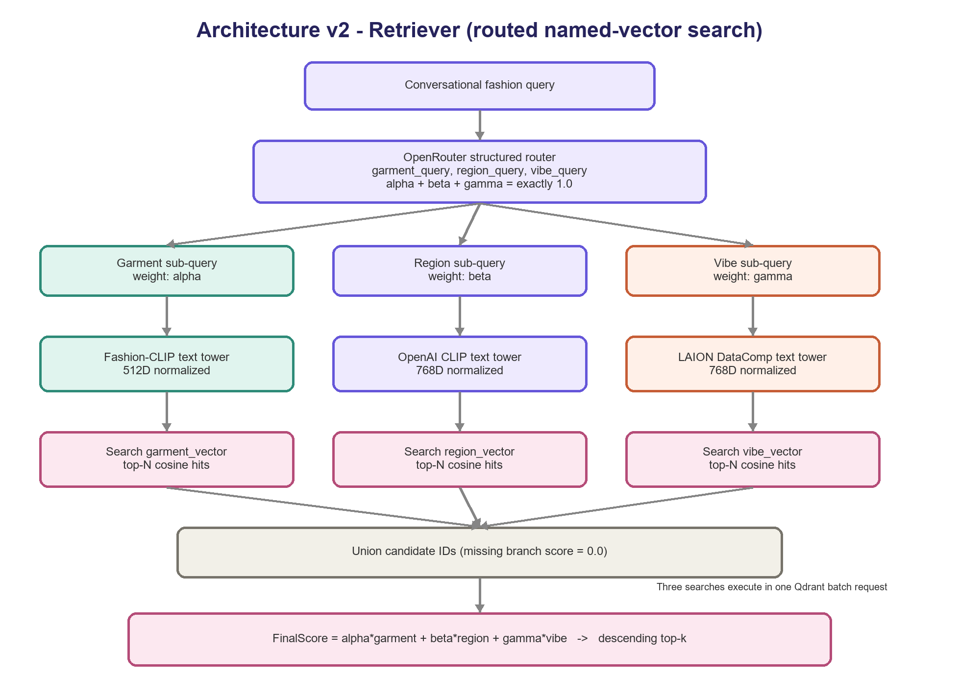
Qdrant executes the three named-vector searches in one batch request and returns the top-N cosine matches from each space. Candidate IDs are unioned; a branch that did not retrieve a candidate receives the configured baseline score 0.0. Fusion is deterministic: FinalScore = alpha * garment_score + beta * region_score + gamma * vibe_score. Results are sorted by FinalScore and the top-k image paths, payloads, fused scores, and raw branch scores are returned as structured JSON.

7.3 Why v2 is useful and observed benchmark behavior
V2 makes query emphasis explicit without collapsing the specialist spaces. A garment-heavy query can receive a high alpha, while place- or mood-heavy language can increase beta or gamma. Named vectors preserve independent ANN indexes inside one record, making branch scores inspectable and avoiding duplicate image records or early vector concatenation.
The submitted index contains 800 images sampled deterministically from 3,200 files with seed 2020; verification found 800 points, 800 unique hashes, and the exact 512/768/768 schema. For "Vintage oversized leather jacket at a rainy train station," the router chose weights 0.50/0.30/0.20, all three searches returned 100 candidates, and the warm CPU path took 4.97 seconds (4.25 seconds LLM routing, 0.67 seconds encoding, 0.042 seconds Qdrant, 0.002 seconds fusion). All top ten images contained outerwear, several contained leather, and rank ten captured a wet urban scene; none clearly showed a train station. This is a successful end-to-end and qualitative zero-shot check, not a substitute for labeled Precision@K or nDCG evaluation.

8. Comparative Evaluation & Conclusion
Three designs were considered: a vanilla Fashion-CLIP baseline, the v1 region-detection hybrid with fixed sum-of-max reranking, and the implemented v2 Strategy A architecture. Initial v1 testing underperformed the baseline because detector, crop, and label-matching errors compounded. V2 keeps the useful specialist separation but makes each branch an independent retrieval signal, so a garment miss does not remove the region and vibe evidence.
The likely cause is cascading error across v1's multi-stage pipeline: detector recall below 100%, imperfect crop boundaries, and label-matching heuristics each introduce independent error, and these errors compound multiplicatively across stages rather than averaging out. A single well-tuned end-to-end model (vanilla FashionCLIP) has no such compounding, since it has only one stage that can fail. This is a known risk with multi-stage retrieval pipelines: additional structure only pays off once every stage in the chain is individually reliable, and v1's detector/crop/label-matching stages were not independently validated before being chained together — noted here as a process gap, not only an architectural one.

8.1 Shortcomings by approach
- Vanilla FashionCLIP baseline: cannot bind attributes to the correct object in multi-object scenes (the core compositionality problem this project targets); no separation between garment, location, and style signals — everything is one pooled vector; fast and reliable precisely because it has only one stage, but with a hard ceiling on compositional queries.
- v1 — region-detection hybrid, fixed sum-of-max: multi-stage cascading error (detector recall, crop quality, label-matching all compound); a static, equal-weighted aggregation rule that cannot adapt to query type, which empirically hurt style-inference queries specifically; conflates location (“office,” “park”) and style/mood (“casual,” “formal”) into a single scene-phrase axis, losing resolution between two genuinely different query types; more moving parts than the baseline for a result that, on initial testing, did not clear that baseline.
- v2 - Strategy A three-branch dynamic weighting (recommended): requires three model spaces and more index-time compute; the garment branch still depends on a single detector crop; the LLM adds latency and can allocate valid but poorly calibrated weights; missing top-N branch hits receive a zero baseline; region and vibe semantics can overlap; and local embedded Qdrant plus absolute image paths are development choices rather than a million-image production deployment.

8.2 Conclusion
Architecture v2 is the recommended and implemented approach. It meets the assignment's two workflow requirement, improves on vanilla pooled retrieval by separating garment, location, and aesthetic evidence, and remains explainable through logged sub-queries, branch scores, and weights. The 800-image benchmark verifies the complete index-to-query path and shows promising zero-shot fashion relevance, while the missed train-station concept documents the current limit honestly. The next rigorous step is a human-labeled evaluation of the five assignment queries plus compositional hard negatives, followed by weight calibration and branch-specific error analysis.

