Multimodal Fashion & Context Retrieval
Glance ML Internship Assignment - Final Submission
Himkesh Tak · BTech, Computer Science, IIT Jodhpur

1. Project Overview
This document proposes a solution for an intelligent fashion image search engine that retrieves images from a diverse database based on natural language descriptions — covering not just garment attributes, but scene context and overall style. The system is built as two modular pipelines: an Indexer that processes raw images into a searchable multi-vector representation, and a Retriever that parses natural language queries and returns ranked results.

2. Approaches Considered
Several architectural directions were evaluated before settling on a final approach. The comparison below focuses on how well each handles fashion-specific compositional queries — the core challenge this assignment is designed around.
Approach | Core idea | Pros | Cons
Vanilla CLIP zero-shot | Dual encoder, pooled global embeddings, cosine similarity search. | No training, fully zero-shot, fast. | Fails compositional queries (attribute-binding / bag-of-words problem).
Domain-adapted CLIP (FashionCLIP) | Same architecture, fine-tuned on fashion image-text pairs. | Much better fashion vocabulary and product-level accuracy. | Still pooled-vector, inherits the same binding weakness.
Hard-negative fine-tuning (NegCLIP-style) | Fine-tune with deliberately attribute-swapped captions as hard negatives. | Directly targets the binding problem; well studied. | Needs curated negative data and GPU fine-tuning budget.
V2 multi-vector named querying (implemented) | Route one query into garment, region, and vibe text; search three matched named-vector indexes and fuse weighted scores. | Modular, interpretable, query-adaptive, and scalable bounded fusion. | Three model spaces, detector dependency, LLM latency, and weight-calibration risk.
Structured attribute / region hybrid (v1) | Detect garment regions, embed each region, decompose query into phrases, score with sum-of-max. | Modular, explainable, extensible, handles compositional AND-queries well. | More moving parts; detector/parser errors can propagate.
VLM re-ranking | Use CLIP for fast recall, then a vision-language model verifies top-K candidates. | Best raw compositional accuracy. | Not scalable as a first-pass filter; per-call latency and cost.

3. Architecture v1 - Region-Level Late Interaction
V1 was the initial architecture proposed to improve compositional retrieval beyond a single pooled Fashion-CLIP vector. Its offline indexer builds separate garment-region, global-recall, and scene/context representations. At query time, a global ANN gate supplies candidates for fixed late-interaction scoring across garment, scene/action, and global-style phrases, followed by optional VLM verification. This is a self-contained historical design; it is not the implemented V2 pipeline described later.
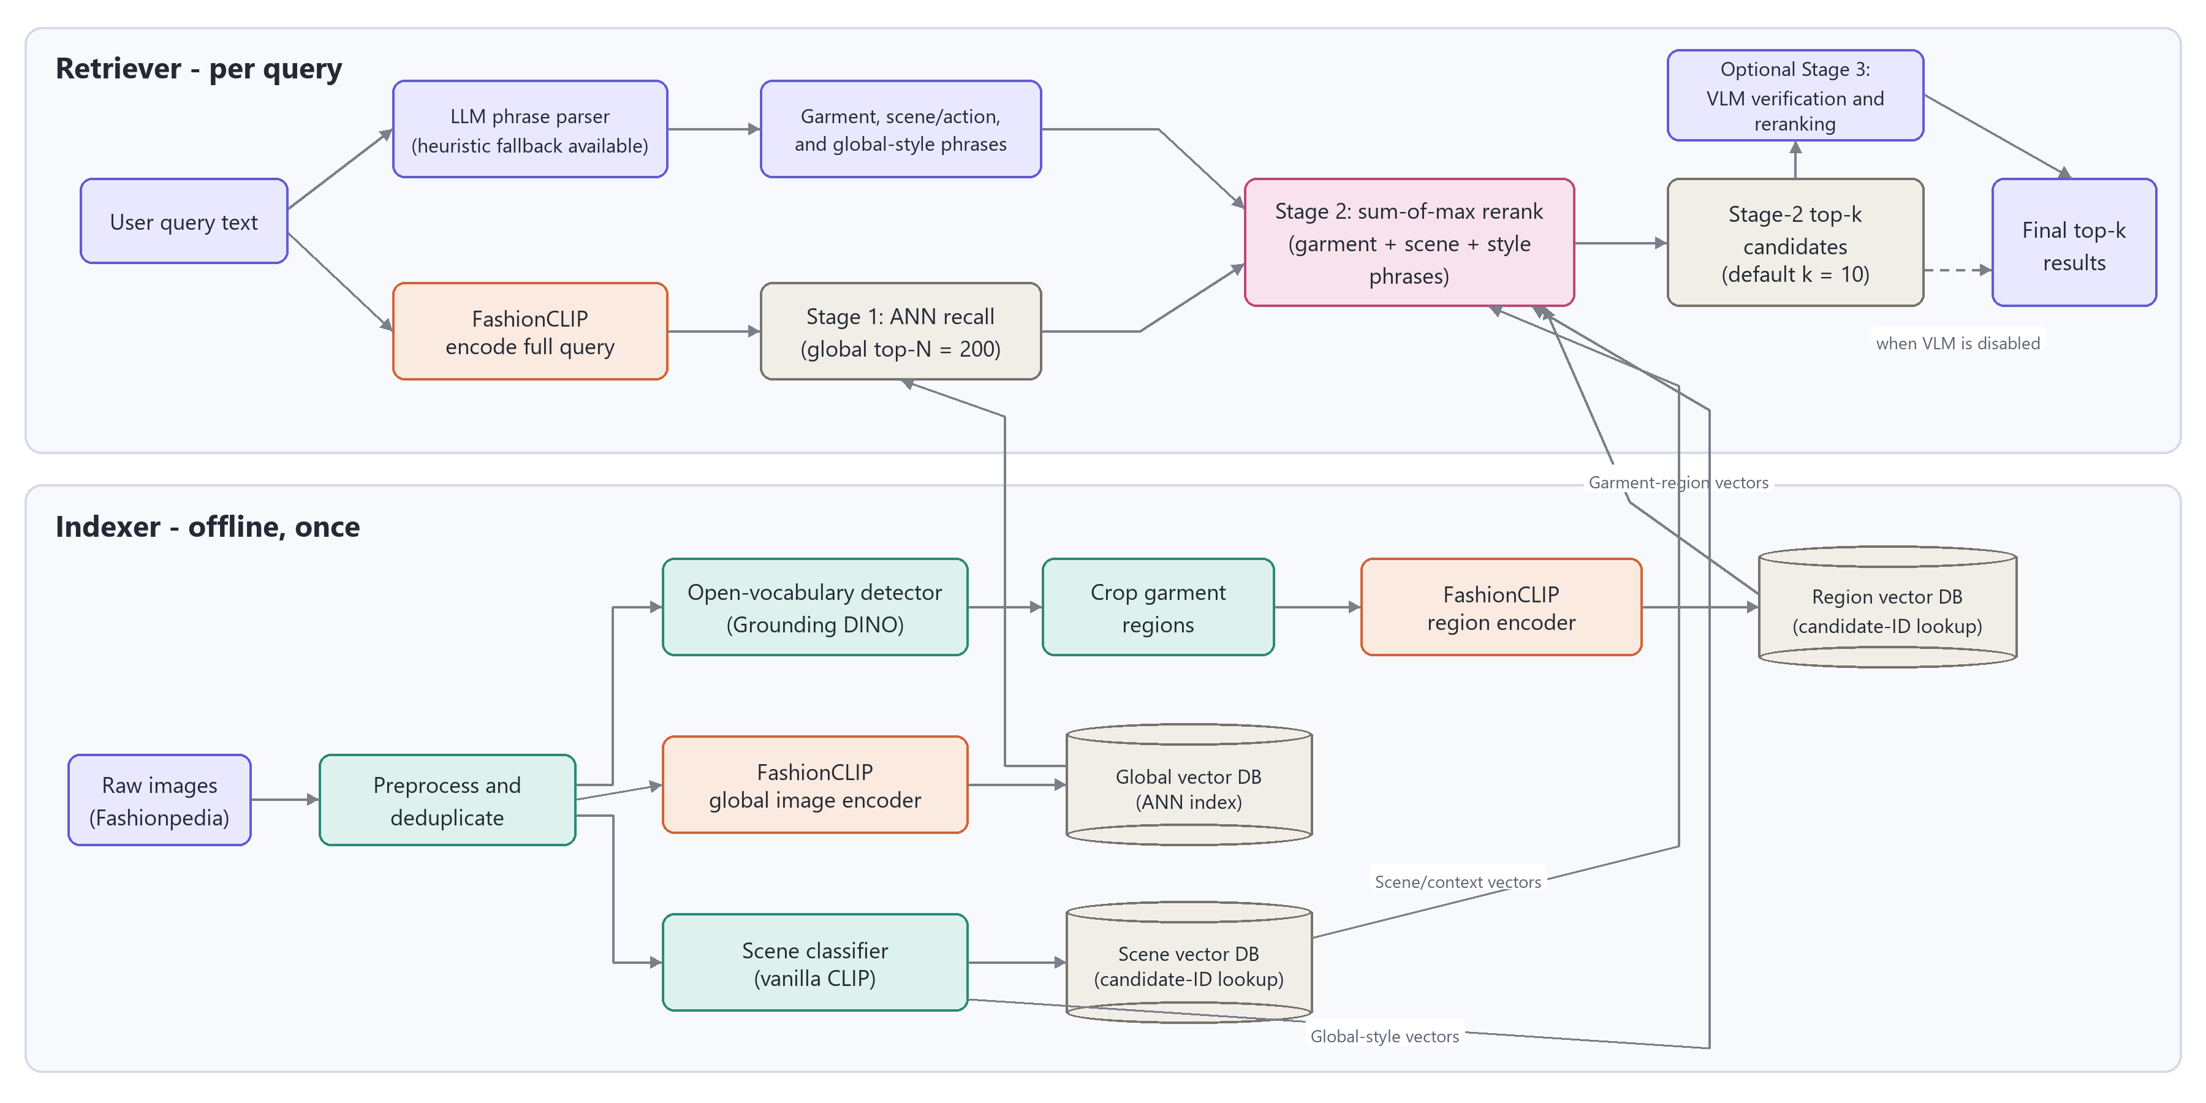
Figure 1. V1 offline indexer and staged retriever with optional VLM verification.

3.1 V1 indexer
- Validate, resize, deduplicate, and reject corrupt Fashionpedia images before any model inference.
- Run the open-vocabulary Grounding DINO detector, crop every valid garment region, and retain the source image ID for candidate lookup.
- Encode each garment crop with the Fashion-CLIP region encoder and store its vector in the Region vector DB, keyed by candidate image ID.
- Encode the full image with the Fashion-CLIP global image encoder and store one vector in the Global vector DB used by the ANN recall stage.
- Run a vanilla CLIP scene classifier on the full image; store scene/context vectors in the Scene vector DB and retain its global-style representation for Stage-2 scoring.

3.2 Architecture v1 - Retriever and Query Behavior
V1 uses two mandatory retrieval stages plus an optional verification stage. Stage 1 encodes the full query with Fashion-CLIP and retrieves the global top-N = 200 candidates. Stage 2 reranks only those candidates with a fixed sum-of-max over garment, scene/action, and global-style phrases. It emits top-k = 10 candidates, which either proceed directly to the final results or pass through optional Stage-3 VLM verification and reranking.
- Parse the user text with an LLM phrase parser into garment, scene/action, and global-style phrases; use the heuristic parser if the LLM path is unavailable.
- Encode the full query with Fashion-CLIP and search the Global vector DB for Stage-1 ANN recall with global top-N = 200.
- For each retained candidate, match garment phrases against its Region vector DB entries, scene/action phrases against its Scene vector DB entry, and global-style phrases against the vanilla-CLIP style representation; keep each phrase's maximum similarity.
- Sum the per-phrase maxima with the fixed Stage-2 rule, retain top-k = 10, and either return them directly or use the optional VLM to verify and rerank before producing final top-k results.

V1 mapping to the five assignment prompts
# | Query | How the pipeline handles it
1. Attribute specific | "A person in a bright yellow raincoat." | After Stage-1 global recall, the garment phrase "yellow raincoat" is scored against all candidate garment-region vectors; Stage 2 keeps the highest regional similarity.
2. Contextual / place | "Professional business attire inside a modern office." | The parser produces a garment phrase and a scene/action phrase. Stage 2 scores business attire against region vectors and "modern office" against the candidate scene vector, then adds their maxima.
3. Complex semantic | "Someone wearing a blue shirt sitting on a park bench." | The garment phrase "blue shirt" is matched to candidate regions, while the scene/action phrase "sitting on a park bench" is matched to scene/context vectors; their maxima contribute independently.
4. Style inference | "Casual weekend outfit for a city walk." | The parser emits scene/action and global-style phrases such as "city walk," "casual," and "weekend." Stage 2 scores them through the vanilla-CLIP scene/style representations after global recall.
5. Compositional | "A red tie and a white shirt in a formal setting." | The two garment phrases "red tie" and "white shirt" independently select their best candidate regions. Their separate maxima are summed, which directly targets the pooled-vector binding failure.

3.3 Architecture v1 - Shortcomings and Future Work

V1 shortcomings
- Cascading errors: missed Grounding DINO detections or poor crops remove garment evidence before region-level reranking can use it.
- Stage-1 recall ceiling: an image excluded from the global top-N = 200 set cannot be recovered by stronger garment, scene, style, or VLM evidence later.
- Fixed late-interaction rule: the sum-of-max cannot dynamically raise scene importance for place queries or global-style importance for aesthetic queries.
- Scene/style entanglement: scene/action and global-style signals are derived from the same vanilla-CLIP branch, so location and aesthetic language can interfere.
- Operational complexity: multiple region vectors plus separate region, global, and scene stores complicate indexing, synchronization, candidate-ID lookups, and updates; optional VLM verification adds latency.

V1 modularity, scalability, and zero-shot behavior
Modularity: preprocessing, Grounding DINO detection, Fashion-CLIP region and global encoding, vanilla-CLIP scene/style encoding, the three vector stores, ANN recall, phrase parsing, sum-of-max reranking, and optional VLM verification remain separable components. Scalability: only the Global vector DB is searched corpus-wide; Stage 2 is bounded to 200 candidate IDs and optional VLM work to 10, but several region vectors per image and three synchronized stores increase memory and operations. Zero-shot: the open-vocabulary detector and CLIP-family encoders accept unseen garment, scene/action, and style phrases, while novel fine-grained descriptions remain limited by detection quality, phrase parsing, vanilla-CLIP priors, and the Stage-1 recall gate.

V1 future work
- Measure Grounding DINO recall, crop quality, and Stage-1 Recall@200 independently before tuning the reranker.
- Train Fashion-CLIP region representations with attribute-swapped hard negatives and improve multi-box filtering and candidate-ID association.
- Replace fixed sum-of-max aggregation with calibrated phrase-group weights or learned fusion across garment, scene/action, and global-style evidence.
- Separate scene/action from global style with distinct encoders or stores, and make top-N adaptive when Stage-1 confidence is low.
- Use the VLM only for uncertain Stage-2 candidates and evaluate all five assignment prompts with human labels, Precision@K, Recall@K, MRR, and nDCG.

4. Architecture v2 - Strategy A Multi-Vector Named Querying
V2 is the implemented and recommended architecture. It stores one Qdrant point per image while preserving garment, region, and vibe as three independently searchable named vectors. Unlike V1, there is no global-recall gate that can remove an image before the other experts contribute.

4.1 V2 indexer and vector contract
Global preprocessing computes an MD5 over raw bytes, skips duplicates, rejects corrupt or oversized files, applies EXIF orientation, composites transparency onto white, converts to RGB, and safely bounds image dimensions before model-specific normalization.
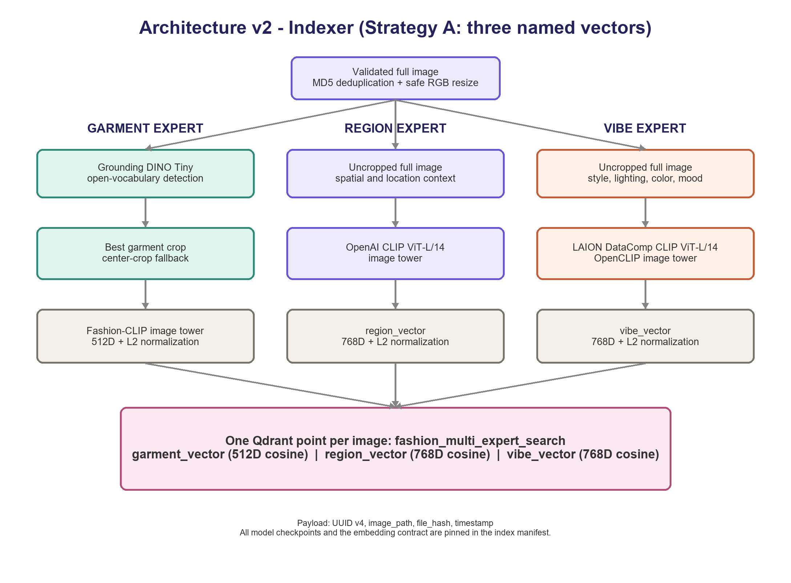
Figure 2. V2 indexer: one record with three independent named vectors.
- Garment expert: Grounding DINO Tiny selects the best garment crop; center crop is the fallback; Fashion-CLIP outputs a normalized 512D garment_vector.
- Region expert: the uncropped image passes through OpenAI CLIP ViT-L/14, producing a normalized 768D region_vector with a matching text tower.
- Vibe expert: the uncropped image passes through LAION DataComp OpenCLIP ViT-L/14, producing a normalized 768D vibe_vector for styling, palette, lighting, and mood.

4.2 Architecture v2 - Retriever and Score Fusion
OpenRouter returns a strict Pydantic QueryPlan with garment_query, region_query, vibe_query, alpha, beta, and gamma. Each query must be non-empty, every weight must be in [0, 1], and decimal validation requires alpha + beta + gamma to equal exactly 1.0.
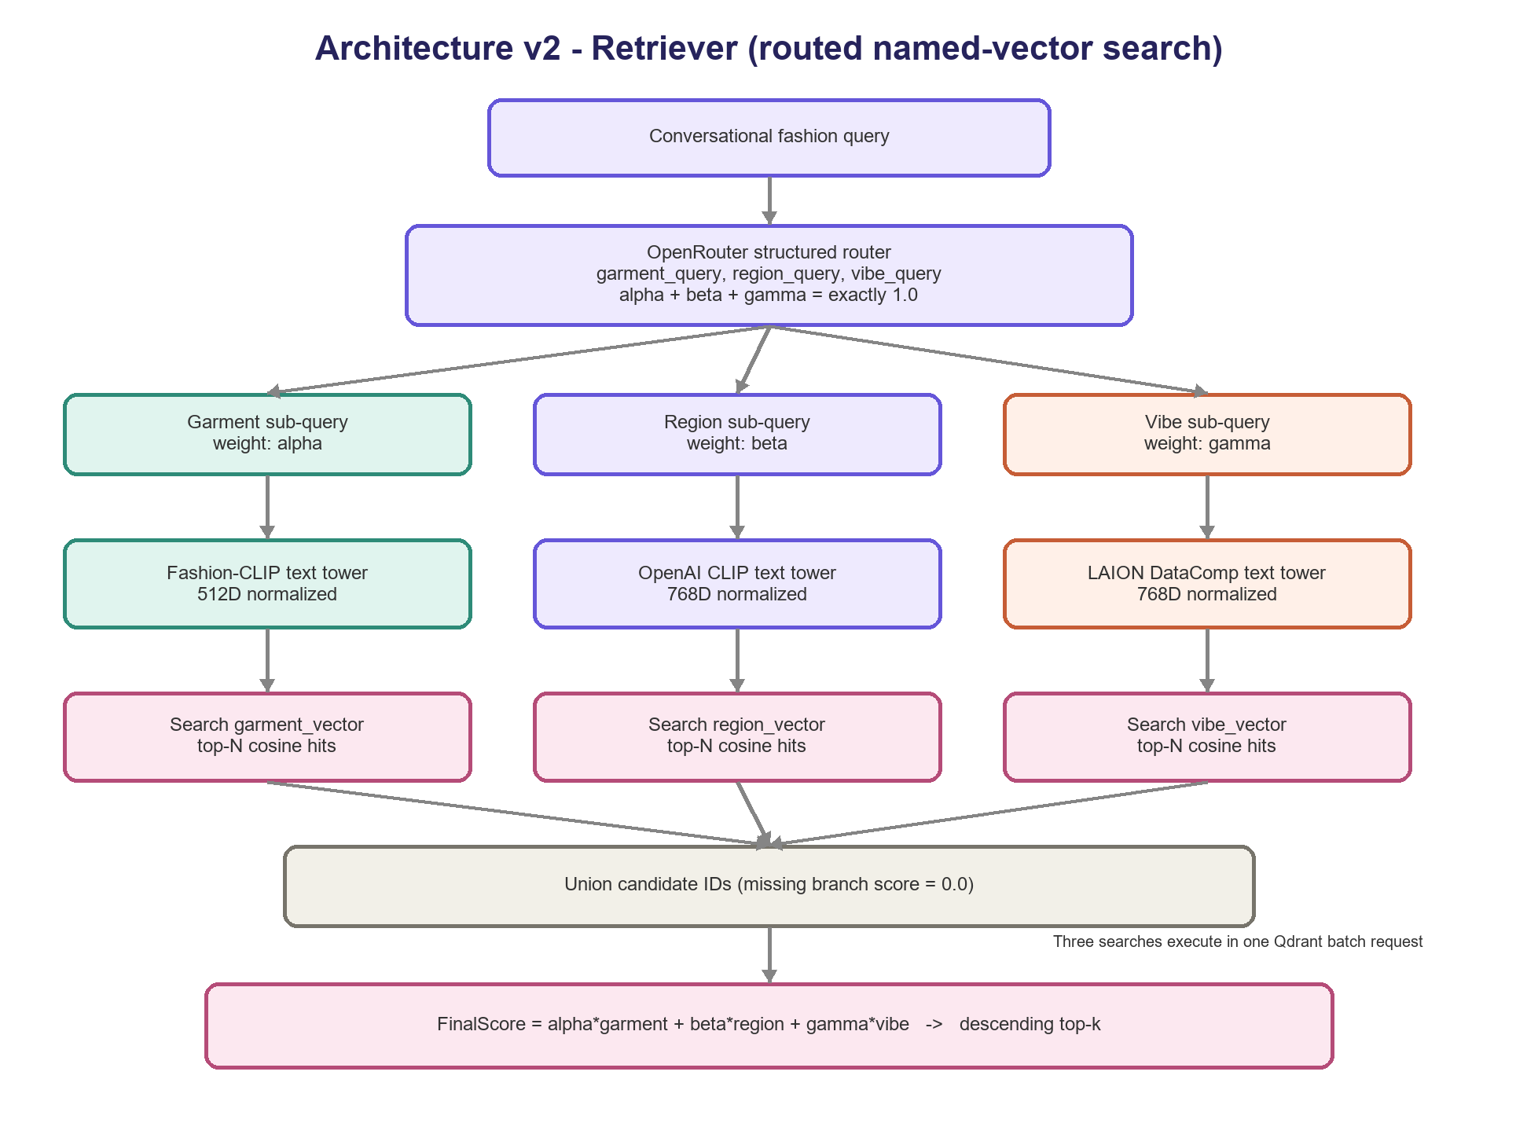
Figure 3. V2 query routing, three named-vector searches, and deterministic fusion.
Fashion-CLIP, OpenAI CLIP, and LAION DataComp text towers encode the routed sub-queries into normalized 512D, 768D, and 768D vectors. Qdrant executes all three top-N searches in one batch. Candidate IDs are unioned, a missing branch receives baseline 0.0, and results are sorted using the exact formula below.
FinalScore = alpha * garment_score + beta * region_score + gamma * vibe_score

4.3 Architecture v2 - Results, Shortcomings, and Future Work

Observed benchmark
The verified index contains 800 deterministic samples from 3,200 images, 800 unique hashes, and the exact 512/768/768 named-vector schema. For the unseen query "Vintage oversized leather jacket at a rainy train station," weights were 0.50/0.30/0.20; each branch returned 100 candidates; warm CPU latency was 4.97 seconds, including 4.25 seconds for LLM routing, 0.67 seconds for text encoding, 0.042 seconds for Qdrant, and 0.002 seconds for fusion. Outerwear and leather relevance was strong, but no top-ten image clearly showed a train station.

V2 shortcomings
- Single-crop garment branch: the highest-confidence box can miss secondary garments or fine compositional attributes.
- Weight calibration: valid weights can still overemphasize one expert; no minimum branch floor is currently enforced.
- LLM overhead: routing dominates warm latency and introduces cost plus limited run-to-run variation.
- Semantic overlap: region and vibe can both respond to backgrounds, so branch meanings require prompt discipline.
- Development deployment: embedded Qdrant and absolute image paths are not the final one-million-image production design.

V2 modularity, scalability, and zero-shot behavior
Modularity: indexer and retriever packages separate preprocessing, experts, storage, routing, encoding, and fusion. Scalability: Qdrant performs three ANN searches and application fusion touches at most 3N IDs, but one million float32 points require about 8.2 GB of raw vectors plus HNSW and payload overhead; server or cluster mode, sharding, on-disk vectors, and GPU-batched ingestion are required. Zero-shot: matched CLIP text-image towers and open-vocabulary detection accept novel combinations, with weaker behavior for rare fabrics, negation, counting, and precise spatial relations.

V2 future work
- Calibrate or bound dynamic weights and log every routed plan for branch-level error analysis.
- Support multiple garment boxes and hard-negative Fashion-CLIP fine-tuning.
- Add place-aware and weather named vectors while retaining one Qdrant point per image.
- Use a cross-encoder or VLM only for uncertain top-k reranking and evaluate with labeled IR metrics.

5. Repository and Reproducibility
GitHub repository: https://github.com/Himkeshtak/Final-pipeline-Glance-Fashion
The submitted code is divided into two packages that communicate through the validated Qdrant schema and model manifest. Runtime images, Qdrant data, model caches, and credentials remain outside application logic and source control.
Final-pipeline-Glance-Fashion/
fashion_indexer/ preprocessing, experts, database, pipeline, cli
fashion_retriever/ llm, encoders, database, fusion, pipeline, cli
index_fashion.py indexing entry point
retrieve_fashion.py retrieval entry point
benchmark_retrieval.py qualitative benchmark and gallery

Reproduction commands
- Index: python index_fashion.py --images-dir val_test2020/test --max-images 800 --shuffle-seed 2020
- Retrieve: python retrieve_fashion.py "Vintage oversized leather jacket at a rainy train station" --top-k 10
- Benchmark: python benchmark_retrieval.py "Vintage oversized leather jacket at a rainy train station" --candidate-limit 100 --top-k 10

6. Final selection
V1 remains documented as an independently defined historical architecture with its own retrieval logic, limitations, scalability profile, zero-shot behavior, and future work. V2 is the separately defined implemented submission because named-vector querying retains specialist evidence without V1's global-recall gate, supports query-dependent weighting, exposes branch scores for debugging, and has already completed an 800-image end-to-end benchmark. The next rigorous milestone is human-labeled evaluation of the five assignment prompts with compositional hard negatives and standard ranking metrics.

