Orbital Mechanics Coursework 2024-25
Davide Amato
CID: 01234567

Part 1
Problem 1.i
Starting from the calculation of the magnitude $b$,

$$b=\sqrt{b_{x}^{2}+b_{y}^{2}+b_{z}^{2}}=0.8912.$$

Part 2
Problem 2.i
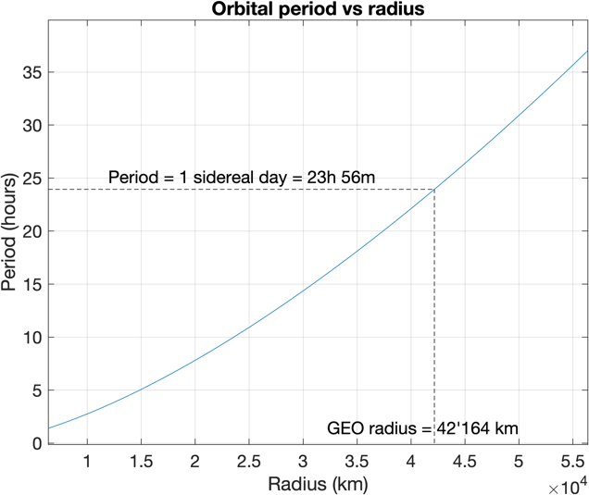
Figure 1: Orbital period as a function of the semi-major axis.
The plot in Figure 1 shows the orbital period as a function of the semi-major axis.

Problem 2.ii
By using the relations detailed above, the answer is $a=2.893 km/s$.

