VOXA
HARDWARE COMPONENT GUIDE

Core Components

1. ESP32-S3 (Recommended)
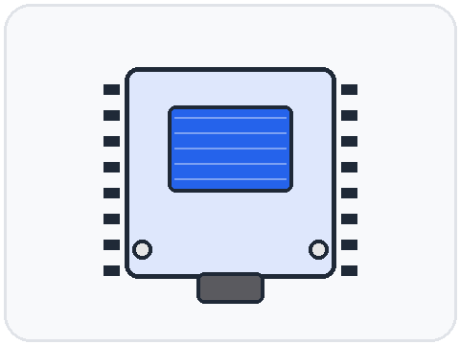
AVOID basic ESP32 DevKit.
RECOMMENDED ESP32-S3 DevKit
Why?
- Better AI support
- More RAM
- Better USB support
- Better audio processing
- Future-proof
🔗 Espressif ESP32-S3-DevKitC-1 — Robu.in → View photos & current price

2. Microphone
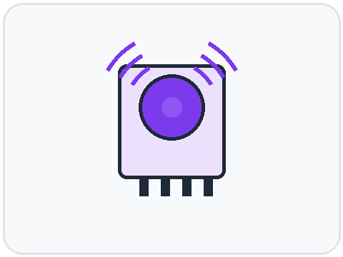
DON'T USE Cheap analog microphones.
USE INMP441
Advantages:
- Digital audio
- Noise resistant
- Works directly with ESP32-S3
- Excellent for Whisper
🔗 INMP441 I2S MEMS Microphone — Robu.in → View photos & current price

3. Display
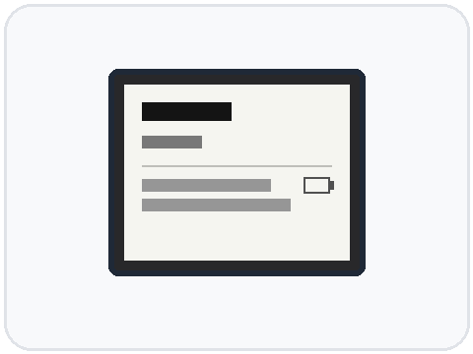
BEST OPTION Waveshare 2.13 Inch E-Ink Display
Why:
- Very low power
- Excellent readability
- Matches the inspiration project
Display:
VOXA

Ready

Battery: 87%
WiFi: Connected
🔗 Waveshare 2.13" E-Ink Display — Robu.in → View photos & current price

4. Storage
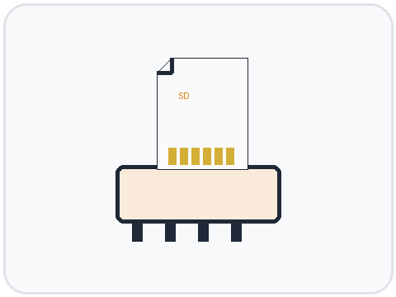
USE MicroSD Card Module
With:
8GB
16GB
32GB
More than enough.
Even if cloud upload fails:
Audio remains safe locally
🔗 MicroSD Card Module (SPI) — Robu.in → View photos & current price

Battery
This is where safety matters.
DO NOT Buy random Li-ion cells from unknown sellers.
Avoid:
18650 no-brand cells
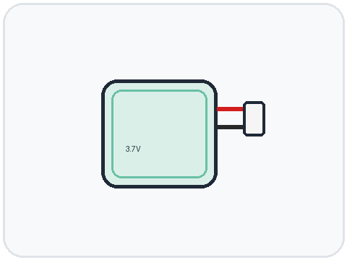
RECOMMENDED LiPo Battery
3.7V
2000mAh
or
3.7V
3000mAh
Good balance:
- Small size
- Safe
- Rechargeable
🔗 3.7V 2000mAh LiPo Battery — Robu.in → View photos & current price

Charging Circuit
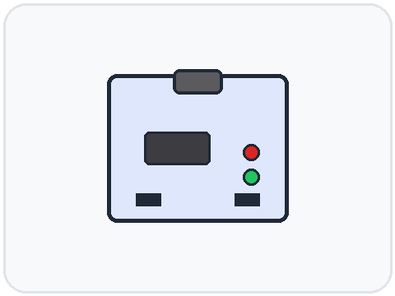
RECOMMENDED TP4056 USB-C Charging Module
Features:
- Overcharge protection
- Short-circuit protection
- Easy charging
🔗 TP4056 USB-C Charging Module — Robu.in → View photos & current price

Voltage Regulation
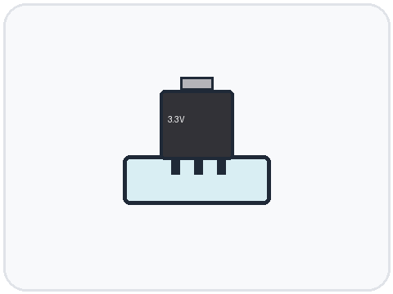
ESP32 needs stable power.
RECOMMENDED Use a 3.3V regulator
3.3V regulator
Such as: AMS1117-3.3
or better: MPM3610
🔗 AMS1117-3.3V Regulator Module — Robu.in → View photos & current price
🔗 MPM3610 3.3V Buck Converter — Robu.in → View photos & current price

Buttons
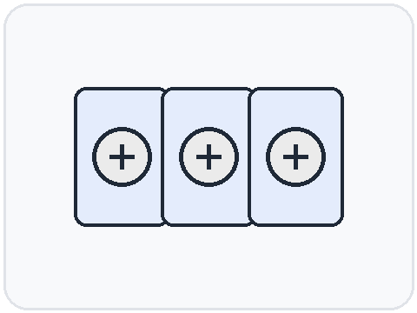
At minimum:
Record Button
Hold → Record
Release → Save
Menu Button
Change category
Select Button
Confirm option
🔗 6×6mm Tactile Push Buttons (pack) — Robu.in → View photos & current price

Future Hardware Additions
Not needed now. But later:
Vibration Motor
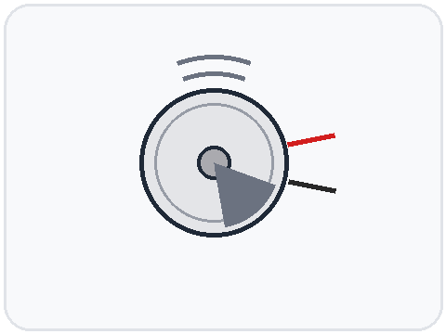
Reminder notifications
🔗 Coin Vibration Motor — Robu.in → View photos & current price
RGB Status LED
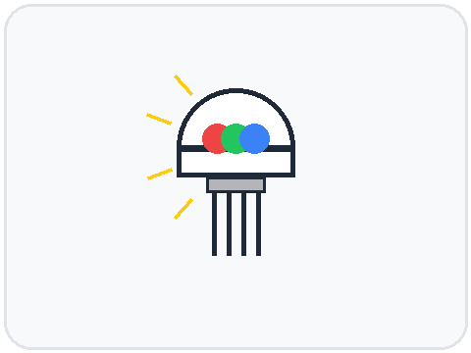
Green = Ready
Blue = Uploading
Red = Error
🔗 RGB LED (Common Cathode) — Robocraze → View photos & current price
Speaker
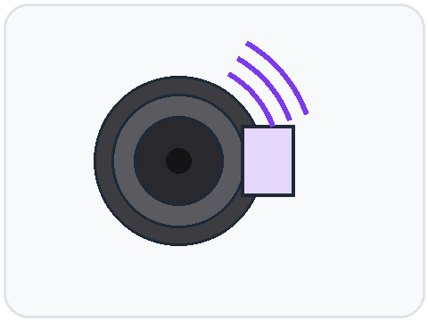
Voice feedback
🔗 0.5W 8Ω Mini Speaker — Robu.in → View photos & current price

Recommended Build Versions

V1 — Learning Prototype
Easy and cheap.
ESP32-S3
INMP441
MicroSD Module
2.13" E-Ink
TP4056
2000mAh LiPo
3 Buttons
Cost roughly:
₹2500 - ₹4500

V2 — Premium Prototype
Custom PCB
USB-C
Battery Gauge
Better E-Ink
3D Printed Case
Power Management
Cost:
₹5000 - ₹8000

What I'd Buy First
If I were building Voxa this month:
Order List
- ESP32-S3 DevKit — buy / view photo
- INMP441 Microphone — buy / view photo
- 2.13" Waveshare E-Ink Display — buy / view photo
- MicroSD Module — buy / view photo
- 16GB MicroSD Card
- 2000mAh LiPo Battery — buy / view photo
- TP4056 USB-C Charger Module — buy / view photo
- Breadboard + Jumper Wires
- Push Buttons — buy / view photo
- USB-C Cable
That's enough to build a fully functional Voxa prototype that can:
- Record audio
- Save locally
- Connect to Wi-Fi
- Upload to Google Cloud
- Trigger your backend pipeline
- Display status on E-Ink
…without designing a custom PCB yet.

