Activity | Data Type
Number of beatings from Wife | Discrete
Results of rolling a dice | Discrete
Weight of a person | Continuous
Weight of Gold | Continuous
Distance between two places | Continuous
Length of a leaf | Continuous
Dog's weight | Continuous
Blue Color | Categorical/Nominal
Number of kids | Discrete
Number of tickets in Indian railways | Discrete
Number of times married | Discrete
Gender (Male or Female) | Categorical/Nominal
Q1) Identify the Data type for the Following:

Q2) Identify the Data types, which were among the following
Nominal, Ordinal, Interval, Ratio.
Data | Data Type
Gender | Nominal
High School Class Ranking | Ordinal
Celsius Temperature | Ratio
Weight | Ratio
Hair Color | Nominal
Socioeconomic Status | Ordinal
Fahrenheit Temperature | Ratio
Height | Ratio
Type of living accommodation | Ordinal
Level of Agreement | Ordinal
IQ(Intelligence Scale) | Interval
Sales Figures | Ratio
Blood Group | Nominal
Time Of Day | Ordinal
Time on a Clock with Hands | Ratio
Number of Children | Ratio
Religious Preference | Nominal
Barometer Pressure | Nominal
SAT Scores | Ordinal
Years of Education | Ratio

Q3) Three Coins are tossed, find the probability that two heads and one tail are obtained?
ANS: Total Possible Events : 8 , No of desired events: 3
P = 3/8

Q4) Two Dice are rolled, find the probability that sum is
- Equal to 1
- Less than or equal to 4
- Sum is divisible by 2 and 3
ANS: a) 0
b) 1/6 = 0.167
C) 5/36 = 0.139

Q5) A bag contains 2 red, 3 green and 2 blue balls. Two balls are drawn at random. What is the probability that none of the balls drawn is blue?

ANS: 10/21 = 0.476

Q6) Calculate the Expected number of candies for a randomly selected child
Below are the probabilities of count of candies for children (ignoring the nature of the child-Generalized view)
CHILD | Candies count | Probability
A | 1 | 0.015
B | 4 | 0.20
C | 3 | 0.65
D | 5 | 0.005
E | 6 | 0.01
F | 2 | 0.120
Child A – probability of having 1 candy = 0.015.
Child B – probability of having 4 candies = 0.20
ANS: 3.09

Q7) Calculate Mean, Median, Mode, Variance, Standard Deviation, Range & comment about the values / draw inferences, for the given dataset
- For Points,Score,Weigh>
Find Mean, Median, Mode, Variance, Standard Deviation, and Range and also Comment about the values/ Draw some inferences.
Use Q7.csv file
ANS:
 | MEAN | MEDIAN | MODE | Variance | Std. Dev | Range
Points | 3.59 | 3.70 | 3.92 | 0.29 | 0.53 | 2.17
Score | 3.22 | 3.33 | 3.44 | 0.96 | 0.98 | 3.91
Weigh | 17.85 | 17.71 | 17.02 | 3.19 | 1.79 | 8.40

- No case has the variable Mean = Median = Mode
- Thus as seen in the graph dataset “score” and “Weigh” has outliers

Q8) Calculate Expected Value for the problem below
- The weights (X) of patients at a clinic (in pounds), are
108, 110, 123, 134, 135, 145, 167, 187, 199
Assume one of the patients is chosen at random. What is the Expected Value of the Weight of that patient?
ANS : 145.33

Q9) Calculate Skewness, Kurtosis & draw inferences on the following data
Cars speed and distance
Use Q9_a.csv
ANS:
 | Skewness | Kurtosis
speed | -0.11 | 2.42
dist | 0.76 | 3.25

- “dist” is positively skewed where as “speed” is negatively skewed
  - Thus dist has distribution of data concentrated on the left whereas speed has distribution on the right. As seen in the graph
- Both dist and speed has positive Kurtosis

Use Q9_b.csv
ANS:
 | Skewness | Kurtosis
SP | 1.55 | 5.72
WT | -0.59 | 3.82
- “SP” is positively skewed where as “WT” is negatively skewed
  - Thus SP has distribution of data concentrated on the left whereas WT has distribution on the right. As seen in the graph
- Both WT and SP has positive Kurtosis

Q10) Draw inferences about the following boxplot & histogram
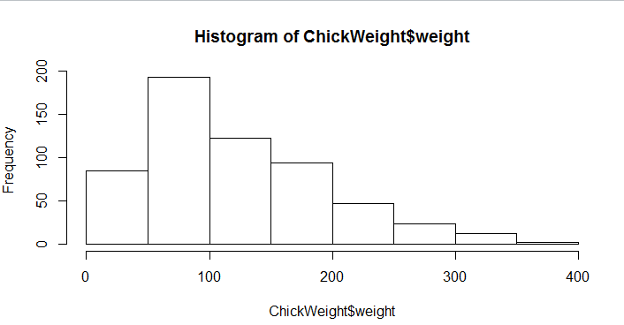
ANS :
- Majority of the Chicks has weight in range 50 – 100, followed by 100 -150 and 150 – 200
- The data is positively Skewed
- 3 Categories can be define (Under weight >50; Avg weight 51 – 150; Over weight <150)

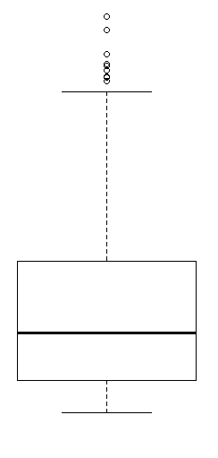

ANS:
- Data has outliers
- Data is positively skewed

Q11) Suppose we want to estimate the average weight of an adult male in Mexico. We draw a random sample of 2,000 men from a population of 3,000,000 men and weigh them. We find that the average person in our sample weighs 200 pounds, and the standard deviation of the sample is 30 pounds. Calculate 94%,98%,96% confidence interval?
ANS:
 | 94% | 98% | 96%
Upper | 201.04 | 201.38 | 201.17
Lower | 198.96 | 198.62 | 198.83

Q12) Below are the scores obtained by a student in tests
34,36,36,38,38,39,39,40,40,41,41,41,41,42,42,45,49,56
- Find mean, median, variance, standard deviation.
ANS:
Mean | 41
Median | 40.50
Variance | 25.53
Std Deviation | 5.05

- What can we say about the student marks?
ANS:
- Not normally distributed
- Data has outlier
- Majority of the students scored between 35 – 45 Marks

Q13) What is the nature of skewness when mean, median of data are equal?
ANS: Skewness = 0. Perfectly symmetric bell shaped curve

Q14) What is the nature of skewness when mean > median ?
ANS: Skewness = Positive. Data is distributed more on left

Q15) What is the nature of skewness when median > mean?
ANS: Skewness = Negative. Data is distributed more on right

Q16) What does positive kurtosis value indicates for a data ?
ANS: High and narrow peak on central part of the data

Q17) What does negative kurtosis value indicates for a data?
ANS: wider peak on central part of the data

Q18) Answer the below questions using the below boxplot visualization.
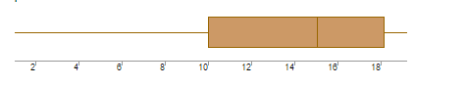
What can we say about the distribution of the data?
ANS : The data is not symmetric. Data is more concentrated towards right side

What is nature of skewness of the data?
ANS : Skewness = Negative
What will be the IQR of the data (approximately)?
ANS: IQR data is 8 (18-10 = 8)

Q19) Comment on the below Boxplot visualizations?
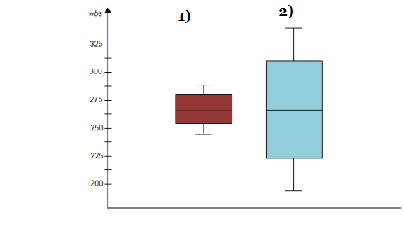
Draw an Inference from the distribution of data for Boxplot 1 with respect Boxplot 2.
ANS:
- Data is Normally Distributed. No Outliers. Center around 262.5. Comparatively, first graph has less range
- Data is Normally Distributed. No Outliers. Center around 262.5
Comparatively, second graph has more range

Q 20) Calculate probability from the given dataset for the below cases

Data _set: Cars.csv
Calculate the probability of MPG of Cars for the below cases.
MPG <- Cars$MPG
  - P(MPG>38)
ANS: 0.4074074
  - P(MPG<40)
ANS: 0.7530864

  - P (20<MPG<50)
ANS: 0.8518519

Q 21) Check whether the data follows normal distribution
- Check whether the MPG of Cars follows Normal Distribution
Dataset: Cars.csv
ANS: MPG is Normal Distribution

- Check Whether the Adipose Tissue (AT) and Waist Circumference(Waist) from wc-at data set follows Normal Distribution
Dataset: wc-at.csv
ANS: Both AT and Waist doesn’t follow Normal Distribution

Q 22) Calculate the Z scores of 90% confidence interval,94% confidence interval, 60% confidence interval
ANS:
90% | ± 1.711
94% | ± 1.828
60% | ± 2.492

Q 23) Calculate the t scores of 95% confidence interval, 96% confidence interval, 99% confidence interval for sample size of 25
ANS:
95% | ± 2.060
96% | ± 2.167
99% | ± 2.787

Q 24) A Government company claims that an average light bulb lasts 270 days. A researcher randomly selects 18 bulbs for testing. The sampled bulbs last an average of 260 days, with a standard deviation of 90 days. If the CEO's claim were true, what is the probability that 18 randomly selected bulbs would have an average life of no more than 260 days
Hint:
rcode pt(tscore,df)
df degrees of freedom
ANS:
t-score = -0.4714,
Degree of freedom = 17
P(t) = 0.3216725

