NGUYỄN THỊ THANH HIỀN – 22001895 – DHKTPM18C

Node.js – Chapter 2 Lab Handbook

Lab 1: Node.js Fundamentals (3 hours)
Objectives:
- Understand Node.js runtime
- Create and use modules
Tasks:
1. Install Node.js
2. Create a simple Node.js program
3. Create a custom module and import it
Below is a step-by-step Lab Handbook students can follow directly.

Node.js – Chapter 2 Lab Handbook

Lab 1: Node.js Fundamentals (3 hours)

Lab Overview
In this lab, you will:
- Install Node.js and verify it works
- Run a simple Node.js program
- Create your own custom module and import it into another file

Learning Objectives
By the end of this lab, you can:
- Explain what Node.js is (runtime for running JavaScript outside the browser)
- Use the terminal to run Node programs
- Create and use modules with module.exports and require()

Part 0 — What You Need (Before Start)
✅ A computer with Internet
✅ A code editor (VS Code recommended)
✅ Terminal access:
- Windows: Command Prompt / PowerShell
- macOS: Terminal
- Linux: Terminal

Task 1 — Install Node.js (Approx. 30–40 minutes)

Step 1: Download Node.js
- Open the Node.js official website.
- Download LTS version (recommended for stability).
- Run the installer and follow default settings.
Tip: LTS is best for class + lab environments.

Step 2: Verify installation
Open Terminal (or PowerShell) and run:
node -v
You should see something like:
v20.x.x
Then check npm:
npm -v
You should see something like:
10.x.x
✅ If both commands show version numbers → installation is successful.

Common errors and fixes

Error: node is not recognized... (Windows)
- Restart Terminal
- Restart your PC
- Reinstall Node.js and ensure “Add to PATH” is enabled

macOS permission issue
Use the official installer. Avoid random third-party packages.

Task 2 — Create a Simple Node.js Program (Approx. 50–60 minutes)

Step 1: Create a lab folder
Choose a location (Desktop is fine). In terminal:
mkdir node-lab1
cd node-lab1

Step 2: Open folder in VS Code
If you have code command:
code .
(If not, open VS Code → File → Open Folder → select node-lab1)

Step 3: Create your first Node file
Create a file named:
📄 app.js
Add this code:
console.log("Hello Node.js!");

Step 4: Run the program
In terminal (inside node-lab1 folder):
node app.js
Expected output:
Hello Node.js!
✅ You have successfully executed JavaScript using Node.js.

Task 3 — Create a Custom Module and Import It (Approx. 70–80 minutes)

Step 1: Create a module file
Create a new file:
📄 mathUtils.js
Add this code:
function add(a, b) {
return a + b;
}

function subtract(a, b) {
return a - b;
}

module.exports = {
add,
subtract
};

What this means
- You created 2 functions: add, subtract
- You exported them so other files can use them via module.exports

Step 2: Import module into app.js
Update your app.js:
const mathUtils = require("./mathUtils");

console.log("Add:", mathUtils.add(5, 3));
console.log("Subtract:", mathUtils.subtract(10, 4));

Step 3: Run again
node app.js
Expected output:
Add: 8
Subtract: 6
✅ You created and used a custom Node.js module.

Extra Practice (If you finish early)

Practice A: Add one more function in module
Add this function to mathUtils.js:
function multiply(a, b) {
return a * b;
}
Export it and use it in app.js.

Practice B: Create a “greeting” module
Create:
- greeting.js exporting a function sayHello(name)
- import into app.js and print hello message

Submission Checklist (Student Evidence)
Students should submit:
- Screenshot of terminal showing:
  - node -v
  - npm –v
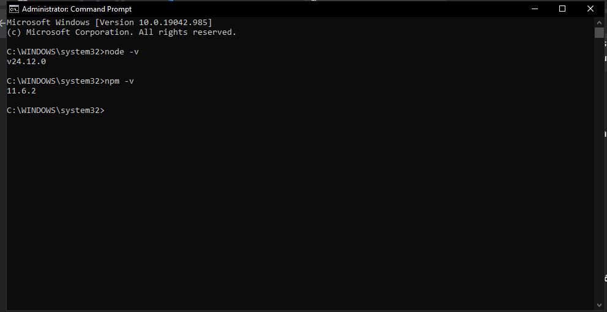
- Project folder includes:
  - app.js
  - mathUtils.js
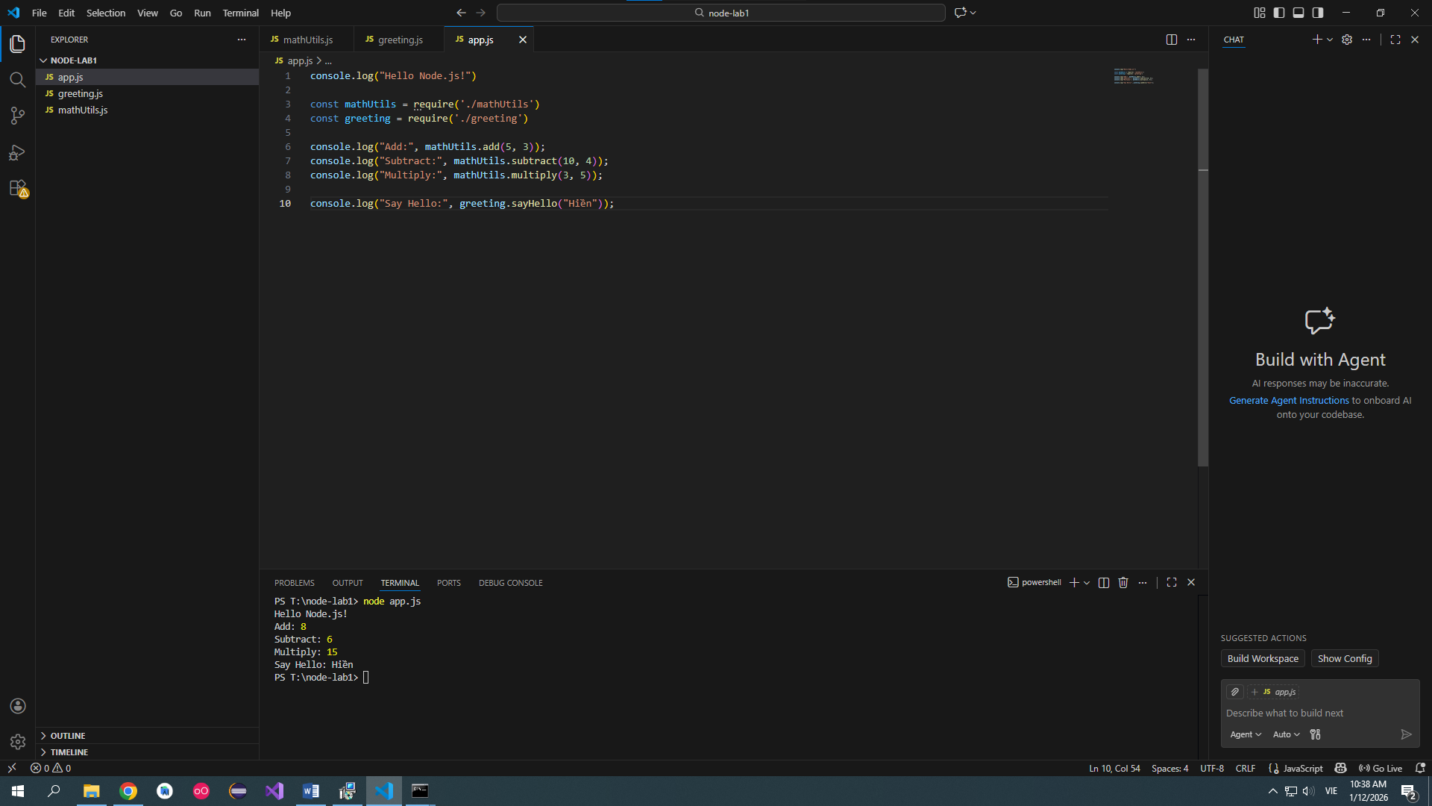
- Terminal output of running the final program
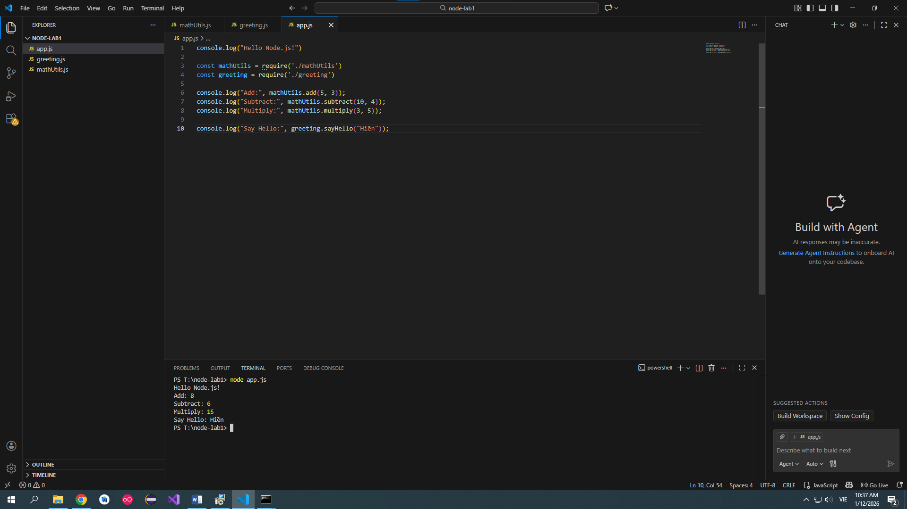

Quick Rubric (10 points)
- (2) Node.js installed + version verified
- (3) Simple Node program runs correctly
- (5) Custom module created, exported, imported, and used successfully

Lab 2: File System & NPM (3 hours)
Objectives:
- Use fs module
- Manage dependencies with npm
Tasks:
1. Read and write files asynchronously
2. Initialize npm project
3. Install and use third-party package
Below is a complete, step-by-step Lab Handbook you can give directly to students.
It is written in a procedural + learning-by-doing style, suitable for a 3-hour lab, with extra exercises at the end for stronger students.

Chapter 2 – Lab 2: File System & NPM (3 hours)

Lab Title
Lab 2: Working with File System & NPM in Node.js

Lab Objectives
After completing this lab, students will be able to:
- Use the Node.js File System (fs) module
- Read and write files asynchronously
- Initialize and manage a Node.js project using npm
- Install and use third-party npm packages
- Understand the role of package.json and node_modules

Prerequisites
Students should already be able to:
- Install Node.js
- Run JavaScript files using node
- Create simple Node.js programs (Lab 1)

Software & Tools
- Node.js (LTS version)
- VS Code (or any code editor)
- Terminal / Command Prompt

Time Allocation (3 hours)
Time | Activity
30 min | Review: Node.js modules & async concept
60 min | File System (fs) – read & write files
45 min | npm fundamentals & project initialization
30 min | Using third-party npm packages
15 min | Extra exercises & discussion

Task 1: Read and Write Files Asynchronously (60 minutes)

1.1 Create Project Folder
mkdir lab2-fs-npm
cd lab2-fs-npm
Create files:
touch app.js input.txt
Add content to input.txt:
Hello Node.js!
This is Lab 2.

1.2 Import File System Module
Open app.js:
const fs = require('fs');
📌 Explanation
- fs is a built-in Node.js module
- No installation is needed

1.3 Read File Asynchronously
fs.readFile('input.txt', 'utf8', (err, data) => {
if (err) {
console.error('Error reading file:', err);
return;
}
console.log('File content:');
console.log(data);
});
Run:
node app.js
✅ Expected Output
File content:
Hello Node.js!
This is Lab 2.
📌 Key Concepts
- readFile() is non-blocking
- Callback runs after file reading completes
- 'utf8' converts Buffer → String

1.4 Write File Asynchronously
Add below code to app.js:
fs.writeFile('output.txt', 'File written using Node.js fs module!', (err) => {
if (err) {
console.error('Error writing file:', err);
return;
}
console.log('File written successfully!');
});
Run again:
node app.js
Check the newly created output.txt.

1.5 Append Data to File
fs.appendFile('output.txt', '\nAppending new content...', (err) => {
if (err) {
console.error(err);
return;
}
console.log('Data appended!');
});
📌 Difference
Method | Action
writeFile | Overwrites file
appendFile | Adds content to end
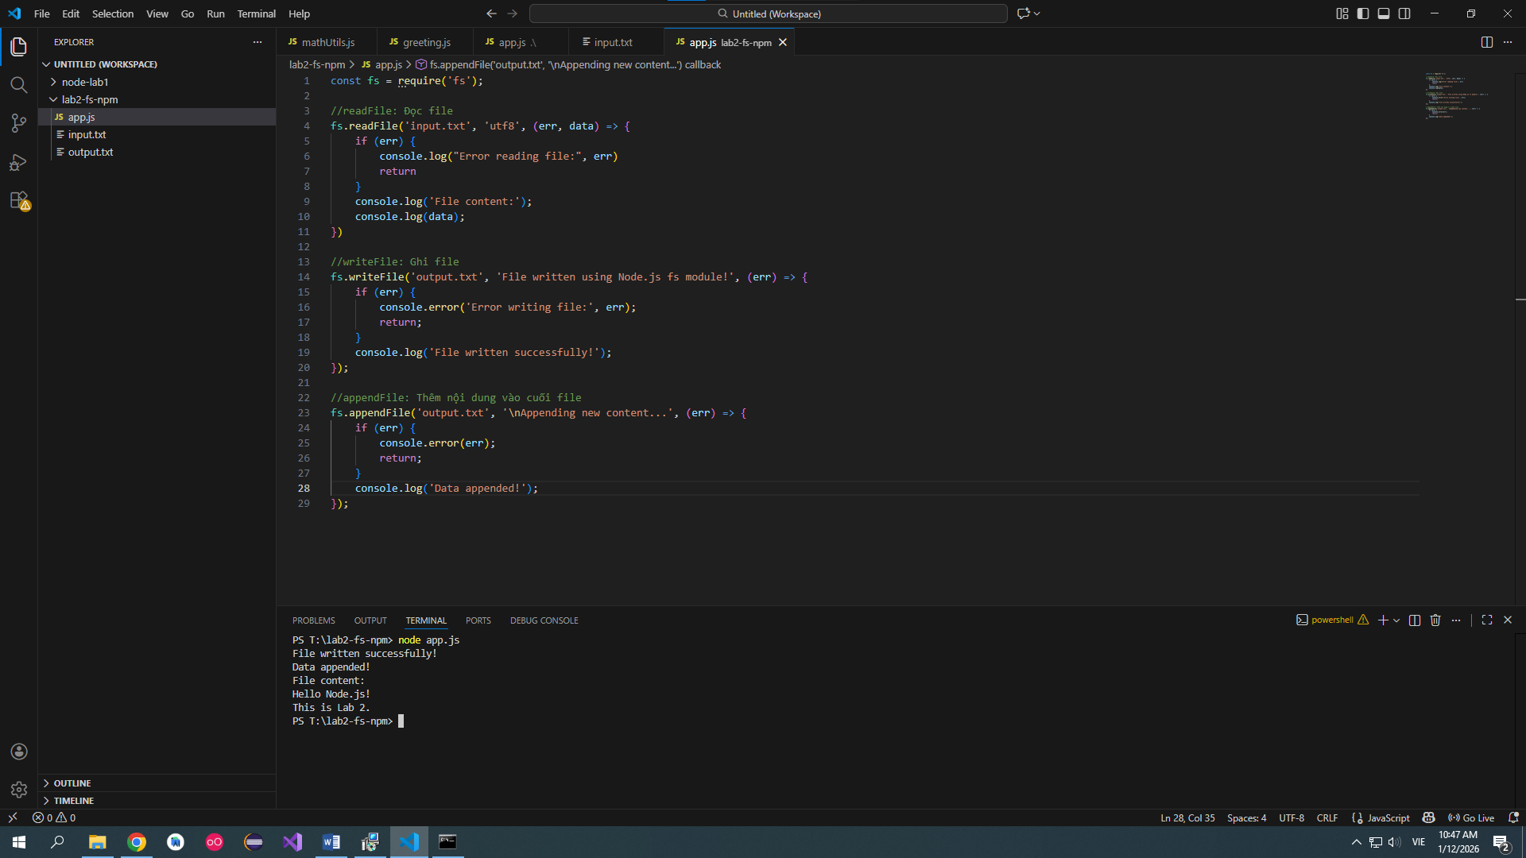

Task 2: Initialize npm Project (45 minutes)

2.1 What is npm?
- npm = Node Package Manager
- Manages:
  - Libraries
  - Project metadata
  - Dependencies

2.2 Initialize npm
Inside lab2-fs-npm:
npm init
Follow prompts or press Enter to accept defaults.
Or use quick mode:
npm init -y

2.3 Understand package.json
Open package.json:
{
"name": "lab2-fs-npm",
"version": "1.0.0",
"main": "app.js",
"scripts": {
"start": "node app.js"
}
}
📌 Important Fields
Field | Meaning
name | Project name
version | Project version
main | Entry file
scripts | Custom commands
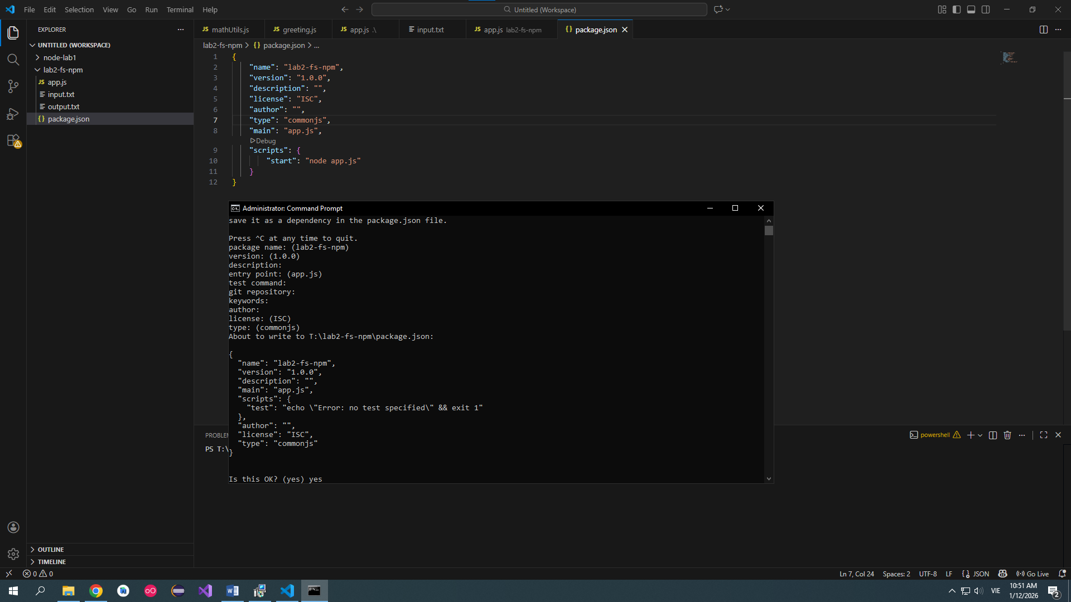

2.4 Run Project Using npm
npm start
Equivalent to:
node app.js

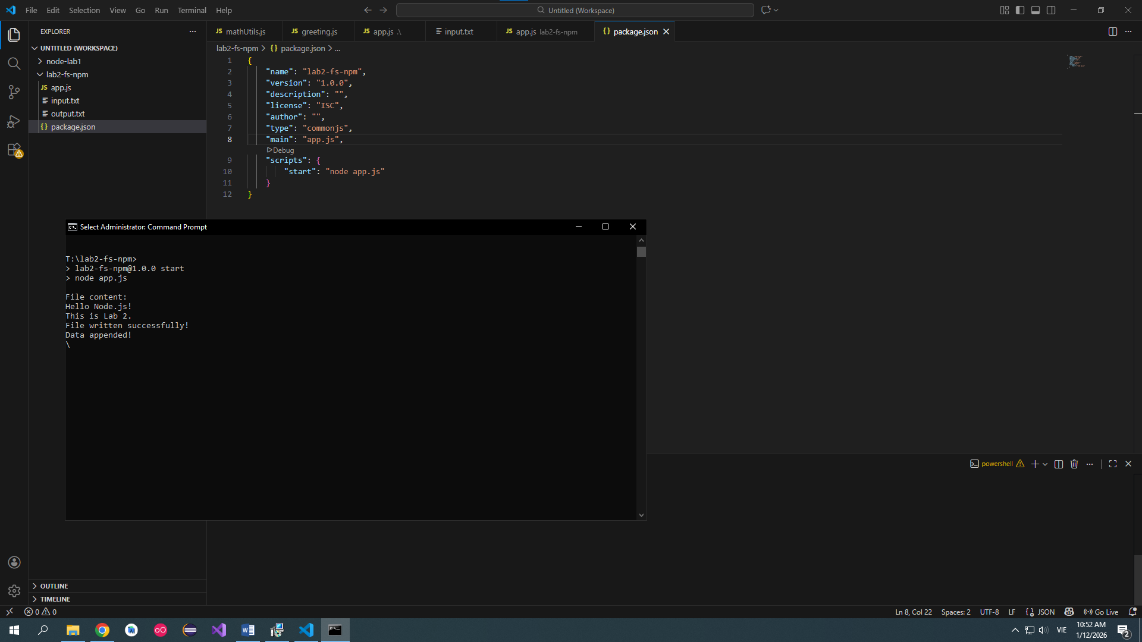

Task 3: Install and Use Third-Party Package (45 minutes)

3.1 Install Package: lodash
npm install lodash
📁 New folders:
- node_modules/
- package-lock.json
📌 Do NOT manually edit node_modules
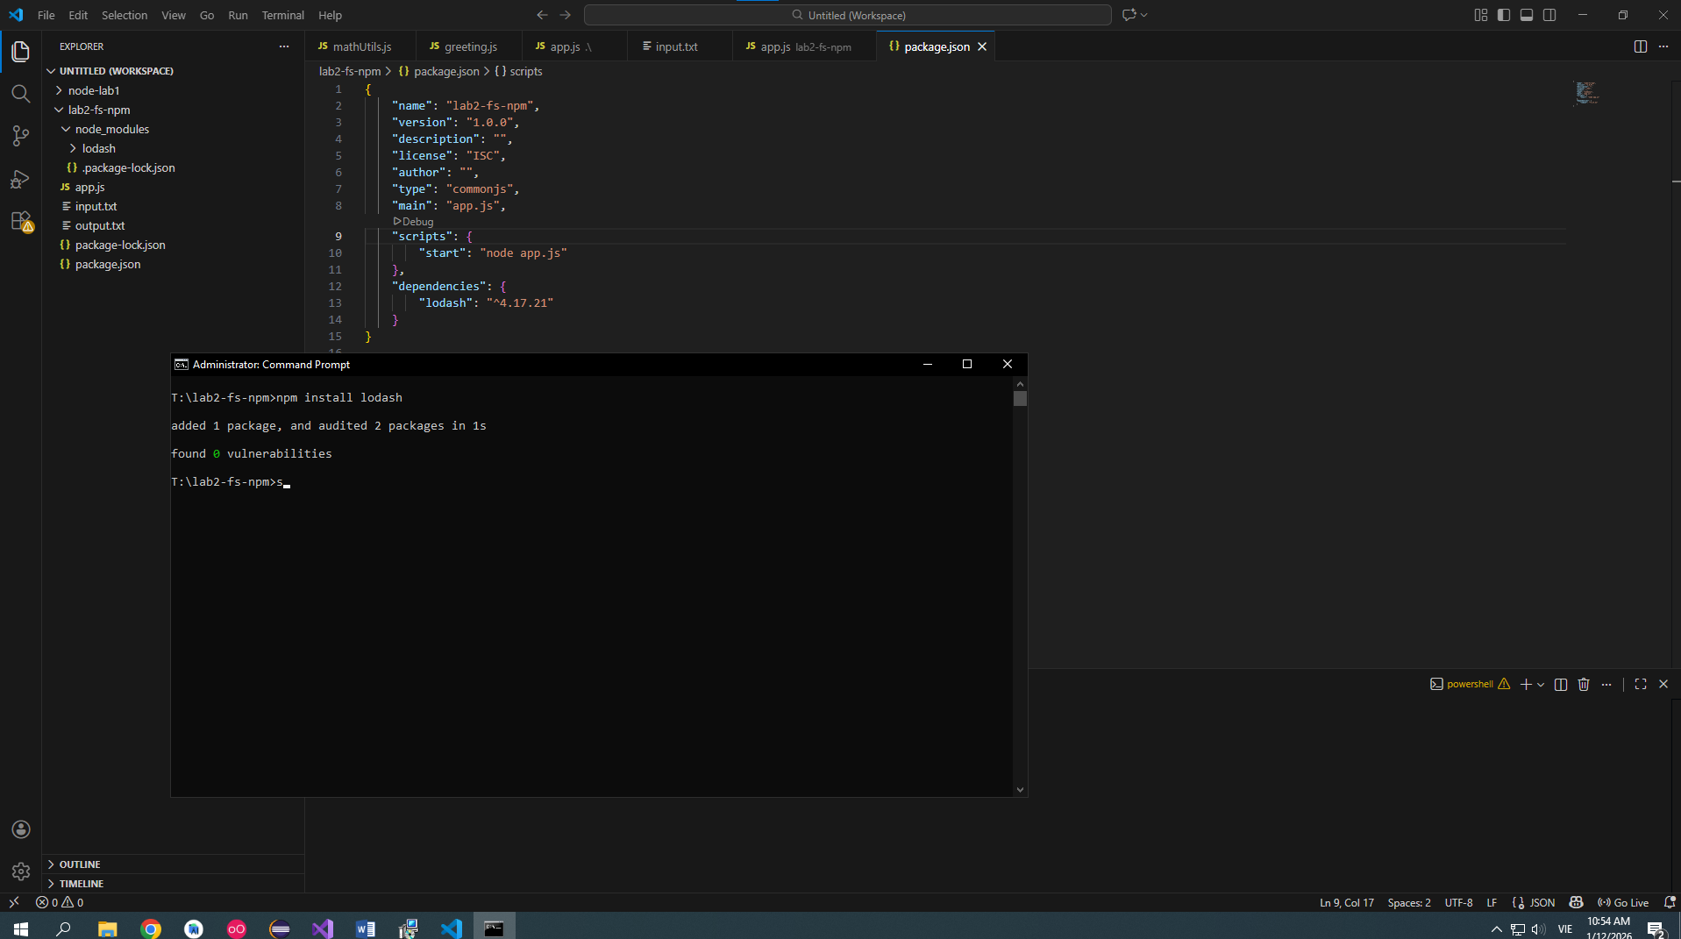

3.2 Use lodash in Code
Update app.js:
const _ = require('lodash');

const numbers = [1, 2, 3, 4, 5];
const shuffled = _.shuffle(numbers);

console.log('Original:', numbers);
console.log('Shuffled:', shuffled);
Run:
node app.js
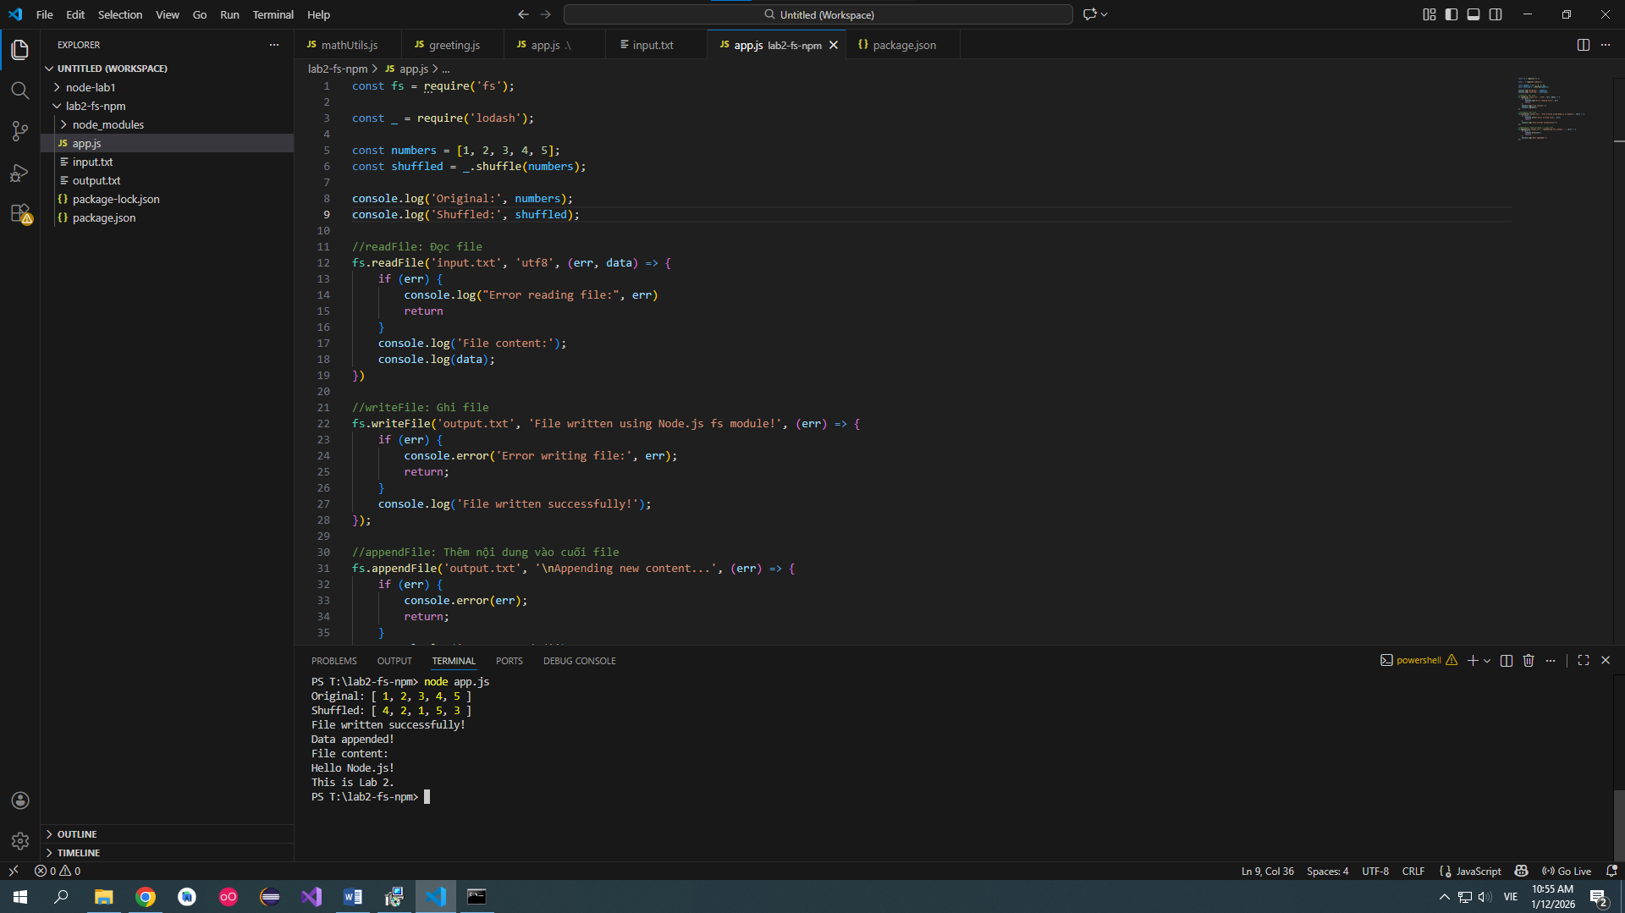

3.3 Check Dependencies
package.json now contains:
"dependencies": {
"lodash": "^4.17.21"
}
📌 Meaning
- npm tracks installed libraries automatically
- Allows easy re-installation using:
npm install
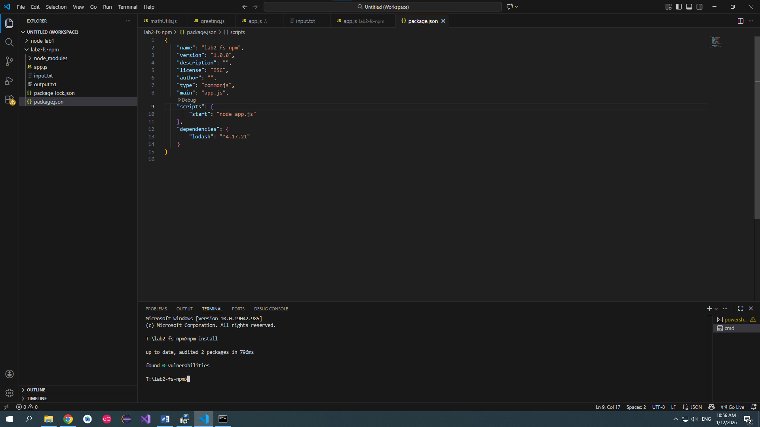

Extra Exercises (30 minutes)

Exercise 1 (Basic)
Create a program that:
- Reads student.txt
- Writes content to backup.txt
- Displays success message
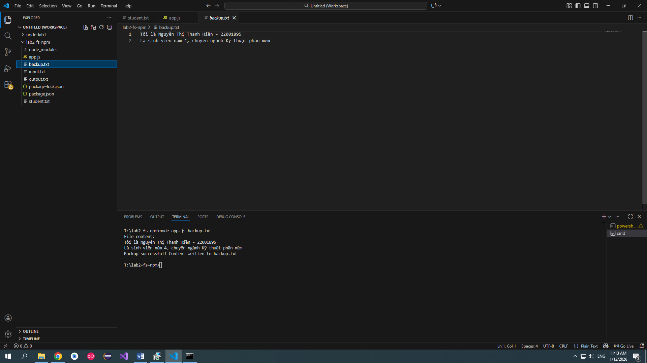

Exercise 2 (Intermediate)
Create a script:
- Reads a file name from command line
node app.js data.txt
- Displays its content
💡 Hint:
process.argv

Exercise 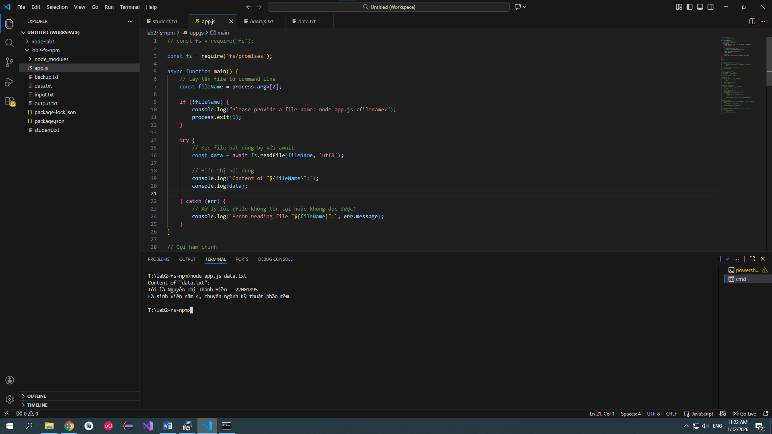 Exercise 3 (Intermediate)
Install chalk package and:
- Print success messages in green
- Print error messages in red
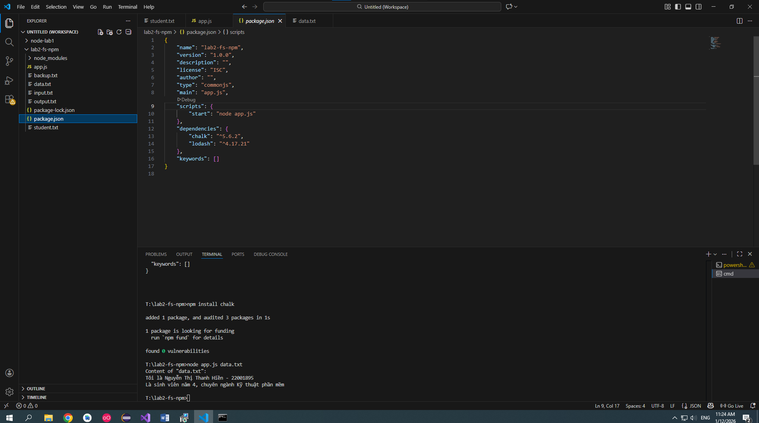

Exercise 4 (Advanced)
Create a mini tool:
- Reads log.txt
- Counts number of lines
- Writes result to report.txt
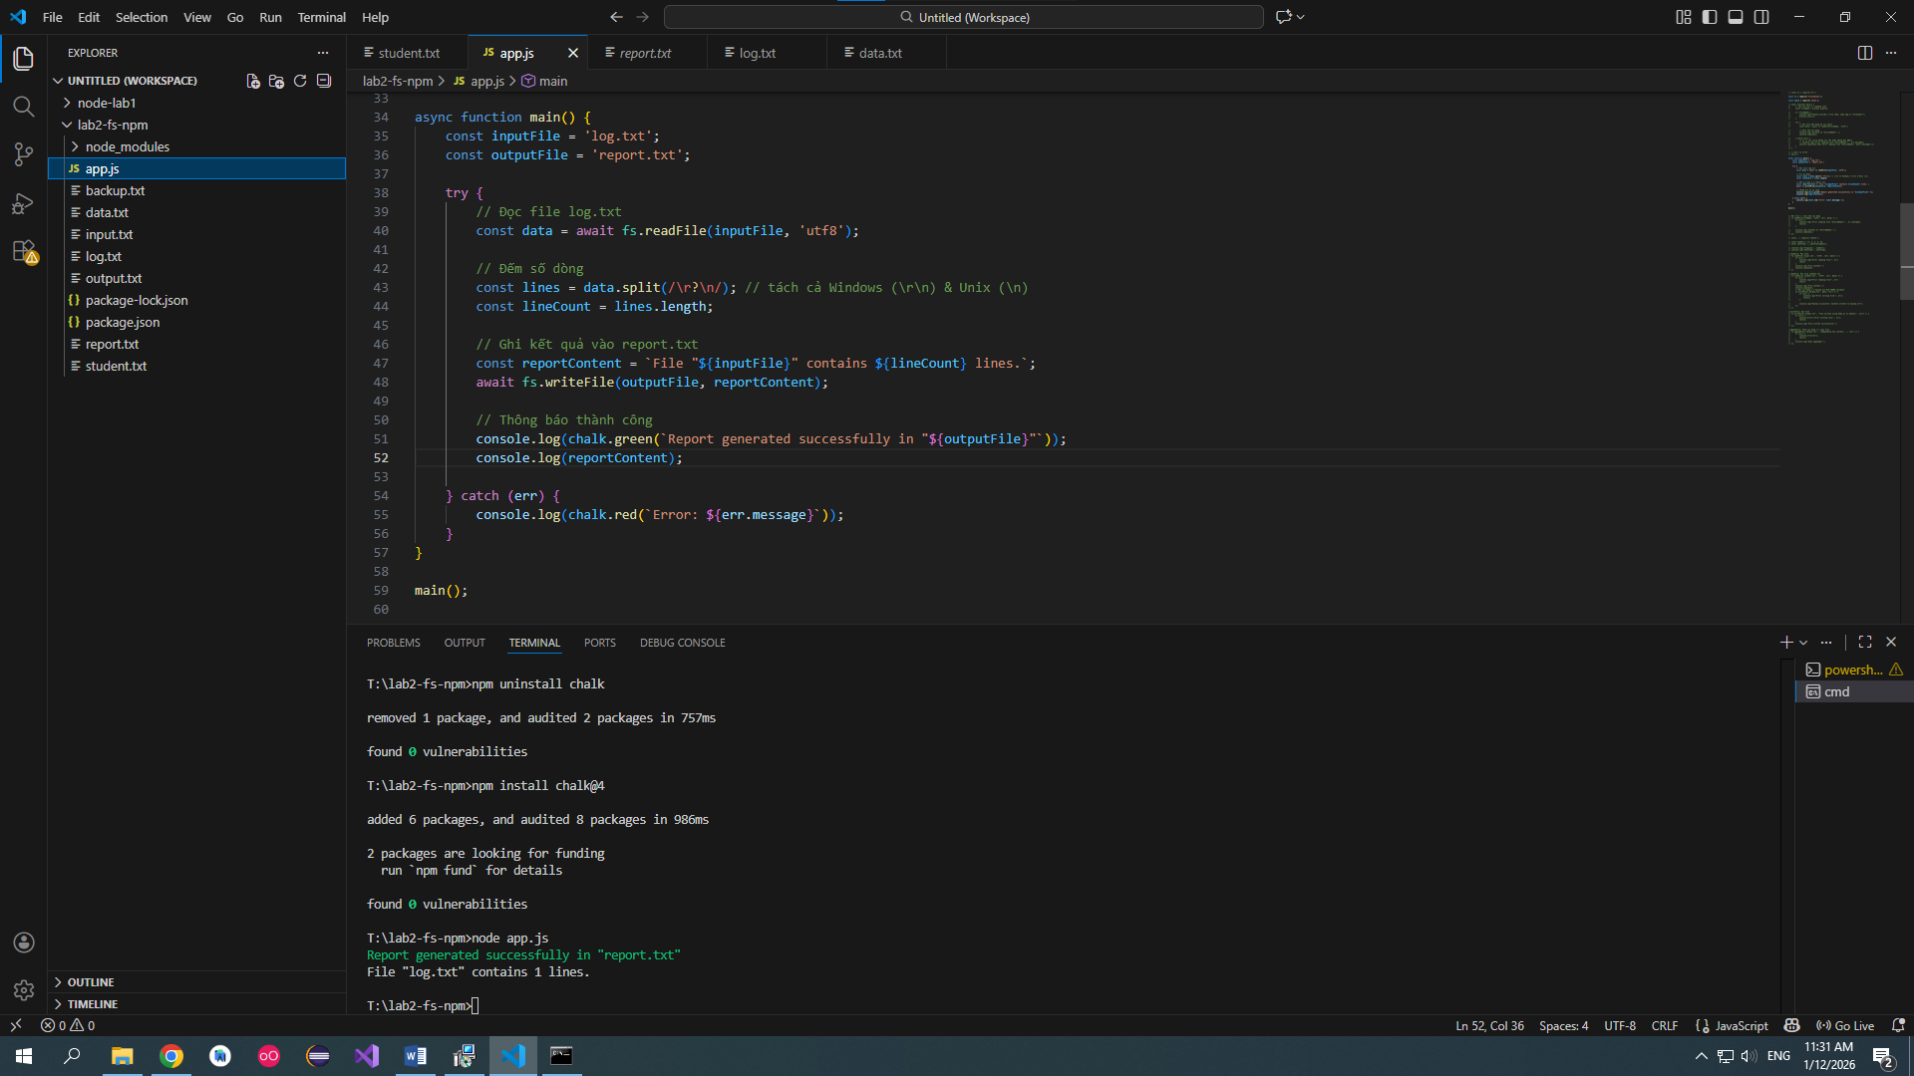

Exercise 5 (Challenge)
Combine:
- fs
- lodash
- npm scripts
Create:
npm run analyze
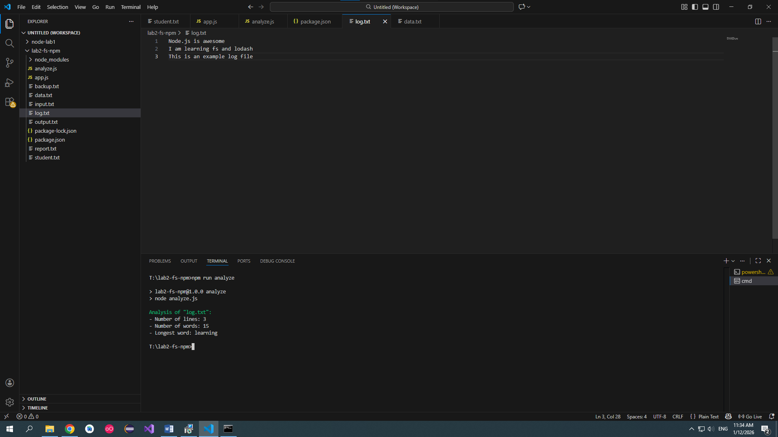

Common Mistakes & Debugging Tips
Problem | Cause | Fix
File not found | Wrong path | Check folder
Cannot find module | Missing install | npm install
Callback not running | Async misunderstanding | Add logs
Encoding issues | Missing utf8 | Add 'utf8'

Lab Summary
✔ Asynchronous file handling
✔ npm project initialization
✔ Dependency management
✔ Using third-party libraries
✔ Preparing for real-world Node.js apps

Lab 3: Event-driven Mini Project (3 hours)
Mini Project: Student Activity Logger
- Emit events when student action occurs
- Log activities to file
- Use EventEmitter and fs
Below is a lecture-ready + lab-ready handbook you can give directly to students for Chapter 2 – Lab 3.
It is written step-by-step, with clear code, and exercises + separated solutions so students must think first.

Chapter 2 – Lab 3

Event-Driven Mini Project (3 hours)

Mini Project: Student Activity Logger

1. Lab Overview

⏱ Duration
3 hours

🎯 Learning Objectives
After this lab, students will be able to:
- Understand event-driven programming in Node.js
- Use EventEmitter to create and emit custom events
- Handle events with listeners
- Use fs module to log data into files
- Build a small event-based mini project

2. Background Knowledge (Before Lab)

2.1 What is Event-Driven Programming?
- The program reacts to events instead of running line-by-line only.
- An event happens → a listener reacts.
Examples in real life
- Click a button → something happens
- Student logs in → system records activity

2.2 EventEmitter in Node.js
Node.js provides the events module.
Key concepts:
- emit(eventName, data) → trigger an event
- on(eventName, callback) → listen to an event

3. Project Description

📘 Mini Project: Student Activity Logger
The system will:
- Simulate student actions:
  - login
  - view lesson
  - submit assignment
- Emit an event for each action
- Log the activity into a text file

4. Project Setup

Step 1: Create project folder
mkdir student-activity-logger
cd student-activity-logger

Step 2: Initialize npm
npm init -y

Step 3: Create files
touch app.js logger.js
Project structure:
student-activity-logger/
├── app.js
├── logger.js
├── package.json

5. Implement Event Logger (logger.js)

Step 1: Import required modules
const EventEmitter = require('events');
const fs = require('fs');

Step 2: Create custom EventEmitter
class StudentLogger extends EventEmitter {}

const logger = new StudentLogger();

Step 3: Create log function
function logToFile(message) {
const logMessage = `${new Date().toISOString()} - ${message}\n`;

fs.appendFile('activity.log', logMessage, (err) => {
if (err) {
console.error('Error writing log:', err);
}
});
}

Step 4: Register event listeners
logger.on('login', (studentName) => {
logToFile(`Student ${studentName} logged in`);
});

logger.on('view_lesson', (data) => {
logToFile(`Student ${data.name} viewed lesson ${data.lesson}`);
});

logger.on('submit_assignment', (data) => {
logToFile(`Student ${data.name} submitted assignment ${data.assignment}`);
});

Step 5: Export logger
module.exports = logger;

6. Emit Events (app.js)

Step 1: Import logger
const logger = require('./logger');

Step 2: Simulate student actions
logger.emit('login', 'Alice');

logger.emit('view_lesson', {
name: 'Alice',
lesson: 'Node.js Events'
});

logger.emit('submit_assignment', {
name: 'Alice',
assignment: 'Lab 3'
});

Step 3: Run project
node app.js

Step 4: Check output file
File created: activity.log
Example content:
2026-01-04T08:15:22.111Z - Student Alice logged in
2026-01-04T08:15:22.114Z - Student Alice viewed lesson Node.js Events
2026-01-04T08:15:22.117Z - Student Alice submitted assignment Lab 3

7. Code Flow Explanation
- app.js emits events
- logger.js listens to events
- Listener writes logs using fs.appendFile
- Event-driven → loosely coupled → scalable design
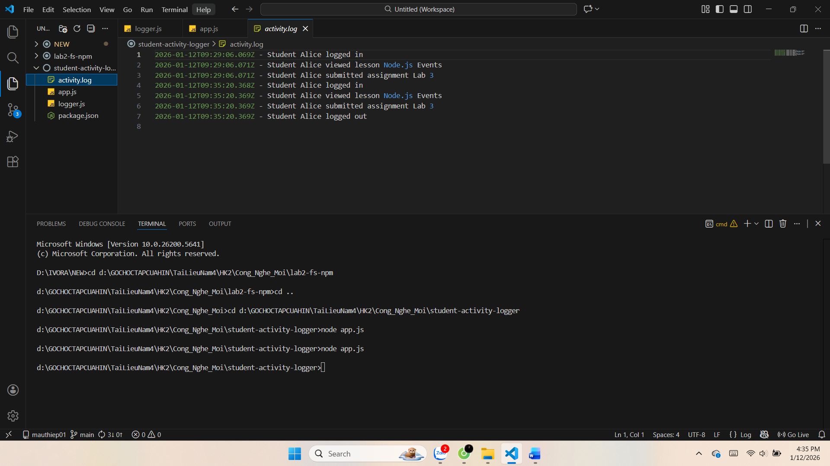

8. Extra Exercises (Students DO FIRST)

🔹 Exercise 1 (Easy)
Add a new event:
logout
Log:
Student <name> logged out

🔹 Exercise 2 (Medium)
Add event:
quiz_attempt
Data:
{
name: 'Bob',
score: 8,
total: 10
}
Log format:
Student Bob attempted quiz: 8/10
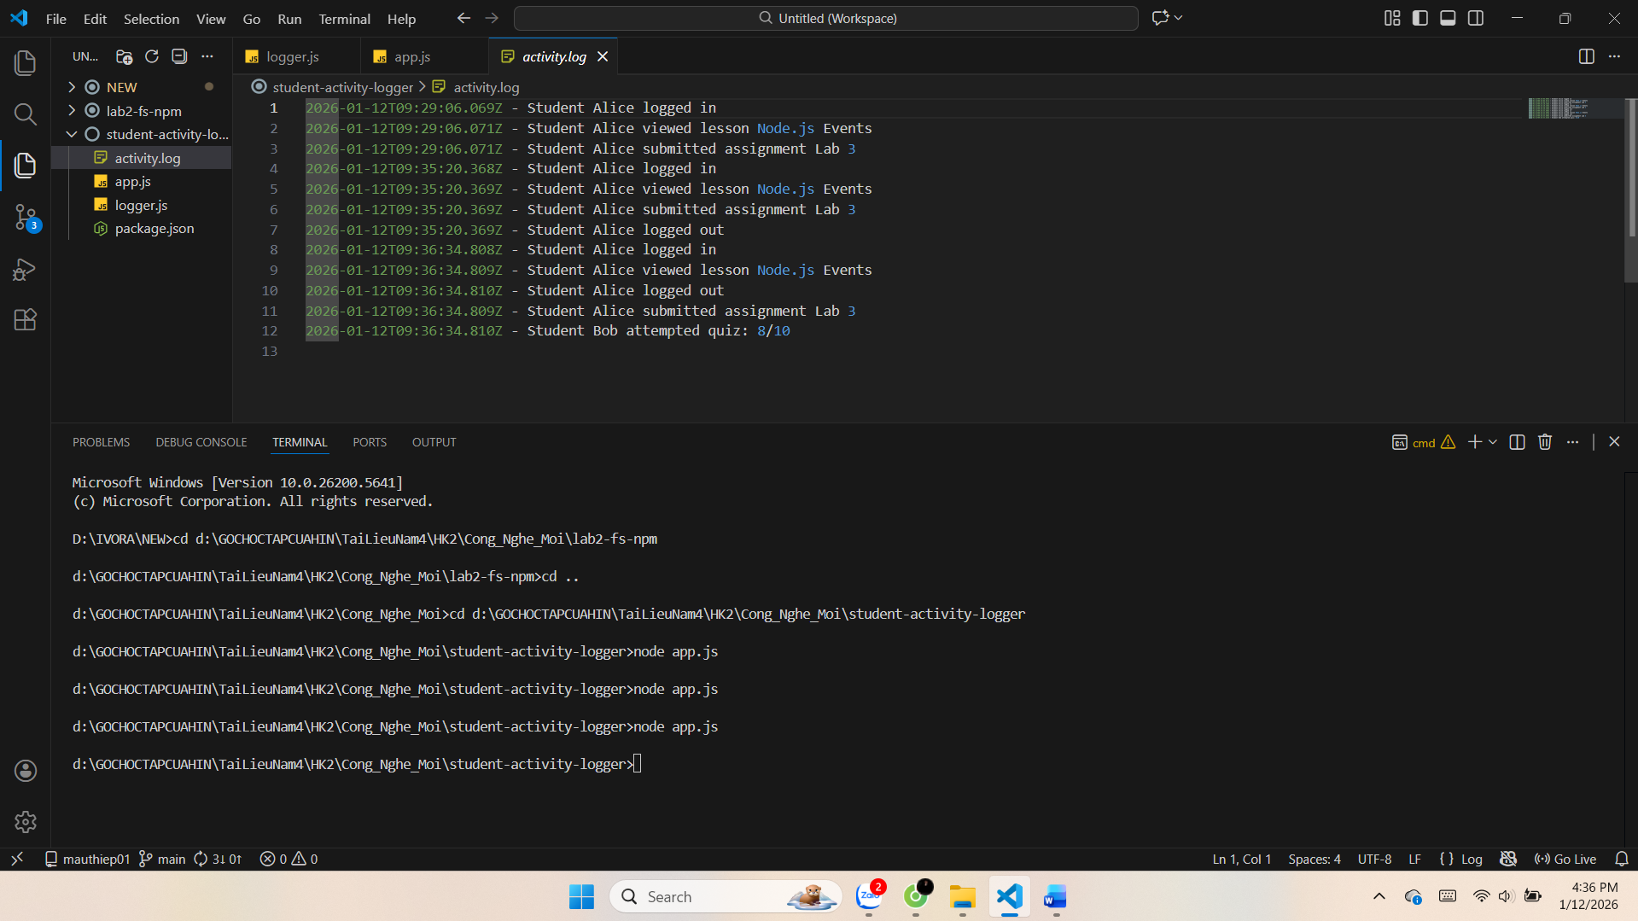

🔹 Exercise 3 (Medium)
Modify logger to:
- Save logs into folder logs/
- File name format: activity-YYYY-MM-DD.log
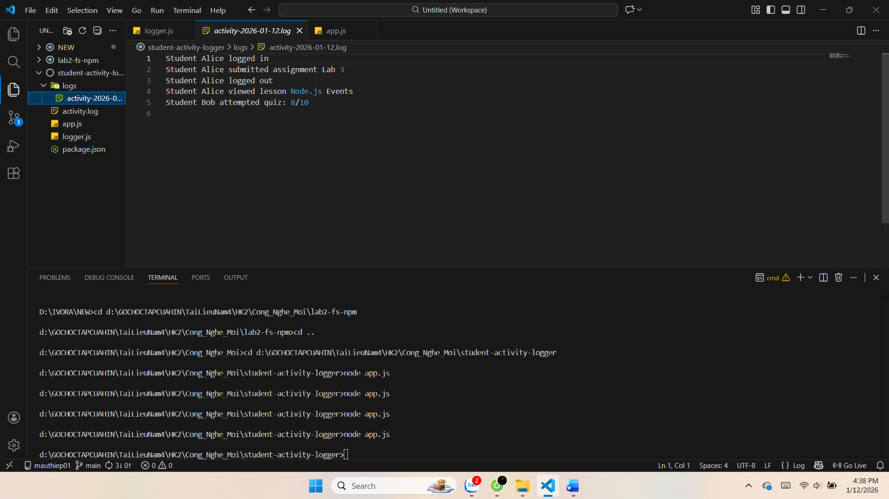

🔹 Exercise 4 (Advanced)
Add:
- error event
- When error happens, log into error.log
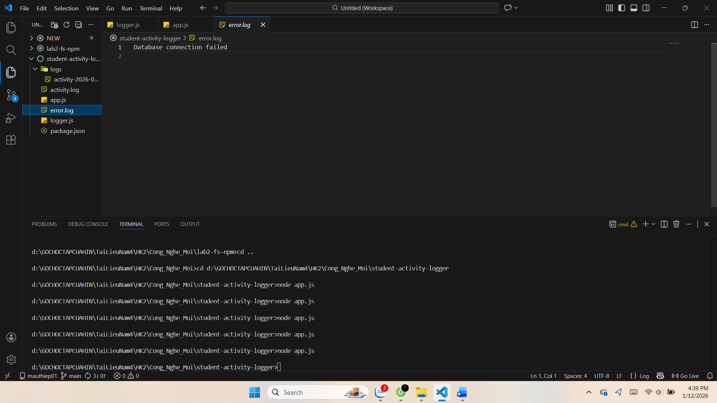

9. Solutions (FOR LECTURER / AFTER STUDENTS FINISH)

✅ Solution – Exercise 1
logger.on('logout', (name) => {
logToFile(`Student ${name} logged out`);
});
Emit:
logger.emit('logout', 'Alice');

✅ Solution – Exercise 2
logger.on('quiz_attempt', (data) => {
logToFile(`Student ${data.name} attempted quiz: ${data.score}/${data.total}`);
});
Emit:
logger.emit('quiz_attempt', {
name: 'Bob',
score: 8,
total: 10
});

✅ Solution – Exercise 3
const path = require('path');

function logToFile(message) {
const date = new Date().toISOString().split('T')[0];
const dir = 'logs';

if (!fs.existsSync(dir)) {
fs.mkdirSync(dir);
}

const filePath = path.join(dir, `activity-${date}.log`);
fs.appendFile(filePath, message + '\n', () => {});
}

✅ Solution – Exercise 4
logger.on('error', (err) => {
fs.appendFile('error.log', err + '\n', () => {});
});
Emit:
logger.emit('error', 'Database connection failed');

10. Teaching Notes (For You)
- Emphasize emit vs on
- Show real-world mapping (logs, notifications, microservices)
- This lab prepares students for:
  - WebSocket
  - Message queues
  - Backend logging systems

