Conclusions that can be drawn from this crowdfunding campaign are as follows:

The ideal time to schedule crowdfunding campaigns are from May – July. The trend over years of data shows the max increase in number of successful campaigns are in this time frame.

The least ideal time to schedule crowdfunding campaigns are in the month of August. In this month we saw the max increase in number of failed campaigns.

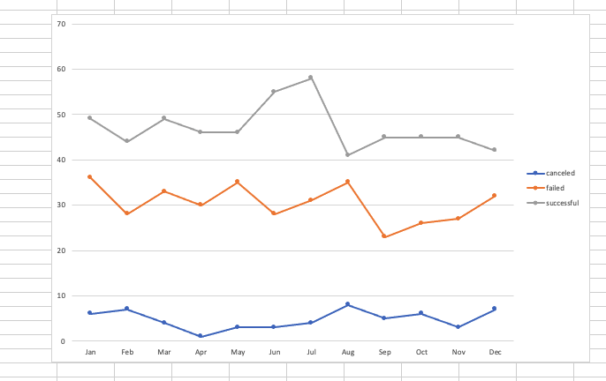

The most popular crowdfunding campaigns are for Theater/Plays. They have the largest reaction of all the categories of campaigns.

The number of failed campaigns in the Theater/Play category is almost the same as the number of successful campaigns in that category.

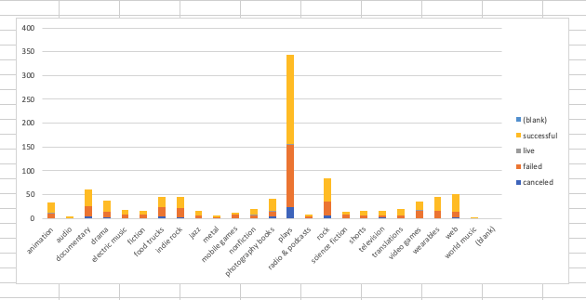

The trend amongst set goal amount reaching a 100% success rate was between $15K - $25K and $30K-$35K.

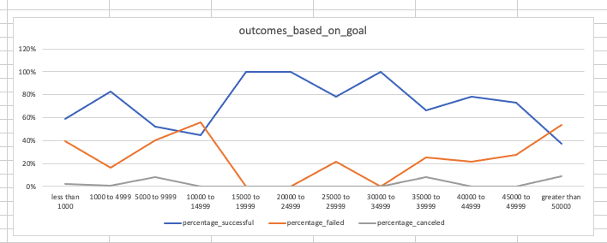

A hidden trend was found when looking at the number of successful campaigns and the duration of a campaign.

The data presents that the optimum duration of a campaign is 1 to 9 days. After that, it’s a consistent drop in the count of successful campaigns that continues to fall, but slows down in the 15 to 30 day range.

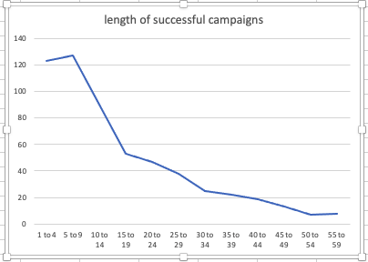

Limitations of the data set are as follows:

The data ended December 2019 and in the following year the planet faced a global pandemic. External world events would be a limitation because it will cause a skew to the campaign.

When looking at variances between two categories such as failed and successful campaigns, often the count of each outcome is different. Lacking a symmetric distribution would affect mean, which affects variance and standard deviation.

When looking at a data set from vast geographical locations it can be challenging. There can be political limitations, cultural, and season limitations as well that can affect the overall outcome of a campaign.

Possible additional hidden trends:

There could be a hidden trend amongst the value of spotlight. We can ask did the effect of having a campaign featured on spotlight have an impact on the percent funded of the actual campaign.

Similarly, we can see if there is a value to staff pick and if that has an impact on the percent funded.