

Computer Vision CCP Assignment

Submitted to: Sir Hamza Farooqui

Name: Hina
Roll No: 23-AI-25
Section: A1
Department: Artificial Intelligence

Table of Content

No. | Topic
1 | Introduction
2 | Angle Computation Approach
3 | Rule-Based Logic Designed
4 | Accuracy Results
5 | Observations
6 | Conclusion

Introduction
This report details the implementation of an automated, real-time human pose estimation and activity classification pipeline. Built upon the modern MediaPipe Tasks API (PoseLandmarker) and OpenCV, the system processes sequential frames to track skeleton topology, extract critical biomechanical joints, compute spatial angles, and execute rule-based heuristic classification to distinguish between three target human activities: Standing, Squatting, and Raising Arm.

The pipeline standardizes all incoming video data to an optimized geometry of 640 × 480 pixels using area interpolation (cv2.INTER_AREA). This guarantees hardware agnostic runtime stability and localized keypoint consistency across variable webcam or video sources.

Angle Computation Approach
The pipeline tracks body geometry by calculating three critical joint angles using their respective sequential landmark sets (A: Top, B: Joint Center Anchor, C: Bottom):

  - Left Knee (θknee): Left Hip (A = 23), Left Knee (B = 25), Left Ankle (C = 27).
  - Left Hip (θhip): Left Shoulder (A = 11), Left Hip (B = 23), Left Knee (B = 25).
  - Left Elbow (θelbow): Left Shoulder (A = 11), Left Elbow (B = 13), Left Wrist (C = 15).

Angles are extracted frame-by-frame from 2D coordinate vectors utilizing the two-argument arctangent (atan2) mapping formula:

𝜃 = |𝑎𝑡𝑎𝑛2(𝐶_{𝑦} − 𝐵_{𝑦,} 𝐶_{𝑥} − 𝐵_{𝑥}) − 𝑎𝑡𝑎𝑛2(𝐴_{𝑦} − 𝐵_{𝑦,} 𝐴_{𝑥} − 𝐵_{𝑥})| ×
180

𝜋

To maintain biological consistency, values exceeding 180º are mirrored (θ = 360º – θ) bounding all results strictly between 0 º and 180 º. To eliminate coordinate sensor jitter before calculation, a Temporal Moving Average Filter (N=5) is applied to smooth raw landmark coordinates across frames.

Rule-Based Logic Designed
A deterministic decision tree runs frame by frame, combining lower body angular metrics with upper body relative height configurations to classify states:

  - Squatting: Triggered strictly when lower-body joint extensions compress past predefined operational thresholds, requiring θknee < 170º and θhip < 135º.
  - Raising Arm: Evaluates vertical structural stacks on both limbs. Because image Y-coordinates
decrease moving upward in OpenCV, a raised arm is declared if either wrist rises above its respective elbow, and that elbow rises above the shoulder line:

Left Raised = (𝑌𝑒𝑙𝑏𝑜𝑤 < 𝑌𝑠ℎ𝑜𝑢𝑙𝑑𝑒𝑟) ∧ (𝑌𝑤𝑟𝑖𝑠𝑡 < 𝑌𝑒𝑙𝑏𝑜𝑤)

Right Raised = (𝑌𝑒𝑙𝑏𝑜𝑤 < 𝑌𝑠ℎ𝑜𝑢𝑙𝑑𝑒𝑟) ∧ (𝑌𝑤𝑟𝑖𝑠𝑡 < 𝑌𝑒𝑙𝑏𝑜𝑤)

  - Standing (Neutral): The default baseline fallback condition triggered automatically when active kinematics fail to satisfy either the squatting or arm-raising structural thresholds.

Accuracy Results
The algorithmic classification pipeline was validated against a manually labeled ground-truth timeline configured across distinct activity zones (Standing: 1–100, Raising Arm: 101–300, Squatting: 301–500).

  - Total Evaluated Frames: 560 Frames
  - Overall Classification Accuracy: 85.04%
  - Minimum Joint Fluctuations Captured: Knee: 61°, Hip: 26°, Elbow: 5°

Observations
  - Joint Angles Chart Analysis: Standing intervals show stable joint extensions near 170° - 180°. During the arm-raising sequence, sharp drops in the elbow curve highlight the precise frame indices where transition changes occur, dropping as low as 5° at peak extension. Squat execution shows a sustained, simultaneous compression of the hip (green line) and knee (red line) down to 26° and 61°.
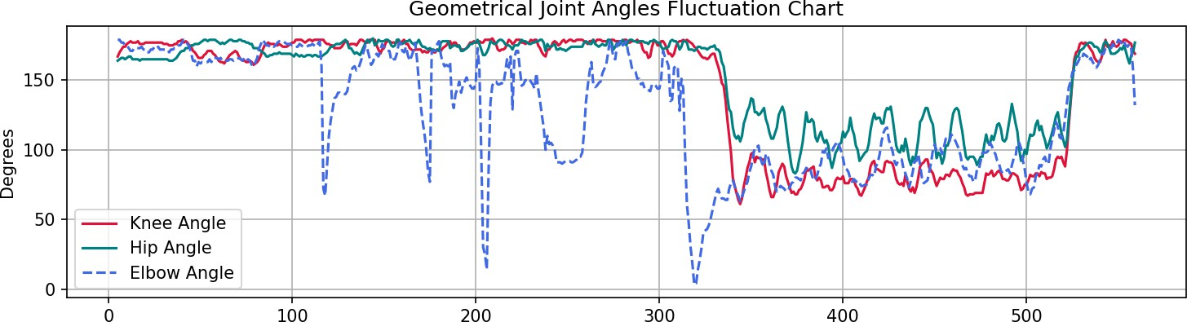

  - Accuracy Curve Analysis: The progression curve starts at a perfect 100%. Sharp, temporary dips occur near Frame 100 and Frame 300, corresponding exactly to physical state transitions. These brief dips happen because human movement is continuous, creating brief transition intervals where the body is halfway between states before fully meeting the rule based thresholds. The curve steadily climbs back up, stabilizing at 85.04% as activities are sustained.

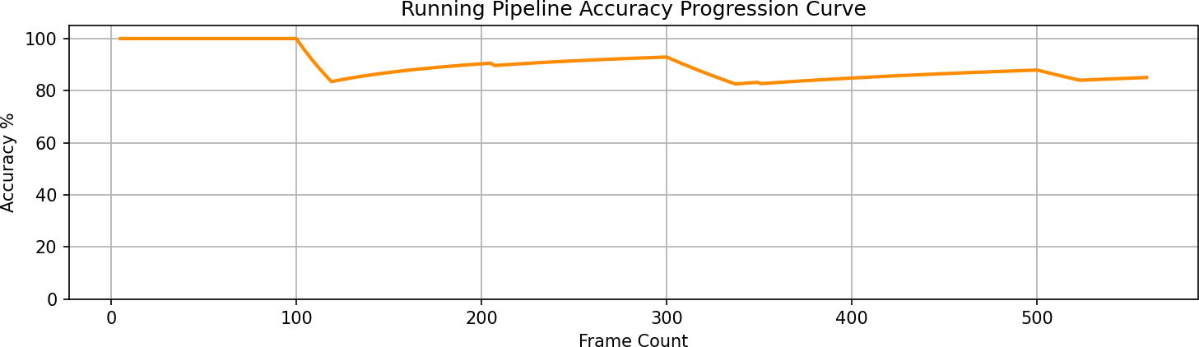

Conclusion
The implementation successfully meets the criteria for a Complex Computing Problem. By linking a modern pre-trained deep learning inference model with deterministic kinematic formulas and spatial heuristics, the pipeline achieves accurate real-time classification across variable environments. The high correlation between joint tracking metrics and live behavior states proves the design is solid for automated physical assessment applications.

