Image Editing – Step-by-Step Documentation

Step 1: Original Image
Downloaded the original image from the link.
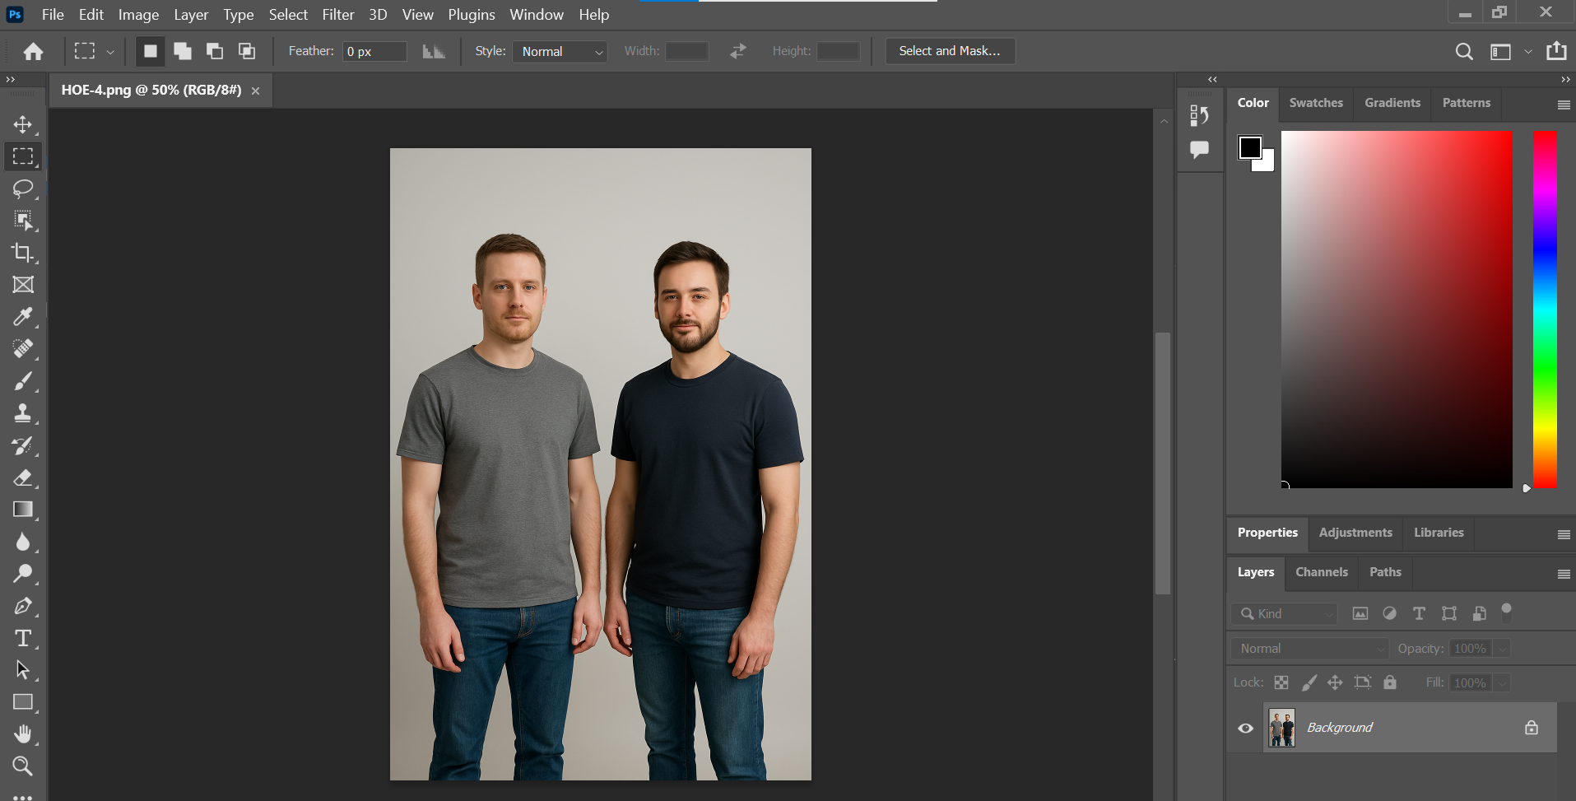

Step 2: Facial Spot Removal / Skin Improvement
Cleared facial spots and smoothed the skin of the person in the gray shirt.
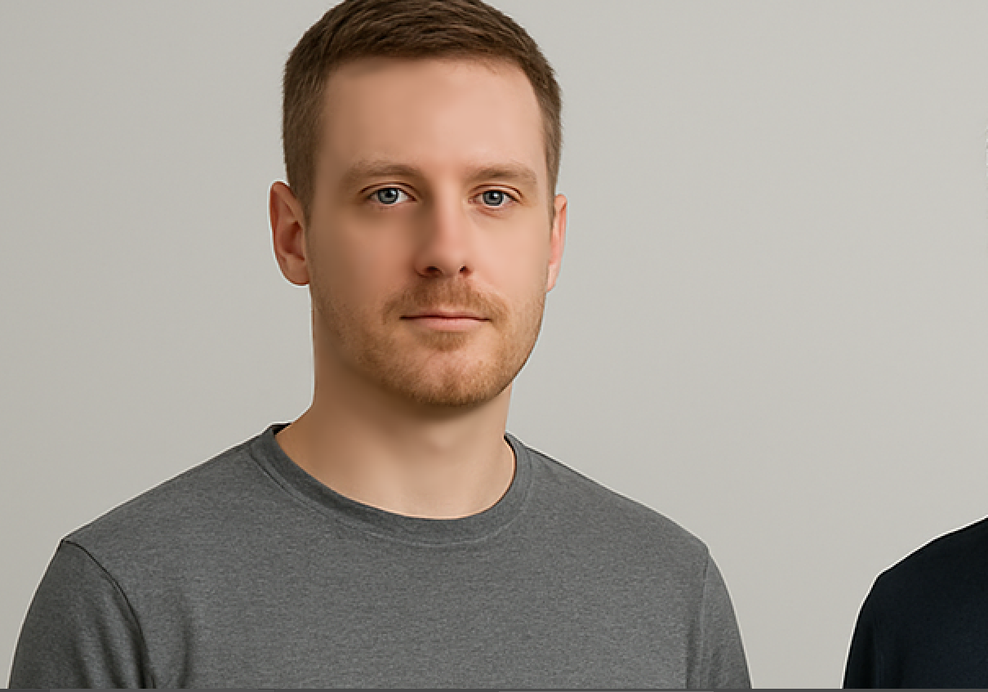

Step 3: Person Removal
Removed the person in black using Content-Aware Fill. Cleaned up the background with Clone Stamp / Healing Brush for natural results.
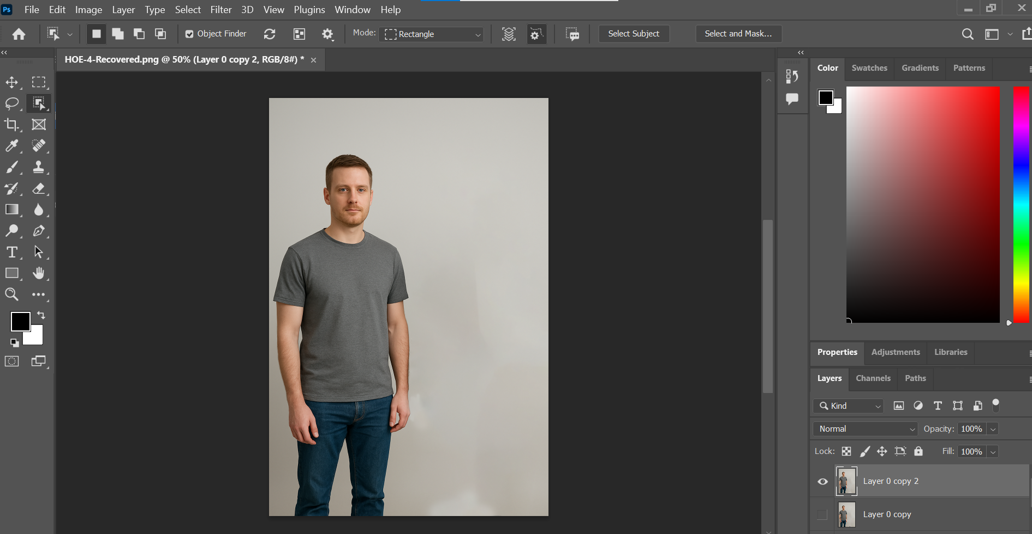

Step 4: Center-align Gray-Shirt Person
Moved the gray-shirt person to the center using Move Tool and vertical guide. Checked visual alignment and adjusted position.

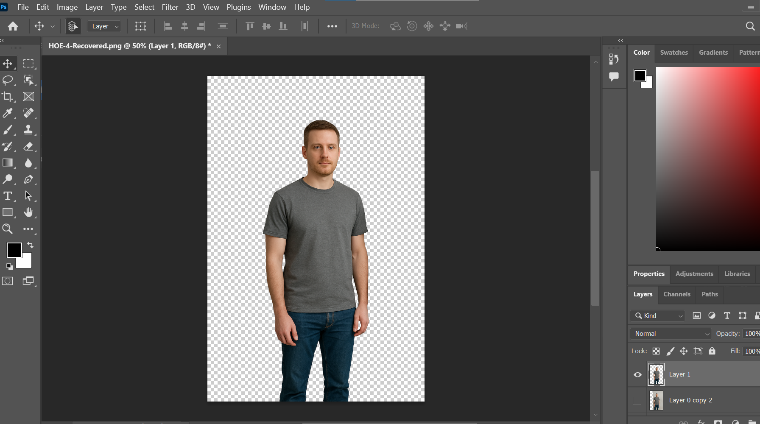

Step 5: Background Replacement
Replaced the flat wall with a hotel background. Adjusted size, position, and lighting to match the person naturally with the new background.
