**Lighthouse Reports before optimization:-**

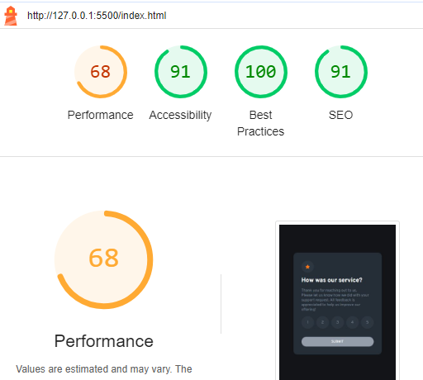

**Lighthouse Reports after optimization:-**

