**CHARACTERS GAMEPLAY**

**Minerva Mcgonagall**

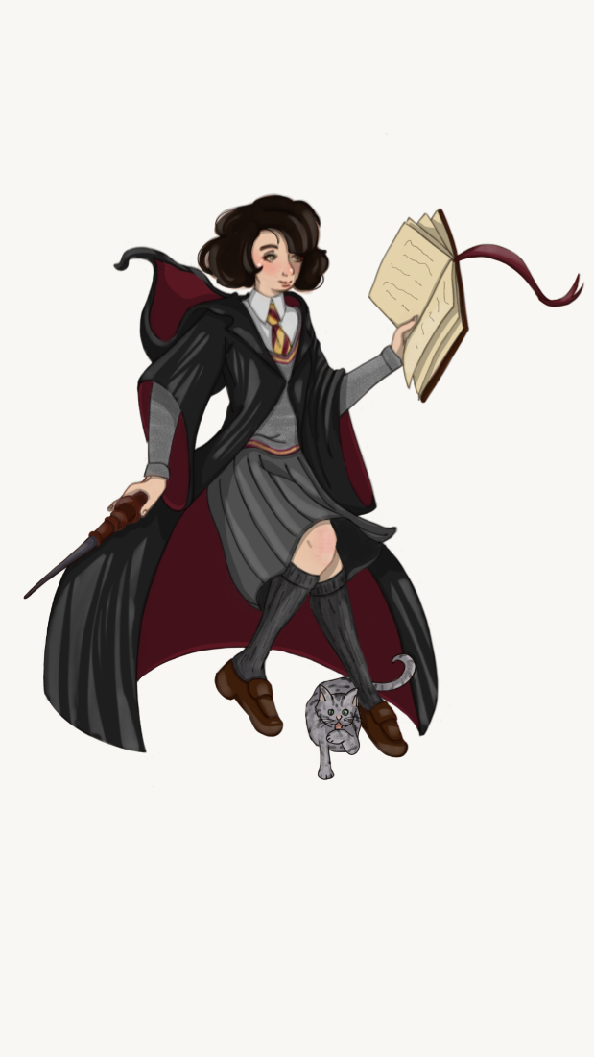

**Initial stats**

|  |  |  |  |  |
| --- | --- | --- | --- | --- |
| **CLASS** | **RACE** | **HIT POINTS** | **ARMOR CLASS** | **SPEED** |
| Wizard | Human | 7 | 10 | 9 metres |

**Race:** Thanks to Minerva's human race, she has a +1 to each characteristic score.

**Armor Class(AC):** The higher AC Minerva has, the harder it will be for enemies to hit she. AC is calculate as follows: 10 + Dexterity modifier.

[**Hit Points**](https://roll20.net/compendium/dnd5e/Artificer#h-Hit%20Points)**at Higher Levels:** 6 + your [Constitution](https://roll20.net/compendium/dnd5e/Ability%20Scores" \l "h-Constitution) modifier per [Wizard](https://roll20.net/compendium/dnd5e/Classes%20by%20Guild" \l "h-Wizard) level after 1st.

**Speed:** It is the distance in feet that the character or monster can walk in 1 round. This number assumes short bursts of energetic movement in the midst of a life- threatening situation.

|  |  |  |
| --- | --- | --- |
| **CHARACTERISTIC SCORE** | **SCORE** | **MODIFIER** |
| **STRENGHT** | 10 | +0 |
| **DEXTERITY** | 11 | +0 |
| **CONSTITUTION** | 13 | +1 |
| **INTELLIGENCE** | 17 | +3 |
| **WISDOM** | 13 | +1 |
| **CHARISMA** | 11 | +0 |

Every 2 points starting from 10 gives +1 to the modifier, while every -2 points starting from 10 gives a -1 to the modifier.

Every 4 levels, one ability point can be increased by 2 or two ability points by 1.

|  |  |
| --- | --- |
| **Spell save Difficulty Class (DC)** | 8 + proficiency bonus + Intelligence modifier |

**Difficulty Class(DC):** It is the number needed to hit or beat to succeed at a roll.

The **Proficiency Bonus** represents the experience from a roleplaying viewpoint, and the power curve from a game design viewpoint. It is added to skills, saves, weapon or spell attacks that Minerva is proficient with.

|  |  |  |
| --- | --- | --- |
| **EXPERIENCE** | **LEVEL** | **PROFICIENCY BONUS** |
| 0 | 1 | +2 |
| 300 | 2 | +2 |
| 900 | 3 | +2 |
| 2.700 | 4 | +2 |
| 6.500 | 5 | +3 |
| 14.000 | 6 | +3 |
| 23.000 | 7 | +3 |
| 34.000 | 8 | +3 |
| 48.000 | 9 | +4 |
| 64.000 | 10 | +4 |

**Initiative:** The combat is structured in cyclic turns, which order is decided by the initiative which is given by the roll of a d20 + the Dexterity modifier, the roll of the d20 is made at the beginning of each fight for both the players and enemies, whoever has higher initiative starts his turn earlier than whoever has low initiative.

A **saving throw (ST)** —also called a save—represents an attempt to resist a spell, a trap, a poison, a disease, or a similar threat. The player doesn’t normally decide to make a saving throw; he/she is forced to make one because the character is at risk of harm. The value of the TS is obtained from the roll of a D20, to which the characteristic modifier corresponding to the saving throw will be added, and if the character has competence in that ST, also the Proficiency Bonus. This roll will have to pass, or match the Difficulty Class of the test to pass.

When the player make an attack, the **Attack Roll (AR)** determines whether the attack hits or misses. To make an attack roll, a D20 is thrown and the characteristic modifier (Intelligence in Minerva's case) and the Proficiency Bonus are added to it.

|  |  |  |
| --- | --- | --- |
| **ANIMAGUS FORM** | | |
|  | **Max Vertical Distance** | **Max Horizontal Distance** |
| **Jump** | 1.5 metres | 3 metres |