**SPELL**

There are four schools of magic represented by the tree diagrams from which Minerva can learn spells: Transfiguration, Defense Against the Dark Arts, Conjuration and Protection. To be unlocked, each spell requires **Spell Points** that can be acquired by defeating enemies and completing the missions present in the various levels, spells with “0” required spell points are unlocked at certain levels.

Each ring present in the various schemes represents a spell whose description can be seen by the player by clicking on it as happens in the game “The Elder Scrolls V: Skyrim”. The moment the spell is learned by Minerva, the ring and the arc of that spell lights up.

The following are the schemes of the spells with the relative tables.

**Transfiguration**

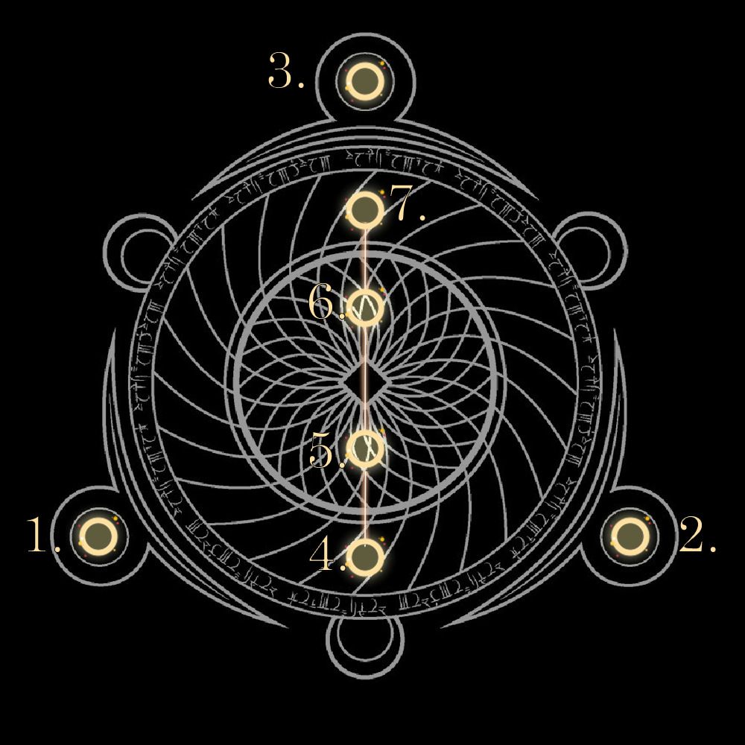

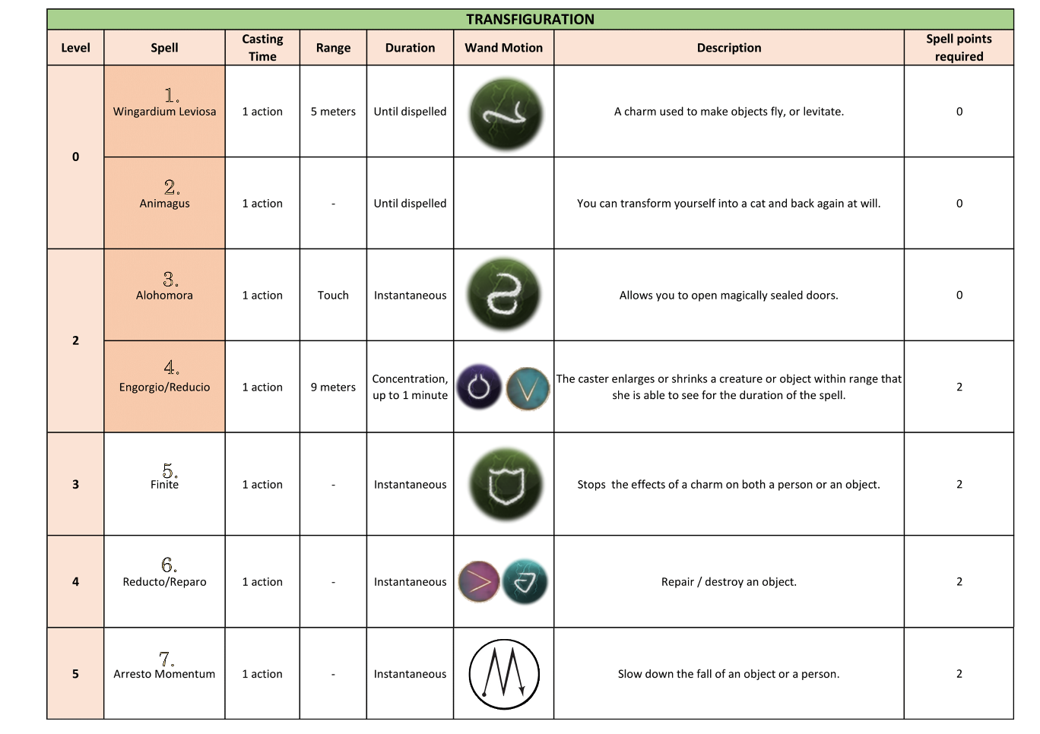

**Defence Against the Dark Arts**

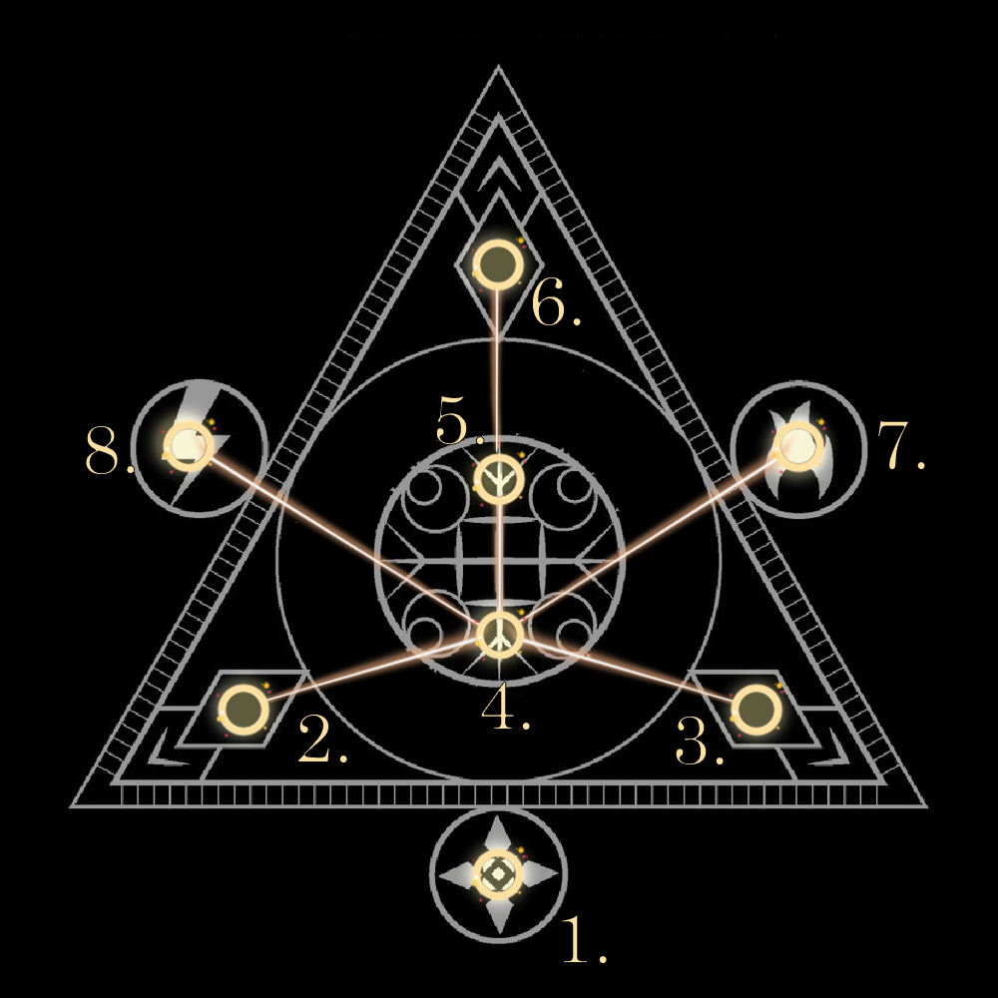

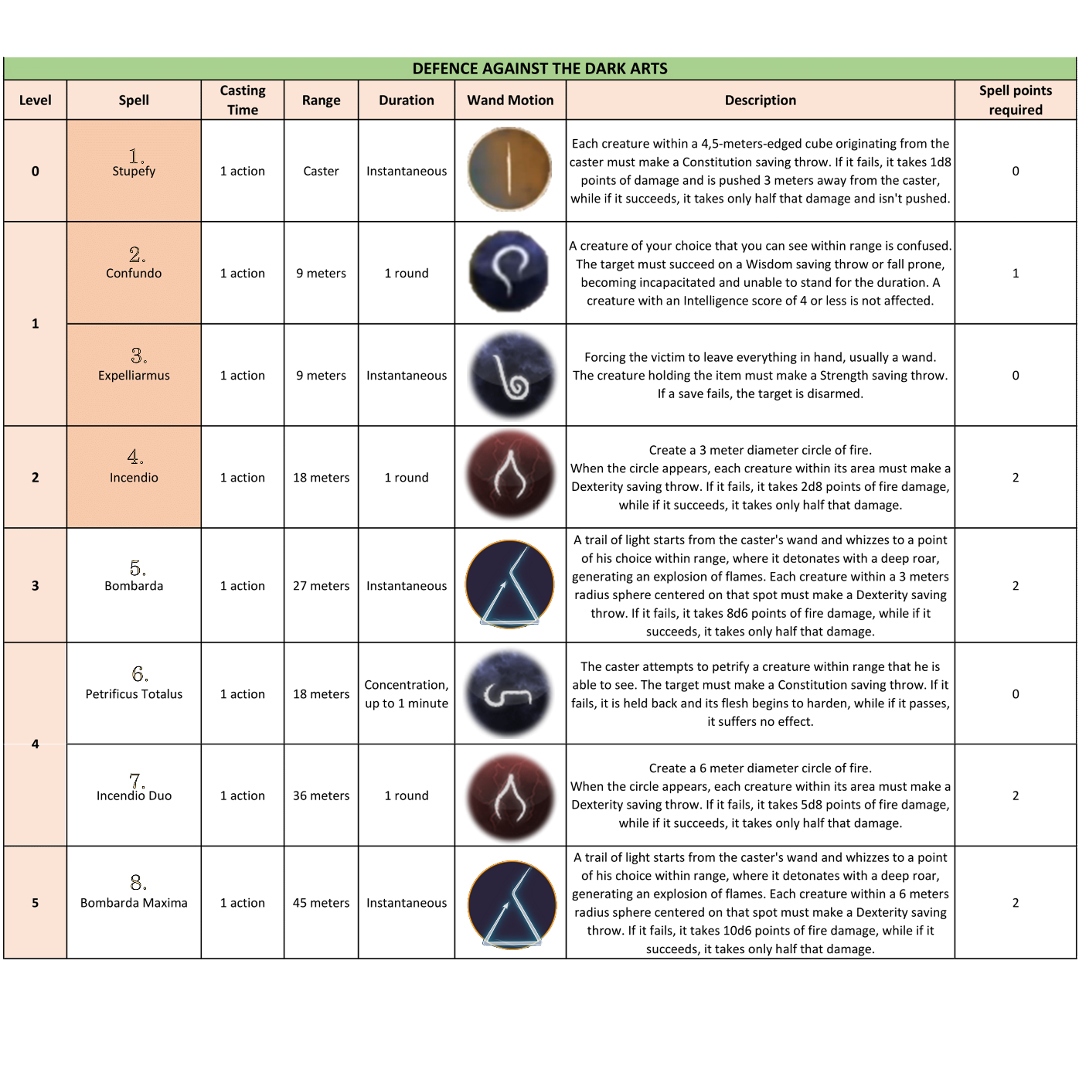

**Conjuration**

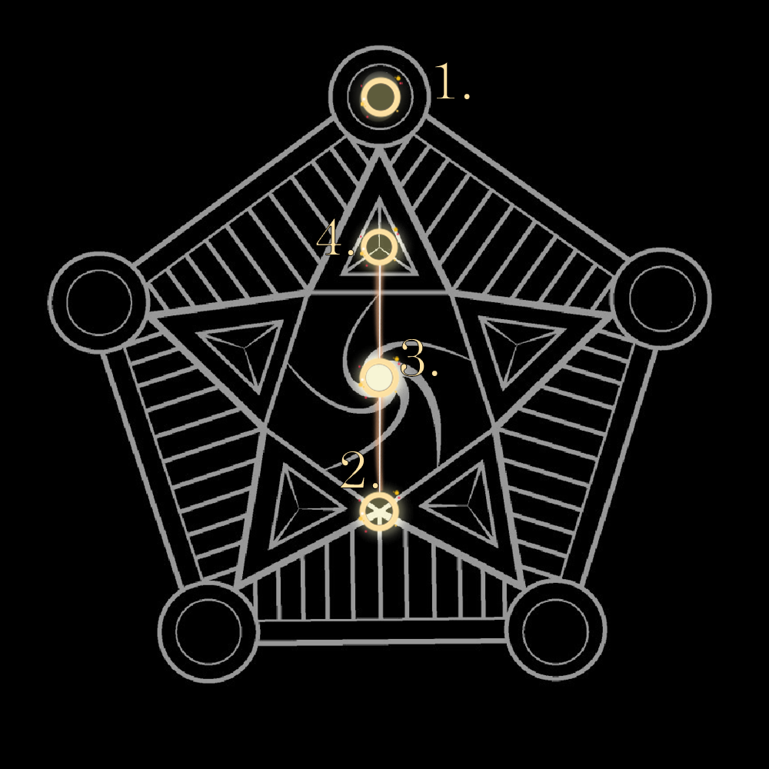

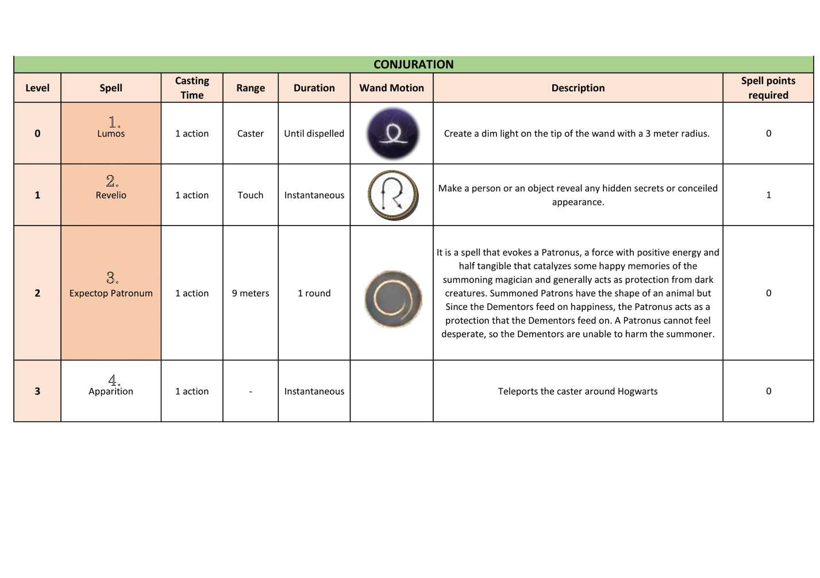

**Protection**

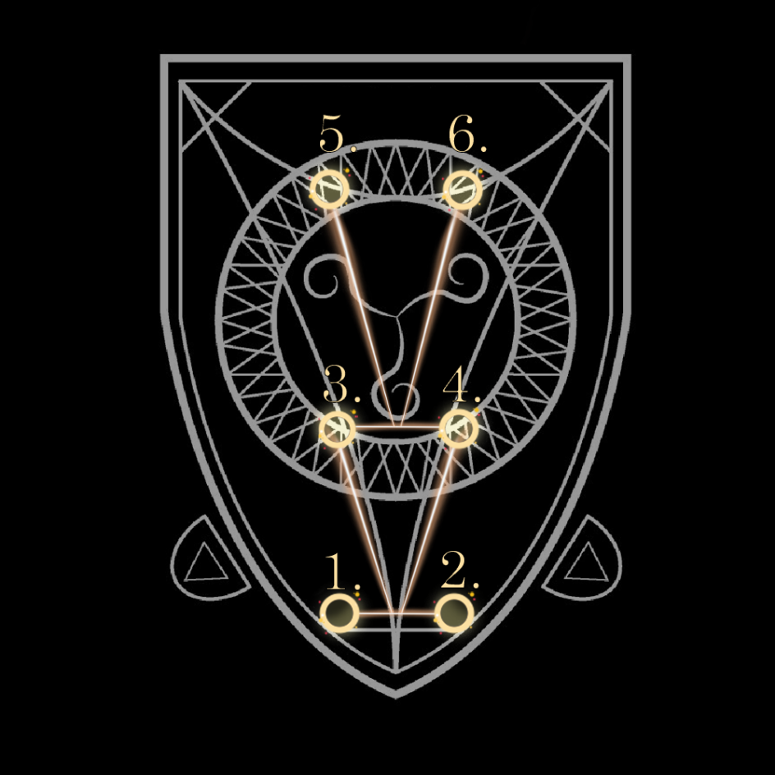

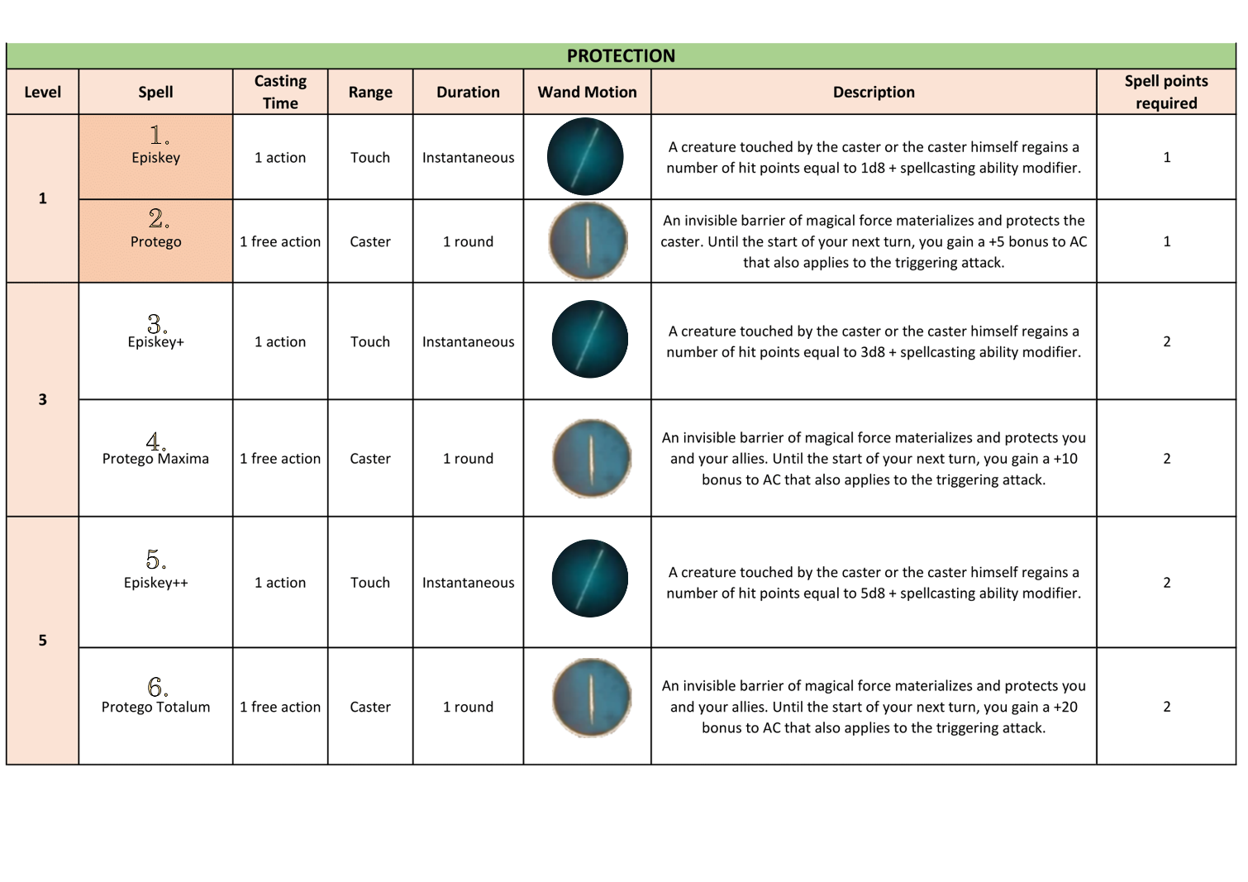

**Mana bar**

When Minerva uses a spell, it consumes mana. The mana bar's capacity increases as Minerva levels up.

|  |  |
| --- | --- |
| **Minerva’s Level** | **Mana bar’s capacity** |
| 1 | 500 |
| 2 | 1000 |
| 3 | 1500 |
| 4 | 2000 |
| 5 | 2500 |
| 6 | 3000 |
| 7 | 3500 |
| 8 | 4000 |
| 9 | 4500 |
| 10 | 5000 |

Mana consumption depends on the spell level of the spell used.

|  |  |
| --- | --- |
| **Spell Level** | **Mana Required** |
| 0 | 0 |
| 1 | 100 |
| 2 | 200 |
| 3 | 300 |
| 4 | 400 |
| 5 | 500 |

Mana regenerates by 5 points every second Minerva passes out of a combat state. This process can be accelerated by using **Mana Potions** that Minerva can also use in combat.