# GOAL OUTLINES

The main story's level progression follows a determined flow here described. For each level in the game is specified how that level impacts the whole game. In the goals outline there are:

### Story goals:

all the objectives that the player must complete for going on during the main quest. That steps could be described as going in some specific location, talking to NPCs, solving puzzles, fighting enemies etc.

### Sidequests unlocked:

at the end of a level, with the progression of the story flow, several sidequest are unlocked. A sidequest can be played in every moment the player wish but after he unlocks it.

### Location:

is the map area where the quest is set in. All the areas at the beginning of the game are locked. During the main quest the player unlocks the areas through the levels which are located in these. When a new location is unlocked is shown with (new)

### Skills achievement:

the player has access to a large number of spells and abilities that he can use at any time in the game, both in dialogues, in fights and in solving puzzles. Some of these spells/abilities (custom spells) are key for the progress of the game, all the others are optional and the player can obtain them by spending skill points to obtain them. Both custom spells and ability points can be obtain at the end of a level.

### Gameplay goals:

are the introduction of some main and advanced mechanics of the game. Some levels aim to teach the player how to use commands, interact with objects, behave in certain situations. Other levels instead aim to perfect the skills learned by the player during the game. These goals are essential in order not to make the player feel uncomfortable during the game.

## References to the map:

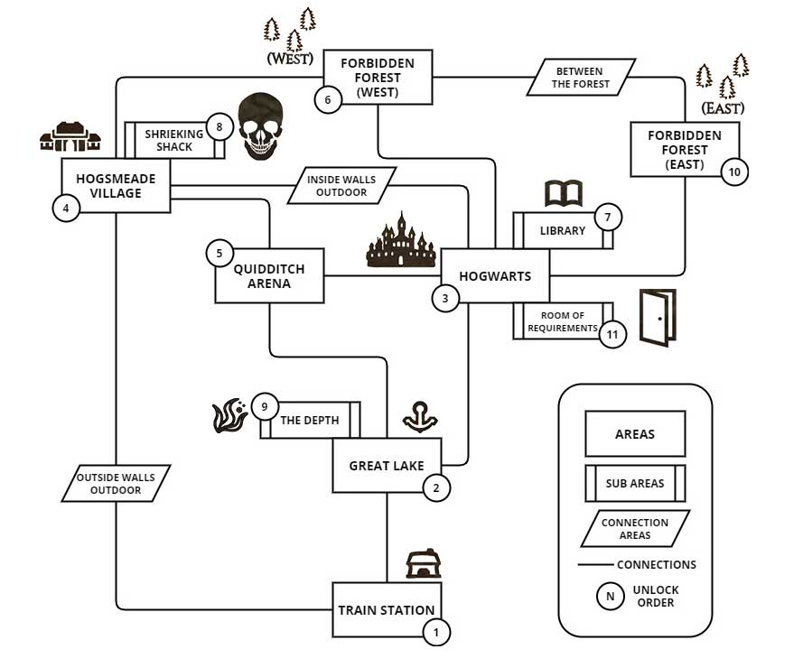



## 1.The wind of the west

Minerva arrives at Hogwarts to start the school year. Arrived at the station she meets her friend, the stationmaster, who informs her of the strange wind blowing

### Story goals:

1. Talk to the trainmaster
2. Fight the bats
3. Reach the castle through the lake

### Sidequests unlocked:

Back to the station

### Location:

Train station (new)

### Skills acheivement:

+1 spell point  
 Animagus (Custom spell)  
 Wingardium Leviosa (Custom spell)

### Gameplay goals:

Basic mechanics tutorial

Spellbook tutorial

Multiple choice dialogue tutorial



## 2.A wizard's blood

Minerva attends Dumbledore's class. After that Minerva sees Magnus harassing a half-blood student, so she intervenes.

### Story goals:

1. Attend Dumbledore's class
2. Fight Magnus

### Location:

Hogwarts (new)

### Skills acheivement:

+1 spell point

Expelliarmus (Custom spell)

Alohomora (Custom spell)

### Gameplay goals:

Spell fight mechanics tutorial



## 3.The prophecy

Minerva and her friend Helena go to Hogsmeade to buy everything they need for the school year. Helena meets an old lady who tolds her a prophecy about the death of her beloved friend Robert.

### Story goals:

1. Go to Hogsmeade
2. Enter the shop
3. Talk with Helena about the prophecy

### Sidequests unlocked:

Paradise flask

### Location:

Hogsmeade (new)  
 Quidditch Arena (new)

### Skills acheivement:

+2 spell point

### Gameplay goals:

Shop tutorial  
 Puzzle tutorial



## 4.Forbidden words

Minerva and Helena enter into the forbidden forest as the old lady suggested for ask the centaur about the prophecy.

### Story goals:

1. Reach the forest
2. Fight the shades
3. Choose a different way to :

3.1 Centaur

3.2 Elf

### Sidequests unlocked:

Broken noble

### Location:

Forbidden Forest West (new)

### Skills acheivement:

+2 spell point  
 Expecto Patronum (Custom spell)

## C:\Users\689290\AppData\Local\Microsoft\Windows\INetCache\Content.Word\library.pngHogwards

## 5.Something old, something borrowed, something new

Minerva must enter the restricted area of ​​the Hogwarts library and retrieve the book. However, the library itself will try in every way to ward off unwanted intruders.

### Story goals:

1. Enter into the library
2. Find the keys for open the restricted section door

2.1 Botany section key

2.2 Spellbook section key

2.3 Bestiary section key

* 1. Astronomy section key

1. Face the ghostly keeper:

* Give him the forged permission with the Minor Illusion spell **or** face him in combat

### Location:

Hogwarts[Library] (new)

### Skills acheivement:

+2 spell point

## Hogwards

## 6a.The right focus

After reading the book, Mineva discovers the three elements to break the prophecy: the pearl, the ancient soul and the stone of resurrection. Minerva decides to ask Helena and Robert to find these element.

### Story goals:

1. Go to dinner
2. Talk to Robert and Helena
3. Cast a spell on a drunk student

### Sidequests unlocked:

Dream Erasure

### Location:

Hogwarts

### Skills acheivement:

+2 spell point

## Hogsmaede



## 7a.The shrieking ghost

Minerva and Helena find out about the old soul locked inside the Shrieking shack. They venture there for retrieve it.

### Story goals:

1. Enter into the shack
2. Turn on the lights
3. Fight the ghosts
4. Break the curse (get the soul)

### Location:

Hogsmeade[Shrieking shack] (new)

### Skills acheivement:

+2 spell point



## 8a.The light in the lake

Minerva and Robert find out about the pearl lost in the backdrop of the lake. They venture there for retrieve it.

### Story goals:

1. Go in the middle of the lake
2. Cast a spell for going on the backdrop of the lake
3. Cast a Patronum for fighting the darkness
4. Fight the siren (get the pearl)

### Location:

Great Lake[The Depth] (new)

### Skills acheivement:

+2 spell point

## Hogsmaede

## 6b.Old acquaintances

After reading the book, Mineva discovers the three elements to break the prophecy: the pearl, the ancient soul and the stone of resurrection. Minerva decides to ask the old lady of the prophecy for help

### Story goals:

1. Go to Hogsmeade
2. Meet the old woman who gave the prophecy
3. Talk with the woman about where you can find the elements to break the prophecy

### Location:

Hogsmeade

### Skills acheivement:

+2 spell point

## Hogwards

## 7b.Paintings like to change

Minerva goes to retrieve the soul locked in a painting hidden in Hogwarts, she has to be care to not be discovered by the ghost of the paintings

### Story goals:

1. Go in the stairs room of Hogwarts
2. Use the Mark of invisibility
3. Search among the paintings the one which holds the ancient soul
4. Find a path within the stairs

### Location:

Hogwarts

### Skills acheivement:

+2 spell point

## Hogwards

## 8b.The embedded watch

Minerva finds out that the pearl is embedded inside the personal watch of Magnus. She goes to Magnus dormitory for steal it but Magnus find her in.

### Story goals:

1. Find Magnus’ dormitory
2. Find a way to get in
3. Solve the puzzle of the chest
4. Fight Magnus after he enters the room

### Location:

Hogwarts

### Skills acheivement:

+2 spell point



## 9.Will of an old one

Minerva has no idea where to find the resurrection stone so, whith the help of Helena, she ventures back in the forbidden forest for finding answers.

### Story goals:

1. Go in the forest east
2. Fight the shades of the forest
3. Find the cursed cabin
4. Break the curse and talk the the old wizard

### Location:

Forbidden Forest East (new)

### Skills acheivement:

+2 spell point

## Hogwards



## 10a.The way of a wizard

Minerva finds out that the resurrection stone is located in the room of requirements. She decides to ask help to Dumbledore. It is revealed that a mysterious outlaw wizard is hiding around Hogwarts. The ministry of magic has sent dementors to neutralize him.

### Story goals:

1. Talk to Dumbledore about the prophecy
2. Start doubting about Helena
3. Learn how to cast advanced spells with Dumbledore

### Sidequests unlocked:

Dumbledore's phoenix

### Location:

Hogwarts[Library]

### Skills acheivement:

+2 spell point  
 Apparition (Custom spell)

### Gameplay goals:

Advanced spell tutorial

## C:\Users\689290\AppData\Local\Microsoft\Windows\INetCache\Content.Word\train.png

## 11a.The man of the train

Minerva goes asking information about the room of requirements to the train keeper. She finds him paralized by a spell. Then returning to Hogwarts in the night she meet and fight a dementor.

### Story goals:

1. Search information about Room of Requirements
2. Break the paralize spell
3. Talk to the train keeper
4. Fight the dementor

### Sidequests unlocked:

Animal sight

### Location:

Train station

### Skills acheivement:

+2 spell point

## C:\Users\689290\AppData\Local\Microsoft\Windows\INetCache\Content.Word\depth.pnglake

## 12a.Drowned truth

Minerva goes searching information about the room of requirements in the depth of the lake, where she has seen some ancient engravings. Back to the surface, she fights a dementor.

### Story goals:

1. Search information about Room of Requirements
2. Enter into the Depth
3. Solve the moonlight riddle
4. Fight the dementor

### Sidequests unlocked:

The fugitive

### Location:

Great Lake[The Depth]

### Skills acheivement:

+2 spell point



## 13a.The pit of dementia

Under the Quidditch arena some secrets are hidden. Minerva goes there to find out something about the room of requirements. Then she meets a dementor.

### Story goals:

1. Search information about Room of Requirements
2. Enter into the arena
3. Fight the enchanted students
4. Save the students from the dementor

### Location:

Quidditch Arena

### Skills acheivement:

+3 spell point

## C:\Users\689290\AppData\Local\Microsoft\Windows\INetCache\Content.Word\shack.pngHogsmaede

## 10b.The shadow of a wizard

Minerva finds out that the resurrection stone is located in the room of requirements. She decides to ask help to the old woman. She teaches her some forbidden spells for stealing memories.

### Story goals:

1. Talk to the old woman about the prophecy
2. Learn how to cast advanced spells with the old woman

### Sidequests unlocked:

Divining

### Location:

Hogsmeade[Shrieking shack]

### Skills acheivement:

+2 spell point

Petrificus Totalus (Custom spell)

### Gameplay goals:

Advanced spell tutorial

## C:\Users\689290\AppData\Local\Microsoft\Windows\INetCache\Content.Word\train.png

## 11b.Memory train

Minerva goes asking information about the room of requirements to the train keeper. She finds him paralized by a spell so she enters in his memory using a Legilimens spell to find informations.

### Story goals:

1. Relive the stationmaster memory, searching for information about the Room of Requirements
2. Talk to the professors about the misterious disappearances
3. Fight the memory spawn and escape from the memory

### Sidequests unlocked:

Animal sight

### Location:

Train station

### Skills acheivement:

+2 spell point

## C:\Users\689290\AppData\Local\Microsoft\Windows\INetCache\Content.Word\depth.pnglake

## 12b.Drowned and forgotten

Minerva goes finding information from the siren in the depth. She fight her and then enters in her memory using a Legilimens spell.

### Story goals:

1. Relive the triton memory, searching for information about Room of Requirements
2. Enter into the Depth
3. Solve the moonlight riddle and find the misterious door in the lost ruins

### Sidequests unlocked:

The fugitive

### Location:

Great Lake[The Depth]

### Skills acheivement:

+2 spell point

## C:\Users\689290\AppData\Local\Microsoft\Windows\INetCache\Content.Word\quidditch.png

## 13b.Quidditch fans

Under the Quidditch arena some secrets are hidden. Minerva goes there to find out something about the room of requirements.

### Story goals:

1. Relive the arena guardian memory, searching for information about the Room of Requirements
2. Enter into the arena
3. Fight the intruders and watch them flee into the locker room

### Location:

Quidditch Arena

### Skills acheivement:

+3 spell point

## room.pngHogwards

## 14.The room of requirements

After all attempts to locate the room of necessity, it magically appears in front of Minerva, Helena and Robert. They enter the room but Magnus follows them.

### Story goals:

1. Find a way to open the room
2. Escape the guardian
3. Fight the hostile enemies in the room

### Location:

Hogwarts[Room of Requirements](new)

### Skills acheivement:

+3 spell point

## room.pngHogwards

## 15.As foretold

They finally find the resurrection stone, but sadly they find out that for open the door that guards it, they have to sacrifice a life. Immediately the old woman appears and is revealed to be Helena from the future. Then the final fight begins.

### Story goals:

1. Find the resurrection stone
2. Meet old Helena
3. Fight for the right sacrifice
4. See Robert been killed by old Helena
5. Fight old Helena

### Sidequests unlocked:

All the sidequest for ending the main story

### Location:

Hogwarts[Room of Requirements](new)

### Gameplay goals:

Game end mode