### Astronomy section

### Area description

The astronomy section is a huge room, developing both in length and height, with bookcases spread throughout it. The ceiling is a glass dome. Under the glass dome there is an observatory capable of reproducing the constellations as a planetarium.

### Lore

One of Hogwarts most suggestive spots. By night, thanks to the the wide glass dome, the moonlight dives in the section and lights all Hogwarts books about universe and constellations. Students can study the constellations, their arrangement and divination. There is a magical instrument at the base of the observatory that allows the students to display the constellations inside the room.

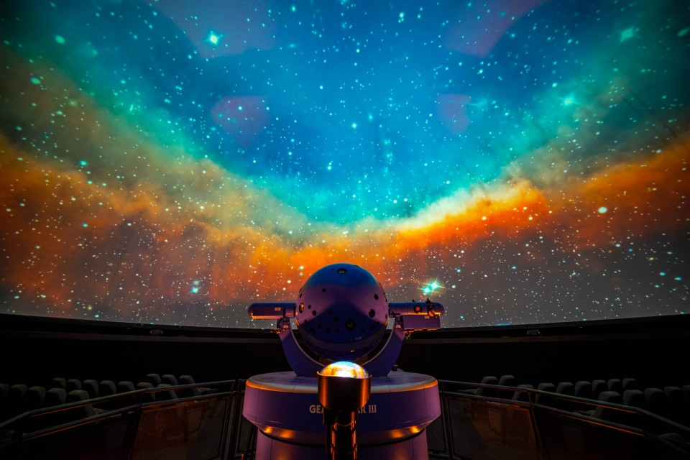

### Map

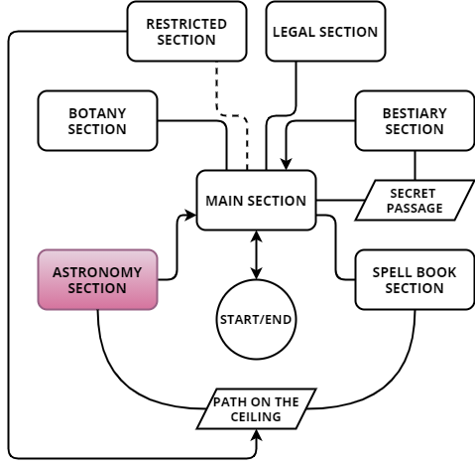

The room is connected to the main section but is not accessible from this. Minerva has to go through the path on the ceiling from the spell book section

The room is particular for its huge observatory. In fact, half the space of the room is occupied by a large cylindrical structure with a glass dome.

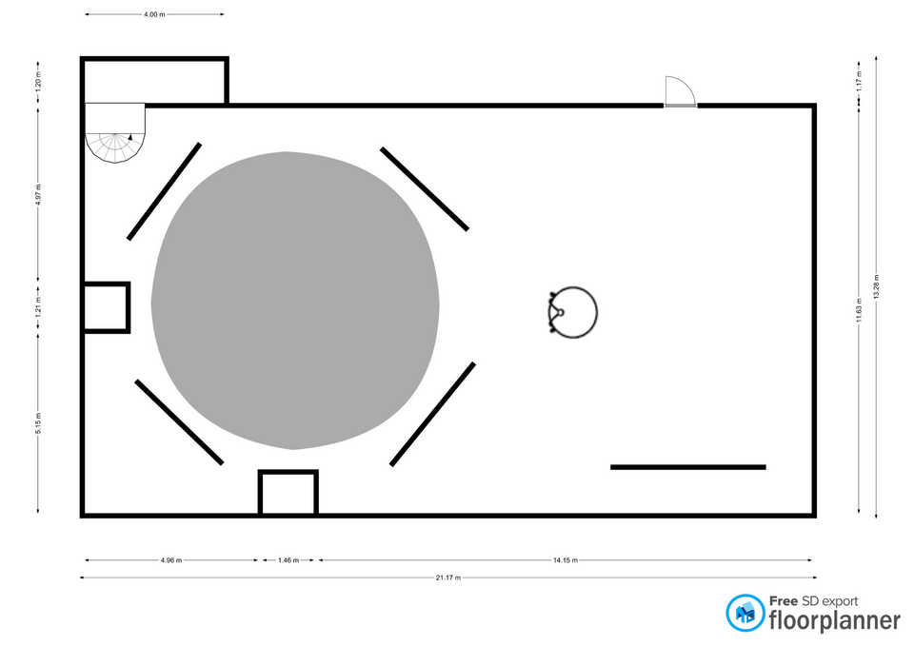

The observatory serves to show the constellations inside the room.

Outside the observatory there is the "Constellator", a magical instrument in the shape of a globe that is used to combine different constellations. Around the observatory there are some shelves that hold books up to the roof of the room.

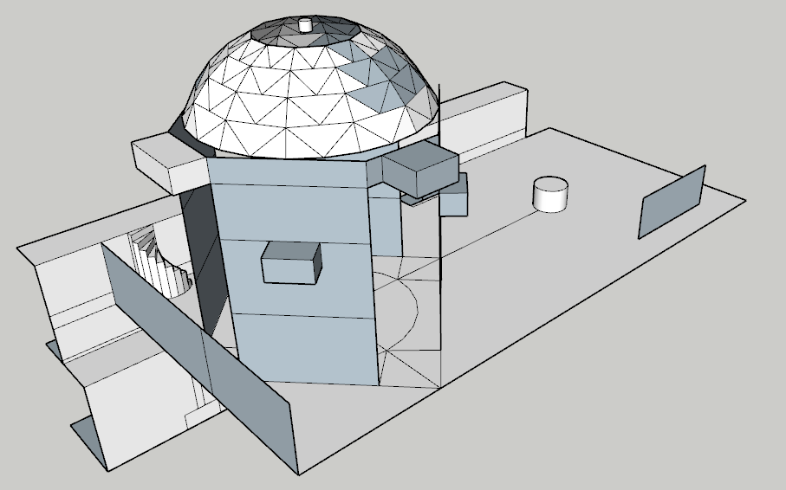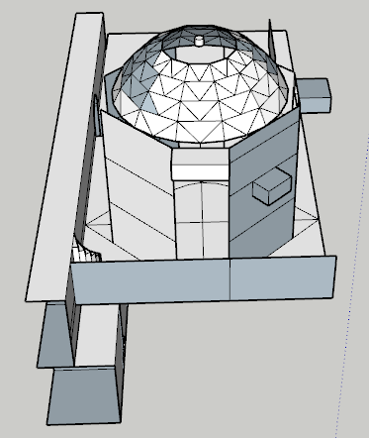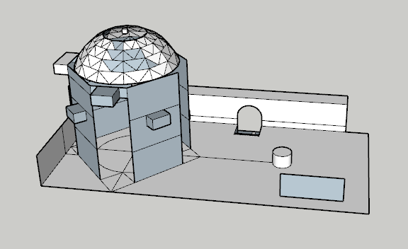

### Goals

As each room, the main goal is to retrieve the signet. The signet is not visible but the Golden Snitch will capture the attention of Minerva. The goal of the room is finding a way to catch the Snitch and retrieve the signet inside it.

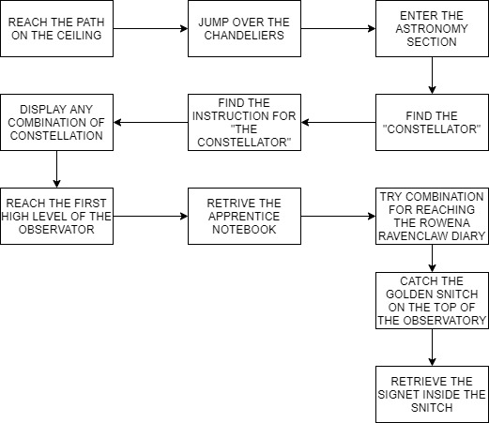Before entering the room, Minerva should cross the path on the ceiling. This path is a platform area where there are six moving chandeliers. Minerva has to cross this area jumping on them. If she falls, she return back in the main section.

The observatory is a puzzle. Minerva can use the "Constellator" to assemble different path for walking inside the observatory. She can reach different spots.

In order to complete the puzzle Minerva need to find some documents inside the room: The Instruction for the "Constellator"(map of the stars), The apprentice's book , Rowena Rawencalw's diary and finally the Golden Snitch.

### C:\Users\689290\Desktop\lvl\ASTRONOMY\ancient-chandelier-hall-house-scientists_127746-900.jpgRoom contents

#### Chandeliers

On the path on the ceiling there are chandeliers. Minerva must use animagus to jump over the chandeliers. The chandeliers come alive the moment Minerva arrives there. They can move in three different directions.

#### astronomy_screen1Observatory/Planetarium

The observatory is the main element within the astronomy section. Through the "Constellator" students can identify the constellations in the sky and reproduce them within the cylindrical structure. The function of the observatory is very similar to a planetarium. Thanks to the magical properties of these tools, students can assemble multiple constellations. The assembled constellations allow you to walk on them.

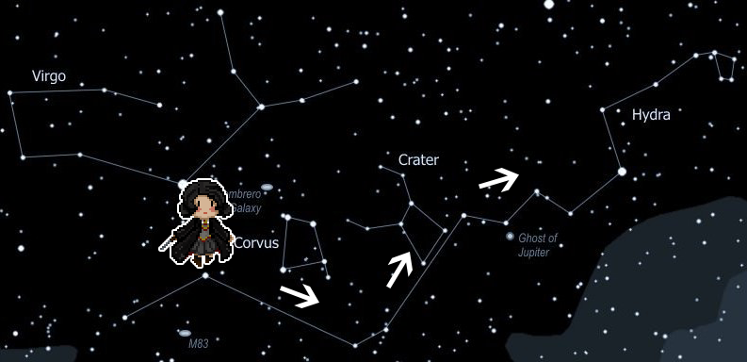

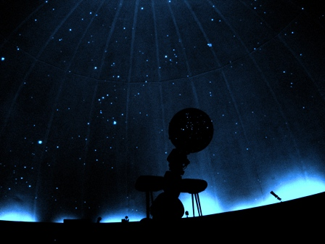There are tree level of height of the observatory.

#### C:\Users\689290\Desktop\lvl\ASTRONOMY\sfere-armillari.pngConstellator

The Constellator is the tool you need to activate the observatory. It is possible to select a constellation of high, medium and low sky and combine them. There are also three star ways that can be activated. The Golden Snitch will follow the selected star way.

#### Golden Snitch

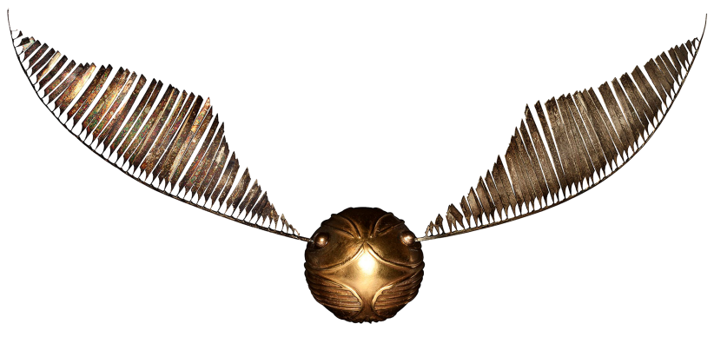On top of the observatory dome is a golden snitch. Snitches of this type are widely used in the study of astronomy and Quidditch sport. This snitch is to show students the star ways. Inside the snitch is the signet.

#### Star ways

Star ways are the path of the celestial light in the space. The Golden Snitch will follow the path once activated.

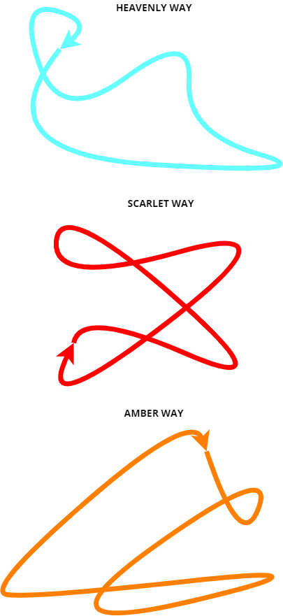

#### Signet

The signet of the botany section, belonging to the muse of Celeste.

#### Map of the stars

It's a manual for using the Constellator. Inside it there are written all the magical constellation. Constellation are divided in: high(blue), medium(yellow), low(pink).

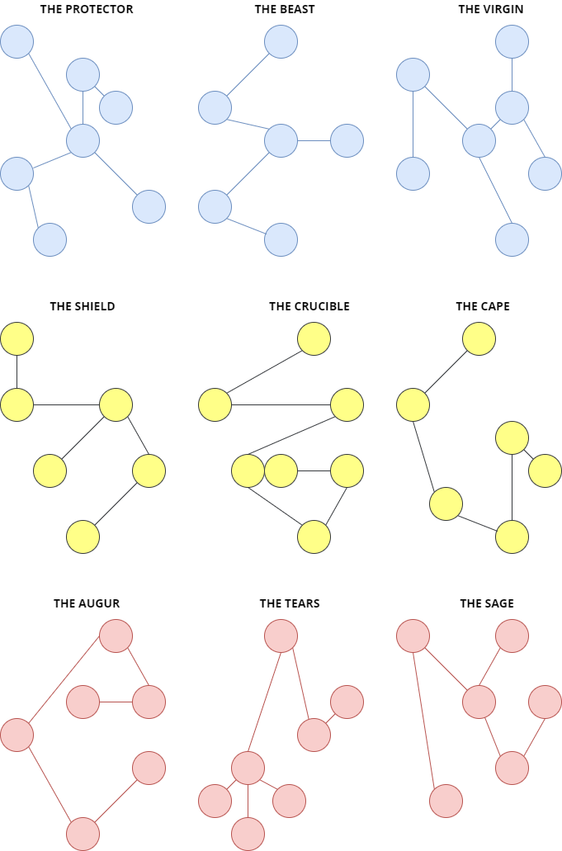

#### The Apprentice's book

It is an Hogwarts student's book. The book is inside the observator in the first level, so it's reachable only displaying one low sky constellation (Augur, Tears or Sage). The reason the book is there is unknown. The apprentice discovered that the right combination of constellation can drive you to a Rowena Ravenclaw's diary page. He discovered that the combination begins with Tears. There aren't Shield or Beast in the combination.

#### Rowena Ravenclaw's diary page

Rowena Ravenclaw, one of the founder of Hogwarts, was an expert of astronomy. She knew the magical mythology. She wrote in her diary the myths related to the constellations. On this page of the diary she tells the myth of "Syriana" the virgin of heaven. The myth tells: "The **augures** of the past spoke of Syriana, the **virgin** of heaven. The courage of this young girl brings her in the sky up to the **amber way.** in order to deliver the **shield** of the deceased grandfather to its rightful owner, she crossed death and came back". This myth gives Minerva all the clues for reaching the Golden Snitch. The diary is in the third level of the observatory

#### C:\Users\689290\Desktop\lvl\ASTRONOMY\Collana-Amuleto-Gioiello-Solare-Katherine-Pierce-Vampire-Diaries-1.jpgLouis Mother's amulet

In the main section Louis Delacroix asked Minerva to retrieve his mother's amulet. The amulet has been hidden in the third level of the observatory.

### Film script

1. When Minerva reach the path on the ceiling, The chandeliers in front of her start to move. The chandelier closest to her hits the beam. Minerva understands that that lap pad can provide her with a path.
2. Once Minerva completes the platform path she looks back. **Minerva:** "*For real?! Also the chandeliers are an issue now?!"*
3. Minerva reach the Astronomy section from the path on the ceiling. A cutscene starts. The camera go all over the room starting from the bottom until it reach the plant of the planetarium. Then the camera start going up until it reach the Golden Snitch. the cutscene ends.
4. Minerva activates the Constellator. **Minerva:** "*That it's gorgeous! I just need a way to understand the name of the constellation!"*
5. Minerva finds the map of the stars. **Minerva:** "*That's what i was looking for! now it's all clear".*
6. Minerva finds the apprentice's book. **Minerva: "***Mmmmm... Magnus maybe? I can't recognize the* *calligraphy. But why are you here book?***"**
7. Minerva reads the Rowena Rawenclaw's diary page. **Minerva: "***Syriana... I didn't know this story, why didn't they teach this in divination class? Know I understand who is the virgin in the constellation.***"**
8. Minerva catch the Golden Snitch. **Minerva: "***Got it! Now let's see what's inside...***".**

### Gameplay

### C:\Users\689290\Downloads\download (2).pngIn this section all the gameplay is built around the observatory puzzle. Minerva has to find all the clues for finding the right constellation path to the Golden Snitch. So there are Exploration moments too. Before Entering the Astronomy section there is a platform path. There aren't any kind of combat or dialogue.

#### Exploration

There are several elements inside the room: the observatory, the constellator, the map of the stars, the apprentice's book, the amulet of Louis's mother, Rowena's diary and the Golden Snitch. In addition there are a potion and a Chocolate frog card.



* Apprentice's book
* Constellator
* Chocolate frog card



* Amulet of Louis's mother



* Map of the stars
* Rowena Ravenclaw's diary



* Golden Snitch



* Potion

#### Puzzle

The astronomy section puzzle is a puzzle based on the combination of various elements. The player must combine a group of three elements (**low constellations**), another group of three elements (**medium constellations**), another group of three elements (**high constellations**) and three possible **star way**. The player has the opportunity to immediately test the combinations freely. There are 91 possible combinations of solutions. It's very unlikely that he will find the right combination. This leads the player to look for clues around the room.

A first clue can be found on the first level of the observatory, **Apprentice's book**. All three (Augur, Tears and Sage) low constellations lead to this clue, so the player will have no problem finding it.

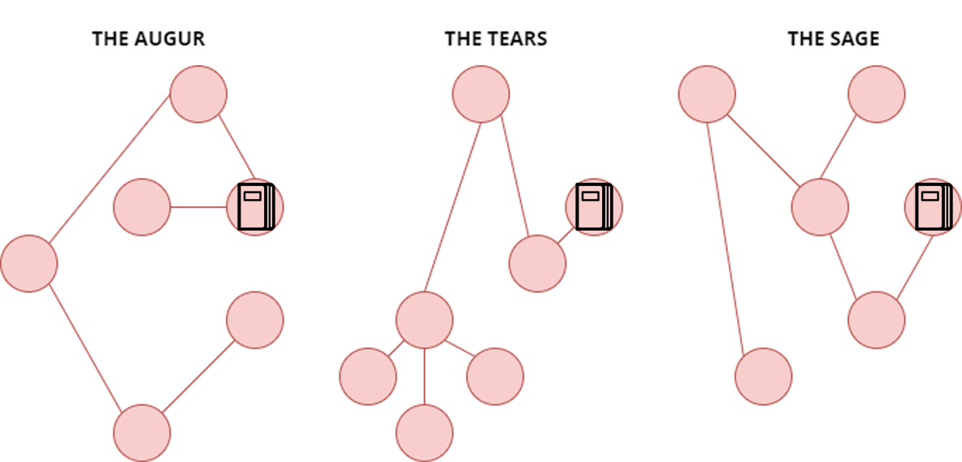

A second clue is found on the shelf behind the Constellator. This is the **Map of the starts** which provides a way to decipher the diary (each constellation corresponds to a name). Once the apprentice's book is deciphered, the player knows that he must obtain **Rowena Ravenclaw's diary** to get the Golden Snitch.

In the book he says that the low constellation is **The Tears**, the medium constellation is **NOT The Shield** and the high constellation is **NOT The Beast**. N.B. the star way is only for catching the snitch, not for Rowena's diary. In this way the possible combinations are 1 x (3-1) x (3-1) = 4. The player must find the right combination between these four. The right combination is: The Tears, The Cap and The Protector.

Once Rowena's diary is found, the player can directly decipher the combination for the **Golden Snitch** (The Augur, The Shield, The Virgin and the Amber way).

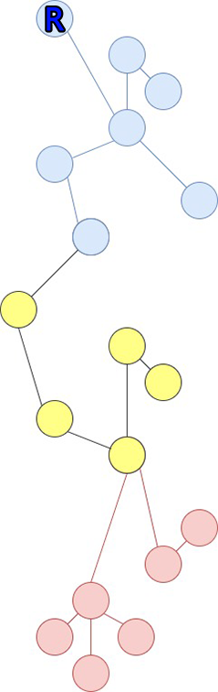There are other combinations for taking the aumulet of Louis's mother, the Chocolate frog and the potions. The path for this element are unknown to the player. Going on in the main story of the game Minerva can understand the right path for the amulet.

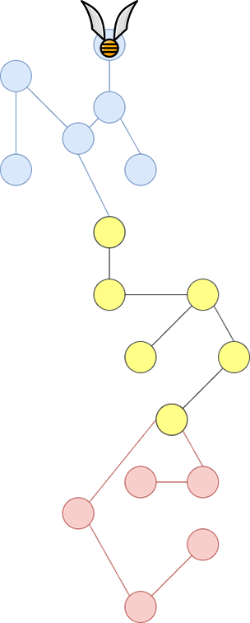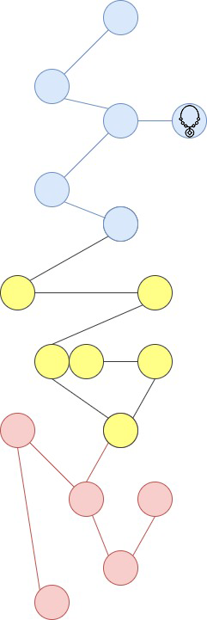

***AUGUR+SHIELD+VIRGIN***

***TEARS+SHIELD***

***TEARS+CRUCIBLE***

***SAGE+CRUCIBLE+BEAST***

***TEARS+CAPE+PROTECTOR***

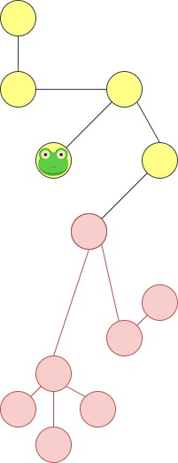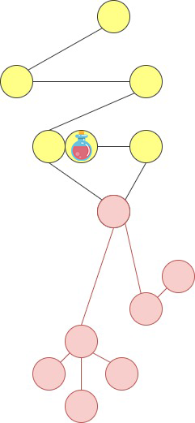

#### Platform

The path on the ceiling cross the main section in the central area. It cross the three main arches of the room.

Between the three arches of the ceiling there are six chandeliers that move independently

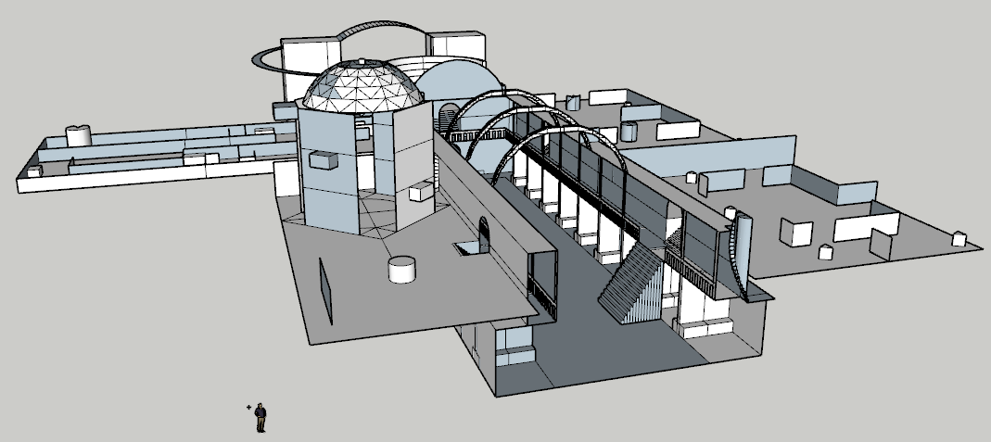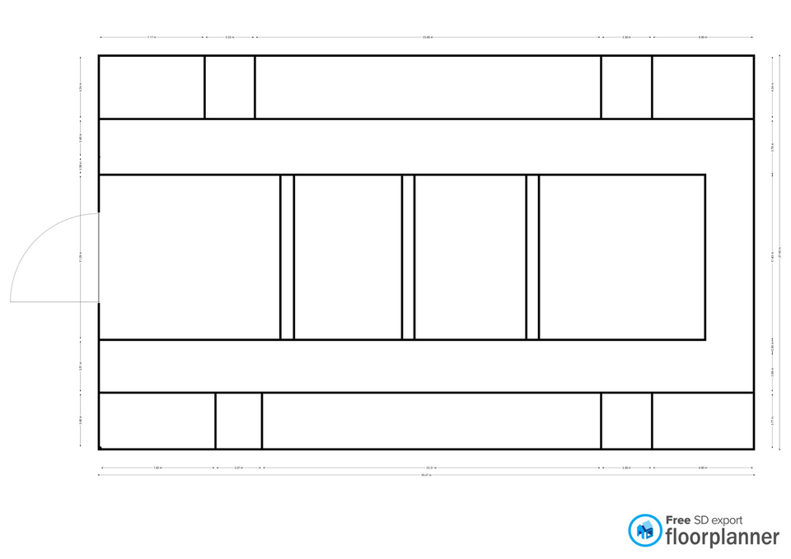

The chandeliers move in three different ways: directly, transversely and obliquely.

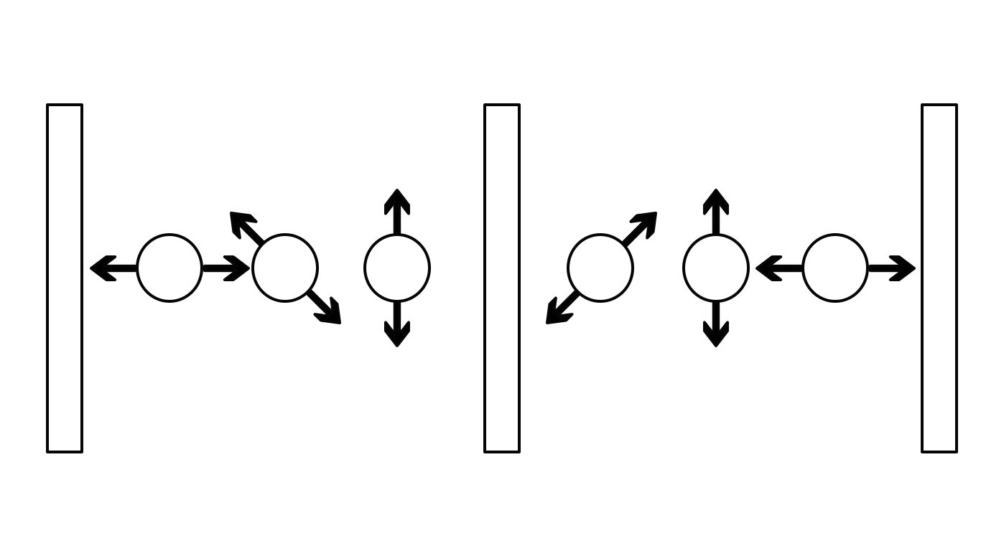

Minerva must jump on the chandeliers when the two adjacent ones are at minimum distance.

### Lights

The room is not very bright. The lights are concentrated on the Constallator and the observatory. Each time a constellation is activated, the lights in the room change position. The star ways are very bright. Each has a color (Blue, Red and Gold). These lights give a shade to the whole room (stronger in the center of the observatory). The lights are designed to highlight the Golden Snitch.

### Sounds

|  |  |
| --- | --- |
| Sound Effect | Track |
| Chandelier crushing | Crush.wav |
| Constellation activation | Constellation.wav |
| Golden Snitch noises | GoldenSnitch.wav |