### Bestiary section

### Area description

The bestiary section is a rectangular room with some bookcases and five statues, each one representing a magical creature.

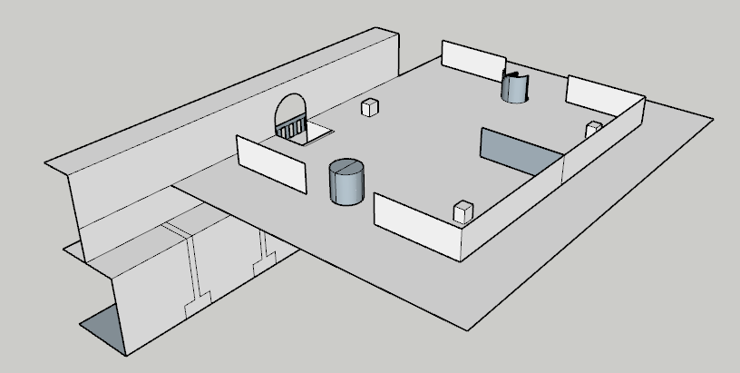

### Lore

All of the library material on magic creatures is contained in this section. It’s very hard to be mistaken, considering that most books in this section have fur, claws or teeth. Standing tall among the corridors of this section are the riddling statues. By night, the unfortunate intruder will have to bear with the souls inhabiting the statues, always trying to trick and disorient their listener.

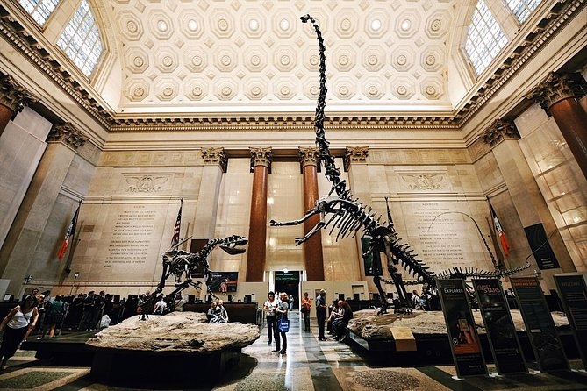

### Map

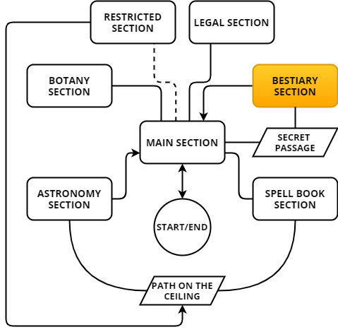

The bestiary section can only be reached by the player through the secret passage in the main section. The secret passage is hidden behind a bookcase.

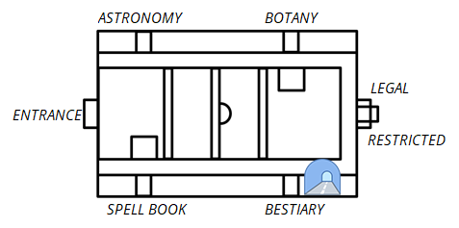

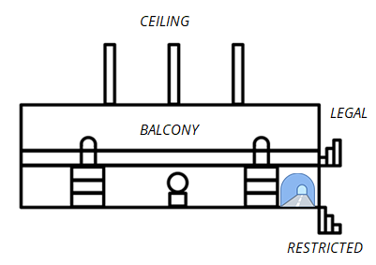

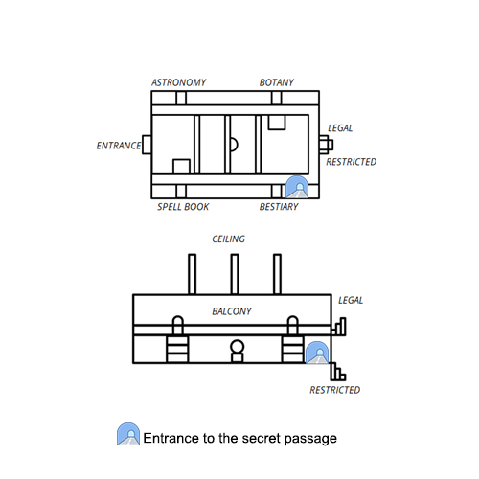

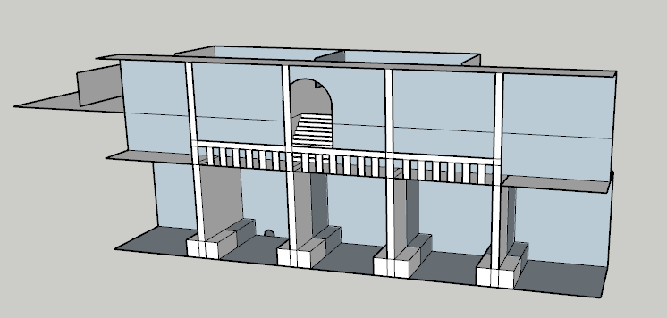

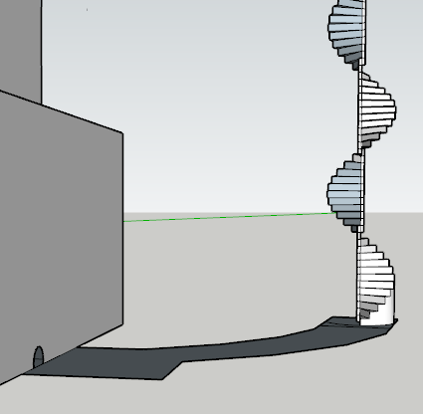

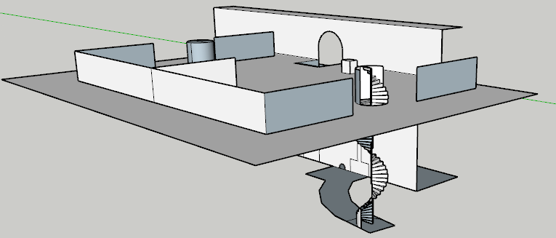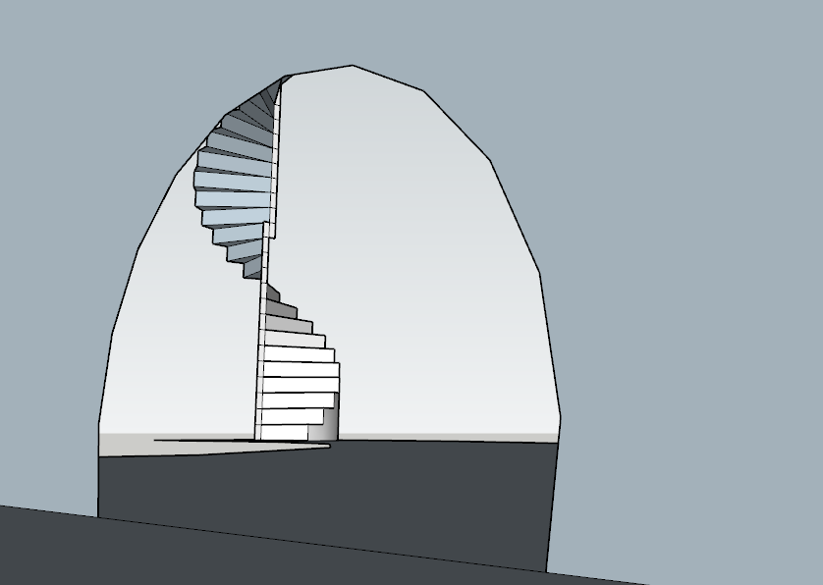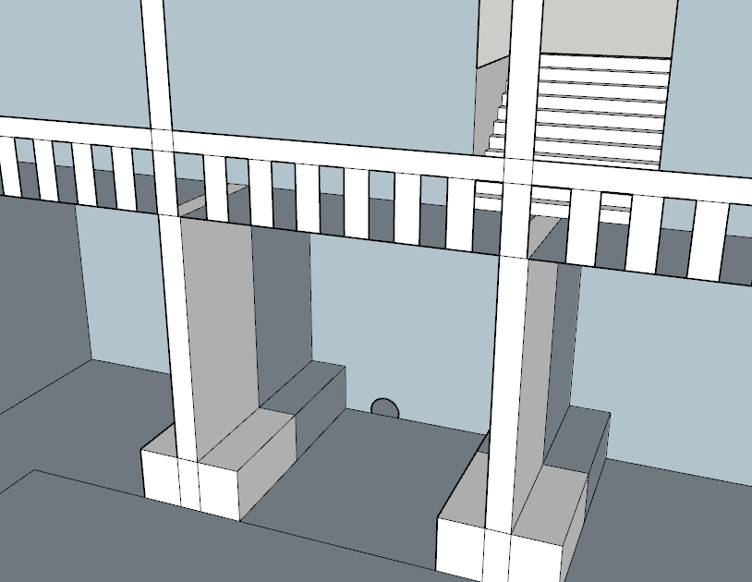

**Structure of the bestiary section:**

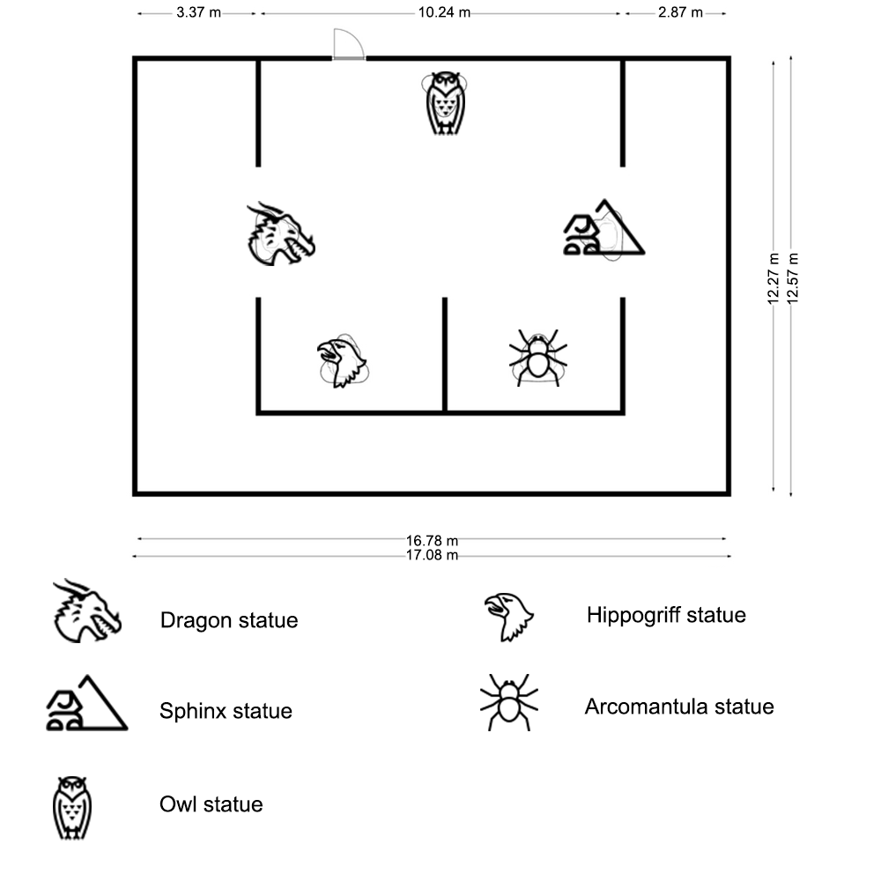

### Goals

The main goal inside the bestiary section is to find the signet of the section. 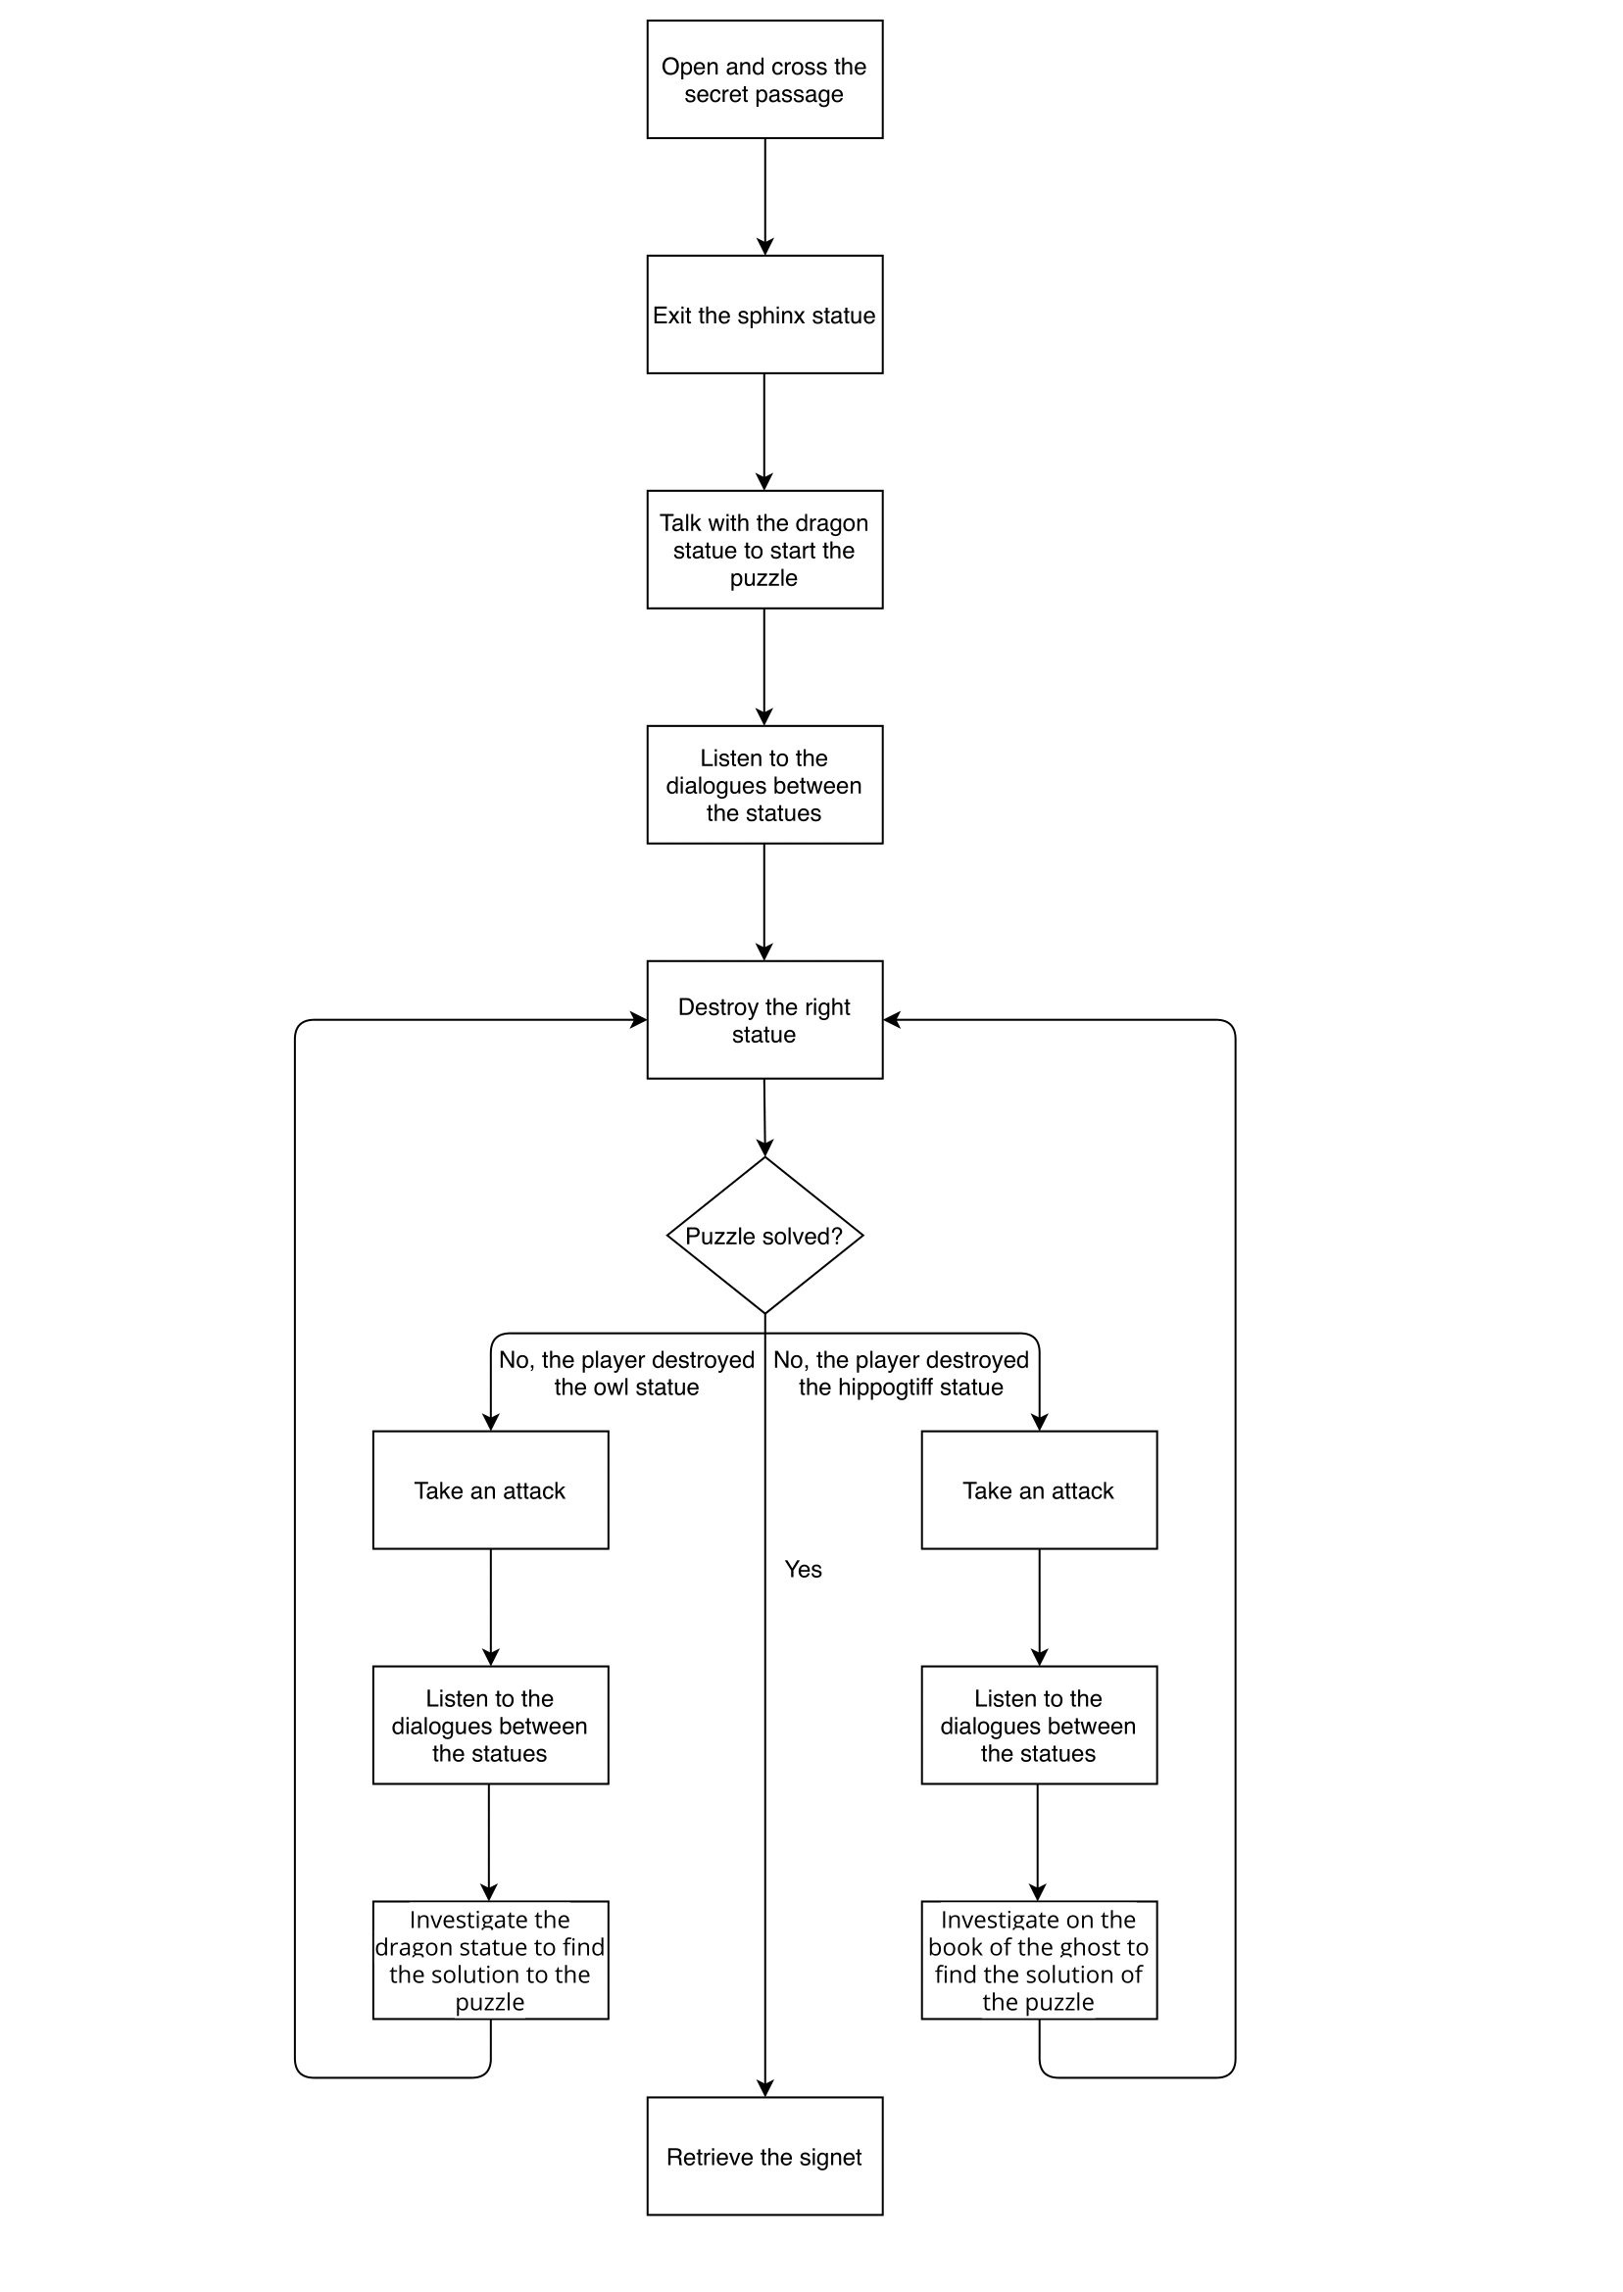

#### Main quest

#### Enter in the secret passage:

Minerva must:

* + Investigate on the strange library
  + Open the door with Alohomora
  + Use Animagus form
  + Enter the passage and take the platform path
  + Get out of the sphinx statue

#### Investigate on the statue of the dragon:

If Minerva interacts with the statue of the dragon this will start the puzzle.

#### Solve the puzzle:

The puzzle is solved when Minerva destroys the correct statue, the statue of the acromantula.

#### Collect the signet:

Miverna must collect the signet of the bestiary section that is required to open the restricted section.

### Room contents

The Bestiary Section has a square structure in which there are bookcases and five statues of creatures: the statue of the sphinx, the statue of the dragon, the statue of the owl, the statue of the hippogriff and the statue of the acromantula. The signet of this section is hidden in the statue of the acromantula.

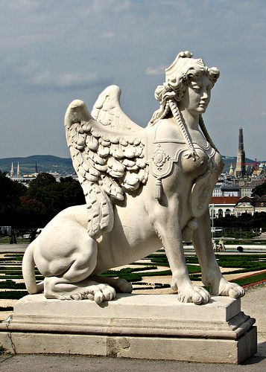

**Sphinx statue:** On the statue there is a plate with the name of the creature and its description: “The Egyptian sphinx has a human head on a lion’s body. Highly intelligent, the sphinx delights in puzzles and riddles. It is usually dangerous only when what it is guarding is threatened.”

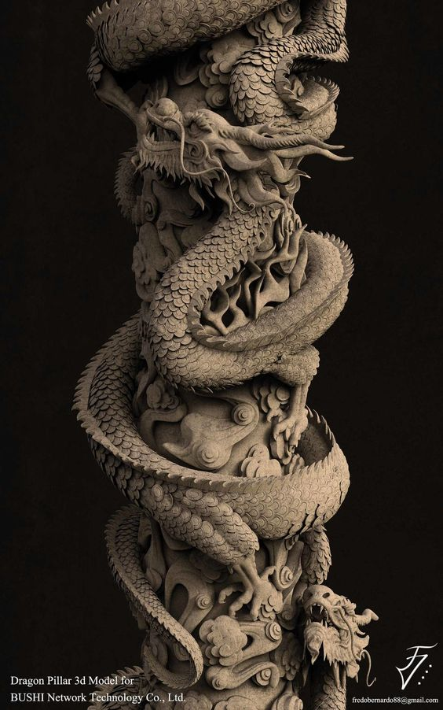

**Dragon statue:** On the statue there is a plate with the name of the creature and its description: “Mountain dragons are giant, winged, ice-spitting reptilian creatures. Widely considered terrifying yet majestic, they can be found all over the world.”

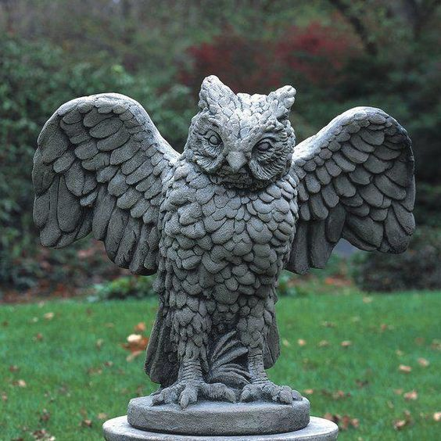**Owl statue:** On the statue there is a plate with the name of the creature and its description: “Owls are magical creatures most often used for delivering post and parcels in the wizarding world. They are known for their speed and discretion and can find recipients without an address.”

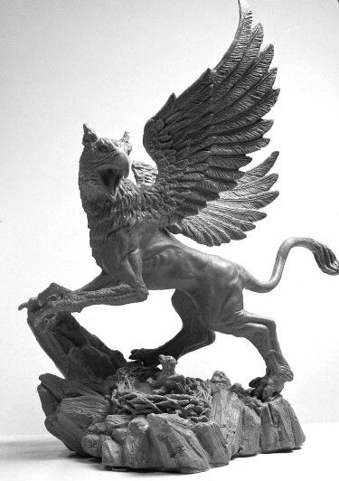

**Hippogriff statue:** On the statue there is a plate with the name of the creature and its description: “Half horse, half eagle creatures, immensely proud and extremely dangerous.”

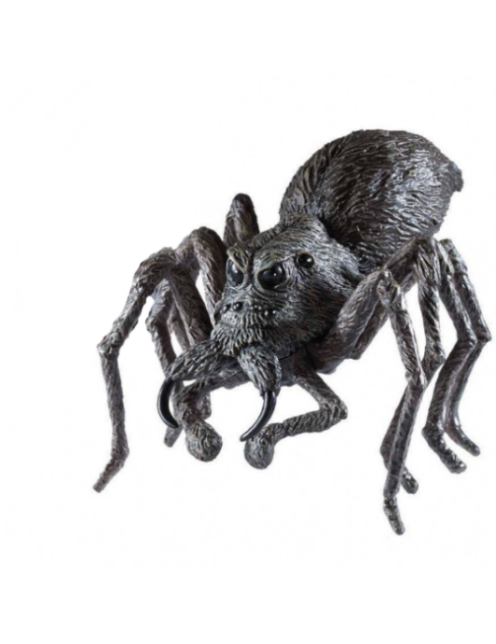

**Acromantula statue:** On the statue there is a plate with the name of the creature and its description: “Spider the size of carthorses, eight-eyed, eight-legged, black, hairy, gigantic.

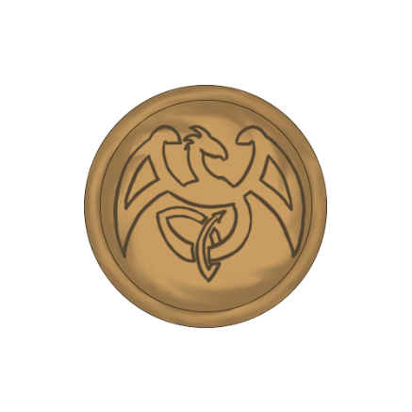

**Signet:** Signet of the Bestiary Section belonging to the muse of creatures.

### NPCs details

**Soul of the statues:** Each night in the bestiary section, the statues of the creatures come to life with the task of deceiving the intruders so as not to make them steal the signet. The souls of the statues are none other than the souls of the creatures they represent:

**Sphinx’s soul:** For over a thousand years she has been used by witches and wizards to guard valuables and secret hideaways. Her name was Alima.

**Dragon’s soul:** One of the wisest and most ancient creatures that in the past protected the peaks of the highest mountains and the creatures it housed with its ice powers. His name was Knut.

**Owl’s soul:** Cunning and deceptive creature who once served the most prestigious wizards. Her name was Aemilia.

**Acromantula’s soul:** One of the most docile creatures to be found in the Hogwarts forest. Despite his frightening appearance unlike his fellows, he has helped many wizards to face the dangers of the forest. His name was Pulcrus.

**Hippogriff’s soul:** Proud creature who in the past defended the borders of Hogwarts from intruders and enemies. His name was Zosimus.

### Cutscenes and Dialogues

1. When the interior of the sphinx statue is reached there is a short **cutscene** showing the opening of the belly of the sphinx to allow entry into the section.
2. Once the player has entered the section, Minerva can interact with the door to open the main entrance and at this point the statue of the sphinx smiles to Minerva in a short **cutscene** where the camera is focused on her statue.

**Sphinx:** *“Well done young student, be careful.”*

1. If Minerva interacts with the statue of the sphinx Minerva starts a **cutscene** where she reads aloud the description of the statue and the camera moves to the statue:

**Minerva:** *“This is the statue of a sphinx. The Egyptian sphinx has a human head on a lion’s body. For over a thousand years it has been used by witches and wizards to guard valuables and secret hideaways. Highly intelligent, the sphinx delights in puzzles and riddles. It is usually dangerous only when what it is guarding is threatened.”*

If Minerva interacts with the statue of the owl Minerva starts reading aloud the description of the statue and the camera moves to the statue:

**Minerva:** “*This is the statue of a owl. Owls are magical creatures most often used for delivering post and parcels in the wizarding world. They are known for their speed and discretion and can find recipients without an address.”*

If Minerva interacts with the statue of the acromantula Minerva starts reading aloud the description of the statue and the camera moves to the statue:

**Minerva:** “*This is the statue of a acromantula. Spider the size of carthorses, eight-eyed, eight-legged, black, hairy, gigantic.”*

If Minerva interacts with the statue of the hippogriff Minerva starts reading aloud the description of the statue and the camera moves to the statue:

**Minerva:** *“This is the statue of a hippogriff Half horse, half eagle creatures, immensely proud and extremely dangerous.”*

If Minerva interacts with the statues they will repeat this sentences.

1. If Minerva interacts with the statue of the dragon it begins to move its head, forelegs and starts talking to the young Minerva in a **cutscene** where the camera is focused on the statue:

**Dragon*:*** *"Well well well, take a look at who came to visit us at this time of the night ... an intruder! But we know what you are looking for, let me guess mmm ... is it by any chance a circular object with some symbol engraved on it? I think I saw it somewhere ... maybe one of my friends keeps it inside his statue, but you know ... if I were you, I wouldn't trust them too much. Only one of my friends is sincere and has the signet. "*

At this point the statues of the owl, the acromantula and the hippogriff also begin to come alive and talk to a surprise Minerva not letting the young student speak. The camera moves from statue to statue.

**Minerva:** *“Oh, how did you-“*

**Owl:** *"What you are looking for is in my possession, you can trust me."*

**Acromantula:** "Don't listen to the owl, she always lies!"

**Hippogriff:** “And do you believe what the acromantula says? He tells a lot of lies."

**Minerva’s thoughts:** "I have to destroy the statue that contains the signet ... but which one?"

If Minerva interacts with the statues they will repeat this sentences.

1. If the player makes a mistake and destroys the wrong statue there are two possible dialogues with two different **cutscene** where the camera is focused on the statue which are speaking:
2. If Minerva destroys the statue of the owl the remaining statues resume talking:

**Acromantula:** *“Now don't say I didn't warn you! I don't lie, as it is true that my friend dragon spits ice!"*

**Hippogriff:** *"You're a gullible girl! Does that look like an ice-breathing dragon? Dragons of this type breathe fire, everyone knows!"*

If Minerva interacts with the statues they will repeat this sentences.

1. If Minerva destroys the statue of the owl the remaining statues resume talking:

**Owl:** *“What is not clear to you about the phrase “I have the key”? You humans are so dull... like Louis Delacrà. "*

**Acromantula:** *"You keep lying as always owl! Listen to me, I tell the truth, as it's true that my ghost friend's name out there is Louis Delacroix and not “Louis Delacrà”. It is also written on the cover of his book!"*

If Minerva interacts with the statues they will repeat this sentences.

1. If the player fails again there is another short **cutscene** and the camera is focused on the acromantula statue:

**Acromantula:** *"Well ... I TOLD YOU! It serves you right."*

1. Once the puzzle is finished, there is a **cutscene** where the statues are rebuilt and the dragon says two different sentences in base on the action of Minerva:
2. If the player has immediately guessed the puzzle he will say:

**Dragon:** *“My congratulations, did you like our little game? Too easy for someone like you, isn't it? AHAHAHAH "*

1. If the player made mistakes:

**Dragon:** *“Ohw I'm sorry you got hurt but you were warned ... My friends can't be trusted, except the acromantula, he can't lie. AHAHAHAHA "*

#### Gameplay

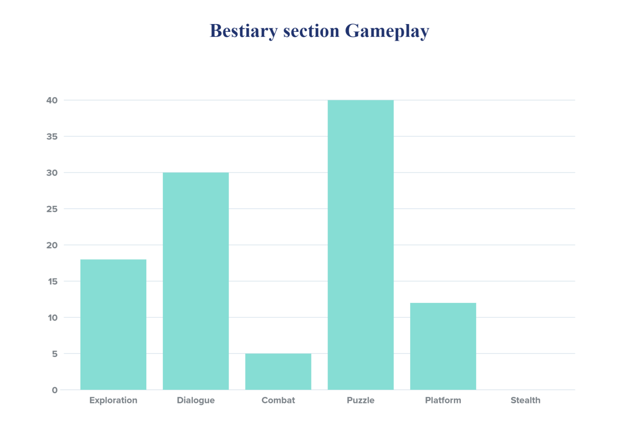This area of ​​the map is mostly dialogue and puzzle oriented. The main goal of the section is to solve the puzzle consisting of dialogues to get the signet of the Bestiary Section.

#### Exploration

The player must explore the main section to find the secret passage leading to the bestiary section. A clue that will help the player find this passage is given by the word “Investigate” that appears when you are near the library.

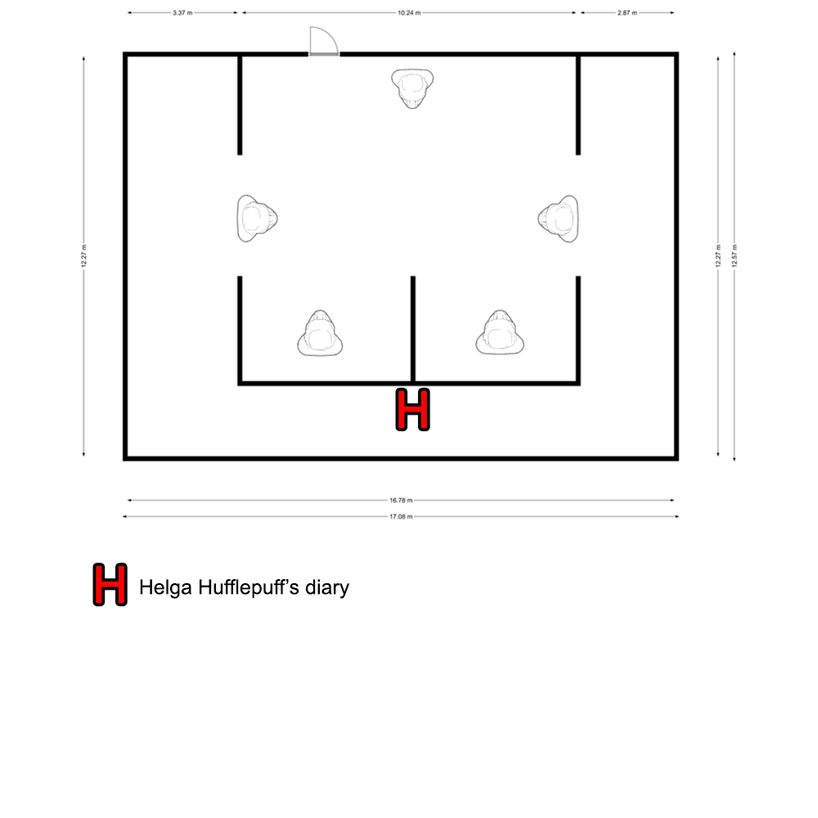In the section there is one hidden collectible.

#### Dialogue

This section is full of dialogues in fact the puzzle consists of a series of dialogues with the statues of the creatures in the room.

#### Combat and Stealth

In this section there are not combat or stealth mode.

#### Puzzle

1. The first puzzle is to find the way to enter the bestiary section by finding the secret passage in the main section. It will be up to the player to understand that he will have to use the "Alohomora" spell to open the library.
2. In the Bestiary Section the main puzzle that allows you to take one of the signets to be inserted in the door leading to the Restricted Section consists of a dialogue between the statues of the creatures. Solving the puzzle earns Minerva **200 experience points.**

If Minerva interacts with the statue of the dragon this will start the puzzle. The dragon statue begins to move its head, forelegs and starts talking to the young Minerva:

**Dragon statue*:*** *"Well well well, take a look at who came to visit us at this time of the night ... an intruder! But we know what you are looking for, let me guess mmm ... is it by any chance a circular object with some symbol engraved on it? I think I saw it somewhere ... maybe one of my friends keeps it inside his statue, but you know ... if I were you, I wouldn't trust them too much. Only one of my friends is sincere and has the signet. "*

At this point the statues of the owl, the acromantula and the hippogriff also begin to come alive and talk to Minerva.  
  
**Owl:** *"What you are looking for is in my possession, you can trust me."*

**Acromantula:** *"Don't listen to the owl, she always lies!"*

**Hippogriff:** *“And do you believe what the acromantula says? He tells a lot of lies."*

**Minerva’s thoughts:** *"I have to destroy the statue that contains the signet ... but which one?"*

In this puzzle the player has to figure out who is the only sincere statue among all the others. To solve the puzzle it will therefore be sufficient to assume that one of the statues is telling the truth and to verify if it is the **only one** to tell the truth. Below are truth tables to verify that the puzzle works.

|  |  |
| --- | --- |
| Let's assume the **owl** is telling the **truth** | |
| Acromantula | **False**  Because he is saying that the owl alway lies. |
| Hippogriff | **True**  Because he is saying that the acromantula is a liar. |

So if we assume that the owl is the sincere statue there will be two statues that tell the truth and therefore the solution to the puzzle is wrong.

|  |  |
| --- | --- |
| Let's assume the **hippogriff** is telling the **truth** | |
| Acromantula | **False**  Because the hippogriff said acromantula is a liar. |
| Owl | **True**  If the acromantula is lying then the owl is telling the truth. |

So if we assume that the hippogriff is the sincere statue there will be two statues that tell the truth and therefore the solution to the puzzle is wrong.

|  |  |
| --- | --- |
| Let's assume the **acromantula** is telling the **truth** | |
| Owl | **False**  Because the acromantula said owl is a liar. |
| Hippogriff | **False**  Because the hippogriff said acromantula is a liar. |

So if we assume that the acromantula is the sincere statue there will be only one statue that tell the truth and therefore the solution to the puzzle is correct so Minerva must destroy that statue.

If the player makes a mistake and destroys the wrong statue, the statue's soul throws a blow at Minerva doing her **4 damage** and than the statue’s soul goes away laughing. There are therefore two cases:

1. If Minerva destroys the statue of the owl the remaining statues resume talking:

**Acromantula:** *“Now don't say I didn't warn you! I don't lie, as it is true that my friend dragon spits ice!"*

**Hippogriff:** *"You're a gullible girl! Does that look like an ice-breathing dragon? Dragons of this type breathe fire, everyone knows!"*

Minerva should now investigate the dragon statue to find the solution placed on a plate containing the description of that creature.

1. If Minerva destroys the statue of the owl the remaining statues resume talking:

**Owl:** *“What is not clear to you about the phrase “I have the key”? You humans are so dull... like Louis Delacrà. "*

**Acromantula:** *"You keep lying as always owl! Listen to me, I tell the truth, as it's true that my ghost friend's name out there is Louis Delacroix and not “Louis Delacrà”. It is also written on the cover of his book!"*

To find out who is telling the truth, Minerva must investigate on the book that the ghost outside the Bestiary Section keeps next to him.

If the player fails again, he takes **another attack** and the acromantula says:

**Acromantula:** *"Well ... I TOLD YOU! It serves you right."*

Minerva must then destroy the acromantula statue and take the signet that the statue drops.

Once the puzzle is finished, the statues are rebuilt and the dragon says two sentences:

1. If the player has immediately guessed the puzzle he will say:

**Dragon:** *“My congratulations, did you like our little game? Too easy for someone like you, isn't it? AHAHAHAH "*

1. If the player made mistakes:

**Dragon:** *“Ohw I'm sorry you got hurt but you were warned ... My friends can't be trusted, except the acromantula, he can't lie. AHAHAHAHA "*

#### Platform

The Bestiary Section is accessible via the secret passage found in the Main Section which can only be traversed by Minerva in her Animagus form. Once inside the passage there is a small platform path that allows the player to go up inside the statue of a sphinx which is located in the Bestiary Section.

### Enemies

In this section there is no enemy to fight. The only damage Minerva can take is from the statues if she gives a wrong answer.

### Lights

The lights in the room are not particularly arranged. The whole room is evenly illuminated. The animal statues are slightly brighter than the rest of the room.

### Sounds

As the statues of creatures speak, at the beginning of each sentence they emit the noises of the creatures they represent.

|  |  |
| --- | --- |
| **Sound Effect** | **Track** |
| Dragon | Dragon.wav |
| Owl | Owl.wav |
| Hippogriff | Hippogriff.wav |
| Acramantula | Acramantula.wav |