**VISUALS**

The Bestiary Section is accessible via the secret passage found in the Main Section which can only be traversed by Minerva in her Animagus form. Once inside the passage there is a small platform path that allows the player to go up inside the statue of a sphinx which is located in the Bestiary Section. When the interior of the statue is reached there is a short **cutscene** showing the opening of the belly of the sphinx to allow entry into the section.

The Bestiary Section has a square structure in which there are bookcases and five statues of creatures: the statue of the sphinx, the statue of the dragon, the statue of the owl, the statue of the hippogriff and the statue of the acromantula.

**Sphinx statue**

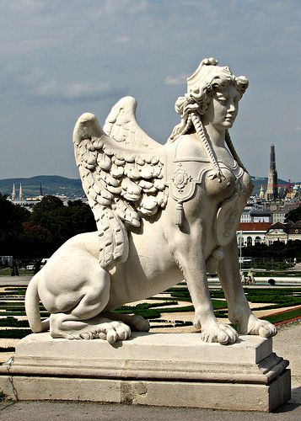

**Dragon statue**

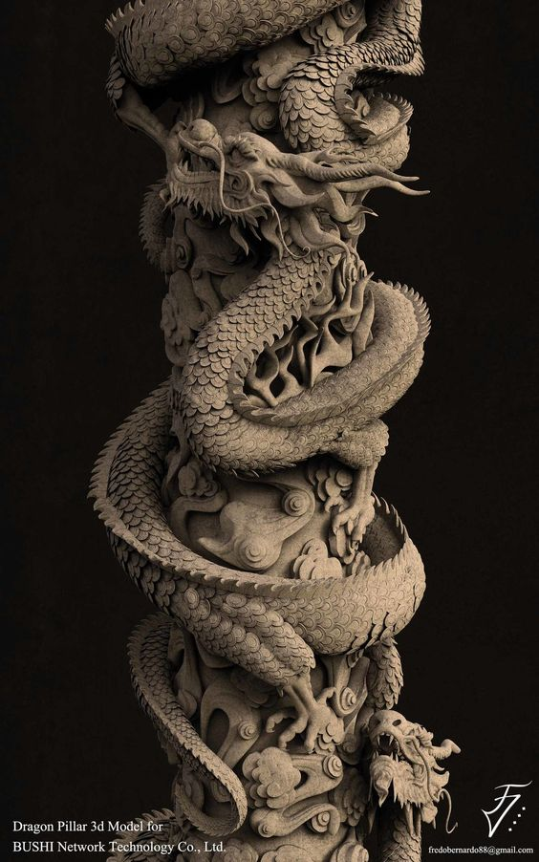

**Owl statue**

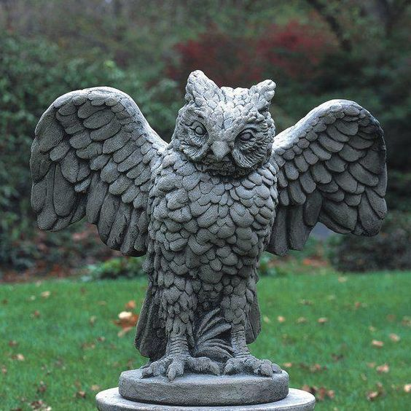

**Hippogriff statue**

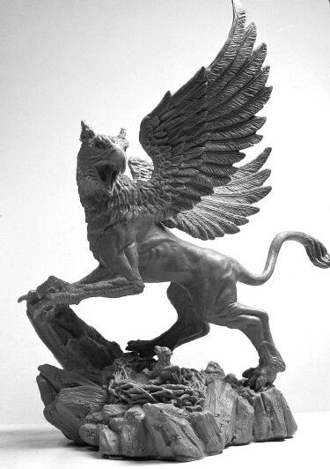

**Acromantula statue**

