### Botany section

### Area description

The botany section is a rectangular room with a few bookcases as well as some potion work desks. In the corner furthest from the entrance there’s a gigantic Salix. Its branches climb all over the room and its shelves.

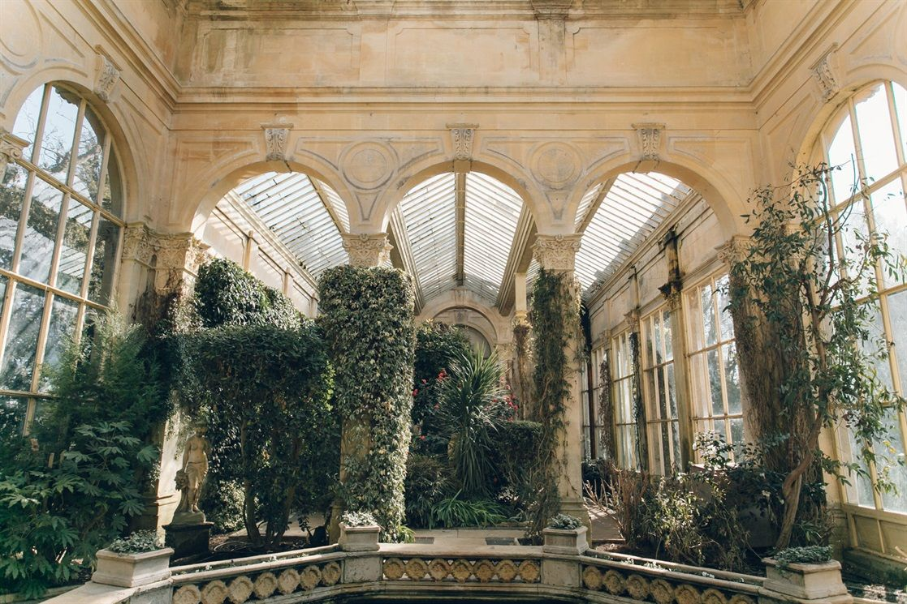

### Lore

The botany section contains books regarding nature, herbology and potions. The botany section is also home for the Sibyline Salix. The tree was brought in the library in a pot while it was as tall as a peanut, to brighten the mood. It is said that in just one night the salix grew up into covering the entire section with its crumbling branches, giving the room the verdant look it still has nowadays. Despite the numerous attempts to trim and contain the salix, it always grew back. Eventually, it was decided to leave the Salix be, given that it was always very polite in not invading the rest of the library.

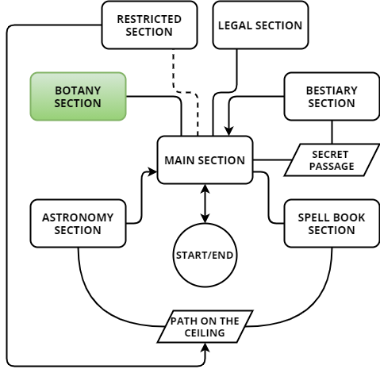

### Map

The botany section is directly accessible at any moment from the balcony of the main section. On the inside, the section assumes two different structures.

### Rest form

Normally, the room is quite empty, with bookcases along its walls, a few potion desks and a big tree in the farthest corner from the entrance.

### Maze form

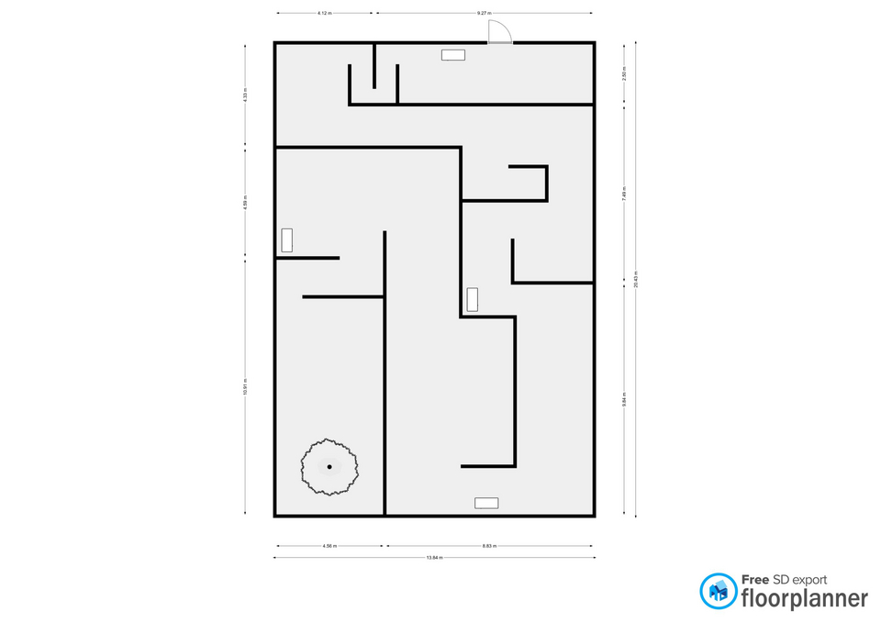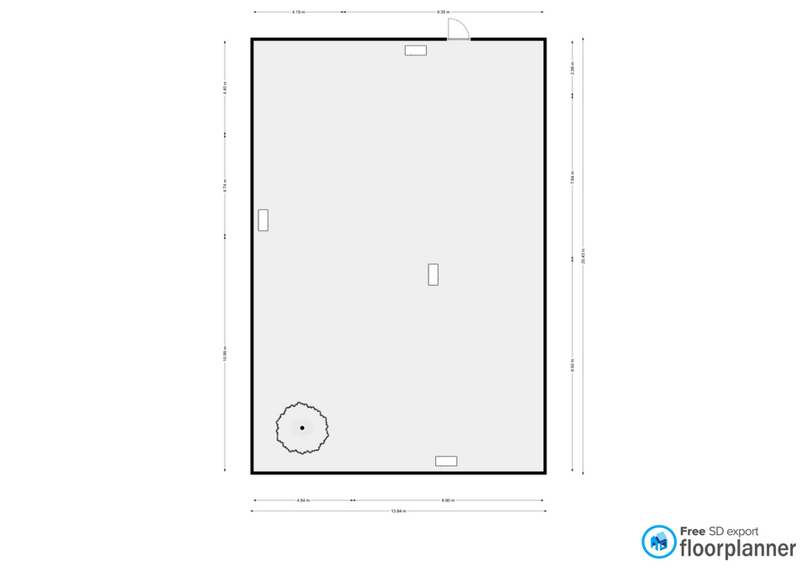When the player takes the room signet the room changes. The initial structure persists, while a maze appears inside it. The maze is really just an articulated corridor, to give the player the impression of being trapped in the room, without adding the logical challenge of solving a maze to the various goals of the area.

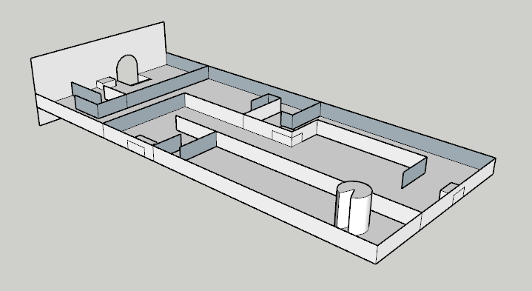

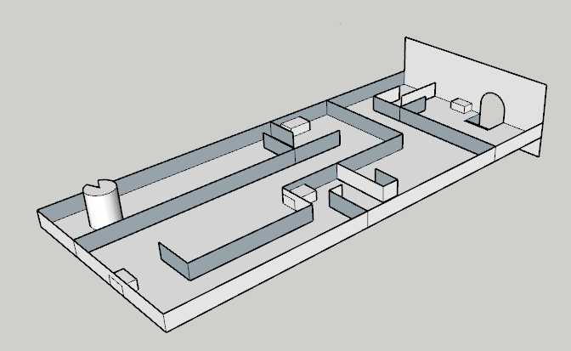

### Goals

The main goal inside the botany section is to retrieve the section’s signet. Finding the signet is very easy. The challenge lies in bringing it out of the room.

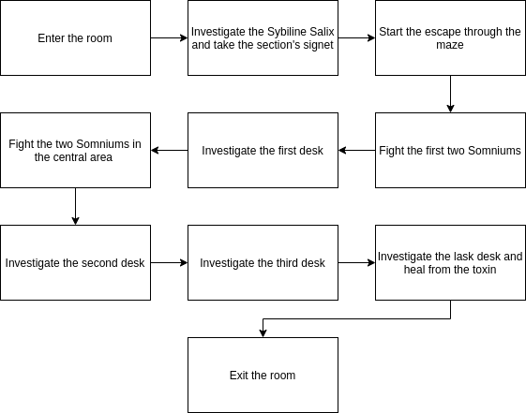The signet is held by the sybiline salix. As soon as Minerva interacts with the salix, the tree intoxicates her. The toxin causes Minerva to hallucinate. Minerva sees a maze growing in the room and has to escape it. While escaping the maze, Minerva has to find a cure for the toxin, investigating the potion desks spread in the room. Along the maze Minerva encounters some enemies (Somniums), and has to defeat them.

### Room contents

The Botany Section has a rectangular structure. Inside there are bookshelves, some **work tables** with various potions and **antidotes** on them and on the opposite side of the entrance there is a huge vase containing a **tree** surrounded by flowers in the middle of which the **seal** of the section is hidden. Among these flowers is an ancient green flower called **Somnium Viridis** which protects the library by poisoning intruders through hallucinogenic spores it releases. When Minerva begins to hallucinate from the spores, a long corridor formed by tall **hedges** appears in the section.

|  |  |
| --- | --- |
| Work tables Provided with a wide variety of tools and ingredients, these tables allow the students to practice the knowledge they acquire in the botany section. |  |
| Antidote On the work tables, among the various potions, there are some antidotes. A few of them has the property of healing the toxin of the Somnium Viridis, the green flower that has grown on the Sybilin Salix and protects the signet. |  |
| Sybiline Salix The botany section is home for the Sybilin Salix, a giant tree that has expanded in the entire room with his branches, giving it its verdant look. The salix holds the section’s signet and an exemplar of Somnium Viridis, a very rare and toxic flower. |  |
| Somnium Viridis A very rare and toxic flower. Its toxin causes strong hallucinations. The Sybiline Salix uses the Somnium Viridis to protect the section’s signet from intruders. |  |
| Signet The signet of the botany section, belonging to the muse of flora. |  |
| Hedges The maze that appears to the intruder while he is hallucinating is composed of high hedges |  |

### Cutscenes and Dialogues

1. When Minerva enters the room for the first time:  
    **Minerva:** “The botany section. Not many places to hide the signet in here. One thing I am sure of: if something is up in the botany section, the Salix is involved.”
2. When Minerva interacts with a work desk, before interacting with the signet:  
    **Minerva:** “*Potions, elixirs, antidotes. The library really has it all.*”
3. When Minerva interacts with the signet held by the Salix a **cutscene** starts. The cutscene shows Minerva grabbing the signet and observing it for a little while.  
    **Minerva:** “Well, that was easy.”  
    The noise of the Somnium Viridis spores is heard and the spores are visually represented by a green bright powder. Minerva starts coughing and waving her arms to try and dissipate the spores. The camera loses and regains focus to show Minerva senses being altered by the toxin. Minerva falls on her knees. The camera zooms on her face while she keeps coughing. Minerva stops coughing and slowly rises her head. When she does, her eyes open wide. At this point the camera zooms out, showing what Minerva sees in her hallucination. She is know surrounded by high and thick hedges. The salix is still behind her and she is holding the signet in her hands.  
    **Minerva:** “*What is going on? Where am I?”*  
   The cutscene ends with Minerva slowly standing up on her feet.
4. When Minerva approaches the location of the first enemy spawn a brief cutscene starts, showing the two Somniums crawling out of the hedges.
5. When Minerva defeats the two Somniums:  
    **Minerva:** “What were those? Am I still in the library?”
6. When Minerva reaches the first work desk, the camera briefly zooms on it.  
    **Minerva:** “Wait, so I am still in the library. This is the strongest hallucination I’ve ever seen. Those creatures felt so real! I need to find an antidote, now.”
7. When Minerva investigates the first work desk:  
    Minerva: *“Nothing useful here. I think I can just… proceed.”*
8. When Minerva reaches the location of the second enemy spawn, as two Somnium crawl out of the hedges:  
    **Minerva:** “Oh! Not this again.”
9. When Minerva investigates the second work desk:  
    **Minerva:** “Seriously? No antidotes? I hate this room.”
10. When Minerva investigates the third work desk:  
     **Minerva:** “No antidotes here either. I’m starting to feel so weak...”
11. When Minerva investigates the last desk:  
     Minerva: *“Finally!”*  
    A brief **cutscene** starts. The camera zooms on Minerva drinking the antidote and expressing disgust with her face. As soon as she recovers from the terrible taste of the antidote, she looks around. The camera zooms out, showing the room has returned to its original shape. Minerva looks at the signet, still lying in her hand.  
     **Minerva:** “This wasn’t that easy, after all.”

### Gameplay

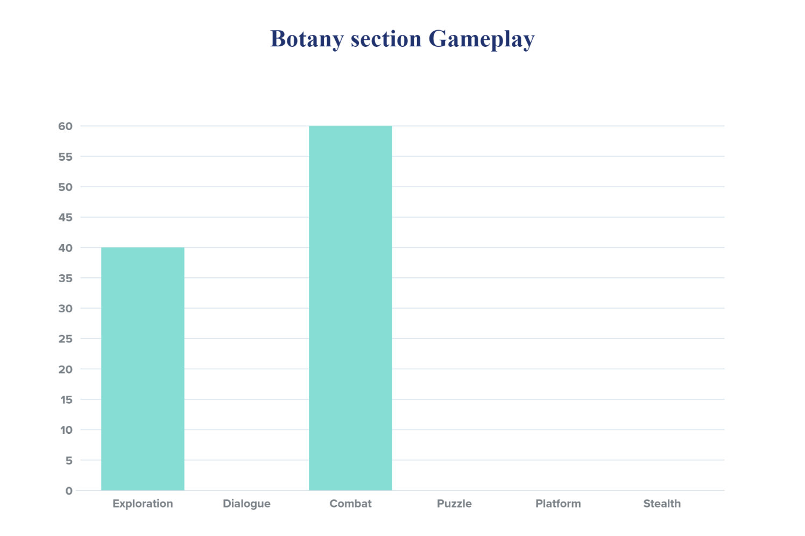This area of the map is focused on exploring the maze and fighting a few enemies.

#### Exploration

Minerva has to explore the maze in search of the exit and the work desks, where she hopes to find the antidote for the toxin. Escaping the room earns Minerva **200 experience points**. The maze is actually just a long and articulated corridor, that doesn’t present the player with branches. Along the corridor the player encounters two fights and a hidden collectible item. The hidden collectible item is a page of Rowena Ravenclaw’s diary.

#### Combat

Minerva encounters two fights in this section of the map. Both fight are against two enemies (two Somniums) and earn Minerva **200 experience points** each.

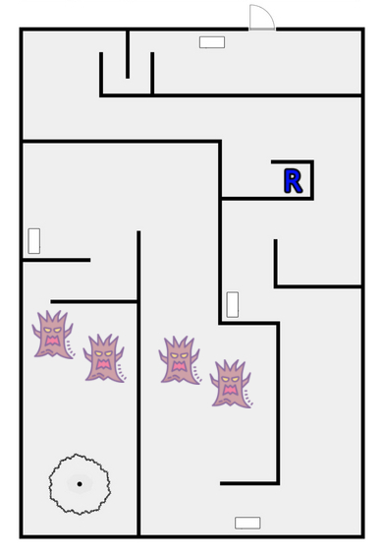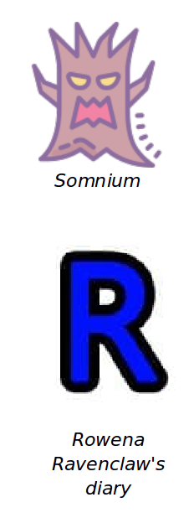

### Enemies

#### Somnium

**Description:** A Somnium is generated by the hallucination given by the poison produced by an ancient flower called Somnium Viridis. This creature is similar to a humanoid tree that defends the library from intruders launching ranged attacks with its long branches.

**Armor Class:** 15

**Hit Points:** 7

**Speed:** 9 metres

|  |  |  |  |  |  |
| --- | --- | --- | --- | --- | --- |
| STR | DEX | CON | INT | WIS | CHA |
| 8(-1) | 10(+0) | 10(+0) | 14(+2) | 8(-1) | 8(-1) |

**Ranged Weapon Attack:** d20 +4 to hit, range 24 meters, one target. Hit: 1d6 +2 magic damage.

**EXP:** 100

### Lights

While in rest form, the room is filled with a weak but warm ambient light. Candles are placed in correspondence of the work desks, acting as the light sources of the room and highlighting the desks to the player. The corner where the tree is located is more lit, in order to attract the player to the main element of the room.

When the room changes to maze form the ambient light becomes colder. The candles are still present aside of the desks, in order to provide the player with some reference to the old structure of the room.

### Sounds

|  |  |
| --- | --- |
| Sound Effect | Track |
| When the Somnium Viridis releases the spores | FlowerSpray.wav |
| When the hedges appears | Hedges.wav |
| Somnium noises | Somnium.wav |