**Somnium**

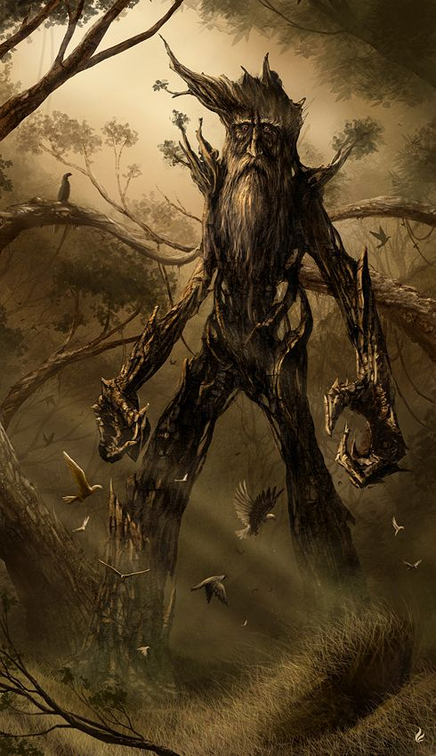

**Description:** A Somnium is generated by the illusion given by the poison produced by an ancient flower called Somnium Viridis. This creature is similar to a humanoid tree that defends the library from intruders launching ranged attacks with its long branches.

**Armor Class:** 15

**Hit Points:** 7

**Speed:** 9 metres

|  |  |  |  |  |  |
| --- | --- | --- | --- | --- | --- |
| **STR** | **DEX** | **CON** | **INT** | **WIS** | **CHA** |
| 8(-1) | 10(+0) | 10(+0) | 14(+2) | 8(-1) | 8(-1) |

**Ranged Weapon Attack:** d20 +4 to hit, range 24 meters, one target. Hit: 1d6 +2 magic damage.

**EXP:** 100