**VISUALS**

The Botany Section has a rectangular structure. Inside there are bookshelves, some **work tables** with various potions and **antidotes** on them and on the opposite side of the entrance there is a huge vase containing a **tree** surrounded by flowers in the middle of which the **seal** of the section is hidden. Among these flowers is an ancient green flower called **Somnium Viridis** which protects the library by poisoning intruders through hallucinogenic spores it releases. When Minerva begins to hallucinate from the spores, a long corridor formed by tall **hedges** appears in the section.

**Work tables**

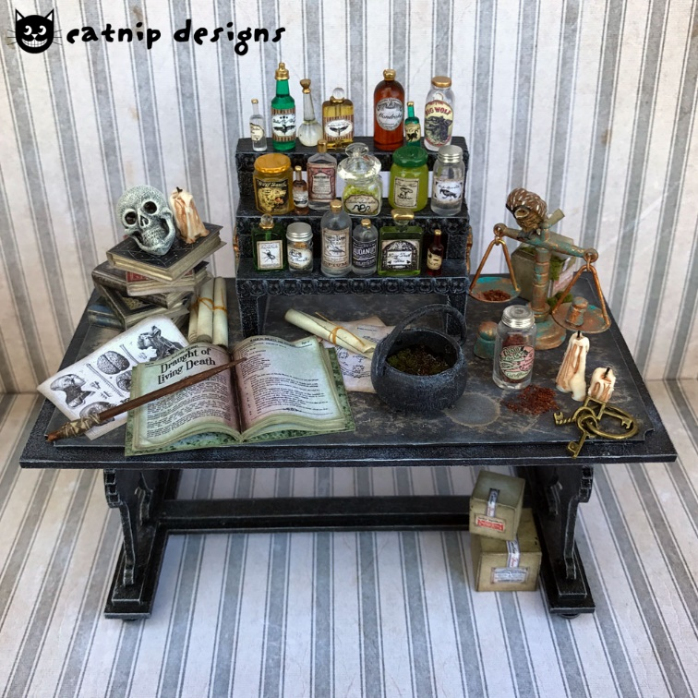

**Antidote**

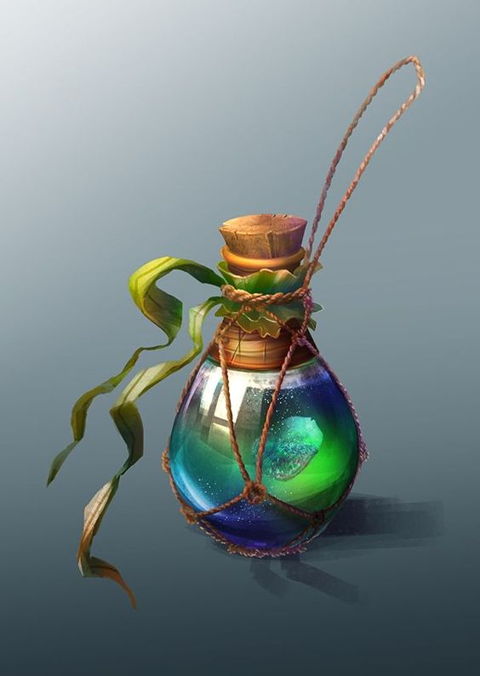

**Tree**

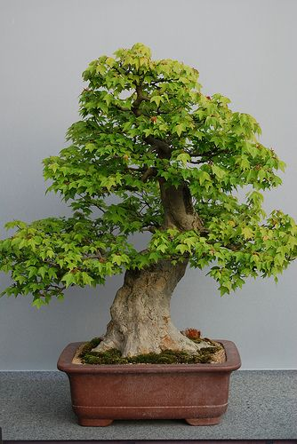

**Somnium Viridis**

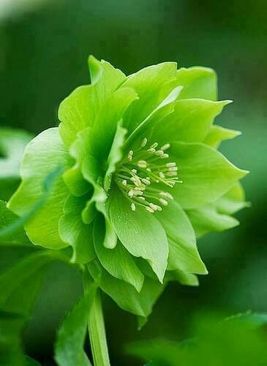

**Seal**

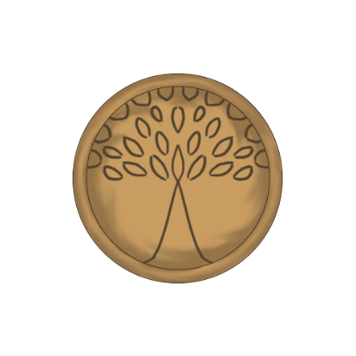

**Hedges**

