### Legal section

### Area description

The Legal Section is similar to a courtroom with a circular shape containing many bookcases and the library logbook.

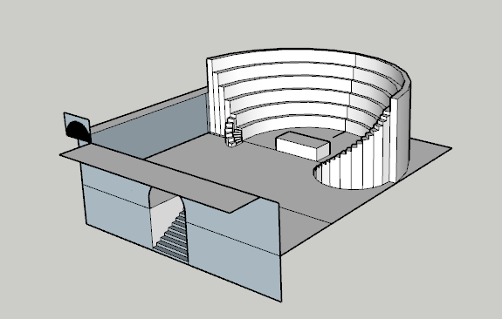

### Lore

The legal section provides the students with every possible knowledge on wizard laws. It’s the least frequented section of all. This is due to both the lack of interest that students show for the subject and to the loud argument books have with each other, discussing quibbles and old trials and making concentrating almost impossible.

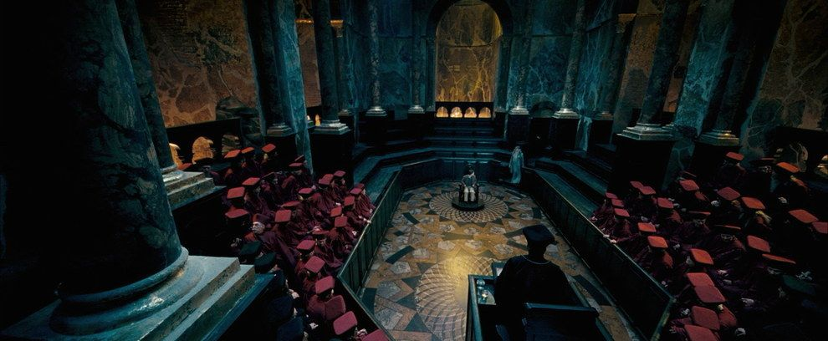

### Map

The legal section is located on the upper floor of the library and can be reached via the stairs of the main section.

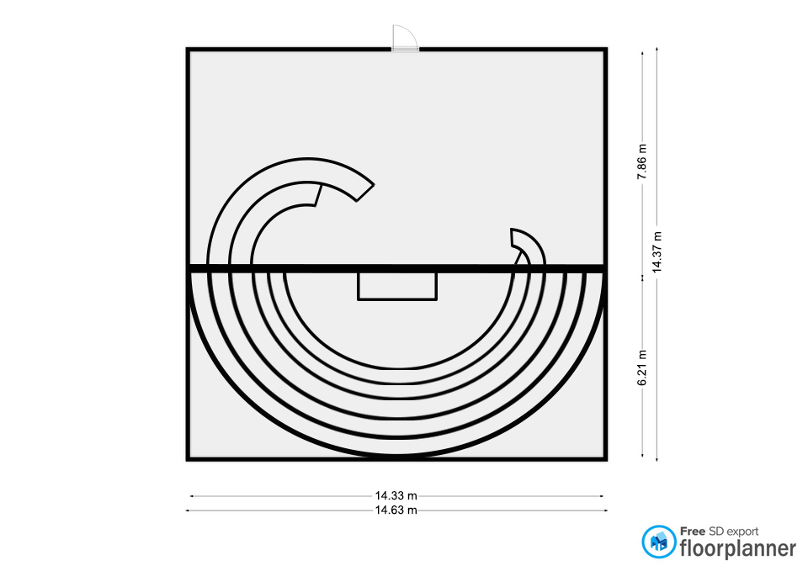

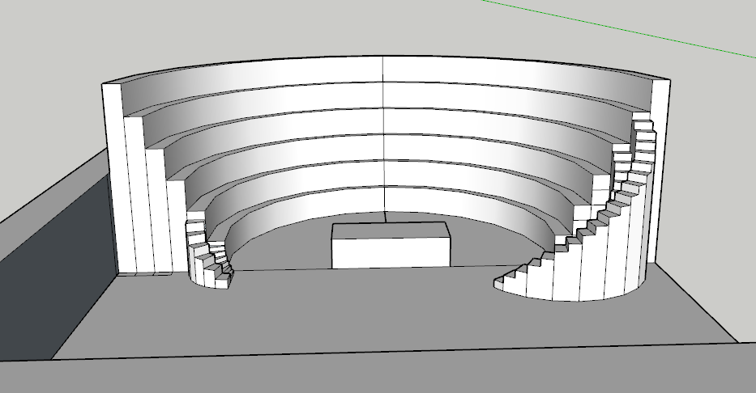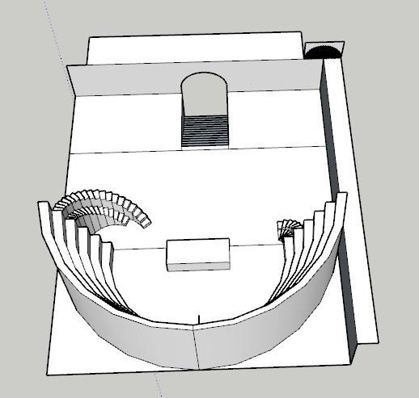

### Goals

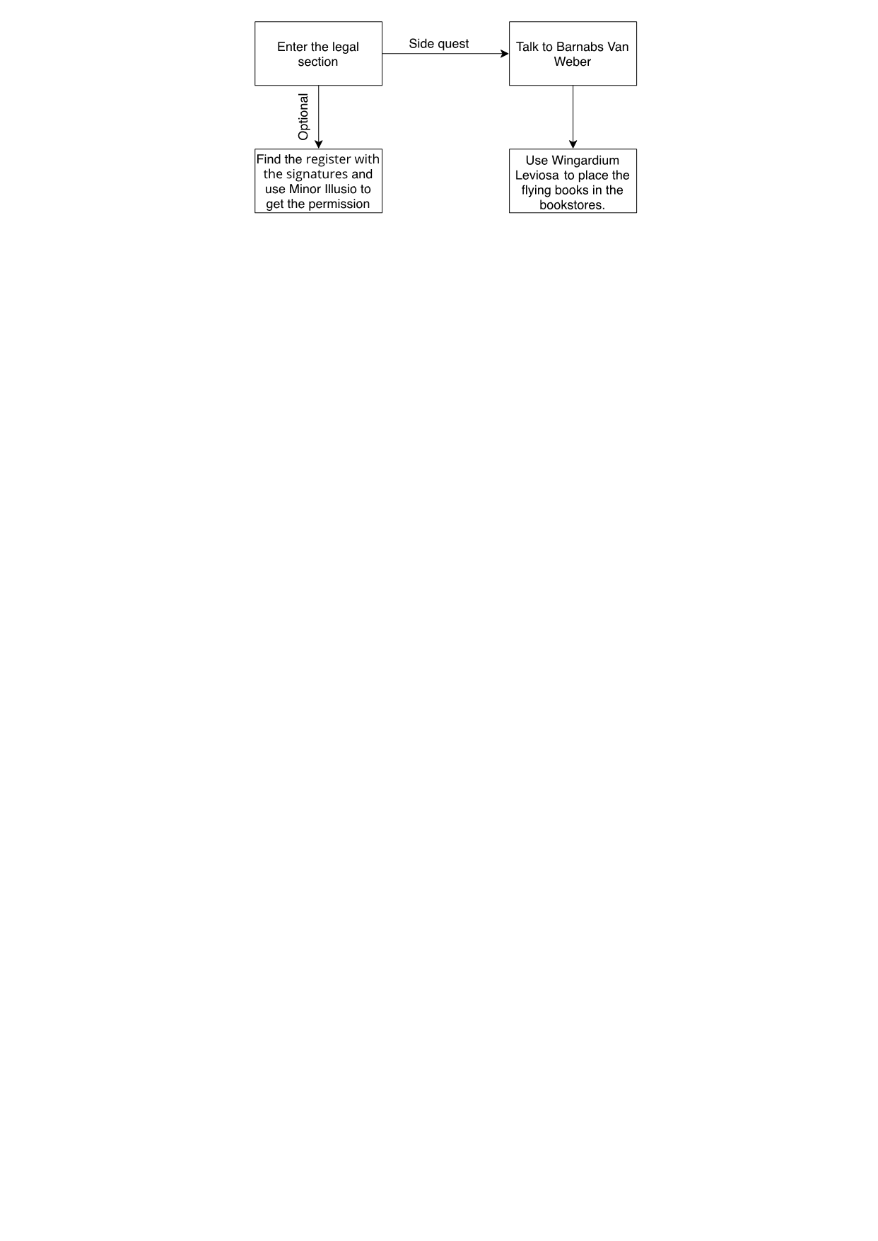

#### Main quest (optional)

#### Get the permission:

It is an optional quest because the player can choose whether to face Onorius Durandal, the ghost keeper of the restricted section, or to falsify a written permit thus avoiding combat.

#### Barnabs Van Weber side quest

#### Talk to Barnabs Van Weber:

Minerva can find the ghost of Barnabs Van Weber in the legal section

#### Put away the annoying books:

Minerva must put the books in their library using the spell "Wirgardium Leviosa".

### Room contents

The predominant element in this section is an **amphitheater-like structure** with bookcases on top that contain books discussing legal issues with the ghost of one of the school's legal advisor called **Barnabs Van Weber**. In the middle of the room there is an antique desk with a **balance and a gavel** on it.

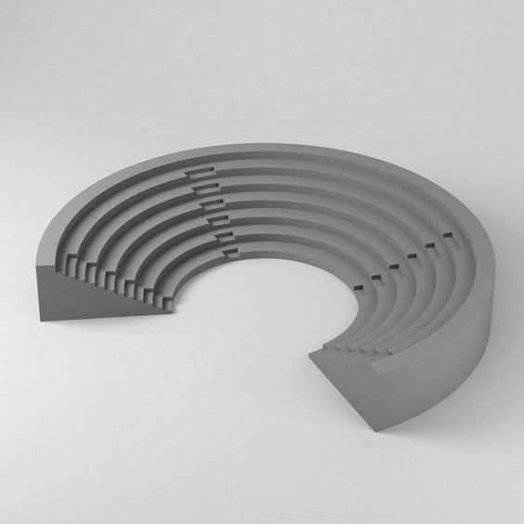

**Amphitheater-like structure:** This structure, in addition to having a row of bookcases on it, can be crossed to go up to the top floor of it.

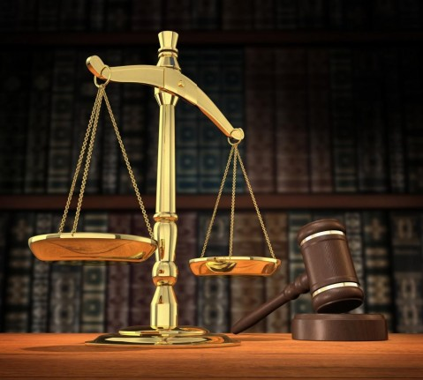**Balance and gravel:** The balance is the symbol of justice and civil behavior, and, in particular, of measure, prudence, balance, the comparison between actions and obligations. The gravel represents the power to direct and conclude a business.

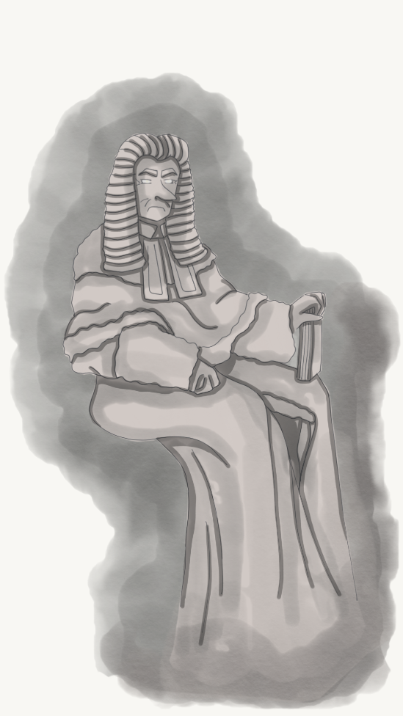 **Barnabs Van Weber:** Barnabs Van Weber was a German judge. He spends most of his time as a ghost in the legal section, arguing with the books. Every dispute ends with the books making fun of him for his very long nose.

### Cutscenes and Dialogues

1. Minerva can investigate on the desk at the centre of this section to get the permission to give to Onorius Durandal. When Minerva investigates on the desk, a **cutscene** starts:

The camera moves to the desk drawer that Minerva opens. Inside there is a logbook with the signatures of some professors. The camera moves to Minerva who uses the "Minor Illusio" spell to create a sheet with permission to access the restricted section and an exact copy of a professor's signature. The cutscene ends with Minerva carefully putting the fake permit back in her pocket.

1. Minerva can talk to Barnabs Van Weber to start a side quest:
2. When Minerva passes by Barnabs Van Weber before accepting the quest:

One of these two different lines of text is randomly chosen each time Minerva walks by the NPC, before accepting the quest:

1. **Barnabs:** “*For the last time: that is not what this law states. Are you even listening?*”
2. **Barnabs:** “*Here we go again. What does my nose have to do with this?*”
3. First time Minerva talks to Barnabs Van Weber:

**Minerva:** “*Is everything alright, Mr Van Weber?*”

**Barnabs:** “*Just a second milady. Oh! Good evening Minerva. I didn’t recognize you at first. Such a pleasure to see you. I mean * clears throat * what are you doing this late in the library? You shouldn’t be here!*”

**Minerva:** “*Hem… I was… I was thinking about a trial I read about some days ago. I really couldn’t sleep without figuring out what was bothering me about it, so I came here to do some… research!*”

**Barnabs:** “*Oh! Well, if that’s the case. I perfectly know that feeling. And let me tell you: it doesn’t go away until you satisfy your thirst for knowledge. Really compelling subject, magical law. Isn’t it?*”

**Minerva:** “*Is it? I mean: of course! So compelling!*”

**Books:** “*His nose is compelling!*”

**Barnabs:** “*beats the gavel* *Stop it! You’re as rude as…*”

**Books:** “*Your nose?*”

**Minerva:** “*I should really head back to the dorm, Mr Van Weber. Have a good night!*”

**Barnabs:** “*Wait, Minerva! Since you’re here, may I ask for your help with these pesky books? Rumor has it that you have a very firm hand. I’m trying to prove a point, but all they seem to be interested in is making silly jokes about my nose.*”

**Books:** “*Hi hi hi. He said nose!*”

**Minerva:** “*I can’t believe I’ve been involved in this. Of course, Mr Van Weber. I’ll help you.*”

1. When Minerva passes by Barnabs Van Weber during the quest:
2. **Barnabs**: “*Come on, make those hateful books pay!*
3. **Barnabs:** “*They are unbearable!*”
4. When Minerva talks to Barnabs Van Weber during the quest:

**Barnabs:** “*Use a spell and put those books back in their place!”*

1. When Minerva passes by Barnabs Van Weber after completing the quest:

One of these two different lines of text is randomly chosen each time Minerva walks by the NPC, after completing the quest:

1. **Barnabs**: “*Hey! You Behave! Or I will call Miss McGonagall!*”
2. **Barnabs:** “*I said “cause”, not “nose”!*”

### Gameplay

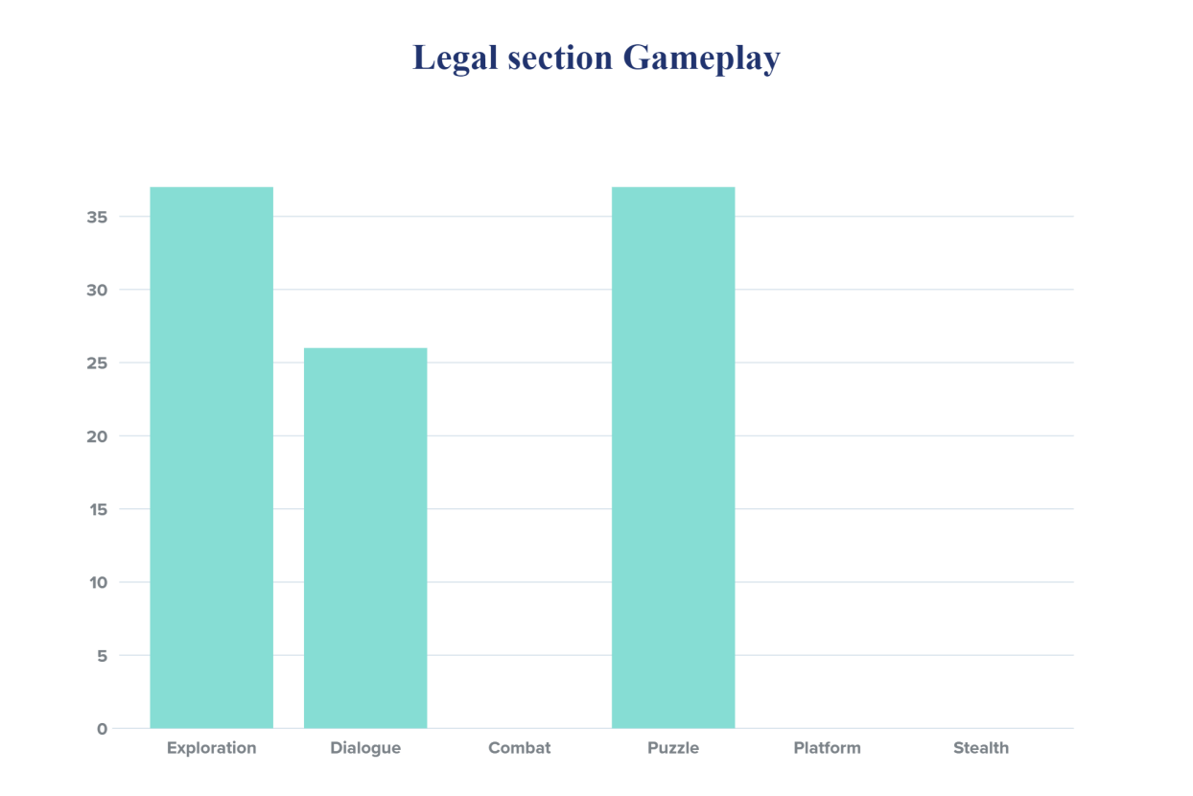In this area of ​​the map there is a little puzzle giving by the side quest of Barnabs Van Weber but this section is mostly exploration orientes. The main goal of the section is to get the permission to be given to Onorius Durandal to take the “Book of no more”.

#### Exploration

1. Minerva must explore the section to find the logbook with the signature to forge that is in the desk in the center of the room. If Minerva completes the mission she gains **100 experience points**.

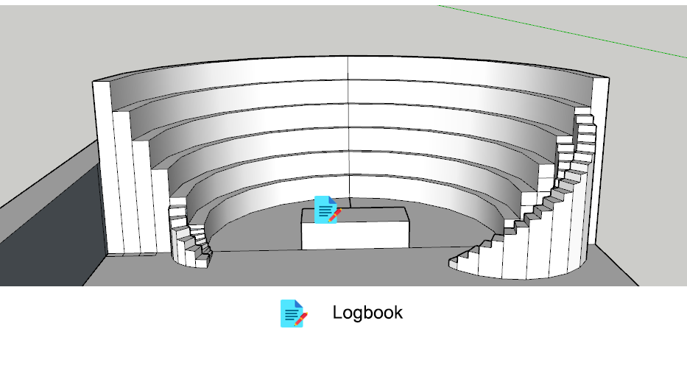

1. In this section there are two collectibles:

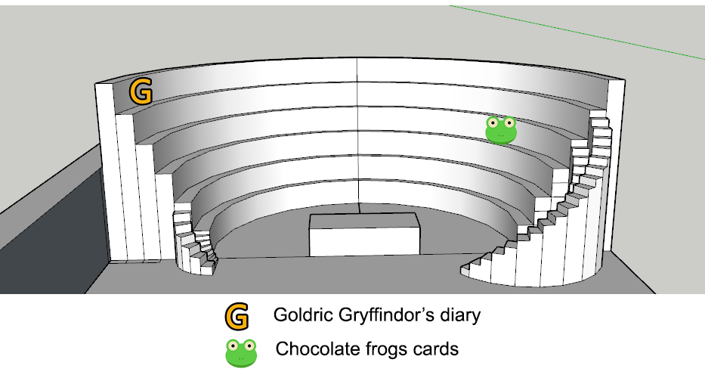

#### Dialogue

In this section there is a dialogue with Barnabs van Weber who needs help to to get rid of the books that bother him.

#### Combat and Stealth

In this section there are not combat or stealth mode.

#### Puzzle

1. If Minerva talks with Barnabs Van Weber she will start a side quest which if completed gives Minerva **50 experience points**. This side quest consists of using the “Wingardium Leviosa” spell to place the flying books in the section in the various bookstores.

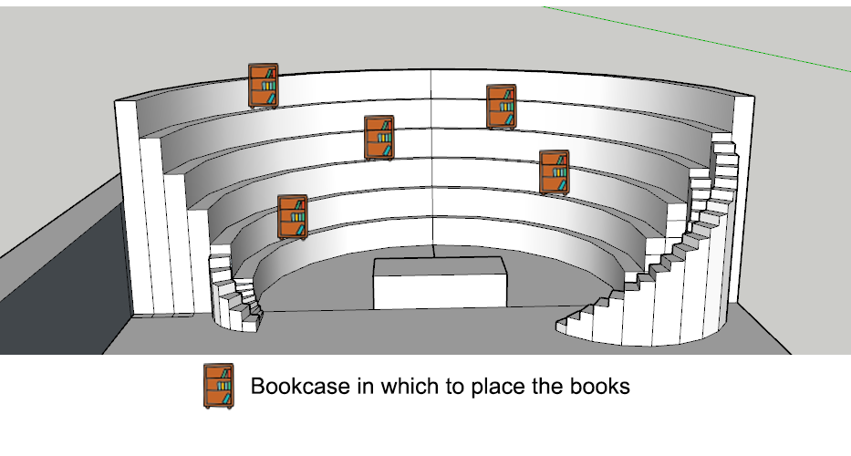

#### Platform

In this section there are not platform path.

### Enemies

In this section there is no enemy to fight.

### Lights

The arrangement of the central light. The lights illuminate the center of the amphitheater from every corner of the room, from top to bottom.

### Sounds

|  |  |
| --- | --- |
| **Sound Effect** | **Track** |
| When books laugh at Barnabs' nose | Laughs.wav |
| When Barnabs hits the gavel | Gavel.wav |