**VISUALS**

The Legal Section is similar to a courtroom with a circular shape. The predominant element in this section is an **amphitheater-like structure** with bookcases on top that contain books discussing legal issues with the ghost of one of the school's legal advisor called **Barnabs Van Weber**. In the middle of the room there is an antique desk with a **balance and a gavel** on it.

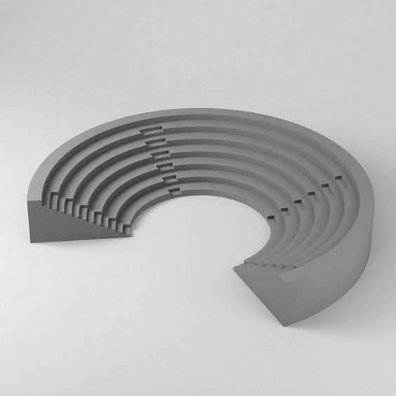

**Amphitheater-like structure:** This structure, in addition to having a row of bookcases on it, can be crossed to go up to the top floor of it.

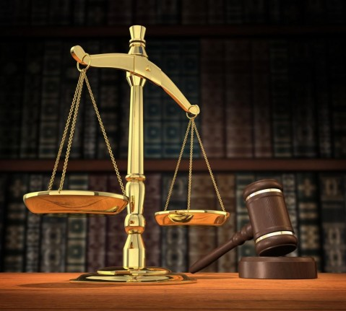**Balance and gravel:** The balance is the symbol of justice and civil behavior, and, in particular, of measure, prudence, balance, the comparison between actions and obligations. The gravel represents the power to direct and conclude a business.

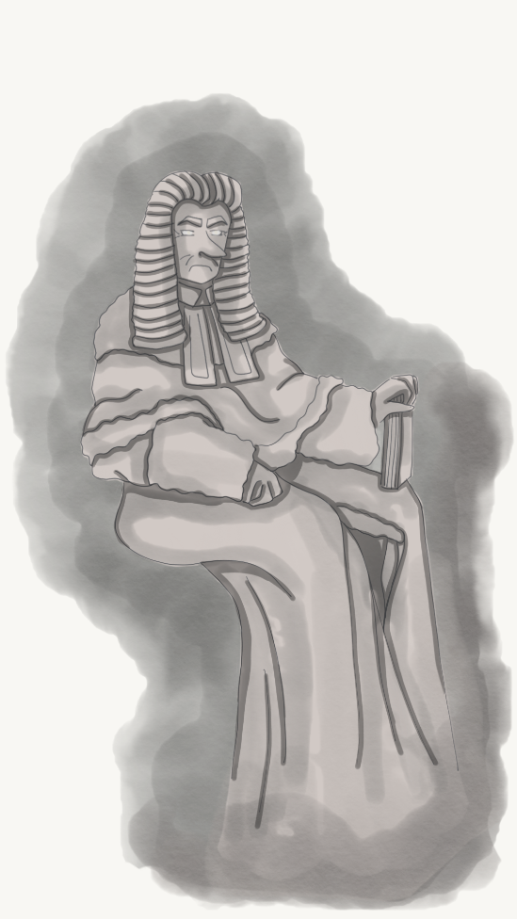 **Barnabs Van Weber:** Barnabs Van Weber was a German judge. He spends most of his time as a ghost in the legal section, arguing with the books. Every dispute ends with the books making fun of him for his very long nose.