### Main section

### Area description

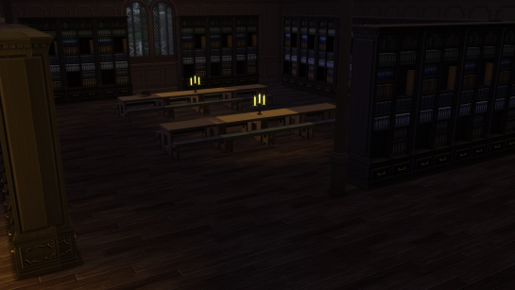The main section is a big rectangular room with lots of tables and bookcases. The ceiling is built as a wide archway, with wooden beam crossing the room. In the center of the room there’s a big globe. The entrance to the library and the door to the restricted section are opposed to each other on the two short edges of the room. On the two long sides of the room there are two stairs, offset horizontally. Both lead to the balcony, where five arches allows to enter the five accessible sections of the library.

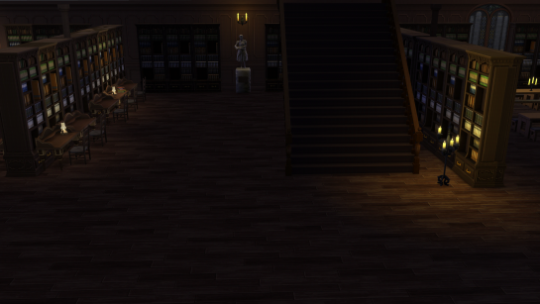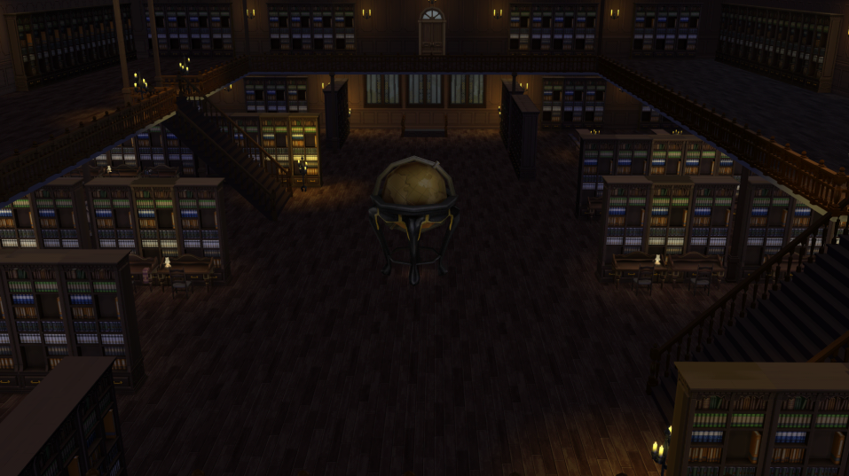

### Lore

The main section is the first and biggest room one encounters when entering the library. Here, the majority of students sits and studies in silence. The enchanted globe located in the center of the room spins slowly and shows the events of the wizarding world as they happen.

### C:\Users\689290\Downloads\mapdgm (1).jpgMap

The main section is the central room of the library. It is connected to all the other rooms. It is the largest room in the library. The main function of the room is structural: it connects the play areas.

The room mainly expands in length and height. it is divided into three levels of height: ground floor, balcony and ceiling.

The ground floor connects to the entrance and to the restricted section. The balcony connects to the other rooms: astronomy section, botany section, spell book section, bestiary section and legal section.   
The ceiling is the path above the balcony. It connects the spell book section with the astronomy section.

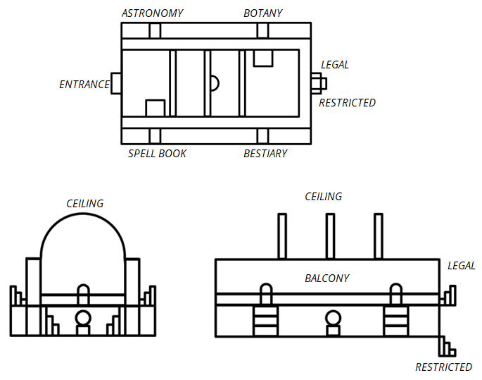

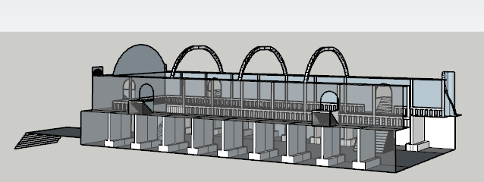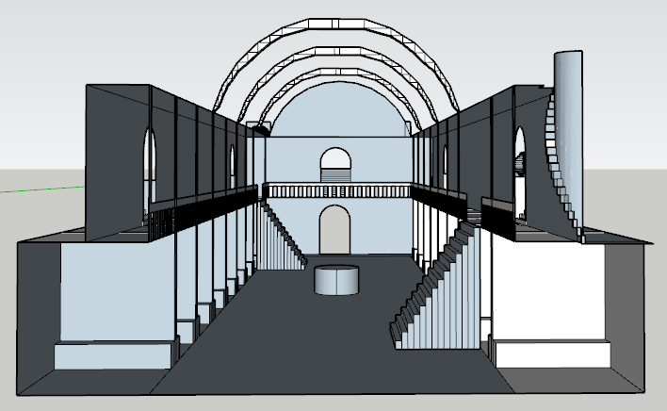

### Goals

The main goal inside the room is to open the passage to the restricted section. Minerva must explore the area to find access to the other rooms in the library. The goal outline of the room is divided as follows:

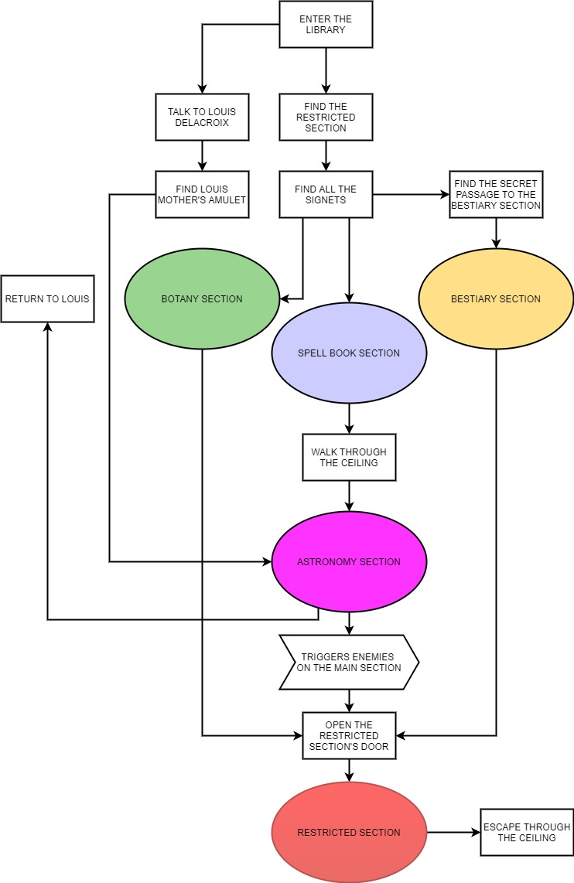

### Main quest

#### Enter the library:

The quest begins. Minerva enters the library from Hogwarts indoor.

#### Find the restricted section:

Minerva must find the "book of no more". It's in the restricted section of Hogwarts library. The entrance of the restricted section is visible in the room.

#### Find all the signets:

Door of restricted section requires four signets hidden in the other rooms of the library. Minerva has to visit the rooms one by one to retrieve the signets.

#### Find the secret passage to the bestiary section:

Bestiary section's main entrance is closed. Minerva needs to find an alternative way to get in. There is a hidden passage below the balcony.

#### Walk through the ceiling:

Astronomy section's main entrance is closed. Minerva needs to find an alternative way to get in. There is a path on the ceiling reachable from the spell book section. This passage crosses the main section.

#### Triggers enemies on the main section:

When Minerva retrieves the signet in the astronomy section, the books of main section come alive. They follow a simple path on the ground floor. Minerva can stealthily avoid them.

#### Escape through the ceiling:

When Minerva retrieves the "book of no more" the restricted section's door will close. There is a connection through the restricted section and the path on the ceiling. Minerva can escape from the library that way.

### Louis Delacroix side quest

#### Talk to Louis Delacroix:

Minerva can find Louis Delacroix among the ghosts on the balcony.

#### Find Louis mother's amulet:

Louis asks her to find an amulet lost in the library.

#### Return to Louis:

Minerva will find the amulet in the botany section.

### Room contents

In the center of the room there is a huge enchanted **globe** and next to it there are two stairs leading to the balcony on the upper floor where a ghostcalled **Louis Delacroix** wander. On the opposite side of the entrance there are stairs leading to the lower floor where there is a small corridor with a closed **door** which leads to the restricted section. At the back of the room on the right side there is a small **secret passage** behind a bookcase that leads to the astronomy section.

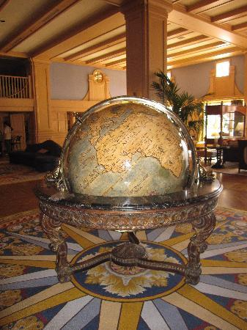

**Globe:** The enchanted globe spins slowly and shows the events of the wizarding world as they happen.

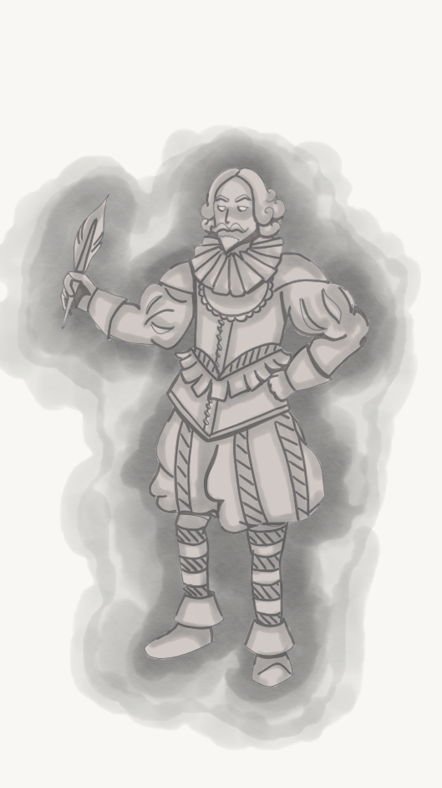

**Louis Delacroix:** He was one the most renowned French poet of the wizarding world. Now he wanders in the library, looking for his mother’s amulet.

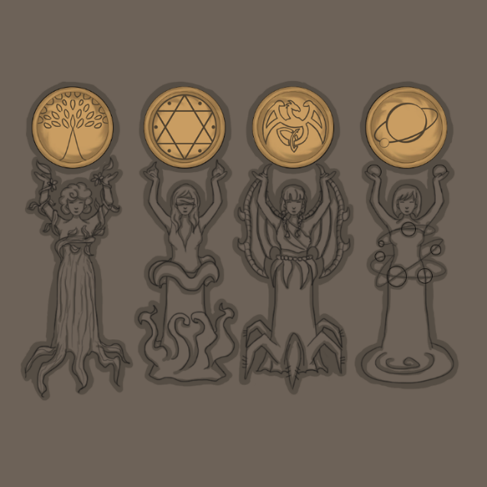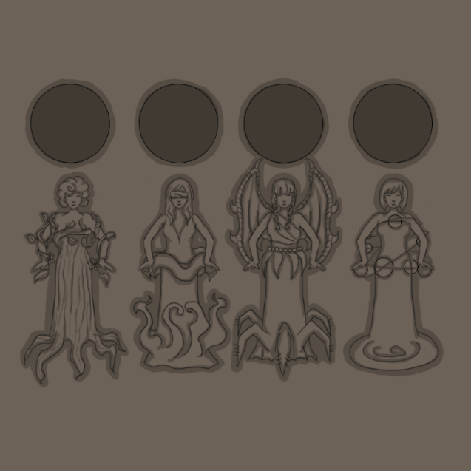**Door:** To open the door leading to the Restricted Section Minerva needs four signets located in four sections of the library (Spell Section, Botany Section, Bestiary Section and Astronomy Section). Then this signets must be inserted correctly in the slots on the door. Under each slot a woman is depicted in high relief whose representation provides a clue to the player on where to insert the various signets. On each signet are represented some symbols that recall the theme of the various sections. When a signet is inserted correctly, the women depicted raise their arms.

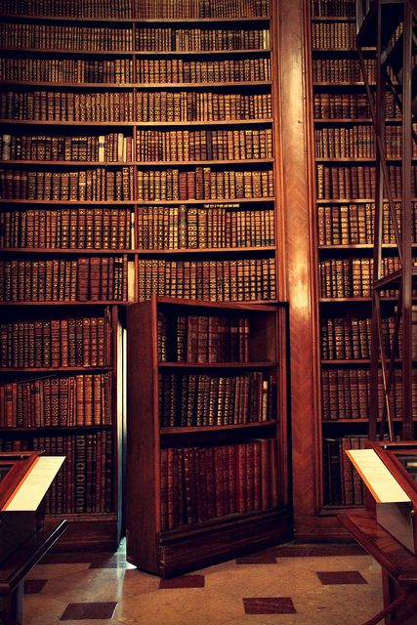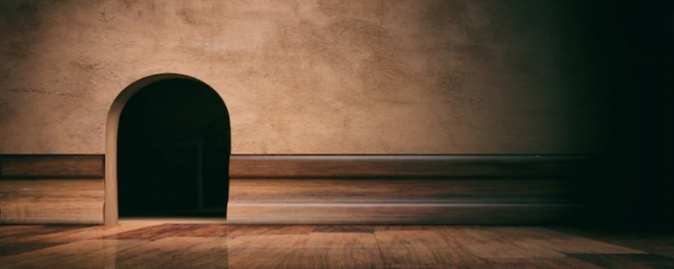

**Secret passage:** In the main section, behind one of the bookcases, located to the right of the stairs leading to the lower floor, there is a small secret passage that leads inside the statue of the sphinx present in the Bestiary Section, in fact this is the only way to enter that section. A clue that will help the player find this passage is given by the word *“Investigate”* that appears when you are near the library.

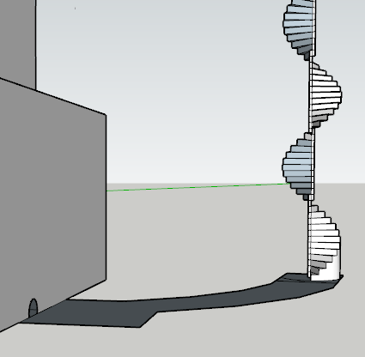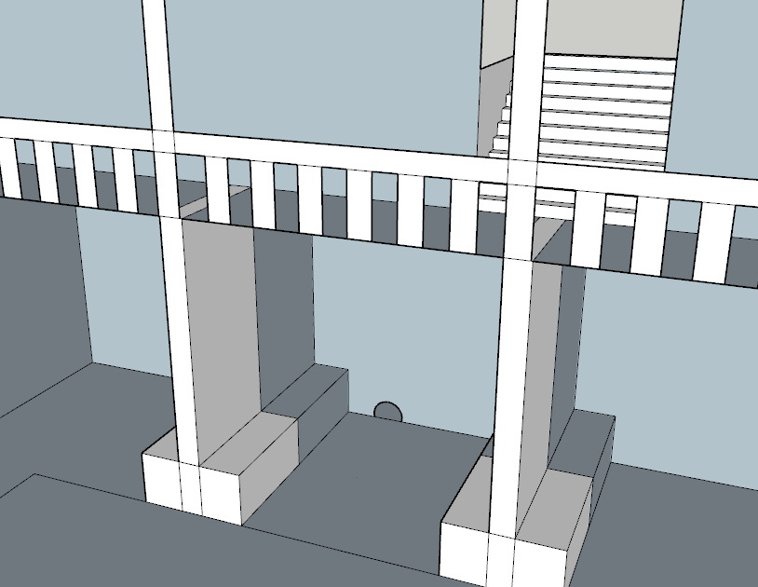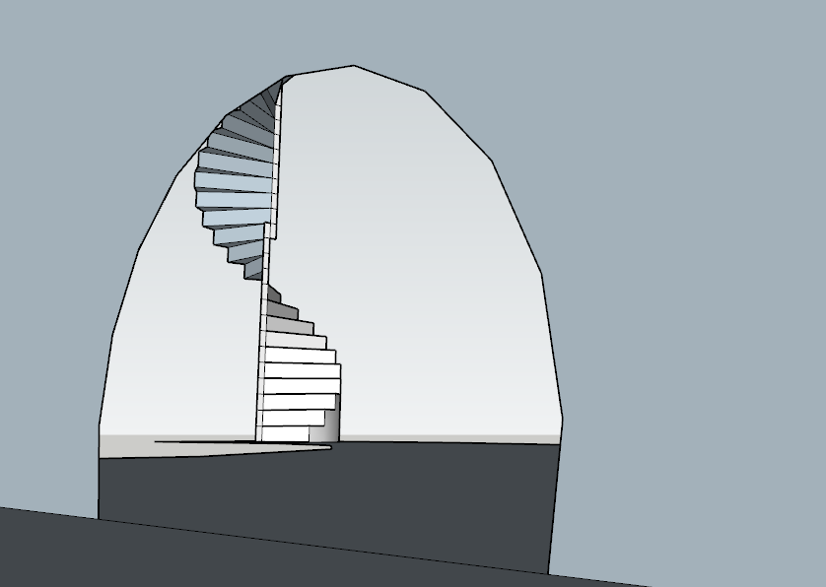

### Cutscenes and Dialogues

1. When the player reaches the door leading to the restricted section, a **cutscene** starts in which young Minerva inspects the door with curiosity trying to understand the mechanism.

**Minerva*:*** *"This door must lead to the Restricted Section, but it seems blocked by a strange mechanism ..."*

At this point the camera frames the door and Minerva keeps talking.

**Minerva:** *"There are four cracks, maybe something has to be inserted in them. These muses seem to give clues as to where to find the missing pieces ... do they refer to some sections of the library?"*

After Minerva first interacts with the door, a zoom of the door will be shown when she interacts with it again to allow the player to think through the puzzle and insert signets into the slots.

1. Once the player has interacted with the library that hides the secret passage, a short **cutscene** will start in which the strange library will be framed and Minerva starts talking.

**Minerva:** *"Hmm weird ... this bookcase seems to be hiding something. I should use a spell to try to open it ..."*

Once the cutscene is over it will be up to the player to understand that he will have to use the "Alohomora" spell to open the library. Once this is done, Minerva will only be able to enter the passage after using her form of Animagus.

#### Louis Delacroix dialogues

# When Minerva passes by before accepting the quest

One of these two different lines of text is randomly chosen each time Minerva walks by the NPC, before accepting the quest:

“*Where is it? Where did I already look? What was I looking for?*”

“*Why is there my name on this book? Am I famous?*”

# First time Minerva talks to him

M: “Good evening, sir. May I help you?”

L: “Bonsoir, mademoiselle. Actually, I’m not sure. Do I know you? Do you know me? Have you seen it anywhere?”

M: “Seen what?”

L: “Yes! Good question. Seen what? Mmm… I can’t believe I lost it… My name, on this book! Don’t you find exquisitely odd that my name is on the cover of this book?”

M: “Hem… Yes! Quite odd, indeed.”

L: “Two hearts and a broomstick… ha! Who would ever come up with such a silly title.”

M: “Are you Louis Delacroix, sir?”

L: “Oui! Oui! How did you know?”

M: “I read it on the cover of the book you showed me, sir…”

L: “Me too! You’re quite clever, aren’t you?”

M: “I suppose, sir… you mentioned you lost something.”

L: “My mother!”

M: “You lost your mot… ”

L: “She must be so worried about me. Not to mention I lost her amulet! Could you possibly help me find it?”

M: “Actually, I was in the middle of somet…”

L: “Magnifique! So generous of you. I usually lose it in that gorgeous astronomy room. Have you seen it?”

M: “What do you mean usually?”

L: “Usually? Weird word! Did you invent it?”

M: “Huh… forget it. I’ll be right back with your amulet”

L: “Merci! Let me know if you find out who this Louis Delacroix is and why his name is on this book.”

M: “Hem… Sure!”

# When Minerva passes by during the quest

One of these two different lines of text is randomly chosen each time Minerva walks by the NPC, after accepting the quest, but before completing it:

“*Delacroix… is it French? What’s France?*”

“*À-m-u-l-e-t… A-m-u-l-è-t. Sounds funny either way*”

# When Minerva talks to him during the quest

One of these two different dialogues is randomly chosen each time Minerva talks with the NPC after accepting the quest, but before completing it:

1.

M: “*Good evening, monsieur Delacroix!*”

L: “*Ha! Good one! Good evening to you, mademoiselle Delacroix!*”

M: “*What?*”

L: “*Did you find my… thing?*”

M: “*No sir, I’m still looking for you’re amulet.*”

L: “*Oh, an amulet! How fascinating. I think I saw one in that gorgeous astronomy room. Let me know when you find it.*”

2.

M: "*Any idea on where the amulet could be, sir?*"

L: "*Well, that's a weird question. Do you always walk around and ask this kind of question? Anyway, if I were to lose an amulet, i would probably drop it in that gorgeous astronomy room. Speaking of an amulet... I wonder where I left mine.*"

# When Minerva talks to him after finding the amulet

M: "I think I found your amulet, sir."

L: "Oh! Yes, there it is. Where did you find it? So sweet of you to bring it back. How did you know I lost it?"

M: "You told me, sir, a few minutes ago."

L: "Did I? I’m afraid you’re mistaking me for someone else, mademoiselle. Excuse moi, I am so impolite. I didn't introduced myself! I am Louis Delacroix, and my name is on this book. And you are..."

M: "Minerva, sir. Minerva McGonagall. I don't think my name is on any book."

L: "Oh, don't worry about that. You will find one! Now: could you hand me the amulet?”

Minerva hands the amulet to Louis. The amulet is material, while Louis is a ghost. Louis unsuccessfully tries to grab it. After a few attempts, Minerva places the amulet on the bookcase next to her. Louis is disconsolate.

L: “Minerva, may I ask you a strange question?”

M: “Yes, sir. Of course”

L: “Am I… dead?”

M: “I’m afraid so, sir… Is… Is everything alright?”

L: “Yes, I’m just… I don’t remember saying goodbye to my mother. If I knew it was the last time…”

M: “I’m very sorry, sir.”

L: “Oh, it’s fine, I guess. We never know when it’s the last time, do we?”

# When Minerva passes by after completing the quest

One of these two different lines of text is randomly chosen each time Minerva walks by the NPC, after completing the quest:

*“Look at this book. Where have I seen this name before?”*

*“What a lovely amulet. I wonder who it belongs to”*

### Gameplay

This area of ​​the map is mostly exploration oriented. The main goal of the room is to open the restricted section door by retrieving all the signets.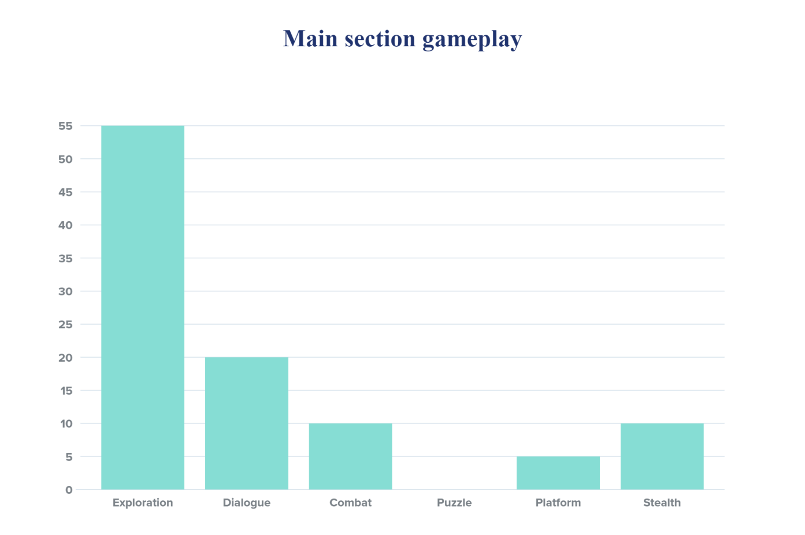

#### Exploration:

Almost all the tasks in this area are about exploration game mode:

* 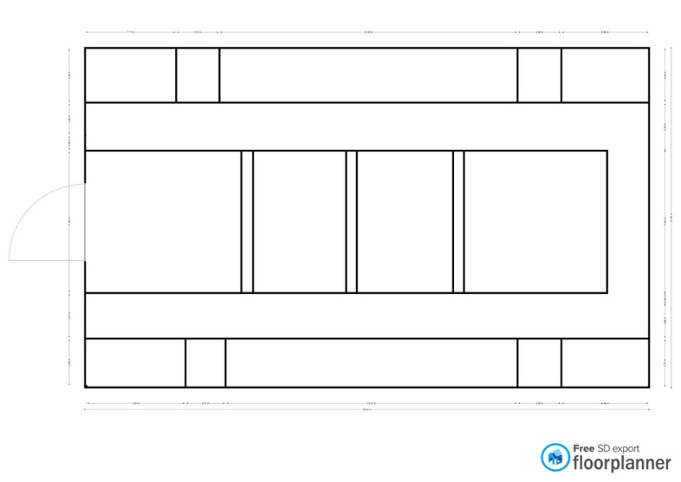Minerva must find the restricted section entrance.



* Minerva must understand the structure of the library. There are three paths to follow. One of them is hidden.



* Minerva can move freely and choose which path to tackle first.



* Minerva must find the secret passage entrance.
* Minerva could seek the Louis mother's amulet.
* Minerva could seek for collectables items around the room. Collectables are 2 Salazar Slyterin diary page(on the ground floor and the balcony) and a Chocolate frog card (on the ceiling).

#### Dialogue:

Dialogue game mode is related to the Louis side quest. There are quite few NPCs in the level. Minerva can ask information about the story of the library, the secret passage, the "book of no more" and the story of the NPCs in the level.

#### Combat and Stealth:

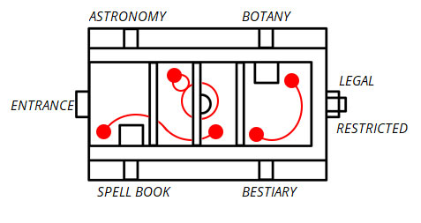After completing the astronomy section, some enemies will patrol the area. Minerva may decide to stealthily face or avoid them. The level can be played stealth.

This is the description of the enemies path. Red balls are the position of the enemies. the connection between them is the path they follow. Minerva con move freely on the balcony.

#### Puzzle:

There aren't puzzles in the area. The restricted section's door contains some statues that require signets to open the door. This is not a real puzzle, but a task of finding and assembling.

#### Platform:

Platform game mode in the area is represented by the path on the ceiling. This path is a connection between the spell book section and the astronomy section.

### Enemies:

#### Enchanted books

**Description:** The enchanted books are intended to protect the library from intruders. They always attack in groups of three using the spells written in them and once defeated they lose their magic falling to the ground in the form of simple books.

**Armor Class:** 15

**Hit Points:** 7

**Speed:** 9 metres

|  |  |  |  |  |  |
| --- | --- | --- | --- | --- | --- |
| **STR** | **DEX** | **CON** | **INT** | **WIS** | **CHA** |
| 8(-1) | 10(+0) | 10(+0) | 14(+2) | 8(-1) | 8(-1) |

**Ranged Weapon Attack:** d20+4 to hit, range 24 meters, one target. Hit: 5 magic damage.

**EXP:** 30

**Icon:**

### Lights

The room is not very bright. The main points of light are the globe in the center of the room and the chandeliers on the roof. There are not very bright lights in the side corridors. These lights are used to illuminate the student tables. The same lights are located on the balcony.

### Sounds

|  |  |
| --- | --- |
| Sound Effect | Track |
| A seal has been placed on the door leading to the Restricted Section | Seal_Insertion.wav |
| The secret passage has been opened | Secret_Passage_Opening.wav |
| Attack of the Enchanted Books | Enchanted_Book_Attack.wav |
| The door to the restricted section has been opened | Restricted_Section_Opening.wav |

