#### Gameplay

This area of ​​the map is mostly exploration oriented. The main goal of the room is to open the restricted section door by retrieving all the signets.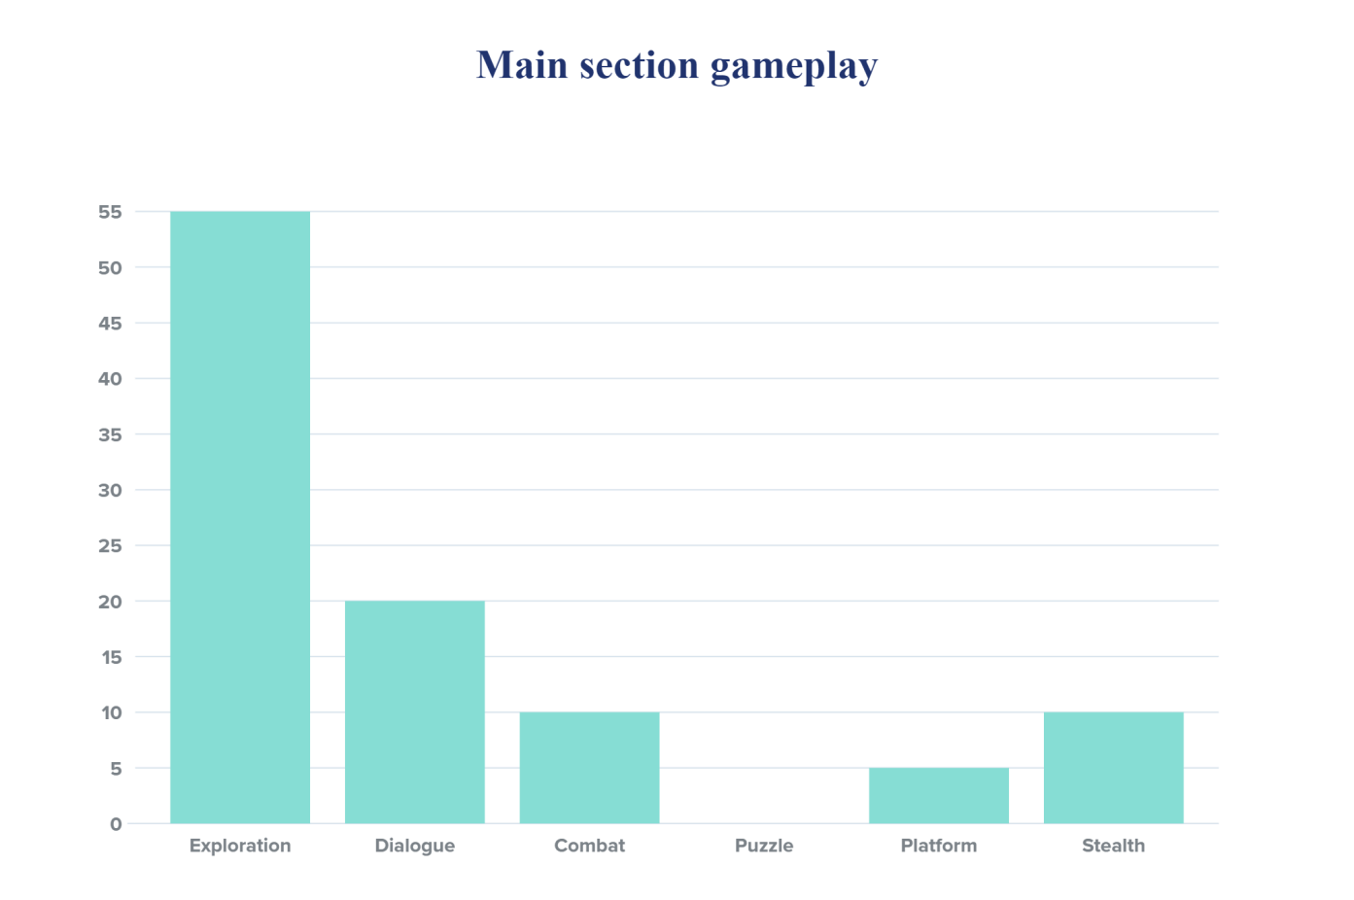

#### Exploration:

Almost all the task in this area are about exploration game mode:

* Minerva must find the restricted section entrance.
* Minerva must understand the structure of the library. There are three paths to follow. One of them is hidden.
* Minerva can move freely and choose which path to tackle first.
* Minerva must find the secret passage entrance.
* Minerva could seek the Louis mother's amulet.
* Minerva could seek for collectables items around the room (S stand for Salazar Slyterin's diary, frogs stand for Chocolate frogs cards).

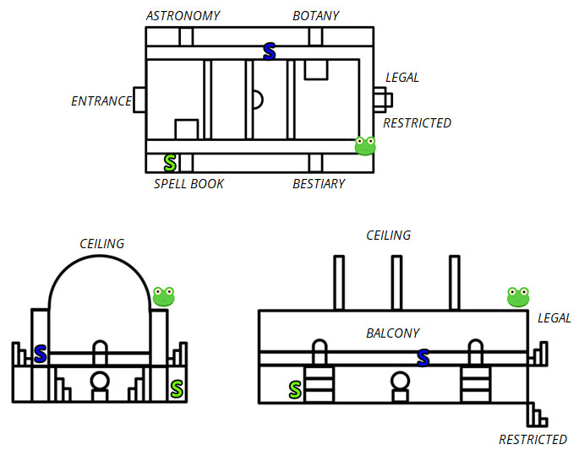

#### Dialogue:

Dialogue game mode is related to the Louis side quest. There are quite few NPCs in the level. Minerva can ask information about the story of the library, the secret passage, the "book of no more" and the story of the NPCs in the level.

#### Combat and Stealth:

After completing the astronomy section, some enemies will patrol the area. Minerva may decide to stealthily face or avoid them. The level can be played stealth.

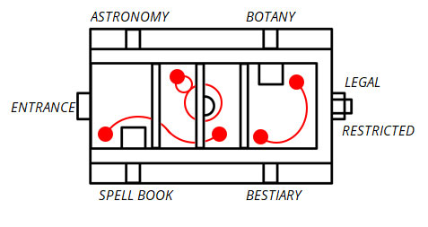

This is the description of the enemies path. Red balls are the position of the enemies. the connection between them is the path they follow. Minerva con move freely on the balcony.

#### Puzzle:

There aren't puzzles in the area. The restricted section's door contains some statues that require signets to open the door. This is not a real puzzle, but a task of finding and assembling.

#### Platform:

Platform game mode in the area is represented by the path on the ceiling. This path is a connection between the spell book section and the astronomy section