### Goals

The main goal inside the room is to open the passage to the restricted section. Minerva must explore the area to find access to the other rooms in the library. The goal outline of the room is divided as follows:

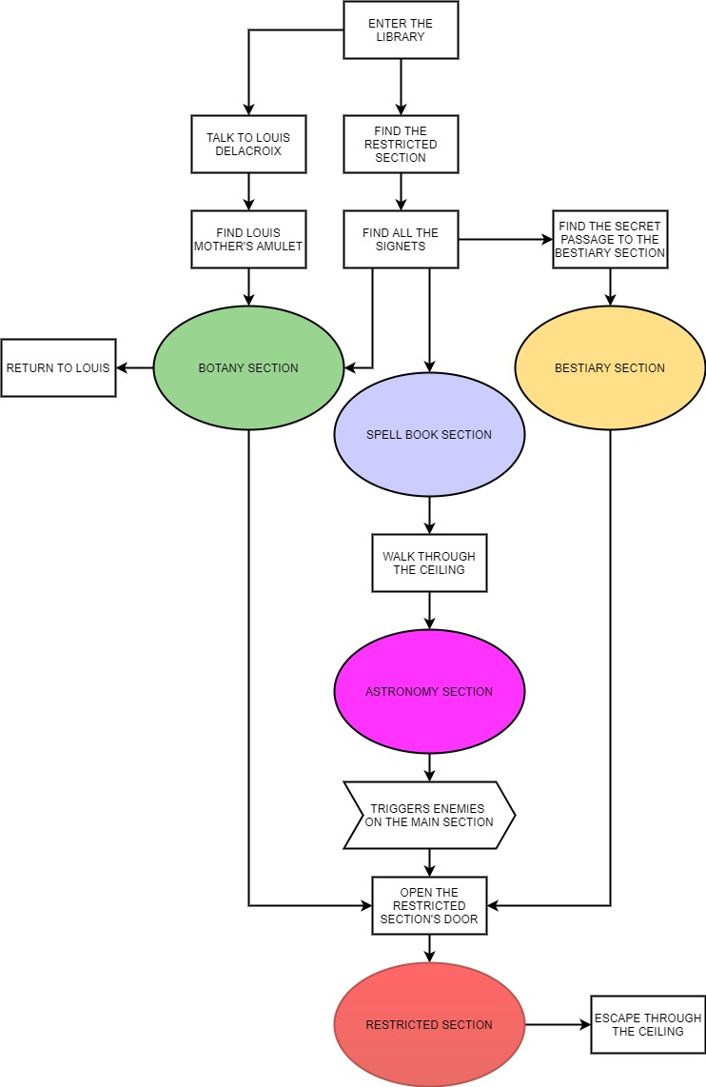

#### Main quest

#### Enter the library:

The quest begins. Minerva enters the library from Hogwarts indoor.

#### Find the restricted section:

Minerva mist find the "book of no more". It's in the restricted section of Hogwarts library. The entrance of the restricted section is visible in the room.

#### Find all the signets:

Door of restricted section requires four signets hidden in the other rooms of the library. Minerva has to visit the rooms one by one to retrieve the signets.

#### Find the secret passage to the bestiary section:

Bestiary section's main entrance is closed. Minerva needs to find an alternative way to get in. There is an hidden passage below the balcony.

#### Walk through the ceiling:

Astronomy section's main entrance is closed. Minerva needs to find an alternative way to get in. There is a path on the ceiling reachable from the spell book section. This passage crosses the main section.

#### Triggers enemies on the main section:

When Minerva retrieves the signet in the astronomy section, the books of main section come alive. They follow a simple path on the ground floor. Minerva can stealthily avoid them.

#### Escape through the ceiling:

When Minerva retrieves the "book of no more" the restricted section's door will close. There is a connection through the restricted section and the path on the ceiling. Minerva can escape from the library that way.

#### Louis Delacroix side quest

#### Talk to Louis Delacroix:

Minerva can find Louis Delacroix among the ghosts on the balcony.

#### Find Louis mother's amulet:

Louis asks her to find an amulet lost in the library.

#### Return to Louis:

Minerva will find the amulet in the botany section.