### C:\Users\689290\Downloads\mapdgm (1).jpgMap

The main section is the central room of the library. It is connected to all the other rooms. It is the largest room in the library. The main function of the room is structural: it connects the play areas.

The room mainly expands in length and height. it is divided into three levels of height: ground floor, balcony and ceiling.

The ground floor connects to the entrance and to the restricted section. The balcony connects to the other rooms: astronomy section, botany section, spell book section, bestiary section and legal section.   
The ceiling is the path above the balcony. It connects the spell book section with the astronomy section.

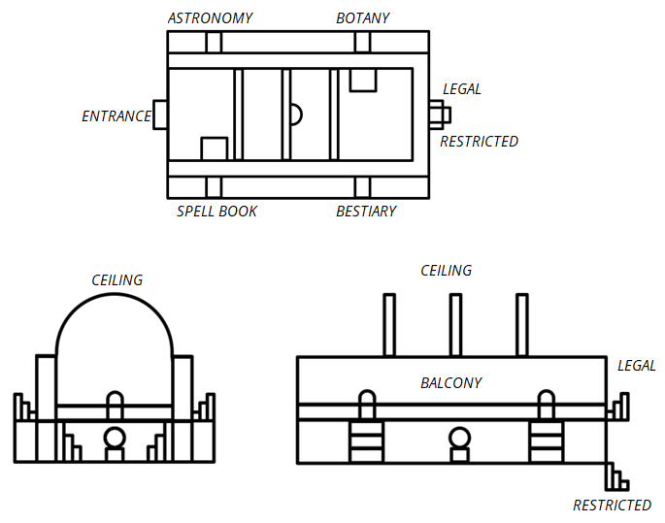

### 3D Map structure

