**PUZZLE**

**Main puzzle**

In the Main Section there is the main level puzzle, positioned on the lower shelf on the door leading to the Restricted Section.

The puzzle consists of retrieving four seals, located in four sections of the library (Spell Section, Botany Section, Bestiary Section and Astronomy Section), and placing them correctly in the slots on the door. Under each slot a woman is depicted in high relief whose representation provides a clue to the player on where to insert the various seals. On each seal are represented some symbols that recall the theme of the various sections. When a seal is inserted correctly, the women depicted raise their arms.

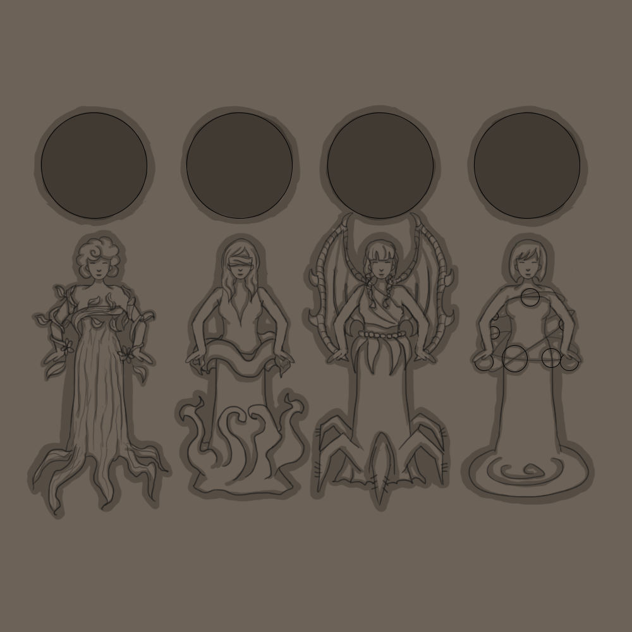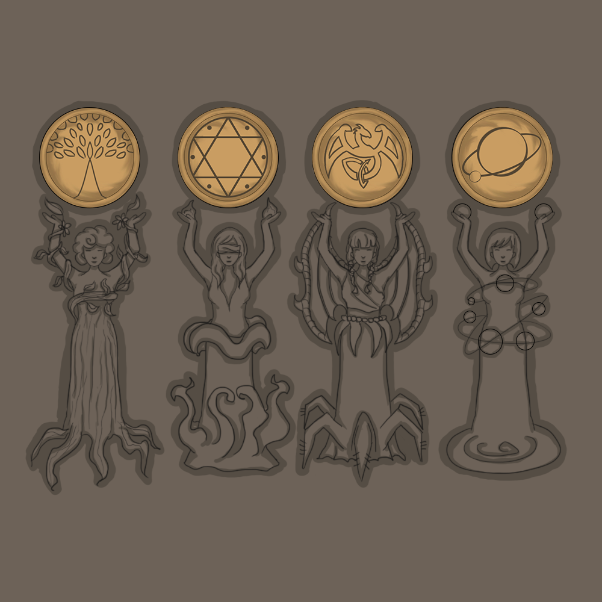

When the player reaches the door, a cutscene starts in which young Minerva inspects the door with curiosity trying to understand the mechanism and says:

*"This door must lead to the Restricted Section, but it seems blocked by a strange mechanism ..."*

At this point the camera frames the door and Minerva continues saying:

*"There are four cracks, maybe something has to be inserted in them. These muses seem to give clues as to where to find the missing pieces ... do they refer to some sections of the library?"*

After Minerva first interacts with the door, a zoom of the door will be shown when she interacts with it again to allow the player to think through the puzzle and insert seals into the slots.

**Secret Passage**

In the Main Section, behind one of the bookcases, located to the right of the stairs leading to the lower floor, there is a small secret passage that leads inside the statue of the sphinx present in the Bestiary Section, in fact this is the only way to enter that section. A clue that will help the player find this passage is given by the word *“Investigate”* that appears when you are near the library. At this point, once the player has interacted with the library, a short cutscene will start in which the strange library will be framed and Minerva will say:

*"Hmm weird ... this bookcase seems to be hiding something. I should use a spell to try to open it ..."*

Once the cutscene is over it will be up to the player to understand that he will have to use the "Alohomora" spell to open the library. Once this is done, Minerva will only be able to enter the passage after using her form of Animagus.

