**VISUALS**

The Main Section of the library looks like a long and vast corridor where there are many bookcases, tables and chairs. In the center of the room there is a huge **globe** and next to it there are two stairs leading to the **balcony** on the upper floor where some **ghosts** wander. On the opposite side of the entrance there are **stairs** leading to the lower floor where there is a small corridor with a **door**, which leads to the Restricted Section, with four women depicted in high relief and a slot on each of them in which four seals must be inserted to unlock the mechanism that opens the door. At the back of the room on the right side there is a small **secret passage** behind a bookcase that leads to the Astronomy Section.

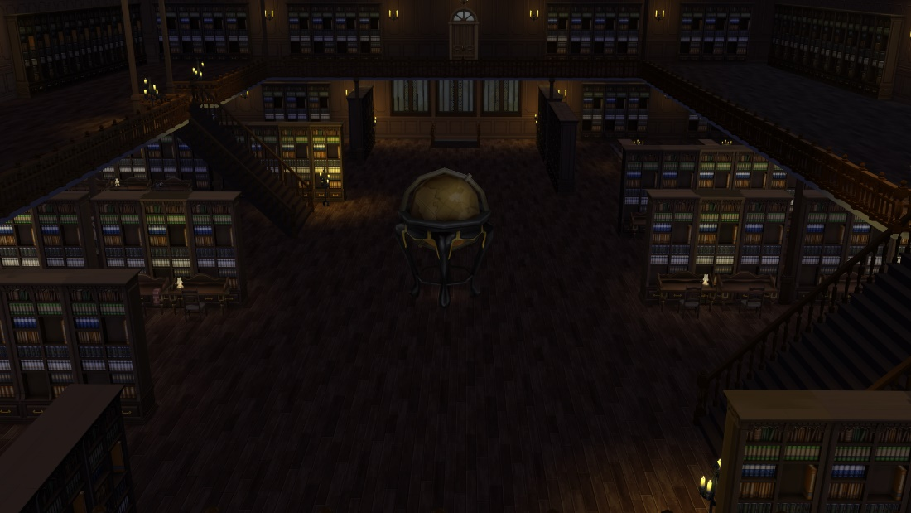

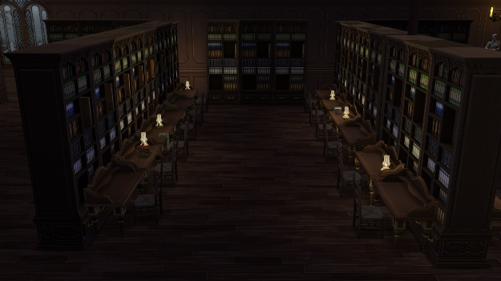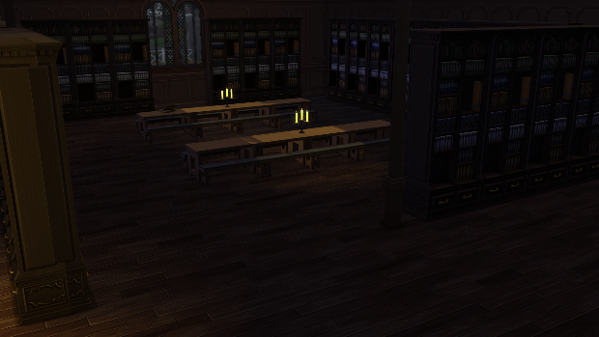

**Stairs**

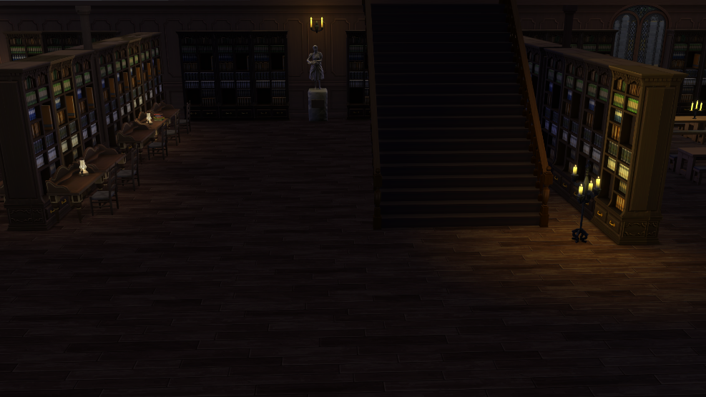

**Balcony**

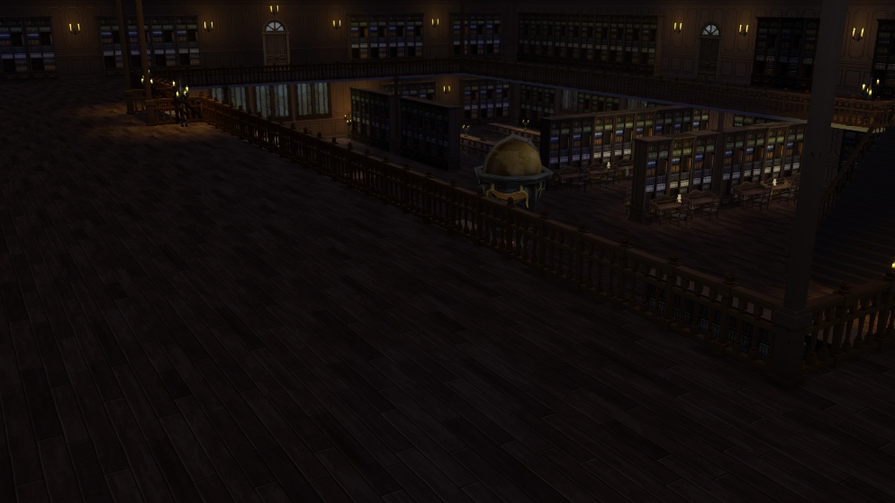

**Globe**

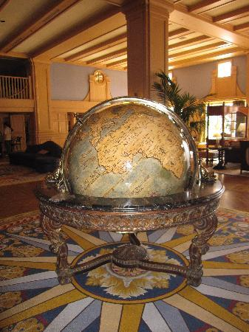

**Door**

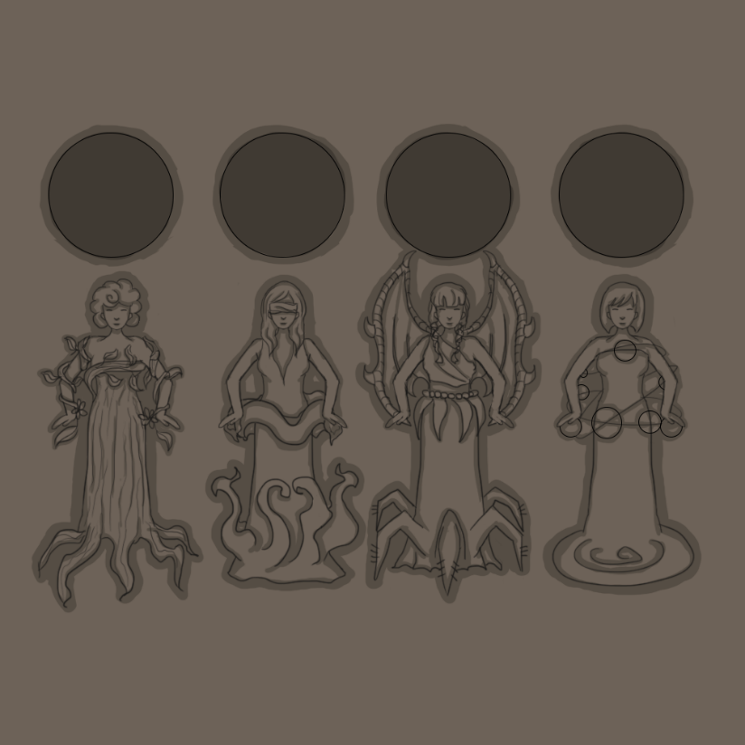

The women depicted on the door leading to the Restricted Section change their position once the seal corresponding to each of them is inserted.

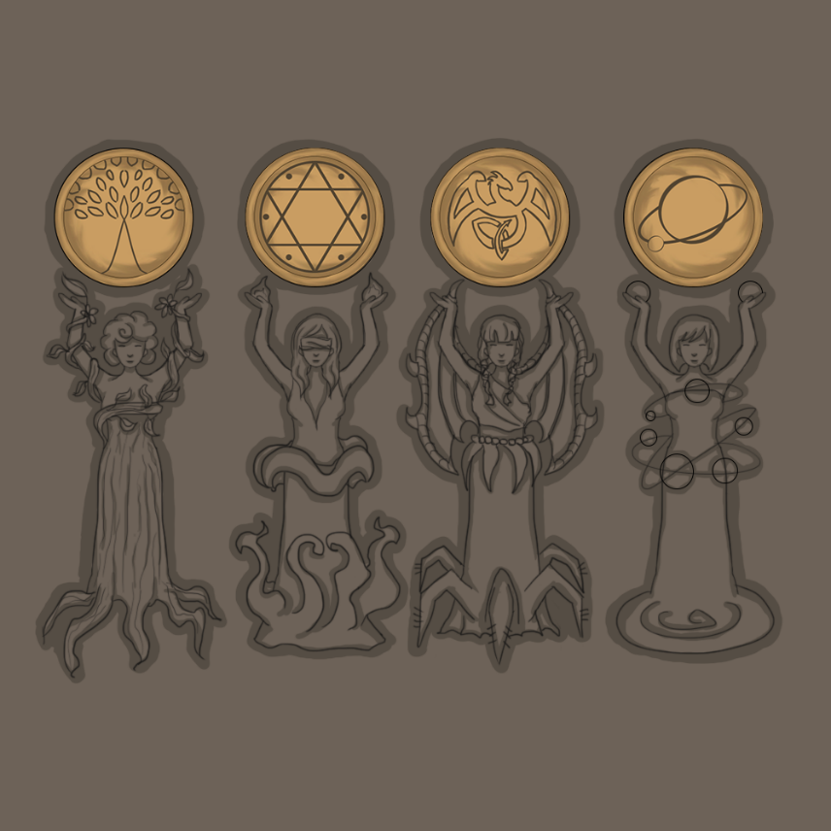

**Secret passage**

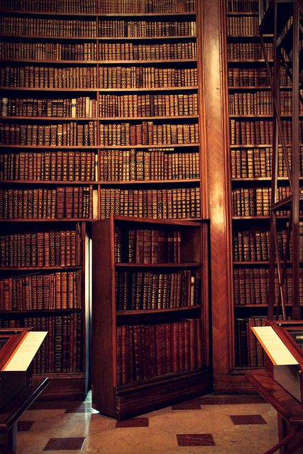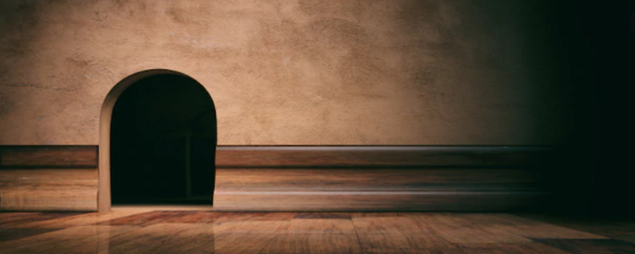

**Ghosts**

