### Restricted section

### Area description

The restricted section has a rectangular structure and inside there are small waterfalls on the columns whose water falls into channels.

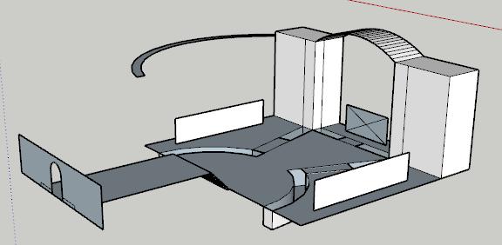

### Lore

Despite always showing an open-mind in teaching to the students, Hogwarts knows that some books are too dangerous or too delicate for a young wizard to read. Those books are held in the restricted section, the only restricted area of the entire library. To enter, students must present an authorization, signed by a teacher and valid only for one specific book. The ghost of Onorius Durandall is responsible for checking these authorizations, and won’t let anyone in without it. Many of the books in this area contains very dark spells, and everyone in the castle knows how unpleasant it is to walk the restricted section’s corridors.

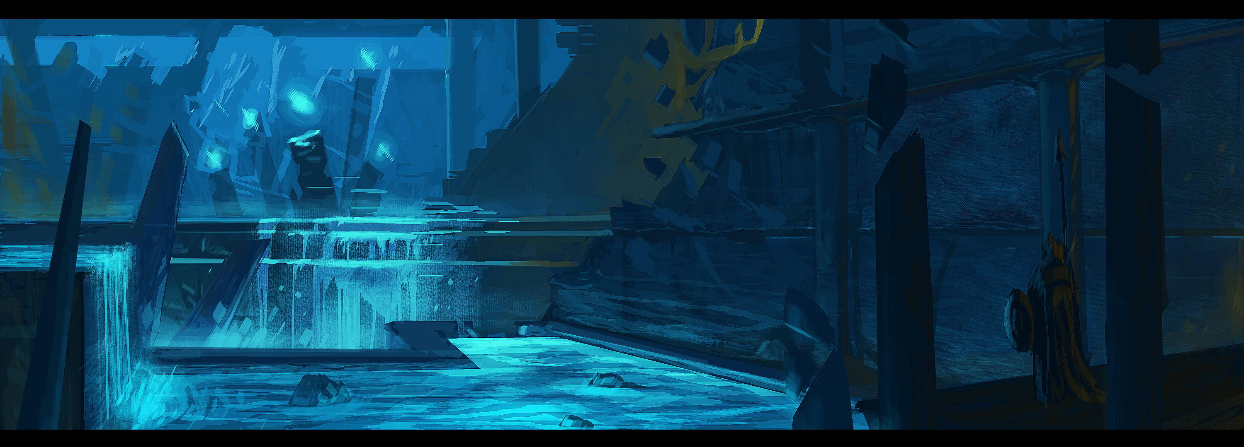

### Map

In the restricted section there is a large arch supported by two columns. In one of the columns there is a staircase that leads to a path on the ceiling and that leads to the legal section whose passage can only be opened once the "book of no more" has been taken from Minerva.

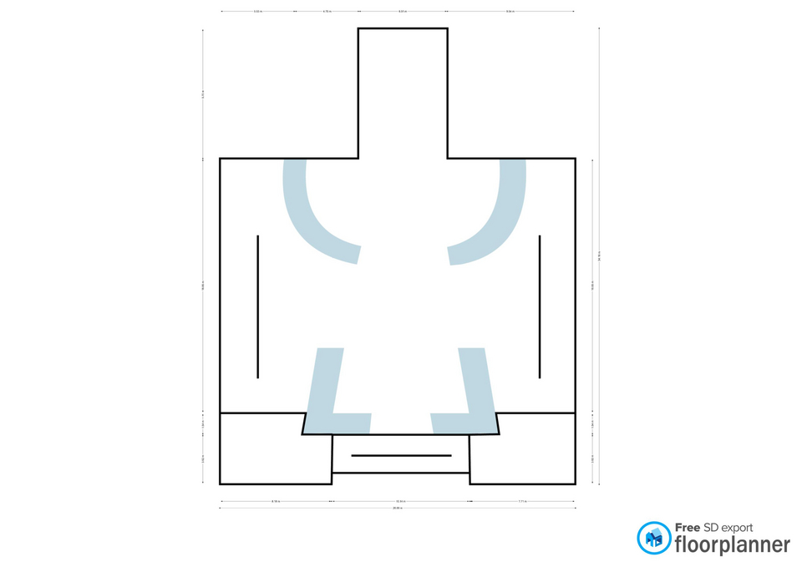

### 

### Goals

The main goal of the restricted section is to get hold of the "book of no more" by being able to overtake the keeper Onorius Durandal by force or deception.

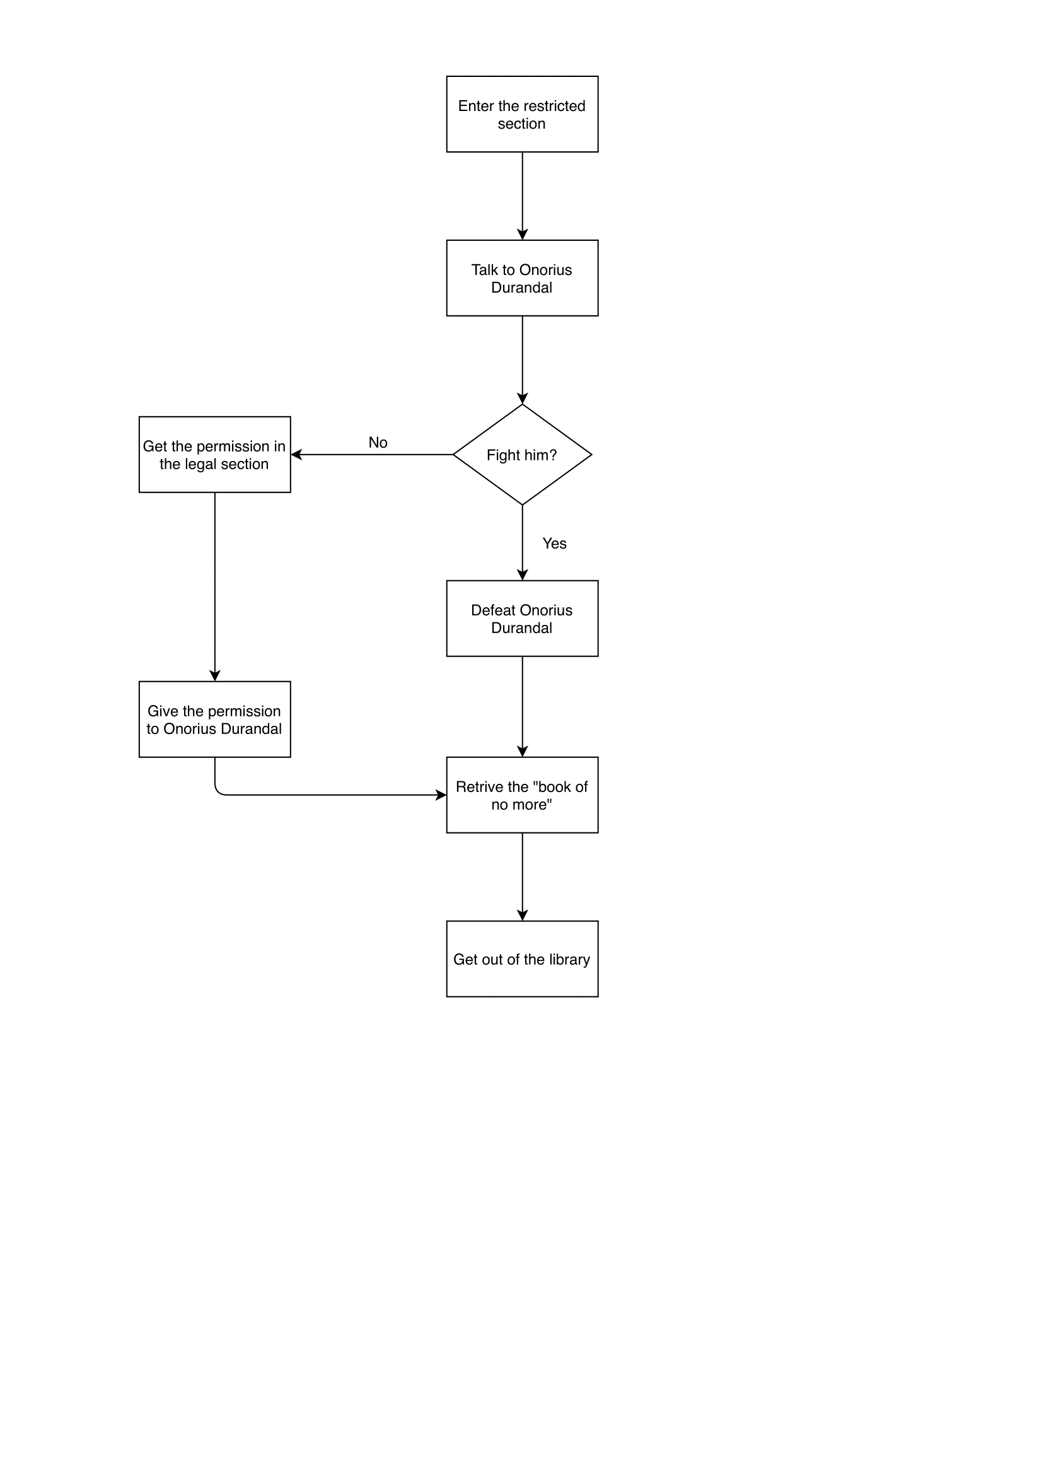

### Main quest

#### Fight or deceive Onorius Durandal:

The player here must make a choice: either take the book by force, facing Onorius Durandal in a fight and thus making a bad choice, or he can take the book by forging a permit and thus making a good choice.

#### Get out of the library:

Once Minerva gets the "book of no more", all that remains is to exit the library to complete the level.

### Room contents

In addition to being a section full of bookcases, the main elements are the **waterfalls** that fall from the columns and end up in canals that can be crossed via small bridges. In one of the columns there is a staircase that leads to a path on the ceiling. Another main element of this section is its ghostly keeper, **Onorius Durandal**.

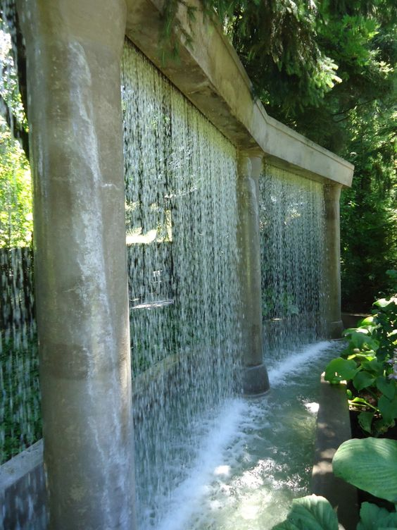

**Waterfalls:** These waterfalls are enchanted and their water does not do any damage to the books of the section.

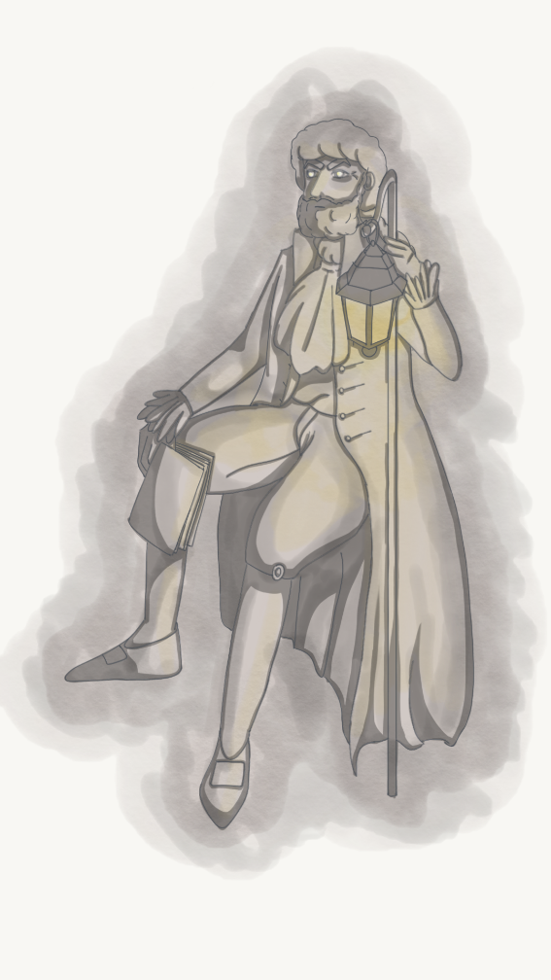

**Onorius Durandal:** He was the first guardian of the library, soon after Hogwarts foundation, and a very powerful and knowledgeable wizard.

#### C:\Users\689290\Desktop\lvl\ASTRONOMY\book.jpgThe book of no more

Wrote decades ago by a group of powerful wizards. It's the product of their foolish research on ways to defeat death and give immortality to the wizards kind. It is full of dark spells and, therefore, Hogwarts copy is safely stored in the restricted section of the library.

### Cutscenes and Dialogues

1. As soon as Minerva manages to enter the restricted section, a **cutscene** starts:

The camera initially moves to the waterfalls that are in the scene and then moves to the ghostly keeper.

A ghostly figure of a man with a thick beard and a book in his hand, who with an intimidating air turns to the frightened and at the same time curious young Minerva.

**The ghostly keeper:** *“Who dares to enter the library at this time?”*  
**Minerva:** *"It's Minerva Mcgonagall, I'm here to read a book ... who are you?”*  
**The ghostly keeper:** *“I am the keeper of these rare books, I am Onorius Durandal. You know well that it is not allowed to enter the library at this time.”*

The keeper remains silent for a while observing the unlocked door mechanism and his expression begins to seem more condescending.

**Onorius:** *“However, I must congratulate you miss, for being able to counteract the enchanted books and find the solution to my riddle, no one had been able to do so until now. I hope at least that you have a permission to take your coveted book.”***Minerva’s thoughts:** *“Permission?.. I need to get one back soon, maybe I could get one of the professors' signatures from the library register. Or I could try a direct clash...”*   
**Minerva:** *“Oh yes, the permission, I almost forgot it.”*

**Onorius:** *“Well, what are you waiting for?”*

The ghostly keeper waits for Minerva to bring him the signed permission of one of the professors to give her the book. When Minerva passes by Onorius before making a choice, Onorius can say two random sentences between these two:

1. **Onorius:** "Well, this permission?"
2. **Onorius:"**My patience has a limit miss!"

Minerva can decide whether to start a fight agains the keeper**(1)** or to trick him with a false permission**(2)**.

**1)** Minerva throws a blow at the keeper and a cutscene starts.

The keeper caught off guard falls to the ground and then gets up and starts railing at Minerva.

**Onorius*:*** *“You ... silly little girl, how dare you challenge me ?! I'll make you pay bitterly for this affront!!”*

Thus began the fight between the two.  
  
**2)** Minerva creates the forged permit, returns to Onorius Durandal, and a cutscene starts.

**Minerva:** *“Here is my permission, sir.”*  
**Onorius:** “*Ah there you are, I thought you never came back. Okay, let's take a look ..”*

The keeper pulls a pair of ghostly glasses out of his tunic pocket to carefully observe the permission. Minerva, worried, hopes that the keeper does not notice the illusion and seems to almost hold her breath waiting for the outcome.

**Onorius:** *“Mh, I would say perfect. You're welcome miss.”*

The keeper spreads his arms to allow Minerva to pass to the shelves while she hurriedly puts the piece of paper back in her pocket before the illusion disappears and then breathes a sigh of relief.

**Minerva:** *“Thank you, sir.”*

1. Once Minerva has found the "book of no more" a **cutscene** starts.

Minerva carefully takes the book from one of the bookstores and looks curiously at the cover.

**Minerva's thoughts:** *"I did it!"*

### Gameplay

In this section the gameplay varies according to the choice made by Minerva: if the player chooses to fight against Onorius then there will also be a combative component, otherwise the section will be mostly dialogue and exploration oriented and there will be no fighting.

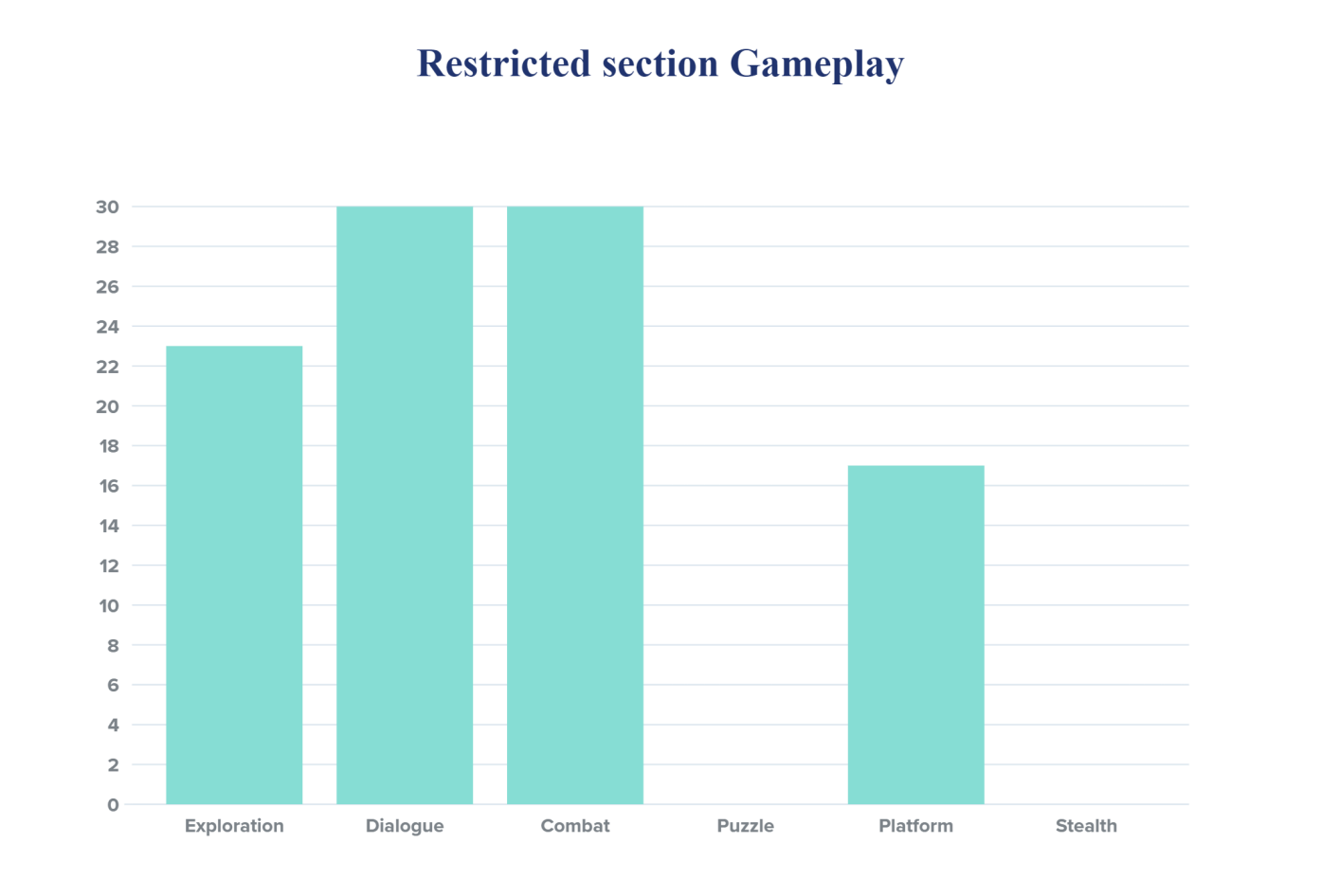

#### Exploration

1. In the section there are 2 collectibles:

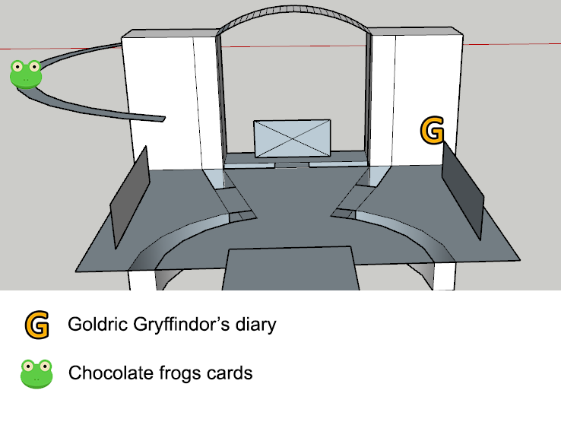

1. By exploring, the player can find a short cut that leads directly to the legal section, via the path on the ceiling.
2. Minerva must explore the room to find the "book of no more".

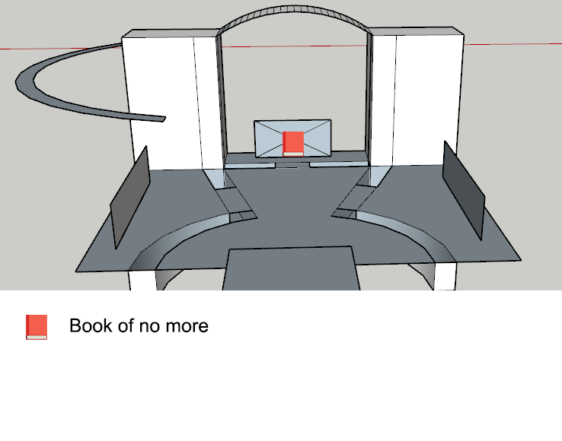

#### Dialogue

Dialogue is the main gameplay element of this section given by the speech between Onorius Durandal and Minerva. Only at the end of the discussion does the player decide what choice to make.

#### Combat and Stealth

There is no stealth mode in this section and combat mode is optional as it is up to the player to decide how to get past Onorius.

The fight takes place in the center of the section. (IMMAGINE)

#### Puzzle

There is no puzzle in this section.

#### Platform

In this section the platform element is given by the path on the ceiling that can be followed by Minerva in her form of Animagus to reach the legal section.

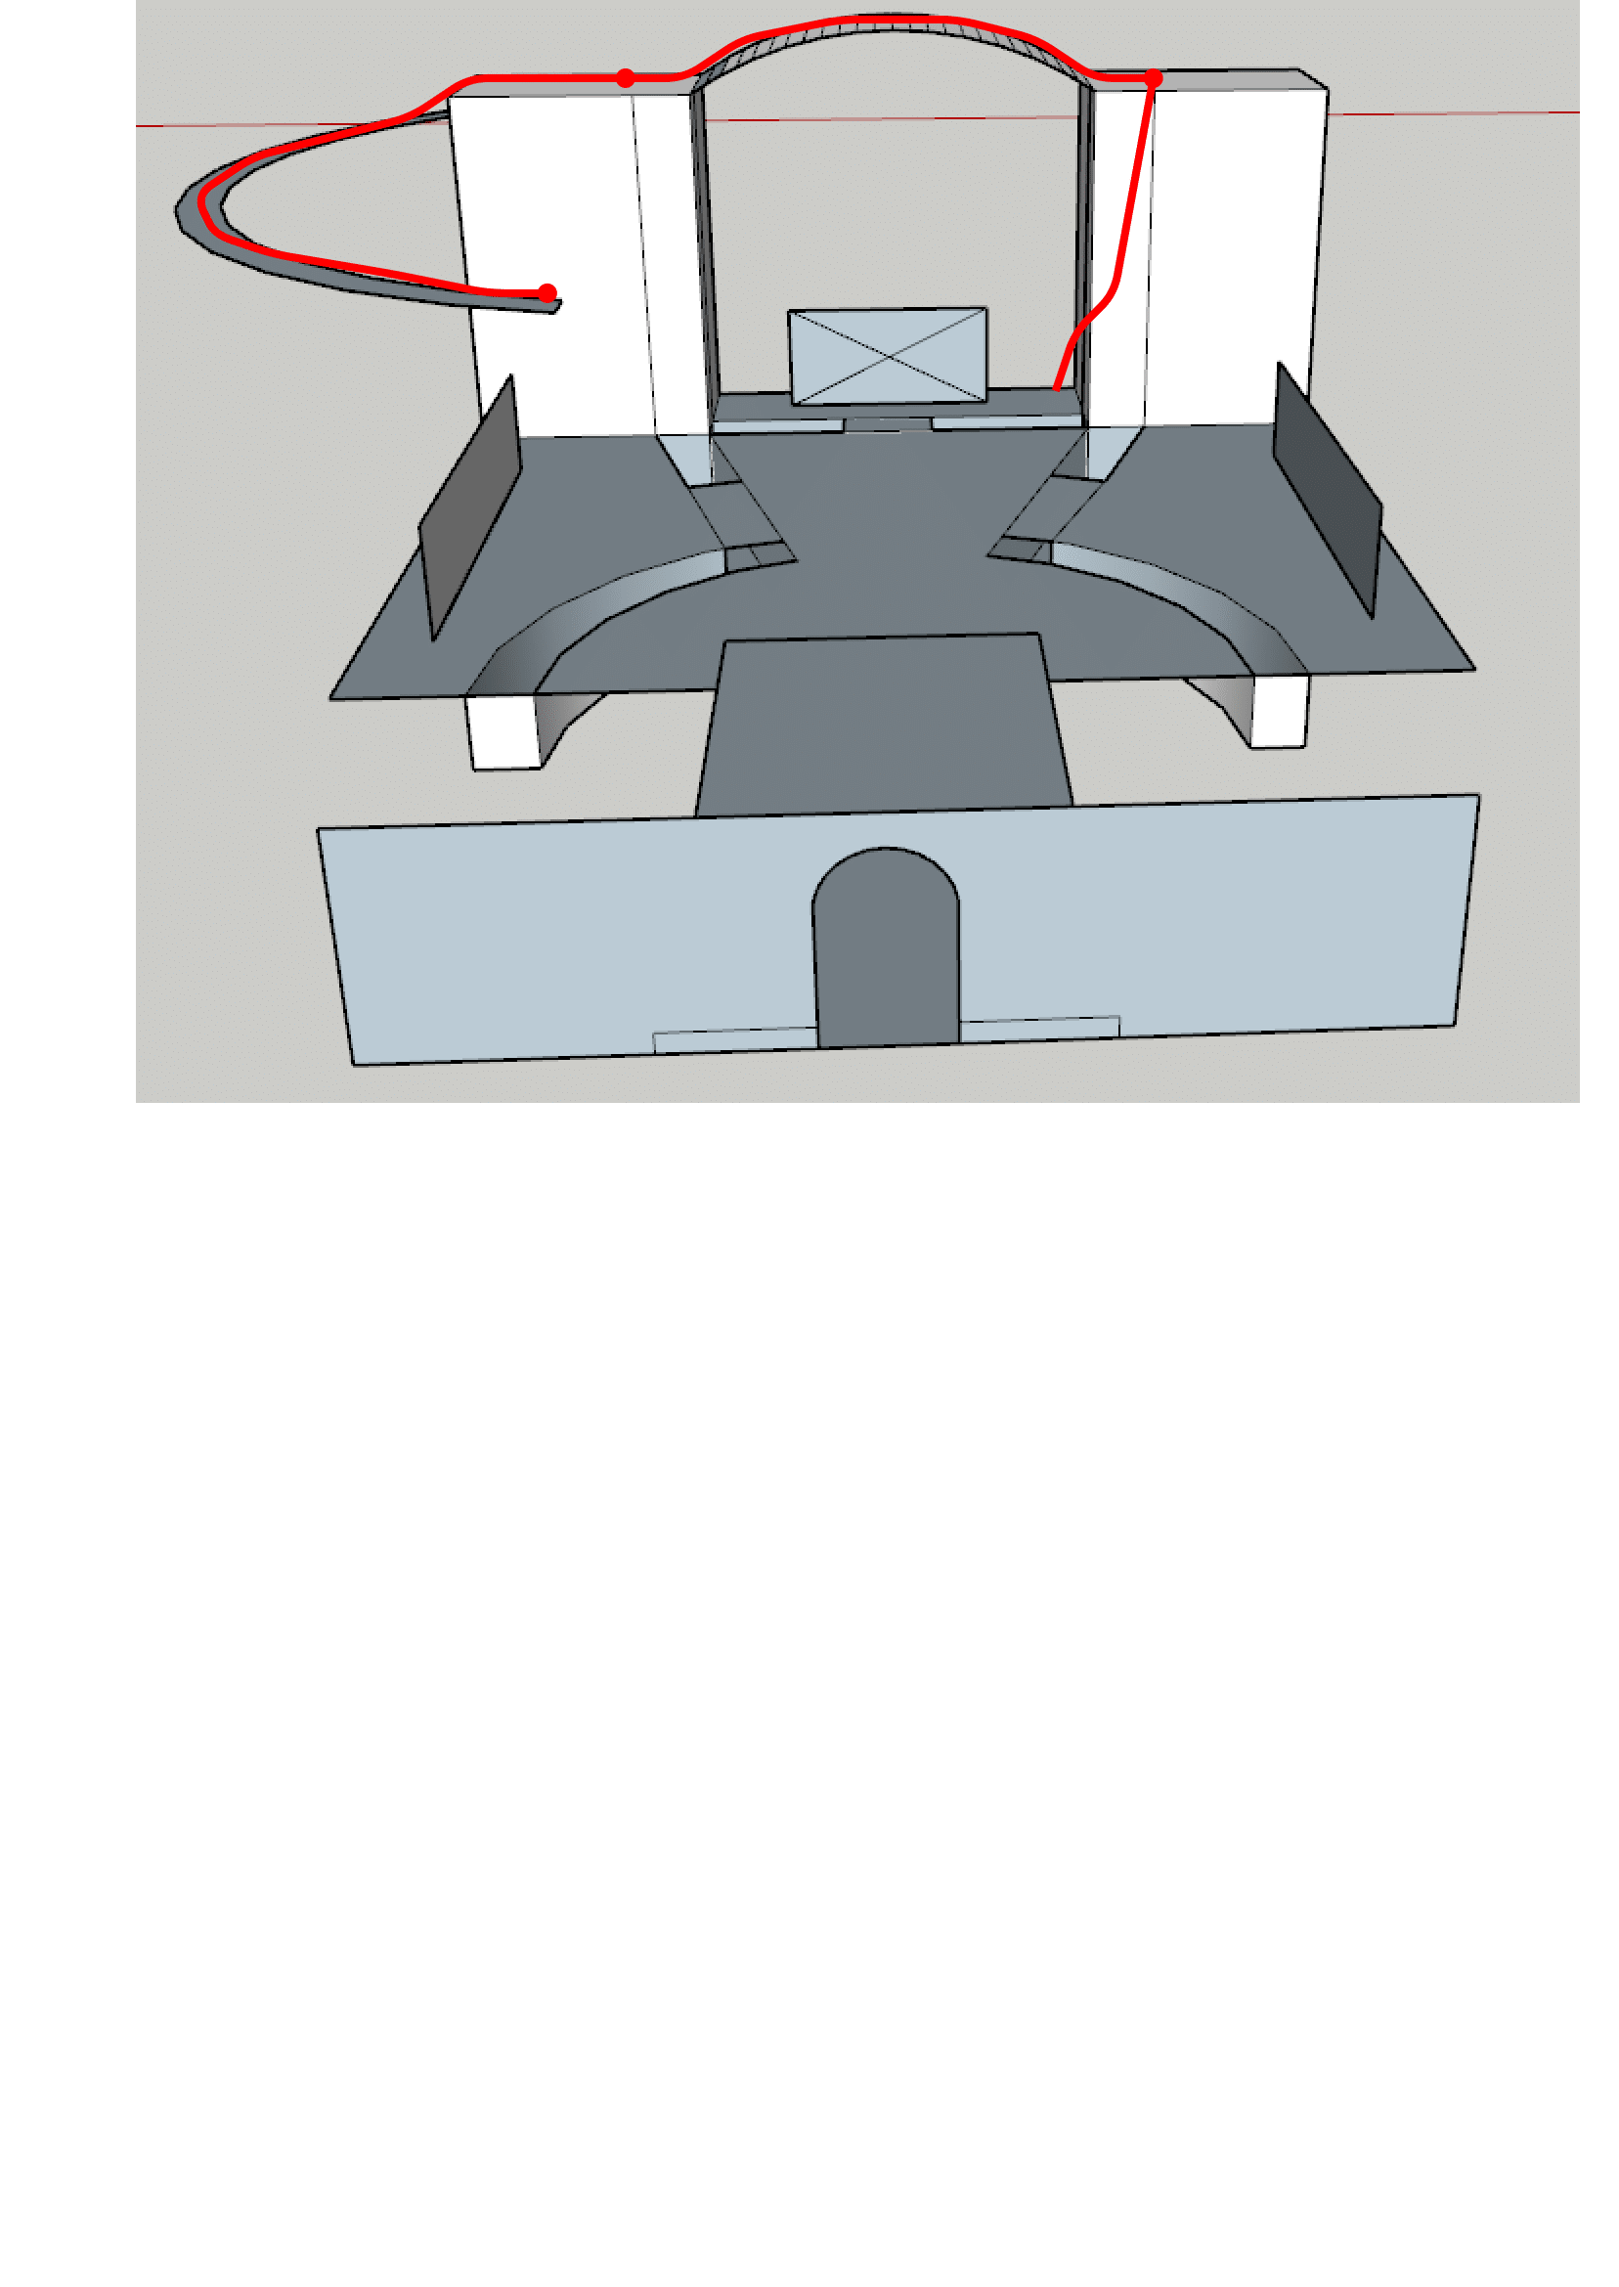

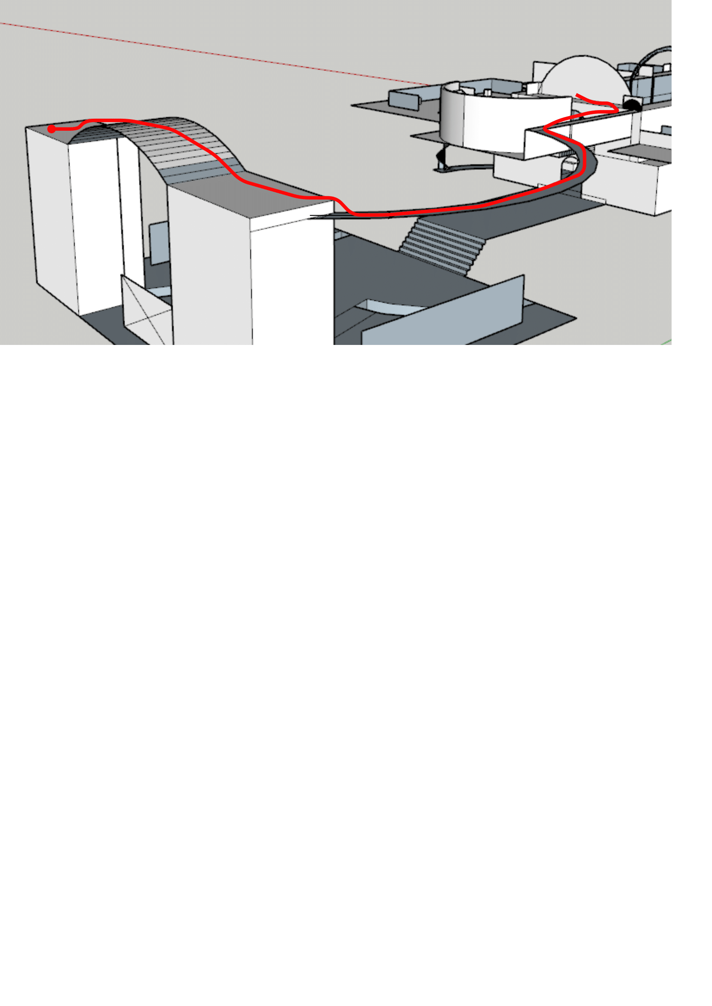

### Enemies

**Onorius Durandal**

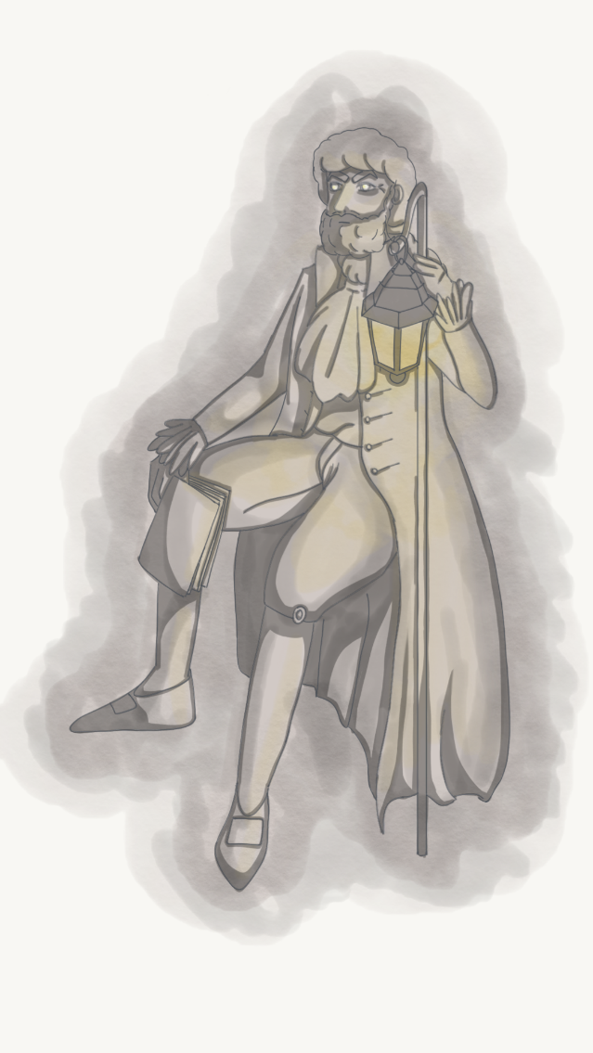

**Description:** Onorius Durandall was the first guardian of the library, soon after Hogwarts foundation. He spent most of his time in it, both guarding and reading the books he was so binded to. This made him a very powerful and knowledgeable wizard.

**Armor Class:** 11

**Hit Points:** 50

**Speed:** 12 metres

|  |  |  |  |  |  |
| --- | --- | --- | --- | --- | --- |
| **STR** | **DEX** | **CON** | **INT** | **WIS** | **CHA** |
| 7(-2) | 10(+0) | 10(+0) | 17(+3) | 12(+1) | 13(+1) |

**Ranged Weapon Attack:** d20 +5 to hit, range 24 meters, one target. Hit: 8 magic damage.

**Incorporeal Movement:** The enemy can move through other creatures and objects.

**EXP:** 400

### Lights

There is a different type of light in the room than in the rest of the library. The atmosphere is colder. There is no more wood from the other rooms in the library. The walls are made of stone. The restricted section looks like a real dungeon. Torches light up the shelves at the edge of the room. A ghostly light comes out of the falls and streams.

### Sounds

|  |  |
| --- | --- |
| **Sound Effect** | **Track** |
| Waterfalls noises | Waterfalls.wav |
| Onorius Durandal noises | Onorius.wav |