**Onorius Durandal**

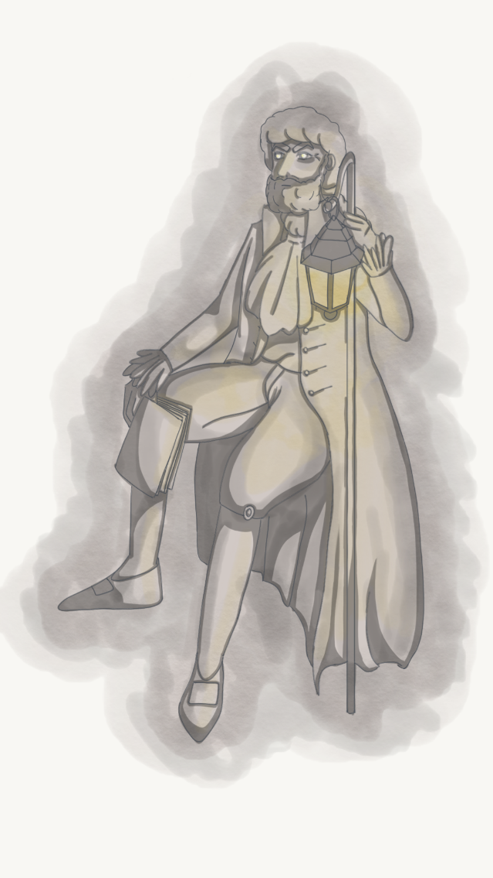

**Description:** Onorius Durandall was the first guardian of the library, soon after Hogwarts foundation. He spent most of his time in it, both guarding and reading the books he was so binded to. This made him a very powerful and knowledgeable wizard.

**Armor Class:** 11

**Hit Points:** 50

**Speed:** 12 metres

|  |  |  |  |  |  |
| --- | --- | --- | --- | --- | --- |
| **STR** | **DEX** | **CON** | **INT** | **WIS** | **CHA** |
| 7(-2) | 10(+0) | 10(+0) | 17(+3) | 12(+1) | 13(+1) |

**Ranged Weapon Attack:** d20 +5 to hit, range 24 meters, one target. Hit: 8 magic damage.

**Incorporeal Movement:** The enemy can move through other creatures and objects.

**EXP:** 400