**Pallium Umbra**

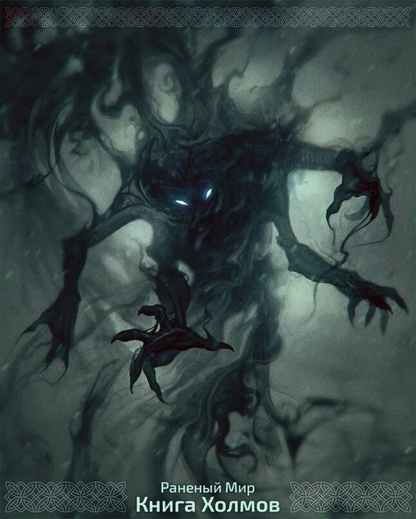

**Description:** Pallium Umbra is a shadow generated by an enchanted book that defends the Spell Section from intruders by trying to keep the room dark. This enemy is made up of three combat phases between which he will follow the path of Minerva to blow out the candles that have been lit. Between each stage the enemy recovers his hit points and in the last stage he can attack Minerva as she tries to light the candles by throwing a blow.

**Armor Class:** 12

**Hit Points:** 16

**Speed:** 12 meters

|  |  |  |  |  |  |
| --- | --- | --- | --- | --- | --- |
| **STR** | **DEX** | **CON** | **INT** | **WIS** | **CHA** |
| 6(-2) | 14(+2) | 13(+1) | 6(+1) | 10(+0) | 8(-1) |

**Melee Weapon Attack:** d20 +4 to hit, reach 1 meter and a half, one target. Hit: 7 necrotic damage. When attacking the enemy to approach the target to deliver a blow and then return to its initial position.

**Attack and Escape:** In the last stage he can attack Minerva as she tries to light the candles by throwing a blow. Hit: 2 necrotic damage.

**Incorporeal Movement:** The enemy can move through other creatures and objects.

**Exp:** 400